Tourism in Mazowieckie Voivodship in 2025
12.4%
Increase in the number of tourists in tourist accommo-dation establishments y/y
28 May 2026
In 2025, 7,719.2 thousand tourists were accommodated in tourist accommodation establishments in Mazowieckie Voivodship, with 12,507.3 thousand overnight stays provided to them. Compared to 2024, it was more by 12.4% and 12.2%, respectively. The occupancy rate of bed places amounted to 46.4% and during the year increased by 1.2 pp.
Tourist accommodation establishments
At the end of July 2025, tourists had 648 tourist accommodation establishments at their disposal
As of the end of July 2025, there were 648 tourist accommodation establishments in Ma-zowieckie Voivodship, of these 615 were open all year. During a year, the number of accom-modation establishments increased by 81. More than half (59.1%) of tourist accommodation establishments were located in warszawski stołeczny region.

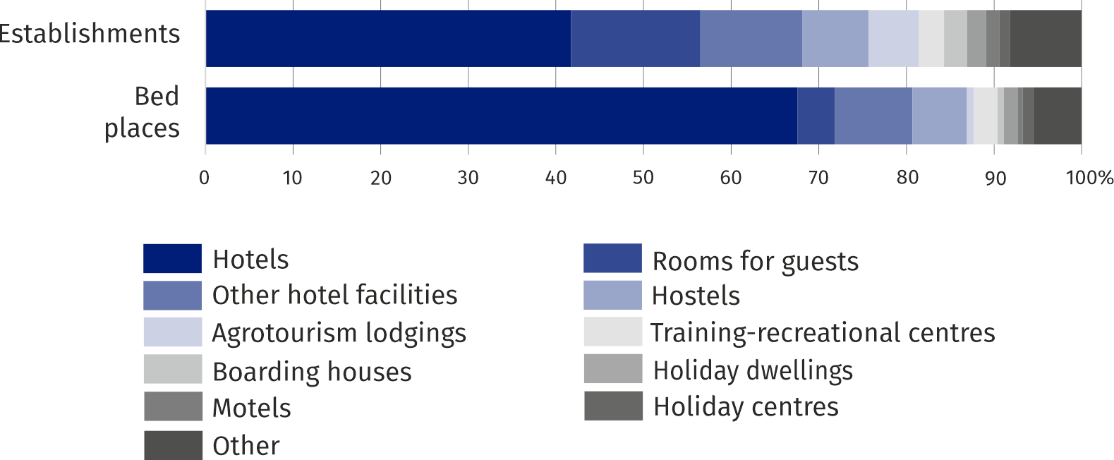
Chart 1. Structure of tourists accommodation establishments and bed places by type at the end of July 2025
There were 79.8 thousand bed places prepared for tourists In tourist accommodation estab-lishments in Mazowieckie Voi-vodship
The accommodation establishments consisted of 372 hotels and similar establishments (hotels, motels, boarding houses and other hotel facilities) and 276 other facilities. The numer of hotels and similar establishments increased by 18, and the numer of other facilities by 63. As in previous years, the largest group among hotels and similar establishments was hotels – 270 facilities (7 more than in 2024). The next largest group were other hotel facilities i.e. facilities that do not meet the categorisation requirements for hotels, motels and boarding houses, but provide services typical for hotels (e.g. guest houses and inns). As of 31 July 2025, there were 75 such facilities (1 more than the previous year). Among other facilities, the most numerous were rooms for guests – 96 (by 26 more than in 2024) and hostels – 49 (by 29 more).
At the end of July 2025, there were 79,779 bed places in tourist accommodation establish-ments (by 10.6% more than in the corresponding period of 2043). In the total number of bed places – 96.5% were places open all year (by 0.4 pp more than a year before). Majority of bed places (74.6%) offered facilities located in warszawski stołeczny region.
The data compiled show that one facility in the Voivodship had an average of 123 bed places (127 a year ago). In region warszawski stołeczny, facilities were on average more than twice as large as in region mazowiecki regionalny (155 compared to 77 bed places, respectively).
The largest number of bed places offered hotels (53,895), i.e. 67.6% of all bed places in the Voivodship. In comparison with the corresponding period of the previous year, the number of bed places increased by 6.1%. In 2025, there were 200 bed places on average per one hotel (by 7 more than a year before).

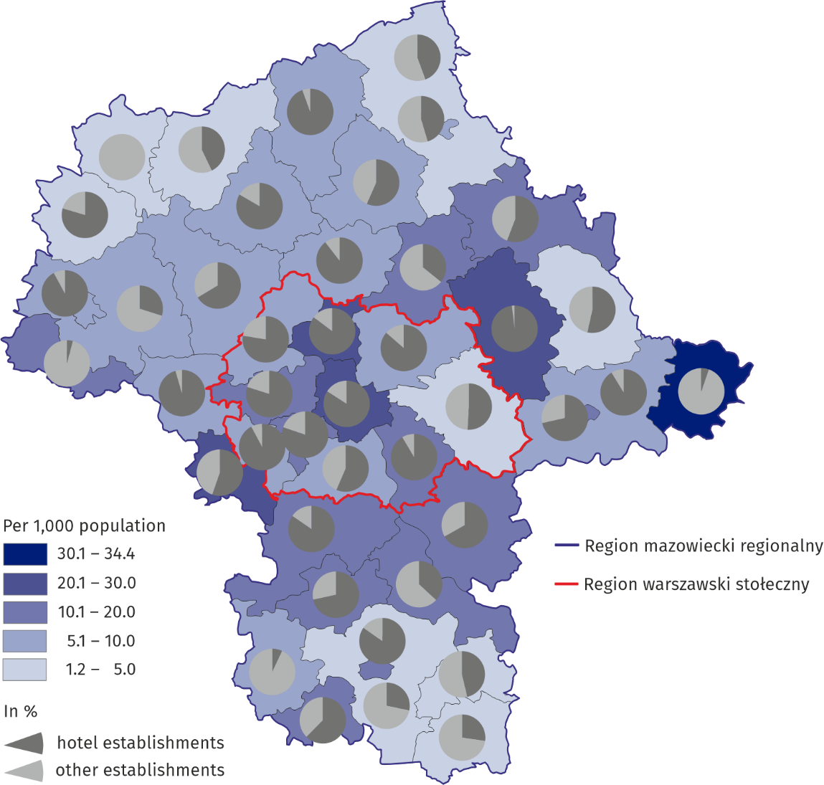
Map 1. Bed places in tourist accommodation establishments by powiats at the end of July 2025
The distribution of tourist accommodation establishments in Mazowieckie Voivodship is uneven. At the end of July 2025, most tourist accommodation facilities were located in m.st. Warszawa. 225 tourist establishments operated here, offering 45,509 bed places (57.0% of the total in the Voivodship). Outside the capital, the largest number of establishments and bed places were located in legionowski powiat (3,206 places in 21 establishments) and Radom (1,999 places in 17 establishments).

Table 1. Tourist accommodation establishments at the end of July 2025
Specification | Number of establishments |  | Number of bed places
Specification | 2025 | 2024=100 | 2025 | 2024=100
Total | 648 | 114,3 | 79779 | 110,6
of which open all year | 615 | 114,7 | 76967 | 111,0
hotels and similar facilities | 372 | 105,1 | 62074 | 106,3
of which hotels | 270 | 102,7 | 53895 | 106,1
other facilities | 276 | 129,6 | 17705 | 128,9
Region warszawski stołeczny | 383 | 114,3 | 59487 | 107,7
Region mazowiecki regionalny | 265 | 114,2 | 20292 | 119,8

Equipment of tourist accommodation establishments
At the end of July 2025, there were 552 catering establishments operating in tourist accommodation establishments (3 fewer than in the previous year). The largest group were restaurants – 273 (49.5%), followed by bars and cafes – 177 (32.1%), canteens – 59 (10.7%), and catering outlets – 43 (7.8%).
The survey of tourist accommodation establishments every four years also covers the equipment of tourist accommodation establishments with conference facilities, sports and recreation facilities and the availability of facilities for persons with mobility disabilities.
263 tourist accommodation establishments had a conference room, of which 177 hotels
In 2025, conferences could be held in 263 tourist accommodation establishments, which constituted 40.6% of all such establishments. Among hotels, this percentage was significantly higher, reaching 65.6% (177 establishments). In total, accommodation establishments offered 1,122 conference rooms with 72,438 seats. 195 tourist accommodation establishments had their own technical support. Wi-Fi was available in 57.1% of tourist accommodation establishments, including 76.7% of hotels.
Among sports and recreational facilities, tourist accommodation establishments most often had a gym – 108 (16.7%), a sauna – 106 (16.4%), a billiards table with equipment – ​​83 units (12.8%), a table tennis table with equipment – ​​70 (10.8%), and a rental of tourist equipment, e.g., bicycles, Nordic walking, skis, ice skates, roller skates – 69 (10.6%). A volleyball or basketball court was located in 65 establishments (10.0%), spa treatments were offered in 59 establishments (9.1%), and a children's playroom was present in 57 establishments (8.8%). Additionally, 40 (6.2%) establishments had an indoor swimming pool, and 15 (2.3%) had an outdoor swimming pool.
The most common facilities for persons with disabilities were designated parking spaces (196 establishments) and accessible elevators (177 establishments). Ramps were available in 168 establishments, and automatic doors were available in 115 units.

Occupancy of tourist accommodation establishments
Tourists most often stayed in hotels (80.8% of total tourists)
In 2025, 7,719.2 thousand persons used tourist accommodation establishments, of which 2,181.1 thousand foreign tourists (28.3%) and compared to 2024, it was by 12.4% and 17.0% more. Similarly to 2024, the most popular among tourists were hotels which received 6,238.2 thousand persons, which accounted for 80.8% of total persons using tourist accommodation es-tablishments in Mazowieckie Voivodship
The vast majority of tourists (85.2%) chose facilities located in warszawski stołeczny region, and 71.3% stayed in facilities located in the capital. M.st. Warszawa is characterised by par-ticularly valuable cultural heritage resources, which causes the development of cultural and urban tourism. The metropolitan nature of the capital city additionally support the development of business tourism. An important element of Warszawa's tourist potential is very good transport accessibility and extensive tourist infrastructure.

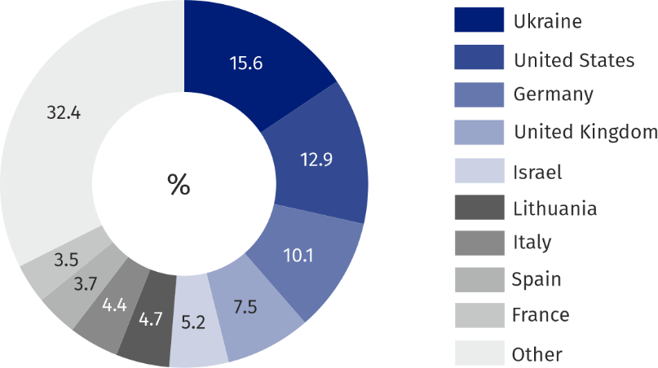
Chart 2. Structure of foreign tourists by country of permanent residence in 2025
2,181.1 thousand foreign tour-ists used tourist accommoda-tion establishments in 2025, most from Ukraine

Tourists from Europe prevailed among foreign tourists using the accommodation establish-ments in Mazowieckie Voivodship. In 2025, 1,531.6 thousand guests from European countries used overnight stays in accommodation establishments and their share was 70.2%. Among all the countries, the greatest number of tourists came from Ukraine – 341.2 thousand, followed by the United States – 280.3 thousand, and Germany – 219.5 thousand.
Tourists, who in 2025 visited Mazowieckie Voivodship spent 12,507.3 thousand nights there (by 12.2% more than in 2024), of which 3,758.1 thousand (30.0%) were foreign tourists. The number of nights spent by foreigners increased by 16.7%. 9,598.1 thousand nights were spent in hotels, that is 76.7% of total nights spent in the Voivodship.

Table 2. Tourists and nights spent in tourist accommodation establishments in 2025
Specification | Tourists accommodated |  | Nights spent
Specification | in thousands | 2024=100 | in thousands | 2024=100
Total | 7719,2 | 112,4 | 12507,3 | 112,2
of which foreign tourists | 2181,1 | 117,0 | 3758,1 | 116,7
hotels and similar facilities | 6755,3 | 107,2 | 10620,4 | 107,5
of which hotels | 6238,2 | 106,4 | 9598,1 | 106,6
other facilities | 963,9 | 169,0 | 1886,9 | 148,7
Region warszawski stołeczny | 6580,2 | 110,0 | 10522,7 | 110,2
Region mazowiecki regionalny | 1139,0 | 128,7 | 1984,6 | 124,1

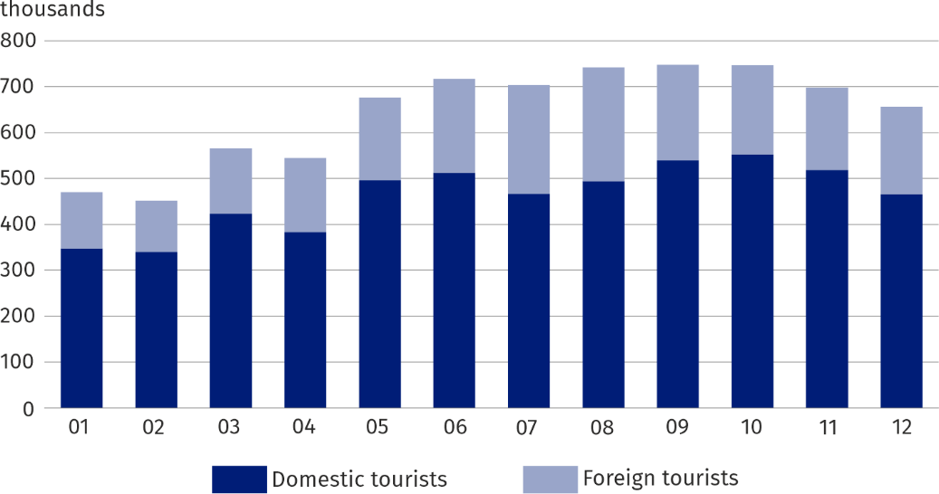
Chart 3. Tourists accommodated by months in 2025
Most tourists visited Mazowieckie Voivodship in September – 747.8 thousand, and the least in February – 451.6 thousand. Foreign tourists were most likely to arrive in August – 248.0 thousand, and the least in February – 111.6 thousand. The largest number of overnight stays was provided in August – 1,265.5 thousand, and the least in February – 749.6 thousand. A similar trend applied to foreign tourists: in August they used 433.1 thousand overnight stays, while in February – the fewest were recorded – 192.0 thousand.
The average length of stay of tourists in tourist accommodation establishments in total in 2025 amounted to 1.6 nights (as in the previous year). The average length of stay of foreign tourists in Masovia did not change and amounted to 1.7 nights.
Occupancy rate of bed places in total tourist accommodation facilities in 2025 amounted to 46.4% and over the year increased by 1.2 pp. The occupancy rate of bed places in hotels and similar establishments amounted to 48.6% i.e. by 0.9 pp more than in 2024, while in other facilities it amounted to 37.0%, i.e. more by 4.8 pp.

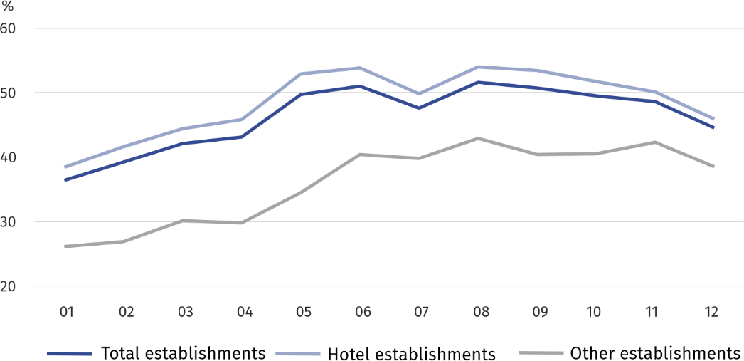
Chart 4. Occupancy rate of bed places by months in 20245 (in %)
In 2025, 6,868.9 thousand rooms were rented in hotels and similar establishments (an increase by 6.9% compared to 2024). Most, as many as 6,274.1 thousand rooms, were rented in hotels (an increase of 6.4%). Occupancy rate of rooms in hotels and similar facilities in 2025 amounted to 62.4%, i.e. by 1.3 pp more than in 2024. The highest occupancy rate of rooms was recorded in September – 69.7%, while the lowest in January – 50.2%.
Of the total number of tourists accommodated in hotels, the most (36.2%) stayed in 4-star hotels; the highest standard hotels, i.e. 5-star, were chosen by 14.5% of them. Foreigners constituted 29.5% of total hotel guests, and in 5-star hotels their share was the highest and totaled 49.6%.

Table 3. Hotels by category and occupancy in 2025
Specification | Num-ber of esta-blishmentsª | Tourists accommodated | Nights spent | Rooms rented | Occupancy rate in %
Specification | Num-ber of esta-blishmentsª | in thousands |  |  | bed places | rooms
Total | 270 | 6238,2 | 9598,1 | 6274,1 | 50,6 | 65,0
5-star | 17 | 903,9 | 1436,9 | 937,5 | 60,7 | 70,3
4-star | 55 | 2256,0 | 3370,6 | 2207,1 | 51,6 | 66,9
3-star | 121 | 1936,1 | 2962,9 | 1994,8 | 47,1 | 61,5
2-star | 51 | 705,3 | 1121,0 | 698,8 | 47,3 | 62,2
1-star | 13 | 252,0 | 417,7 | 250,4 | 48,3 | 66,5
under categorisation | 13 | 184,9 | 289,1 | 185,4 | 52,3 | 66,5
Region warszawski stołeczny | 171 | 5428,2 | 8352,3 | 5458,6 | 52,7 | 67,7
Region mazowiecki regionalny | 99 | 809,9 | 1245,8 | 815,5 | 39,7 | 51,3
a As of end of July.

In case of quoting Statistics Poland data, please provide information: “Source of data: Statistics Poland”, and in case of publishing calculations made on data published by Statistics Poland, please include the following disclaimer: “Own study based on figures from Statistics Poland”.
Prepared by:  Statistical Office in Warszawa  Director Agnieszka Ajdyn  Phone: (+48 22) 464 23 15 | Issued by:  Mazovian Centre for Regional Surveys  Statistical Information Centre  Mobile: (+48) 783 940 141
Press office in the Statistical Office in Warszawa  Mobile: (+48) 783 940 141  e-mail: m.kaluski@stat.gov.pl |   warszawa.stat.gov.pl/en/

@Warszawa_STAT

@UrzadStatystycznywWarszawie

gus_stat

glownyurzadstatystycznygus

glownyurzadstatystyczny


Related information
Tourism in 2024
Tourism in the European Union – data on 2023
Data available in databases
Local Data Bank
Terms used in official statistics
Tourist
Tourist accommodation establishment
Bed places in tourist accommodation establishments
Foreign tourists accommodated in tourist accommodation establishments

Applies to tourist accommodation establishments with 10 or more bed places.
Excursion hotels, shelters, youth hostels, school youth hostels, holiday centres, holiday youth centres, training-recreational centres, creative art centres, complexes of tourist cottages, camping sites, tent camp sites, hostels, health establishments, rooms for guests, agrotourism lodgings, other tourist accommodation establishments.

