Tourism in m.st. Warszawa in 2025
8.8%
Increase in the number of tour-ists and overnight stays in tourist accommodation establishments y/y
28 May 2026
In 2025, there were 5,504.7 thousand tourists using tourists accommodation establishmnets in Warszawa, who were provided with 8,728.8 thousand overnight stays. Both figures were 8.8% higher than the previous year. The occupancy rate of bed places amounted to 54.4% and increased during the year by 1.0 pp.

Tourist accommodation establishments
At the end of July 2024, tourists visiting the capital city had 225 tourist accommodation establishments at their disposal
As of 31 July 2025, there were 225 tourist accommodation facilities in m.st. Warszawa, of which 223 were open all year. During the year, the number of accommodation establish-ments increased by 35.
Taking into account the standard of accommodation services provided, the accommodation base consisted of 139 hotels and similar facilities (hotels, motels, boarding houses and oth-er hotel facilities) as well as 86 other facilities. The largest group among hotels and similar facilities, similarly to previous years, were hotels – 106 facilities (by 2 more than a year before). Among other facilities, the most numerous were hostels – 45 (27 more than in 2024).

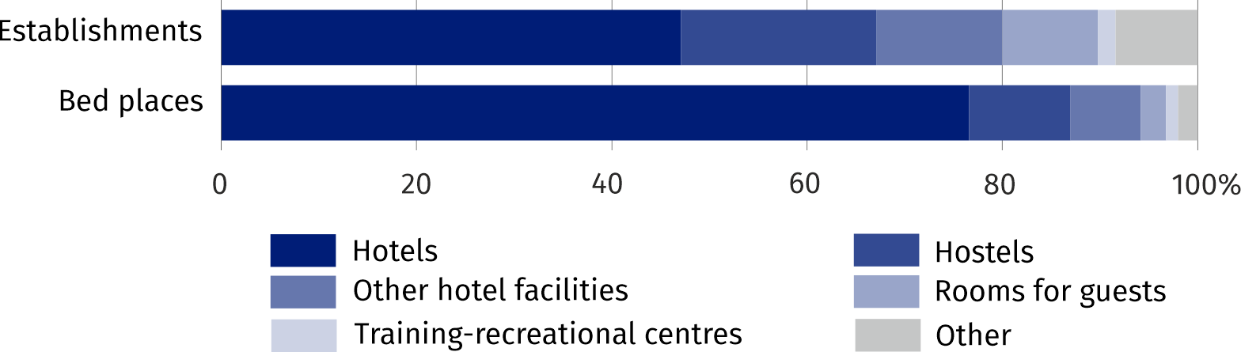
Chart 1. Structure of tourist accommodation establishments and bed places by type at the end of July 2025
At the end of July 2025, 45509 bed places were prepared in tourist accommodation facilities, that is by 8.0% more than in the corresponding period of 2024. According to the compiled data, there was an average of 202 bed places per one facility in the capital city (in 2024 – 222).
The largest number of bed places were offered by hotels – 34870, i.e. 76.6% of all bed places in m.st. Warszawa. Compared to the corresponding period of the previous year, the number of bed places in hotels increased by 1.6%. There was an average of 329 bed places per one hotel (by 1 fewer than in the previous year).

Table 1. Tourist accommodation establishments at the end of July 2025
Specification | Number of establishments |  | Number of bed places
Specification | 2025 | 2024=100 | 2025 | 2024=100
Total | 225 | 118,4 | 45509 | 108,0
of which open all year | 223 | 118,6 | 45254 | 108,7
Hotels and similar facilities | 139 | 104,5 | 38288 | 102,2
of which hotels | 106 | 101,9 | 34870 | 101,6
Other facilities | 86 | 150,9 | 7221 | 155,1
The distribution of the tourist accommodation establishments in Warszawa is uneven. As of the end of July 2025, the largest number of tourist accommodation facilities were located in the Śródmieście district. 60 facilities were operating here, offering 14922 bed places (32.8% of total tourist accommodation facilities in the capital). Apart from Śródmieście, the following districts had the largest number of bed places: Wola (7117 places in 25 facilities), Włochy (6004 places in 26 facilities) and Mokotów (5621 places in 29 facilities).
At the end of July 2025, tourist accommodation estab-lishments in m.st. Warszawa offered 45.5 thousand bed places, of which the most in Śródmieście

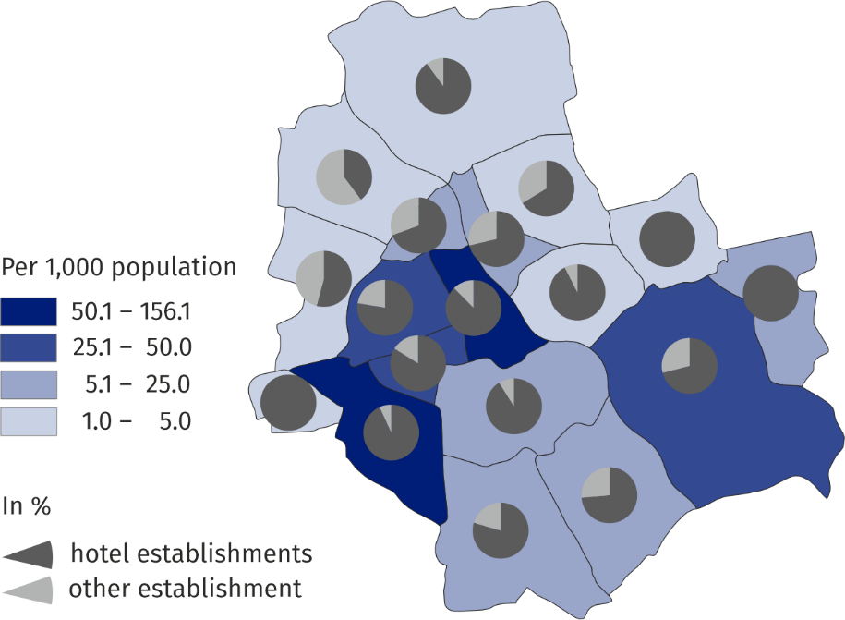
Map 1. Bed places in tourist accommodation establishments by districts at the end of July 2025

Equipment of tourist accommodation establishments
At the end of July 2025, there were 234 catering establishments operating in tourist accommodation establishments (the same number as a year ago). The largest group were restaurants – 108 (46.2%), followed by bars and cafes – 86 (36.8%), canteens – 22 (9.4%), and catering outlets – 18 (7.7%).
The survey of tourist accommodation establishments once every four years also covers the provision of conference facilities, sports and recreational facilities and the availability of facilities for persons with physical disabilities.
In 2025, 106 (47.1%) tourist accommodation establishmnts were prepared to host conferences, while among hotels, this percentage reached 72.6% (77 establishments). Accommodation establishments offered a total of 38,767 seats in 584 conference rooms. In addition to technical equipment, 83.0% of establishments with conference facilities also provided technical support. 61.8% of tourist accommodation establishments, including 83.0% of hotels, had Wi-Fi on-site.
106 tourist accommodation establishments, including 77 hotels, had a conference room
Among the sports, recreation and rehabilitation facilities, tourist accommodation establishments most often had a gym – 60 (26.7%) and a sauna – 49 (21.8%). Spa treatments were offered in 24 (10.7%) establishments, and rehabilitation treatments in 22 (9.8%). A children's playroom was available in 16 establishments (7.1%), an indoor swimming pool in 15 establishments (6.7%), and instructor-led classes (e.g. fitness, yoga, gymnastics) were offered by 14 establishments (6.2%).
In 2025, the majority of tourist accommodation establishments – 101 (44.9%) – had elevators adapted for disabled persons, and 86 (38.2%) had parking with designated spaces for persons with mobility disabilities. Automatic doors were found in 76 (33.8%) units, and an entrance ramp in 66 (29.3%) establishments.

Tourists staying in tourist accommodation establishments
In 2025, 5,504.7 thousand tourists stayed in tourist accommodation establishments, of which 1,823.2 thousand (i.e. 33.1%) foreign tourists, and compared to 2024, it was more by 8.8% and 13.0%, respectively.
As in the previous year, tourists most often stayed in hotels which hosted 4,575.8 thousand persons (i.e. 83.1% of the total number of tourists accommodated). There were 1,544.3 thousand foreign tourists among the hotel guests (33.7%).
Table 2. Tourists accommodated and nights spent in tourist accommodation establishments in 2025
Specification | Tourists accommodated |  | Nights spent
Specification | In thousands | 2024=100 | w tys. | 2024=100
Total | 5504,7 | 108,8 | 8728,8 | 108,8
of which open all year | 1823,2 | 113,0 | 3094,1 | 112,7
Hotels and similar facilities | 4831,1 | 103,3 | 7608,3 | 103,6
of which hotels | 4575,8 | 102,7 | 7062,4 | 102,9
Other facilities | 673,6 | 176,0 | 1120,4 | 165,6
Among foreign tourists using Warszawa's accommodation establishments, Europeans predominated. In 2025, the capital was visited by 1.264,8 thousand persons, or 69.4% of all tourists. Among all countries, the largest group were citizens of Ukraine (267,200), followed by citizens of the United States (225,700), and Germany (169,800).

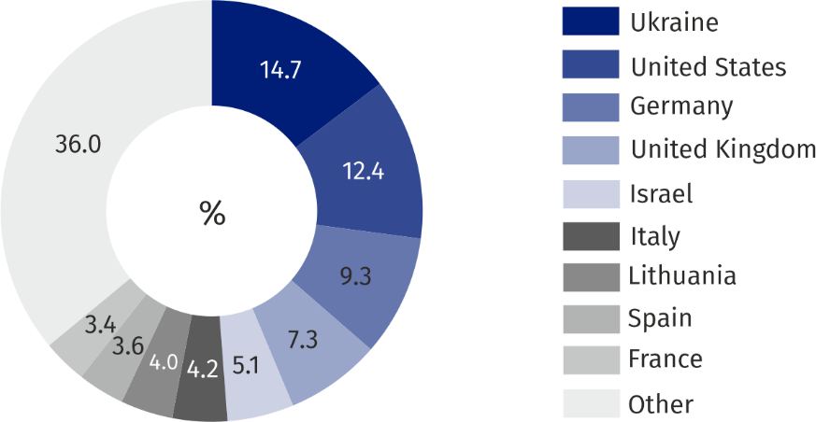
Chart 2. Structure of foreign tourists by country of permanent residence in 2025
1,823.2 thousand foreign tourists stayed in tourist accommodation establishments in the capital in 2025, the majority from Ukraine
Tourists, who visited Warszawa in 2025 were provided with 8,728.8 thousand overnight stays (by 8.8% more than in 2024), of which 3,094.1 thousand (35.4%) to foreign tourists (by 8.7% more). The largest number of overnight stays was recorded in hotels – 7,062.4 thousand (i.e. 80.9% of total nights spent in the capital).
In 2025, on average one tourist stayed 1.6 nights, while a foreign tourist stayed 1.7
On average, each tourist stayed 1.6 nights in 2025, the same as the previous year. The length of stay for foreign tourists also remained unchanged, with an average stay of 1.7 nights.

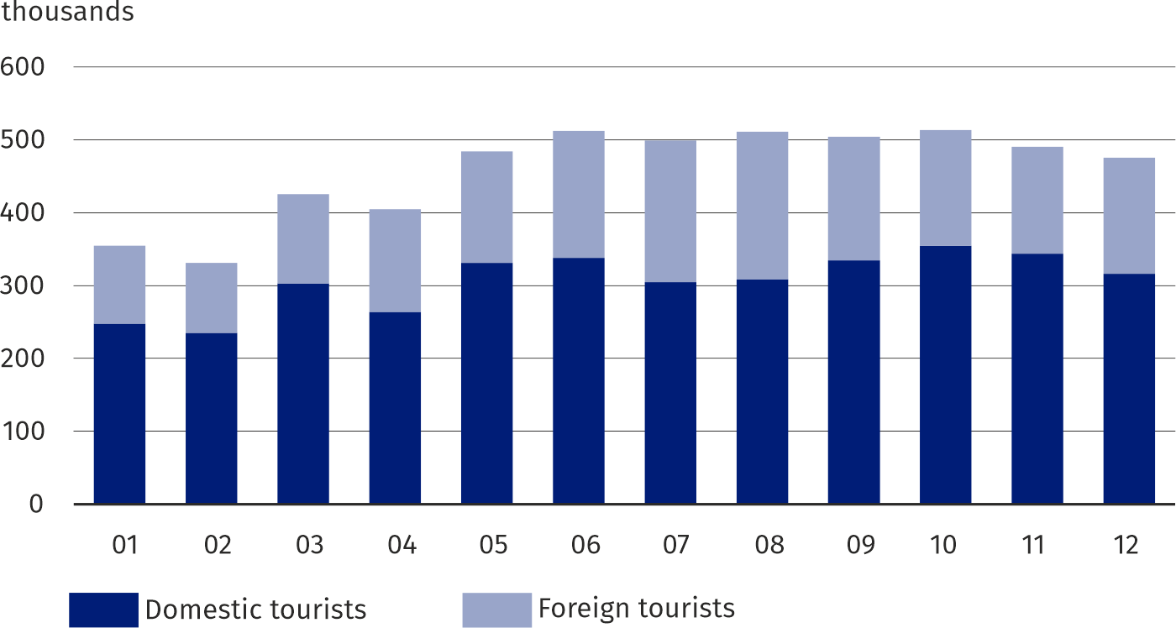
Chart 3. Tourists staying in tourist accommodatin establishments by months in 2025
In 2025, the largest number of tourists visited the capital in October – 513.1 thousand. August saw the highest number of overnight stays, with 840,7 thoudsnd. The lowest tourist traffic occurred in February, with 330.8 thousand tourists and 535.3 thousand overnight stays. August was the most popular month for foreign tourists. 202.1 thousand persons visited Warszawa that month, and 348.7 thousand overnight stays were provided. February saw the lowest tourist traffic, with 95.7 thousand foreign tourists and 161.9 thousand overnight stays.
In 2025, the highest occupancy rate of bed places was recorded in hostels (60.3%)
Occupancy rate of bed places in 2025, amounted to 54.4% and increased by 1.0 pp than in the previous year. Occupancy rate of bed places in hotel facilities amounted to 55.3% (by 1.0 pp more than in the previous year), and in other facilities 49.6% (by 3.9 pp more).

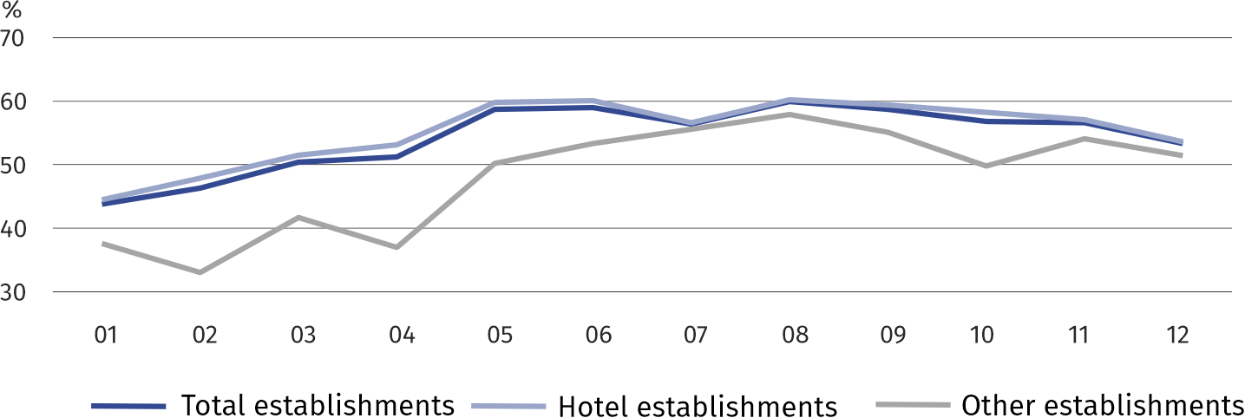
Chart 4. Occupancy rate of bed places by months in 2025 (in %)
In the capital city, 4,973.9 thousand rooms were rented to tourists in hotel facilities, including 1,849.8 thousand (37.2%) to foreign tourists. The occupancy of rooms in hotels, motels, boarding houses and other hotel facilities in 2025 amounted to 70.2% (by 1.4 pp more than in 2024). The highest occupancy rate of rooms was recorded in June – 77.7%, and the lowest in January – 57.1%.
Warszawa is well-equipped with a high-standard tourist infrastructure. 39.3% of total hotels in Mazowieckie Voivodship were located in the capital, including 16 5-star hotels out of 17 in the Voivodship. Among tourists staying in hotels, most stayed in 4-star hotels (39.2%). Hotels of the highest standard (5-star) were chosen by 19.5% of them. Foreigners in hotels consti-tuted 33.7% of all guests, and in the highest standard hotels this share was the highest and amounted to 50.2%.
In 2025, foreign tourists in hotels accounted for 33.7% of all guests, and in 5-star hotels more than half

Table 3. Hotels by category and occupancy in 2025
Specification | Number of establishments ª | Tourists accommodated | Nights spent | Rented rooms | Occupancy rate in %
Specification | Number of establishments ª | In thousands |  |  | bed places | rooms
Total | 106 | 4575,8 | 7062,4 | 4642,5 | 56,1 | 71,4
5-star | 16 | 893,8 | 1417,8 | 926,7 | 60,8 | 70,6
4-star | 31 | 1795,5 | 2708,8 | 1807,7 | 56,2 | 71,6
3-star | 34 | 1177,8 | 1805,0 | 1224,7 | 55,9 | 72,0
2-star | 17 | 450,1 | 705,4 | 426,6 | 51,6 | 70,7
1-star | 4 | 185,0 | 308,0 | 182,9 | 49,2 | 71,7
under categorisation | 4 | 73,5 | 117,5 | 74,0 | 53,6 | 67,7
a As of end of July.
When quoting Statistics Poland data, please provide the information: “Source of data: Sta-tistics Poland”, and when publishing calculations made on data published by Statistics Poland, please include the following disclaimer: “Own study based on figures from Statistics Poland”.

Prepared by:  Statistical Office in Warszawa  Director Agnieszka Ajdyn  Phone: (+48 22) 464 23 15 | Issued by:  Mazovian Centre for Regional Surveys  Statistical Information Centre  Mobile: (+48) 783 940 141
Press Office in the Statistical Office in Warszawa  Mobile: (+48) 783 940 141  e-mail: m.kaluski@stat.gov.pl |   warszawa.stat.gov.pl/en/

@Warszawa_STAT

@UrzadStatystycznywWarszawie

gus_stat

glownyurzadstatystycznygus

glownyurzadstatystyczny

Related information
Tourism in 2024
Tourism in the European Union countries - data for 2023
Data available in databases
Local Data Bank
Terms used in official statistics
Tourist
Tourist accommodation establishment
Bed places in tourist accommodation establishments
Foreign tourists in tourist accommodation establishments

Applies to tourist accommodation establishments with 10 or more beds.
Youth hostels, training-recreational centres, complexes of tourist cottages, camping sites, rooms for guests, agrotourism lodgings, other tourist accommodation establishments.

