Activity of credit intermediation companies in 2025
124.9 billion PLN
Value of granted loans and credits
In 2025, the survey covered 174 enterprises conducting credit intermediation activity and granting loans from own funds. These enterprises provided loans and credits worth 124,874 million PLN.

Basic data on the surveyed credit intermediation enterprises
In 2025, the surveyed enterprises granted loans and credits to individuals worth 112.3 billion PLN, and to enterprises worth 12.6 billion PLN.
Out of the entire population of 174 surveyed entities, 93 granted loans from own funds, 77 acted as an intermediary in granting credits and loans in cooperation with banks, and 4 conducted mixed activity, i.e. cooperated with banks and at the same time provided loans from own funds.
Table 1. Activities of the surveyed entities
SPECIFICATION | Entities granting loans from own funds | Entities cooperating with banks | Entities providing at the same time
SPECIFICATION | Entities granting loans from own funds | Entities cooperating with banks | loans from own funds | cooperating with banks
Total entities | 93 | 77 | 4
Intermediation/granting loans from own funds – only activity | 52 | 43 | - | -
Intermediation/granting loans from own funds – dominant activity | 21 | 26 | 2 | 2
Intermediation/granting loans from own funds – secondary activity | 20 | 8 | 2 | 2
Among the surveyed entities, credit intermediation and granting loans from own funds were the only type of business activity conducted by 95 enterprises, for 51 entities it was the dominant activity. In the case of enterprises engaged in both types of activities mentioned, for two of them, granting loans from own funds was the dominant activity, and credit intermediation was secondary, while for the other two it was the opposite – credit intermediation was the dominant activity, and granting loans from own funds was secondary.
Among the surveyed entities, there were 114 limited liability companies, 28 joint-stock companies, and 32 companies with other legal form. In 138 enterprises, domestic capital dominated, in 36 foreign capital. In the population of surveyed entities dealing with credit intermediation and granting loans from own funds 47 enterprises belonged to groups of enterprises.
As of the end of 2025, the surveyed entities employed 17.2 thousand persons, including 5.1 thousand persons on the basis of an employment contract, and 9.7 thousand persons under a mandate contract, agency contract or specific task contract. The distribution network for loans and credits was operated by 1,124 branches and representatives.

Characteristics of credit intermediation services
In 2025, credit intermediation enterprises granted loans and credits amounting to 124,874 million PLN, of which they provided 112,317 million PLN to individuals and 12,556 million PLN to enterprises. The surveyed entities participated in concluding contracts in cooperation with banks for loans and credits valued at 69,046 million PLN, while they granted loans from their own funds amounting to 55,828 million PLN. Entities cooperating with banks participated in concluding contracts for loans and credits to private individuals worth 65,927 million PLN, and to enterprises amounting to 3,119 million PLN. Entities granting loans from their own funds provided loans to private individuals worth 46,390 million PLN and to enterprises worth 9,437 million PLN.
Credit intermediation enterprises granted the most loans and credits in Mazowieckie Voivodeship (32,9% of the total value) and Śląskie Voivodeship (11,0%)
The largest share in the overall value of contracts had mortgage loans (48.5%), loans from own funds (44.7%) and cash loans and credits (5.7%).
Chart 1. Value of granted loans and credits by selected types
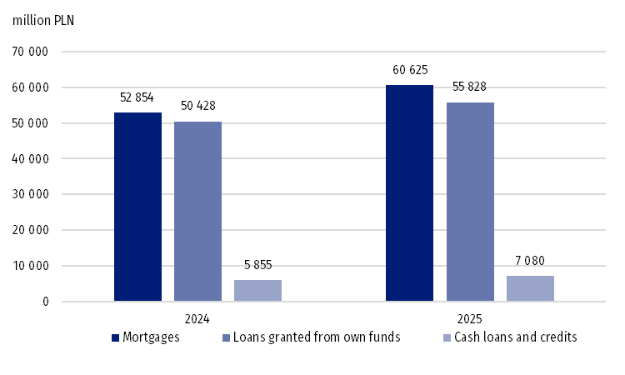
Directly at the branches, 46,325 million PLN in loans and credits were granted (37.1% of the total value of loans and credits), through agents 21,595 million PLN (17.3%), and directly to clients 11,585 million PLN (9.3%). Online, loans and credits worth 42,315 million PLN were granted (33.9%), and by phone 2,004 million PLN (1.6%).

Financial situation of the surveyed credit intermediation companies
Out of 146 enterprises where the surveyed activity was the only or dominant one, 122 entities kept full accounting, and 24 kept the revenue and expense ledger.
The value of assets of 122 entities with full accounting was PLN 21,649 million as at the end of 2025, the largest item (51.3%) were fixed assets worth PLN 11,107 million. Current assets amounted to PLN 10,536 million, which accounted for 48.7% of the total value of assets.
The value of assets of enterprises in which credit inter-mediation activity was the only or dominant kind of activity and which kept full accounting increased by 14.0% during the year
In the liabilities of the 122 enterprises described above, 81.3% of the value were liabilities and provisions for liabilities, and 18.7% were equity.
Revenues from total activity of 122 enterprises amounted to PLN 8,009 million and increased by 15.6% compared to 2024, while the costs from the total activity increased by 13.3% and amounted to PLN 6,342 million. The gross financial result of 122 surveyed entities amounted to PLN 1,670 million, while the net financial result amounted to PLN 1,283 million. Out of this population, 97 enterprises made a net profit (1,365 million PLN), while 25 had losses (-82 million PLN).

In case of quoting Statistics Poland data, please provide information: “Source of data: Statistics Poland”, and in case of publishing calculations made on data published by Statistics Poland, please include the following disclaimer: “Own study based on figures from Statistics Poland”

Prepared by:  Enterprise Statistics Department  Director Katarzyna Walkowska-Macias  Phone: (+48 22) 608 35 66 | Issued by:  Press Office  Mobile: (+48) 695 255 032  Phone: (+48 22) 608 38 04, (+48 22) 449 41 45,  (+48 22) 608 30 09  e-mail: obslugaprasowa@stat.gov.pl

stat.gov.pl/en/

@StatPoland

@GlownyUrzadStatystyczny

@gus_stat

@GłównyUrządStatystycznyGUS

@Glówny Urząd Statystyczny

Related information
Specialized segments of financial market 2024
Terms used in official statistics
Credit
Credit broker
Loan

Information about the financial situation was presented for entities keeping full accounting records, for which credit intermediation activity is the only or dominant activity, i.e., for 122 enterprises.

