Physical education in Poland in 2025
10.8%
Increase in the number of competitors holding Polish sports association licences compared to 2024
In 2025, there were 70 sports associations in Poland. Compared to 2024, the number of competitors, coaches, instructors and judges holding licences from the Polish sports associations increased. Physical education organisations associated 6.6 thousand units. In relation to 2024, the number of units and members increased, while the number of persons practicing sports in these organizations decreased.
Polish sports associations
Nearly 4% of Polish representatives competed for foreign clubs on a daily basis
In 2025, there were 70 Polish sports associations (the same number as in 2024) and 551 regional sports associations. Polish sports associations selected 10.4 thousand members of the national team, of whom 41.3% were women. Polish representatives in junior categories accounted for 43.0%.
Table 1. Basic information on Polish sports associations in 2025
SPECIFICATION | Total | Of which females
Polish representatives | 10 439 | 3 391
of which:
juniors | 4 487 | 2 041
Competitorsª | 949 776 | 191 261
of which:
junior competitors^{b} | 604 547 | 146 365
Coaching staff^{c}
coaches | 40 672 | 4 426
instructors | 14 362 | 4 278
Judges^{c} | 42 383 | 9 040
of which:
with international class | 1 792 | 454
a Including foreign competitors performing in Poland. The competitors can be shown several times if they are licensed in several sports supervised by one sports association. b Total juniors, younger junior "cadets", sub-juniors and children. c Members of the coaching staff and judges can be shown several times if they are licensed in several sports supervised by one sports association.
Compared to 2024, the number of Polish representatives increased by 8.9%. There was also a slight increase in the number of representatives who were members of foreign clubs (from 405 in 2024 to 409 in 2025).
The Polish Judo Association had the largest number of national team members in 2025 (1,236 representatives), followed by the Polish Basketball Association (548). In 2024, the national team of the Polish Basketball Association was the largest (760 representatives).
Chart 1. Polish representatives in 2025
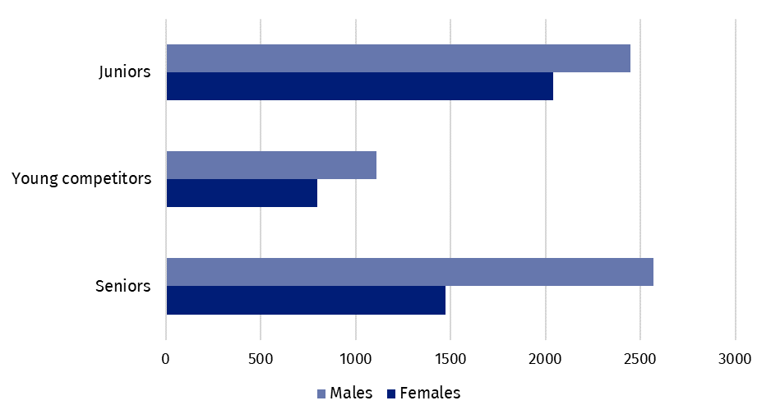
In 2025, 949.8 thousand competitors held licenses of the Polish sports associations (857.7 thousand in 2024), of which 20.1% were women (the same number as in 2024). There were 32.1% competitors in the senior category (32.6% in 2024).
The number of competitors licensed by Polish sports associations in 2025 increased by 10.8% compared to 2024. The percentage of competitors with disabilities was 0.4% and that of foreign competitors was 1.4%
Map 1. Competitors holding licenses of Polish sports associations in 2025
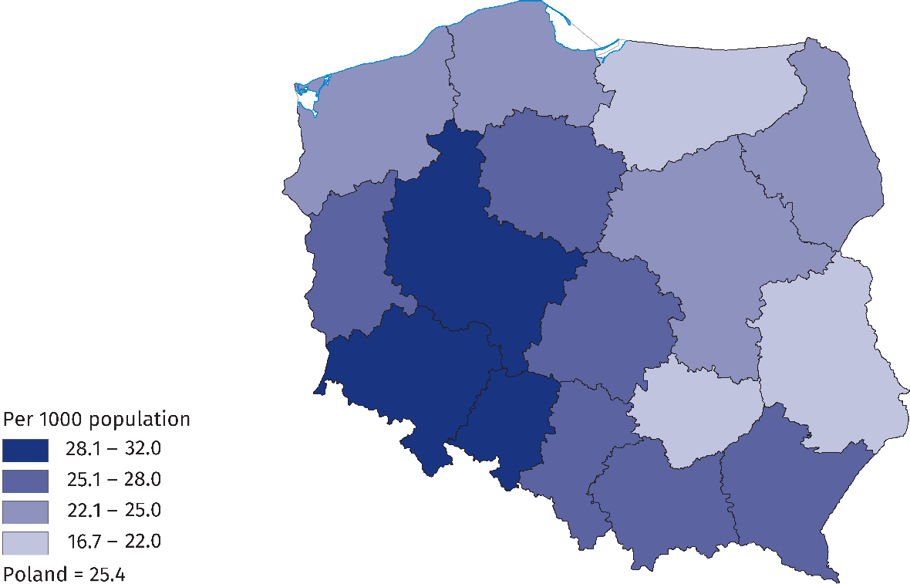

As in previous years, the highest percentage were competitors holding licences from the Polish Football Association– 48.8% (the same number as in 2024). The Polish Sport Shooting Federation ranked second in terms of athlete numbers at 10.8%, followed by the Polish Volleyball Federation at 6.0%. The highest number of persons were practising in Mazowieckie Voivodship (14.3%), followed by Śląskie Voivodship (11.6%) and Wielkopolskie Voivodship (10.3%).
The number of competitors with disabilities holding licenses of the Polish sports associa-tions was 3,401 persons in 2025 (an increase of 11.7% compared to 2024), of whom 74.7% were men. The percentage of competitors with disabilities in relation to the total number of competitors was 0.4% – the highest in Małopolskie Voivodship (0.8%).
Foreign competitors holding licenses of the Polish sports association constituted 1.4% of all competitors in 2025 (1.3% in 2024). Of these, football licensed competitors predominated – 67.6% (69.9% in 2024). Disciplines frequently practiced by foreign competitors were also rugby (5.6%) and basketball (3.7%). The highest percentage of foreign competitors was recorded in Mazowieckie Voivodships (14.0%).
In 2025, the number of coaches, instructors and judges holding licences of the Polish sports association increased in relation to 2024 by 5.9%, 7.8% and 19.1% respectively
In 2025, the coaching staff employed in the Polish sports associations amounted to 685 persons. This number increased in relation to 2024 (by 17 persons). An increase in the employment of medical staff was also recorded (433 persons in 2025 compared to 304 persons in 2024).
In 2025, 40.7 thousand coaches and 14.4 thousand instructors held current licenses of the Polish sports associations. Compared to the previous year, the number of coaches in-creased by 2.3 thousand and the number of instructors by 1.0 thousand.
Chart 2. Coaching staff in Polish sports associations in 2025
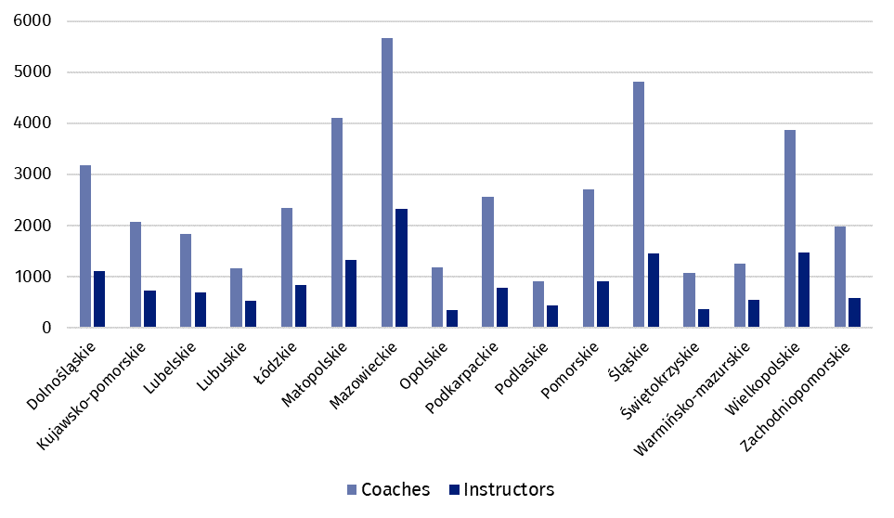
In 2025, 42.4 thousand sports judges were registered in the Polish sports associations (an increase of 19.1% compared to 2024). Of these, 21.3% were women. The percentage of judges with international class was 4.2%. The highest number of judges held licences in sports shooting (28.1%), followed by football (18.8%). Women as judges prevailed mainly in artistic gymnastics – 99.3% and in artistic swimming – 85.9%. A significant part of them were also certified to judge sports acrobatics (79.6%) and cheerleading (75.8%).
Achievements of Polish competitors in the international area
In 2025, the Polish representatives won 239 World Championships medals and 509 European Championships medals

In 2025, at the World Championships, Polish representatives took the podium 239 times (311 times in 2024). They won 66 gold medals, 81 silver medals and 92 bronze medals. The most medal places in 2025 were won by competitors in aerial sports (43 medals, including 11 gold), followed by kick-boxing (26 medals, including 6 gold) and freediving (17 medals, including 7 gold).
At sports events of the European Championships⁵ rank, Poles won a total of 509 medals in 2025 (the same number as in 2024), including: 132 gold, 163 silver and 214 bronze. The most medals were won also in kick-boxing (68 medals, including 18 gold), followed by sumo (41 medals, including 8 gold).
In 2025, the Polish competitors with disabilities won 99 World Championships medals and 80 European Championships medals
In 2025, competitors with disabilities won 99 World Championships medals (34 gold, 32 silver, 33 bronze) and 80 European Championships medals (26 gold, 22 silver and 32 bronze). At the World Championships, competitors with disabilities most often reached the podium in athletics (41 medals, including 21 gold), and at the European Championships in table tennis (16 medals, including 5 gold). In 2024, competitors with disabilities won 56 medals at the World Championships and 86 medals at the European Championships 86.
Table 2. Medals won by Polish competitors in the international arena in 2025
SPECIFICATION | Medals
SPECIFICATION | total | gold | silver | bronze
World Championships | 239 | 66 | 81 | 92
of which young competitors and juniors | 75 | 19 | 24 | 32
European Championships | 509 | 132 | 163 | 214
of which young competitors and juniors | 337 | 83 | 112 | 142
World Championships for persons with disabilities | 99 | 34 | 32 | 33
European Championships for persons with disabilities | 80 | 26 | 22 | 32

Physical education organisations
In 2025, physical education organisations such as: Academic Sports Association (AZS), National „Rural Sports Teams” Association (LZS), The Polish Sports Association for the Disabled ’’Start’’ (PZSN “Start”) and the Society for the Promotion of Physical Education (TKKF) reported a total of 6.6 thousand organisational units (an increase of 2.7% compared to 2024). The organizations associated 341.9 thousand members (14.3 thousand more than in the previous year) and 303.5 thousand persons practising sports (down by 5.5 thousand persons).
In terms of the number of members and persons actively practising sports, the National „Rural Sports Teams” Association was the most numerous one (206.7 thousand members and 178.3 thousand persons practising sports). Academic Sports Association also had a large membership base (90.4 thousand members and 50.0 thousand persons practising sports). The Society for the Promotion of Physical Education reported 42.9 thousand members and 73.9 thousand persons practising sports, while the Polish Sports Association for the Disabled "Start" – 1.8 thousand members and 1.4 thousand persons practising sports.
Men predominated among persons practising sports in physical education organizations, accounting for 68.4% (69.2% in 2024). Just over half of those practising sports (50.4%) were under the age of 18 (50.6% in 2024). The highest number of members of physical education organisations was recorded in Lubelskie Voivodship (11.7%), while the highest number of persons actively practising sports was registered in Wielkopolskie Voivodship (12.2%).
In 2025, physical education organizations organized 77.8 thousand events (80.4 thousand in 2024), the majority of which (90.8%) were carried out by units of the National Association (LZS). The events were attended by 3.6 million people (3.4 million in 2024).

When quoting Statistics Poland data, please provide information: “Source of data: Statistics Poland”, and when publishing calculations made on data published by Statistics Poland, please provide information: “Own study based on Statistics Poland data”.
Prepared by:  Statistical Office in Rzeszów  Acting Director Andżelika Malinowska  Phones: (+48 17) 853 52 10,  (+48 17) 853 52 19 | Issued by:  Press Office  Mobile: (+48) 695 255 032  Phones: (+48 22) 608 38 04, (+48 22) 449 41 45,  (+48 22) 608 30 09  e-mail: obslugaprasowa@stat.gov.pl

stat.gov.pl/en/

@StatPoland

@GlownyUrzadStatystyczny

@gus_stat

@GłównyUrządStatystycznyGUS

@Główny Urząd Statystyczny
Related information
Physical education in years 2023 and 2024
Data available in databases
Local Data Bank
Knowledge Databases - Construction

Terms used in official statistics
Sports instructor
District sports association
Organisation of physical education
Sports judge
Sport
Sports
Sports coach
Competitor
Sports association

Sports associations according to the list of Polish sports associations announced by the Minister of Sport and Tourism – Communication of 22 July 2024. Data are preliminary.
Competitors can be shown more than once if they hold licences in several sports supervised by one sports association.
Coaches and instructors be shown more than once if they hold licences in several sports supervised by one sports association.
Sports judges may be shown more than once if they hold licence in several sports.
In sports supervised by sports associations with the status of a Polish sports association.
This news release covers: in AZS - clubs, in LZS - teams, sports clubs and student sports clubs, in PZSN "Start" - organizational units, in TKKF - centres and clubs.

