Pharmacies and pharmaceutical outlets in 2025
1.8%
Decrease in the number of generally available pharmacies compared to 2024
At the end of 2025, 11.0 thousand generally available pharmacies and 1.1 thousand pharmaceutical outlets were operating, in which a total of 54.1 thousand pharmacists and pharmaceutical technicians were employed. The steady decline in the number of pharmacy facilities and pharmaceutical technicians has continued for several years.

Pharmacies and pharmaceutical outlets
At the national level, the number of population per one pharmacy facility amounted to 3,089 persons
At the end of 2025, 11.0 thousand generally available pharmacies and 1.1 thousand pharmaceutical outlets were operating (by 1.8% and 0.2% less respectively compared to the previous year). Despite the steady decline in the number of pharmacy facilities since 2018, the sales value of prescription medicines and the number of completed prescriptions have increased.
Online sales of medicinal products were carried out by 233 pharmacies and 6 pharmaceutical outlets (236 and 8 in 2024, respectively).

Map 1. Generally available pharmacies and pharmaceutical outlets by voivodships in 2025
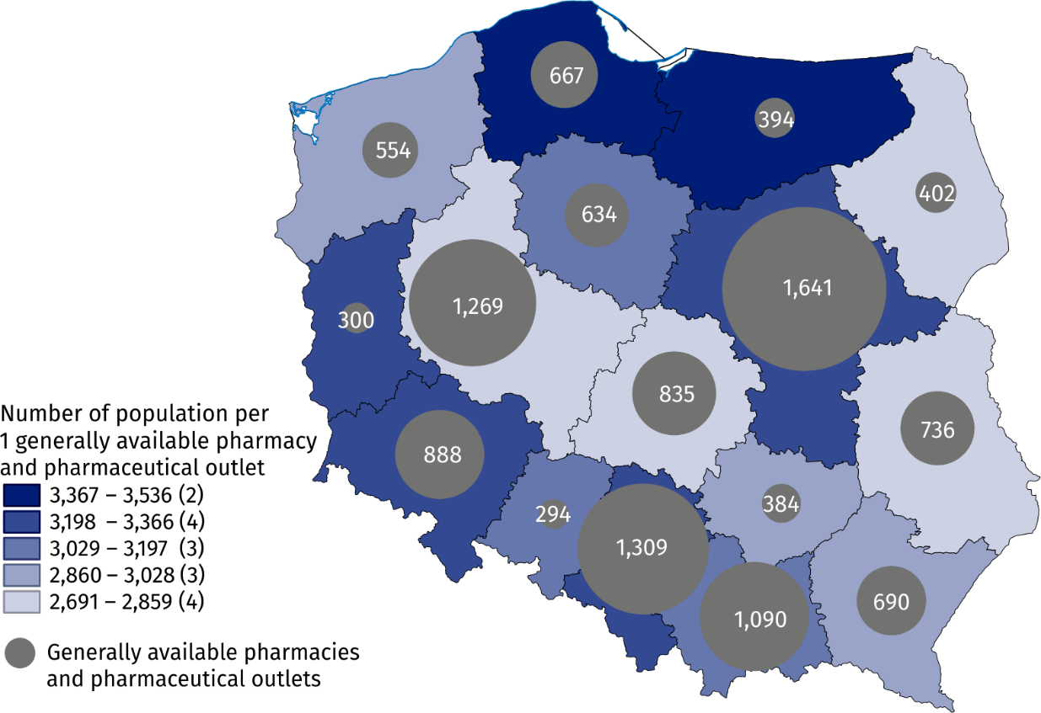
As of 31 December
There were on average 3,089 persons per one generally available pharmacy and pharmaceutical outlet (by 40 more than in the previous year). The highest indicator value was recorded in Pomorskie Voivodship (3,536), while the lowest – in Lubelskie Voivodship (2,691).

Employed in generally available pharmacies and pharmaceutical outlets
Generally available pharmacies and pharmaceutical outlets employed 25.4 thousand pharmacists and 28.7 thousand pharmaceutical technicians
At the end of 2025, generally available pharmacies and pharmaceutical outlets employed 25.4 thousand pharmacists and 28.7 thousand pharmaceutical technicians (by 3.3% and 3.6% less respectively compared to the previous year).
Table 1. Employed in generally available pharmacies and pharmaceutical outlets in 2025
As of 31 December
Specification | Pharmacists | Pharmaceutical technicians
Generally available pharmacies | 25,233 | 26,961
Pharmaceutical outlets | 144 | 1,778
The average number of pharmacists and pharmaceutical technicians per one generally available pharmacy and pharmaceutical outlet was 2.1 and 2.4, respectively. The highest indicator value for pharmacists was recorded in the Pomorskie Voivodship (2.6), while for pharmaceutical technicians in the Śląskie Voivodship and the Świętokrzyskie Voivodship (2.8 each).

Map 2. Employed in generally available pharmacies and pharmaceutical outlets by voivodships in 2025
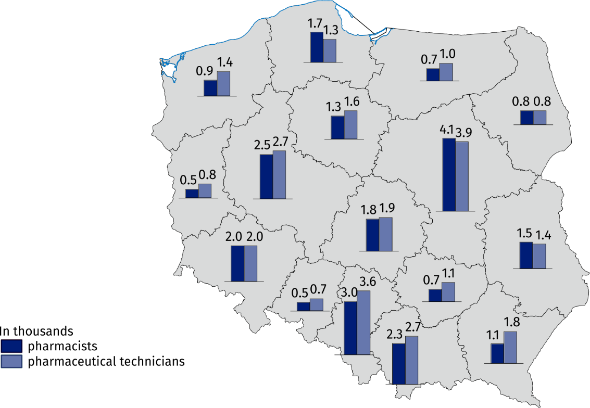
As of 31 December

Methodological notes
Due to data rounding, in some cases the sums of the components may differ slightly from the reported “total” values.
In 2025, data on generally available pharmacies and pharmaceutical outlets as well as the employed pharmacists and pharmaceutical technicians, as of 31 December, were compiled based on administrative data sources of the Chief Pharmaceutical Inspectorate and the National Health Fund, using information on the number of prescriptions completed in December. Due to a change in the calculation method, the data may not be comparable until 2024.
When quoting this publication, please provide its title and identify Statistics Poland as the author. When publishing your calculations based on the data from the publication, please include the following disclaimer: “Own study based on data from the Statistics Poland publication “Pharmacies and pharmaceutical outlets in 2025”.

Prepared by:  Statistical Office in Kraków  Director Agnieszka Szlubowska  Phone: (+48 12) 420 40 50 | Issued by:  Press Office  Mobile: (+48) 695 255 032  Phone: (+48 22) 608 38 04, (+48 22) 449 41 45,  (+48 22) 608 30 09  e-mail: obslugaprasowa@stat.gov.pl

stat.gov.pl/en/

@StatPoland

@GlownyUrzadStatystyczny

@gus_stat

@GłównyUrządStatystycznyGUS

@Glówny Urząd Statystyczny
Related information
Health and health care in 2024
Methodological report. Health and health care statistics – Statistics Poland’s reports
Sales of prescription medicines in 2025
Data available in databases
Local Data Bank -> Health care, social welfare and benefits to the family
Knowledge Databases -> Society -> Health and healthcare
Terms used in official statistics
Generally available pharmacy
Pharmaceutical outlet
Pharmacist

More data in news release “Sales of prescription medicines in 2025”.
Online sales of medicinal products via the website conducted according to the Act of 6 September 2001 – the Pharmaceutical Law (Journal of Laws 2026, item 612 as amended) and Regulation of the Minister of Health of 26 March 2015 on online sales of medicinal products (Journal of Laws 2026, item 466), based on information in the National Register of Permits to Operate Generally Available Pharmacies, Pharmaceutical Outlets.
Population as of 31 December.
Refers to employees for whom the establishment is the main workplace, determined on the basis of the number of prescription items completed in December.

