Financial results of investment funds in 2025
The value of assets held by investment funds at the end of December 2025 amounted to PLN 488.1 billion (an increase of 14.0% compared to the previous year). In 2025, investment funds achieved a result on operations in the amount of PLN 47.7 billion (compared to PLN 20.8 billion in the previous year).
⇧ 14.0%
Increase in the value of assets of investment funds

Table 1. Basic data of investment funds
In 2025 the income from investments of investment funds increased by 18.5% on a yearly basis to PLN 22,873.0 million
Specification | 2024 | 2025
Specification | in million PLN |  | 2024=100
Total assets | 428,010.4 | 488,132.4 | 114.0
Investment income | 19,309.8 | 22,873.0 | 118.5
Result of the operation | 20,760.7 | 47,702.6 | 229.8

Balance sheets of investment funds
At the end of December 2025, the total assets held by investment funds amounted to PLN 488,132.4 million (an increase of 14.0% compared to 2024), of which:
- open-end investment funds assets reached the value of PLN 218,769.8 million (an increase of 31.0%); their share in total fund assets increased from 39.0% to 44.8%;
- specialized open-end investment funds assets amounted to PLN 155,623.9 million (an increase of 38.2%); their share in total assets increased to 31.9% compared to 26.3% the year before;
- closed-end investment funds assets amounted to PLN 113,738.7 million (a decrease of 23.3%); the share of this group of funds in total assets decreased from 34.7% to 23.3%.

Chart 1. Assets of investment funds
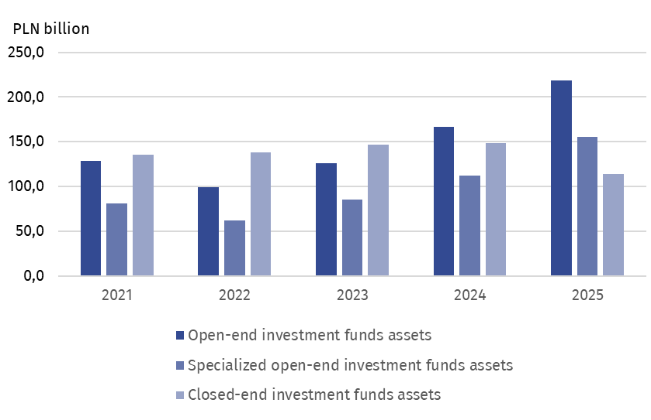
The main item in the assets of investment funds were investments listed on an active market; their value at the end of 2025 amounted to PLN 297,125.4 million and was higher by 35.8% compared to the previous year. The share of this item in assets increased to 60.9% (compared to 51.1% the year before). The next item in terms of its share in the asset structure (34.1%) were investments not quoted on an active market, which amounted to PLN 166.5 billion and was 12.8% higher than in the previous year.
In 2025, investment components listed on an active market accounted for 60.9% of the total assets of investment funds
Liabilities of investment funds reached PLN 37,255.0 million (an increase of 5.8%). The largest liabilities in the amount of PLN 22,866.3 million were shown by open-end investment funds, which accounted for 61.4% of the value of liabilities of all investment funds (59.7% the year before).
On December 31, 2025, the net assets of the investment funds amounted to PLN 450,877.3 million, i.e. they were 14.8% higher than at the end of 2024. The net assets of open-end investment funds amounted to PLN 195,903.5 million (higher by 34.2% than in the previous year), specialized open-end funds reached PLN 146,764.4 million (36.1% higher), and for closed-end investment funds this value stood at PLN 108,209.4 million (22.1% lower).

Table 2. Selected items from the balance sheet of investment funds
Specification | 2024 | 2025
Specification | in million PLN |  | 2024=100
Total assets | 428,010.4 | 488,132.4 | 114.0
of which:
Investment components listed on an active market | 218,753.7 | 297,125.4 | 135.8
Investment components not listed on an active market | 147,598.6 | 166,478.6 | 112.8
Liabilities | 35,227.5 | 37,255.0 | 105.8
Net assets | 392,782.9 | 450,877.3 | 114.8

Investments of investment funds
The value of investments at the end of December 2025 increased by 26,5% to PLN 462,805.0 million. Debt securities reached a value of PLN 275,565.8 million (an increase of 30.8%), and shares increased to PLN 89,876.9 million (by 28.4%). Participation units issued by non-resident mutual investment institutions amounted to PLN 31,958.8 million (growth of 22.8%). Receivables amounted to PLN 20,304.3 million (an increase of 11.7%). Shares in limited liability companies increased to PLN 18,256.5 million (by 7.0%). Deposits increased to PLN 470.4 million (by 66.7%).
The share of debt securities and shares in total investment was 59.5% and 19.4% compared to 57.6% and 19.1% in 2024, respectively.
Table 3. Value of investment of investment funds
In 2025, debt securities accounted for the largest share (59.5%) of the value of investments of investment funds
Specification | 2024 | 2025
Specification | in million PLN |  | 2024=100
Investments | 365 718.2 | 462,805.0 | 126.5
of which:
Shares | 69,981.0 | 89,876.9 | 128.4
Debt securities | 210,738.8 | 275,565.8 | 130.8
Shares in limited liability companies | 17,055.1 | 18,256.5 | 107.0
Receivables | 18,179.1 | 20,304.3 | 111.7
Shares issued by mutual investment institutions established abroad | 26,018.4 | 31,958.8 | 122.8
Deposits | 282.2 | 470.4 | 166.7
Profit and loss account
Investment income in 2025 amounted to PLN 22,873.0 million (18.5% more than in the previous year). The main item was interest income, which amounted to PLN 14,474.7 million and accounted for 63.3% of investment income. Dividends and other profit from shares amounted to PLN 2,615.7 million (PLN 2,388.4 million in the previous year).
Costs of investment funds amounted to PLN 10,618.8 million and were 42.4% higher than the previous year, including remuneration for fund management companies which amounted to PLN 5,077.4 million (an increase of 21.7%).
In 2025, investment funds showed a positive result on operations in the amount of PLN 47,702.6 million (PLN 20,760.7 million in 2024), including the result on operations of open-end funds of PLN 18,884.0 million, specialized open-end funds PLN 16,300.4 million and closed-end funds PLN 12,518.2 million.

Table 4. Selected items from the profit and loss account of investment funds
In 2025 the result from operations of investment funds was positive and amounted to PLN 47.7 billion
Specification | 2024 | 2025
Specification | in million PLN |  | 2024=100
Investment income | 19,309.8 | 22,873.0 | 118.5
of which:
Dividends and other profit sharing | 2,388.4 | 2,615.7 | 109.5
Interest income | 11,266.1 | 14,474.7 | 128.5
Positive balance of exchange differences | 1,621.9 | 92.6 | 5.7
Fund costs | 7,455.5 | 10,618.8 | 142.4
of which:
fund salary | 4,172.3 | 5,077.4 | 121.7
Realized and unrealized gain/loss | 8,872.4 | 35,411.6 | 399.1
of which:
Realized gain/loss on sale of investments | 9,547.4 | 14,232.5 | 149.1
Increase/decrease in unrealized profit/loss on investment valuation | -675.1 | 21,179.1 | x
Result from operations | 20,760.7 | 47,702.6 | 229.8

When quoting Statistics Poland data, please provide the information: “Source of data: Statistics Poland”, and when publishing calculations made on data published by Statistics Poland, please include the following disclaimer: “Own study based on figures from Statistics Poland”.

Prepared by:  Enterprise Statistics Department  Director Katarzyna Walkowska-Macias  Phone: (+48 22) 608 35 66 | Issued by:  Press Office  Mobile (+48) 695 255 032  Phone (+48 22) 608 38 04,  (+48 22) 449 41 45,  (+48 22) 608 30 09  e-mail: obslugaprasowa@stat.gov.pl

stat.gov.pl/en/

@StatPoland

@GlownyUrzadStatystyczny

@gus_stat

@GłównyUrządStatystycznyGUS

@Glówny Urząd Statystyczny
Related information
News releases. Financial results of investment fund companies

Data available in databases
Macroeconomic Data Bank

Terms used inn official statistics
Investment fund
Investment fund company

This news release was prepared on the basis of data received on 15.05.2026 from Polish Financial Supervision Authority (UKNF). The data provided included a total of 406 investment fund financial statements for 2025: 27 statements of open-end investment funds, 57 statements of specialized open-end investment funds and 322 statements of closed-end investment funds. Comparative data for 2024 are based on the financial statements of 431 investment funds: 29 statements of open-ended investment funds, 59 statements of specialized open-ended investment funds, and 343 statements of closed-end investment funds.

