Sold production of industry in June 2026¹
In June 2026, sold production of industry was by 7.6% higher than in June 2025 (when a decrease was recorded by 0.4%), whereas in comparison with May 2026, it increased by 2.0%. In the period January-June of 2026, sold production of industry was by 3.9% higher than in the corresponding period of 2025 (which saw an increase by 1.3%).
7.6%
Increase in sold production of industry compared to June 2025

After seasonal adjustment, sold production of industry in June 2026 increased by 5.5% per year
After eliminating the seasonal factors, in June 2026 sold production of industry reached the level higher by 5.5% than in the corresponding month of 2025 and by 0.1% higher than in May 2026.
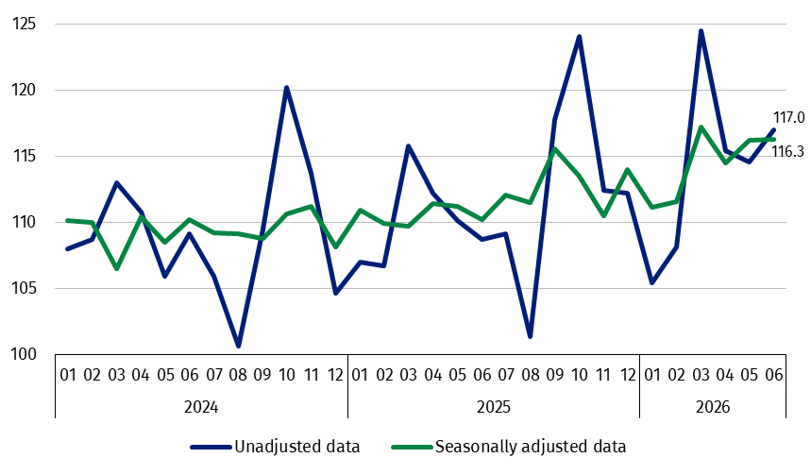
Chart 1. Sold production of industry (constant prices; monthly average of 2021=100)
The highest y/y increase was recorded in the production of intermediate goods, while a decrease – in the production of durable consumer goods

In June 2026, among the main industrial groupings there was an increase per year in the production of intermediate goods – by 11.9%, non-durable consumer goods – by 7.4%, capital goods – by 7.3% and (on a smaller scale) in the production of energy – by 1.8%. A decrease was observed in the production of durable consumer goods – by 1.2%.

1 Preliminary data; comprise enterprises with 10 or more persons employed.
Table 1. Sold production of industry ª (constant prices; unadjusted data)
SPECIFICATION | 2026
SPECIFICATION | 05 | 06 | 05 | 06 | 01-06 | 05 | 06
SPECIFICATION | previous month =100 |  | corresponding period of previous year = 100 |  |  | monthly average  of 2021 =100
INDUSTRY | 99.2 | 102.0 | 104.1 | 107.6 | 103.9 | 114.6 | 117.0
Mining and quarrying | 108.6* | 97.4 | 131.0* | 128.3 | 120.4 | 129.5* | 126.2
Manufacturing | 99.2* | 102.5 | 102.7* | 106.4 | 102.9 | 115.1* | 118.5
Electricity, gas, steam and air conditioning supply | 91.7* | 94.2 | 112.8* | 116.4 | 111.4 | 99.6* | 90.0
Water supply; sewerage waste management and remediation activities | 99.0* | 103.6 | 111.0* | 114.7 | 109.7 | 130.3* | 135.0
a Data including final information on production and prices in May and preliminary data in June.
* Data revised.
Chart 2. Sold production of industry (constant prices; corresponding month
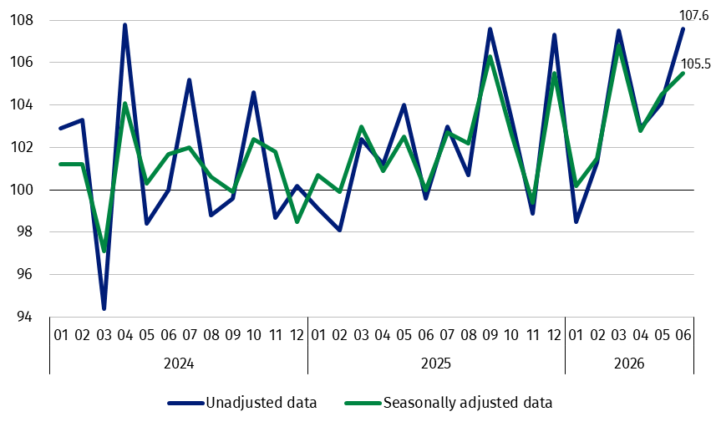
of previous year=100)

According to the preliminary data, in June 2026 an increase in sold production (in constant prices), compared to June 2025, was reported in 26 (out of 34) industry divisions, among others in manufacture of other transport equipment – by 24.9%, manufacture of paper and paper products – by 19.0%, in waste collection, treatment and disposal activities; materials recovery – by 16.5%, in electricity, gas, steam and air conditioning supply – by 16.4%, in manufacture of electrical equipment – by 15.8%, manufacture of machinery and equipment – by 11.3%, in repair and installation of machinery and equipment – by 10.8%, in manufacture of metal products – by 9.6%.
The share in total industry of sold production of divisions which recorded an increase per year amounted to 79.2%
A decrease in sold production of industry, compared to June 2025, was recorded in 8 divisions, among others in manufacture of tobacco products – by 10.2%, manufacture of textiles – by 7.0%, manufacture of furniture – by 2.5%.

Chart 3. Sold production of industry by selected NACE Rev. 2 divisions
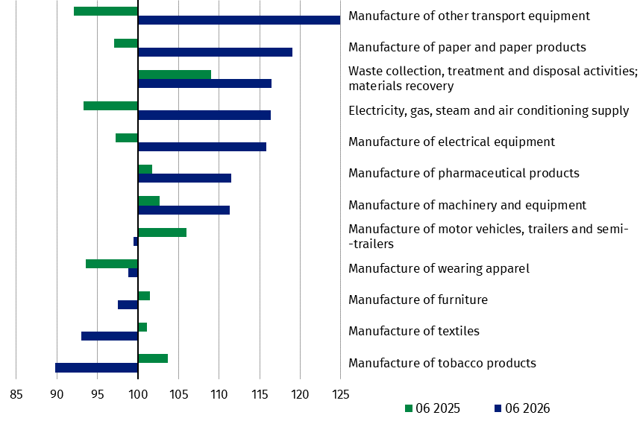
(constant prices; corresponding month of previous year=100; unadjusted data)

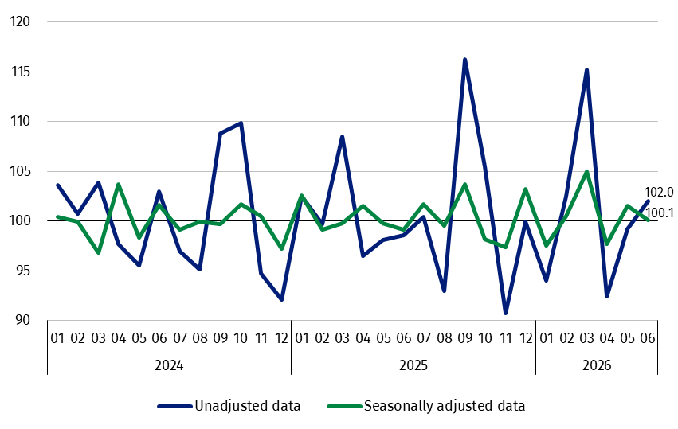
Chart 4. Sold production of industry (constant prices; previous month=100)
The share in total industry of sold production of divisions which recorded an increase compared to May 2026 amounted to 73.4%

In June 2026, an increase in sold production (in constant prices), compared to May 2026, was recorded in 26 (out of 34) industry divisions, among others in manufacture of beverages – by 19.2%, in repair and installation of machinery and equipment – by 10.8%, manufacture of electrical equipment – by 10.5%, manufacture of metal products – by 7.7%, manufacture of motor vehicles, trailers and semi-trailers – by 6.5%, manufacture of basic metals – by 3.3%, manufacture of food products – by 3.0%.
A decrease in sold production of industry, compared to May 2026, was recorded in 8 divisions, among others in manufacture of other transport equipment – by 22.1%, manufacture of other non-metallic mineral products – by 6.1%, in electricity, gas, steam and air conditioning supply – by 5.8%, manufacture of chemicals and chemical products – by 2.3%.

Chart 5. Sold production of industry by selected NACE Rev. 2 divisions
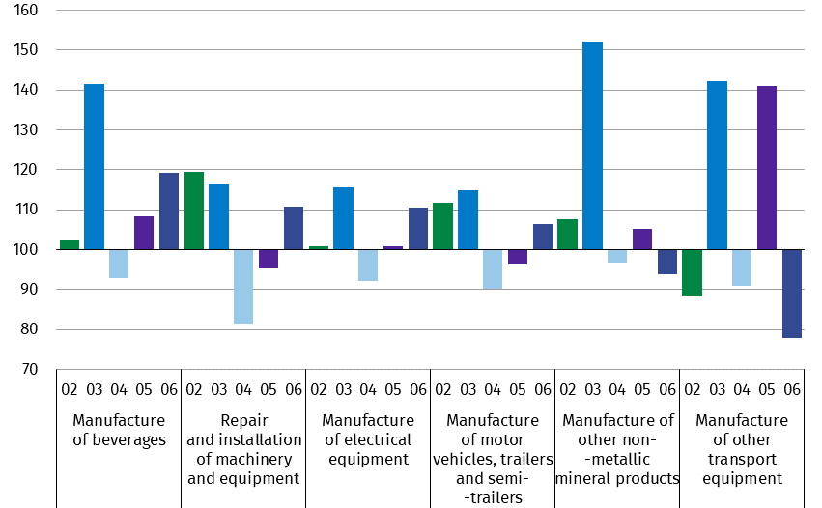
(constant prices; previous month=100; unadjusted data)

Methodological note
Data presented in this news release concern entities with 10 or more persons employed, conducting economic activity classified according to the Polish Classification of Activities (PKD 2007/NACE Rev. 2) to Industry, i.e. to the following sections: ‘Mining and quarrying’, ‘Manufacturing’, ‘Electricity, gas, steam and air conditioning supply’, ‘Water supply; sewerage, waste management and remediation activities’.
Statistical unit, according to which the presented data are compiled, is a legal unit. Methodology of compiling data on sold production of industry is presented in the methodological report Industrial production surveys.
In addition, for the needs of European statistics, data on industrial production are also compiled according to the kind-of-activity unit (KAU). The concept of the kind-of-activity unit is presented in the methodological report Short-term statistics by European concept of the Kind-of-activity unit.

In case of quoting Statistics Poland data, please provide information: “Source of data: Statistics Poland”, and in case of publishing calculations made on data published by Statistics Poland, please include the following disclaimer: “Own study based on figures from Statistics Poland”.
Prepared by:  Enterprises Department  Director Katarzyna Walkowska-Macias  Phone: (+48 22) 608 31 25 | Issued by:  Press Office  Mobile +48 695 255 032  Phone +48 22 608 38 04, +48 22 449 41 45,  +48 22 608 30 09  e-mail: obslugaprasowa@stat.gov.pl

stat.gov.pl

@GUS_STAT

@GlownyUrzadStatystyczny

@gus_stat

@GłównyUrządStatystycznyGUS

@Główny Urząd Statystyczny

Related information
Statistical Bulletin
Socio-economic situation of the country
Methodological report. Industrial production surveys

Data available in databases
Knowledge Database - Industry
Macroeconomic Data Bank
Macroeconomic indicators
Local Data Bank

Terms used in official statistics
Sold production of industry
Seasonally un-adjustedindex of sold production of industry
Seasonally adjustedindex of sold production of industry
Production of capital goods
Production of non-durable consumer goods
Production of durable consumer goods
Production of intermediate goods
Production of goods related to energy

