Emergency medical care in Mazowieckie Voivodship in 2025
In 2025, emergency rescue teams provided health services in the place of occurrence to 466.5 thousand persons. 937.3 thousand persons received out-patient medical services in hospital emergency wards or admission rooms, of which 729.6 thousand were discharged after receiving medical services, and 207.7 thousand were treated in hospitals.
3.0%
Increase in the number of persons who were given medical help in the place of occurrence y/y

Units of emergency medical system and cooperating
At the end of 2025, there were 24.9 thousand residents of Mazowieckie Voivodship on average per every emergency rescue team, and 161.9 thousand per every hospital emergency ward
Under the State Emergency Medical System, in 2025, emergency medical services were provided by 221 emergency rescue teams (35 specialist and 186 basic), as well as 3 medical air rescue teams and 34 hospital emergency wards.
The rate of availability of medical services provided by emergency rescue teams, expressed as the number of teams (basic and specialist) per 100 thousand population in the country, rose from 3.9 to 4.0 compared to 2024 (in the country from 4.4 to 4.6).
The medical rescue system cooperated with 2 trauma centres providing medical services to patients with multiple, multi-organ injuries, including 1 trauma centre for children and 11 admission rooms.

Emergency rescue teams, medical air rescue teams
As of 31 December 2024, the number of personnel included in emergency medical teams was 1782 employees ª. The most numerous group were paramedics – 1599. In addition, there were 89 system nurses, 26 system doctors, as well as 48 drivers and 20 pilots.

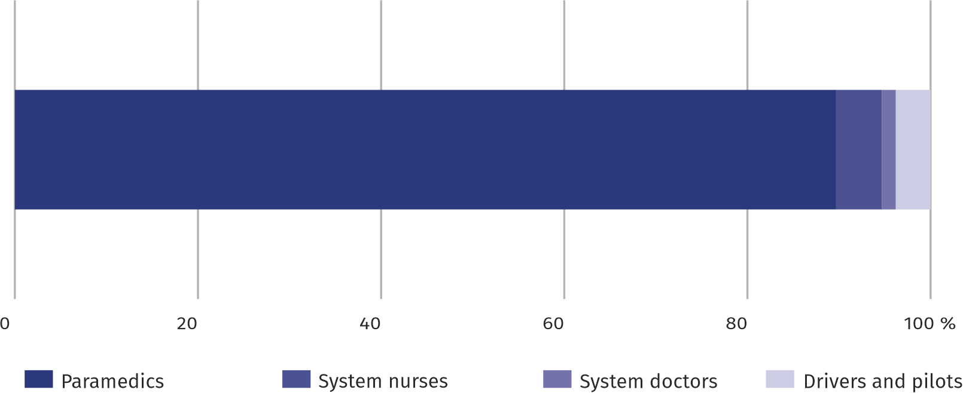
Chart 1. Structure of the compositionª of emergency rescue teams in 2024
As of 31 December
a Refers to the number of persons employed regardless of the form of employment for which this was the main workplace.

Medical emergency procedures
There were on average 85 persons per 1,000 inhabitants of Mazowieckie Voivodship provided with help from emergency rescue teams

In 2025, 464.2 thousand (by 3.0% more compared to 2024) of calls to the occurrence places were recorded, of which the vast majority (75.5%) were calls to the patient's home. Emergency rescue teams provided health care benefits to 466.5 thousand persons (by 3.0% more compared to the previous year), of which 49.2% were persons aged 65 and more, and 6.2% – children and youth up to 18 years of age. Women were provided with medical help more often (50.7%) than men. Before starting or during rescue operations, 7804 persons were found dead (by 2.3% less than in 2024), of which 85.7% at home, and 2.7% in the road traffic.
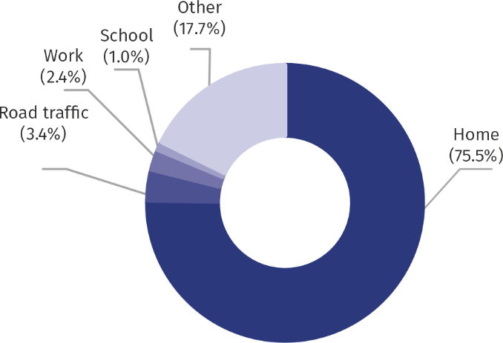
Chart 2. Structure of calls of emergency rescue teams by the occurrence place in 2025

Hospital emergency wards, admission rooms
Hospital emergency wards and admission rooms provide medical care in situations that pose a sudden threat to health or life. Medical services conclude with a discharge with recommendations or a decision to transfer the patient to a hospital ward for continued treatment.
The number of persons to whom outpatient emergency services were provided increased by 5.9%
In 2025, in admission rooms or hospital emergency wards, outpatient emergency medical services were provided to a total of 937.3 thousand persons (by 5.9% more than in the previous year), of whom 729.6 thousand were discharged home after receiving health services, and 207.7 thousand received hospital treatment. Children accounted for 18.9% of the total number of persons receiving health services, and persons aged 65 and over accounted for 28.1% (compared to 18.8% and 27.9%, respectively, in 2024).
Patients whose medical services ended with discharge to home most often used services in the field of surgery (36.0%) and internal medicine (18.0%).
Admission rooms and hospital emergency wards provided nearly 170 out-patient health care services per 1,000 population of Mazowieckie Voivodship
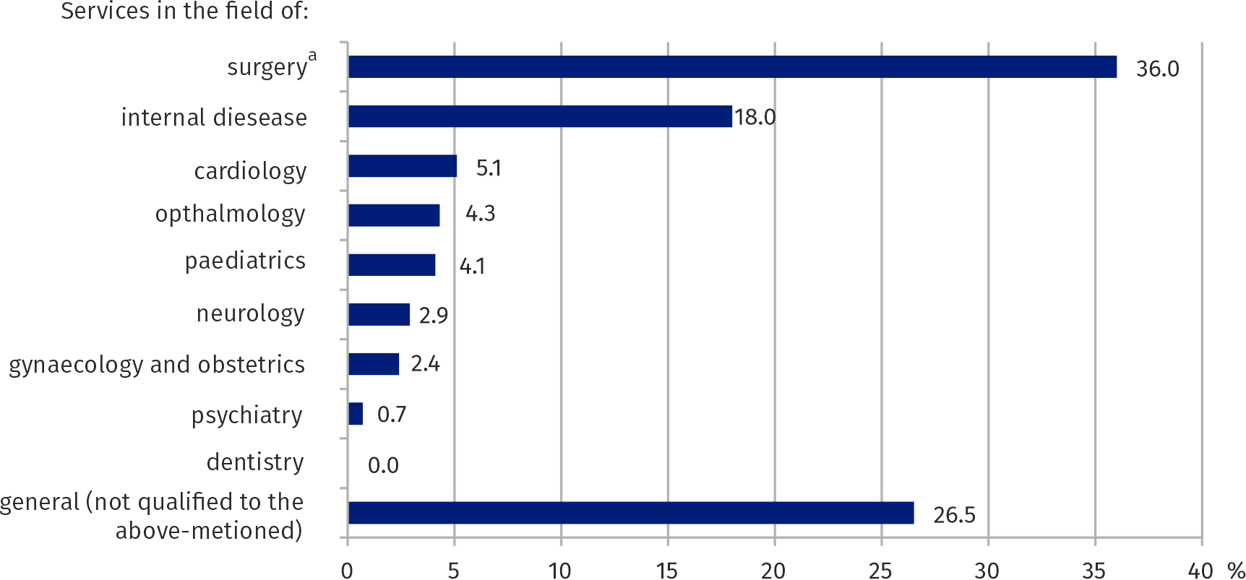
Chart 3. Structure of out-patient medical services provided in admission room or hospital in 2025
In the admission room or hospital emergency ward, most people used health services that ended with discharge to home in the field of surgery

a Including trauma and orthopedic surgery and neurosurgery.

Table 1. Emergency medical services and first aid
Specification | 2024 | 2025
Specification | In absolute numbers |  | 2024=100
Emergency rescue teams ª: | 215 | 221 | 102,8
specialist | 35 | 35 | 100,0
basic | 180 | 186 | 103,3
Medical air rescue teams ª | 3 | 3 | 100,0
Hospital emergency wards ª | 34 | 34 | 100,0
Admission rooms ª | 10 | 11 | 110,0
Calls to the occurrence places ^{b} | 451194 | 464826 | 103,0
of which occurrences::
In road traffic | 15797 | 15968 | 101,1
at work | 11408 | 11314 | 99,2
at school | 3416 | 4509 | 132,0
at home | 338590 | 350723 | 103,6
Persons who received health care bene-fits in the place of occurrence:
in absolute numbers | 452764 | 466495 | 103,0
per 1,000 population | 82,2 | 84,7 | 103,0
Persons provided with out-patient health care services (in admission rooms or hospital emergency wards) | 885039 | 937337 | 105,9
a As of 31 December. b Excluding calls to illnesses.
In the case of quoting data from the Statistics Poland, please provide information: "Statistics Poland data source", and in the case of publishing calculations made on data published by the Statistics Poland, please provide information: "Own study based on Statistics Poland data

Prepared by:  Statistical Office in Warszawa  Director Agnieszka Ajdyn  Phone: (+48 22) 464 23 15 | Issued by:  Statistical Information Centre  Marcin Kałuski  Mobile: (+48) 783 940 141
Press office in the Statistical Office in Warszawa  Mobile: (+48) 783 940 141  e-mail: m.kaluski@stat.gov.pl |   warszawa.stat.gov.pl/en/

@Warszawa_STAT

@UrzadStatystycznywWarszawie

gus_stat

glownyurzadstatystycznygus

glownyurzadstatystyczny

Related information
Emergency medical care in Mazowieckie Voivodship in 2024
Methodological report. Health and health care statistics – Statistics Poland's reports
Data available in databases
Local Data Bank -> Health care. social welfare and benefits to the family
Knowledge Databases -> Health and health care
Terms used in official statistics
Emergency medical services
Units of emergency medical service
Hospital emergency ward
Out-patient health care services
The place of occurrence
Trauma centre
Admission room
Physician of emergency medical services
Nurse of medical emergency services

