Prices of agricultural products in June 2026
Procurement prices of basic agricultural products decreased in June 2026 both in comparison with the previous month (by 0.2%) and compared to the corresponding period of 2025 (by 15.2%).
15.2%
decrease in procurement prices of basic agricultural products in comparison with June 2025

Chart 1. Changes in procurement prices of basic agricultural products in relation to the previous month
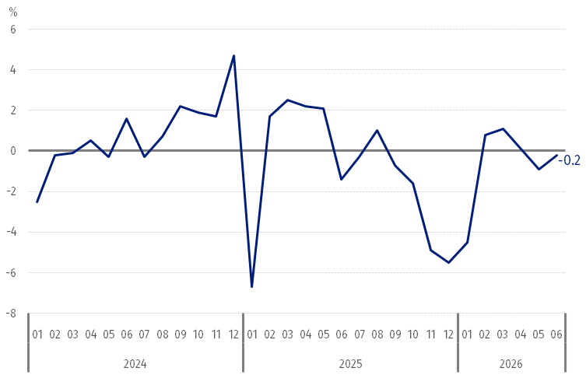
In June 2026, compared to May 2026, the procurement prices of basic agricultural products decreased except for wheat, cattle and poultry for slaughter

Chart 2. Changes in procurement prices of basic agricultural products in relation to the corresponding month of the previous year
Procurement prices of basic agricultural products were lower in June 2026 than those recorded in June 2025 except for cattle for slaughter
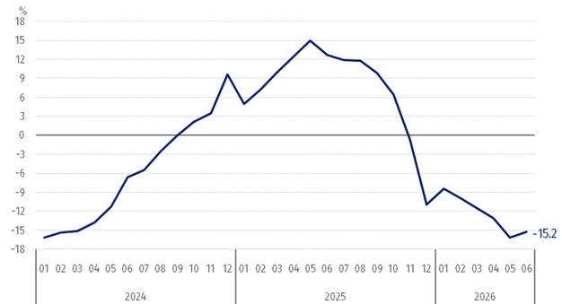

Procurement prices and marketplace prices received by farmers
In June 2026, the majority of agricultural products were sold at the higher procurement prices than in the previous month, while at marketplaces, there was more paid for the most of cereal, but less paid for potatoes and cattle for slaughter. At the both markets, there increased the prices of wheat, triticale and maize, while the prices of barley decreased.
Compared to the corresponding month of 2025, in June 2026 there was recorded the decrease in prices of the agricultural products both in procurement and at the marketplaces except for potatoes and cattle for slaughter in procurement.

Table 1. Prices of agricultural products (excluding VAT) in June 2026
Specification | Procurement prices |  |  | Marketplaces prices
Specification | in zloty | 05 2026 =100 | 06 2025 =100 | in zloty | 05 2026 =100 | 06 2025 =100
Cereal grainª – per dt
Wheat | 80.96 | 102.9 | 91.0 | 104.65 | 100.2 | 90.7
Rye | 63.57 | 100.0 | 85.6 | 78.78 | 100.3 | 87.2
Barley | 72.18 | 98.3 | 87.4 | 98.77 | 99.9 | 89.5
Triticale | 72.53 | 102.3 | 86.9 | 88.87 | 101.1 | 90.1
Oat | 55.72 | 101.1 | 76.9 | 86.15 | 99.2 | 85.3
Maize | 88.16 | 105.9 | 98.4 | 120.48 | 100.2 | 96.2
Potatoes^{b} – per dt | 120.89 | 103.4 | 105.4 | 151.24 | 93.7 | 75.1
Animals for slaughter – per kg
Cattle (excl. calves)^{c} | 14.15 | 100.7 | 105.2 | 12.15 | 99.4 | x
Pigs | 5.08 | 92.5 | 72.4 | . | . | .
Poultry | 6.22 | 106.2 | 96.5 | . | . | .
Cows’ milk – per hl | 174.09 | 96.5 | 77.3 | . | . | .
a Procurement prices – excluding sowing seed. b Procurement prices – total (edible early; seed potatoes; edible late; industrial, including starchy). Marketplaces prices – edible excluding early kinds. c Marketplaces prices – weighted mean of price of cattle for slaughter calculated on the basis of the share of procurement quantity of young cattle and cows for slaughter.

Prices of major agricultural products in June 2026
In June 2026, PLN 80.96 was paid per dt of wheat in procurement, i.e. 2.9% more than in the previous month, but 9.0% less than a year ago. At the marketplaces, the price of wheat (PLN 104.65 per dt) increased by 0.2% in comparison with May 2026 , while the price decreased by 9.3% compared to June last year.
The procurement price of rye (PLN 63.57 per dt) remained at the same level in comparison with May 2026, but it was lower by 14.4% than in June 2025. The price of rye at the marketplace (PLN 78.78 per dt) increased by 0.3% on a monthly basis, while the price decreased by 12.8%.on an annual basis.
In June 2026, PLN 120.89 was paid per dt of potatoes in procurement, i.e. 3.4% more than in the previous month and 5.4% more than in the corresponding period of 2025. At the marketplaces, the price of potatoes (PLN 151.24 per dt) decreased both in comparison with May 2026 (by 6.3%) and compared to June 2025 (by 24.9%).
The procurement price of cattle of slaughter (PLN 14.15 per kg) was higher both on a monthly basis (by 0.7%) and on an annual basis (by 5.2%). At the marketplaces, cattle for slaughter (PLN 12.15 per kg) were sold cheaper by 0.6% than in the previous month.
In June 2026, PLN 5.08 was paid per kg of pigs for slaughter in procurement, i.e. 7.5% less than a month ago and 27.6% less than a year ago.
The procurement price of poultry for slaughter (PLN 6.22 per kg) increased by 6.2% in the comparison with May 2026, while the price decreased by 3.5% compared to the corresponding period of the previous year.
PLN 174.09 was paid in procurement per hl of cows’ milk, i.e. 3.5% less than in the previous month and 22.7% less than a year ago.

Chart 3. Procurement and marketplaces prices of wheat and rye
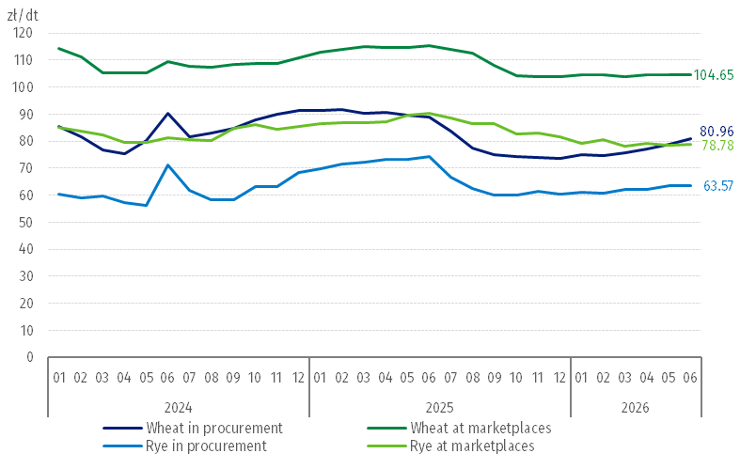

Chart 4. Procurement and marketplaces prices of potatoes
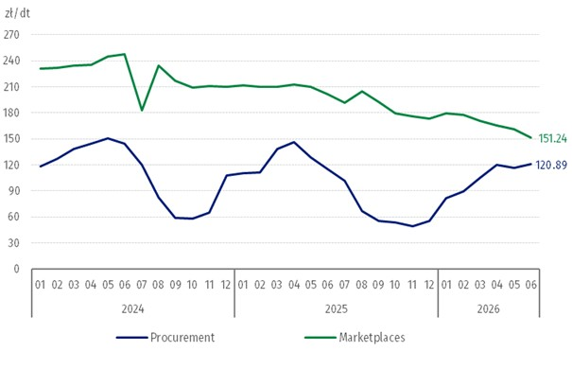

Chart 5. Procurement and marketplaces prices of cattle for slaughter and procurement prices of pigs for slaughter
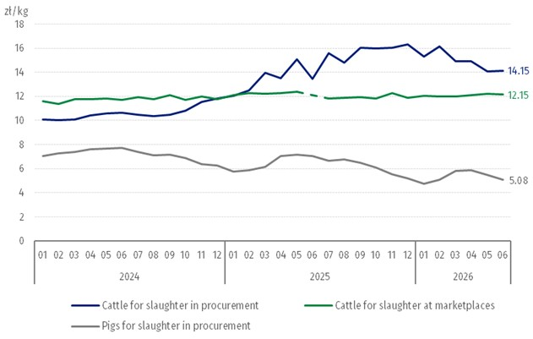

Chart 6. Procurement prices of poultry for slaughter and cows’ milk
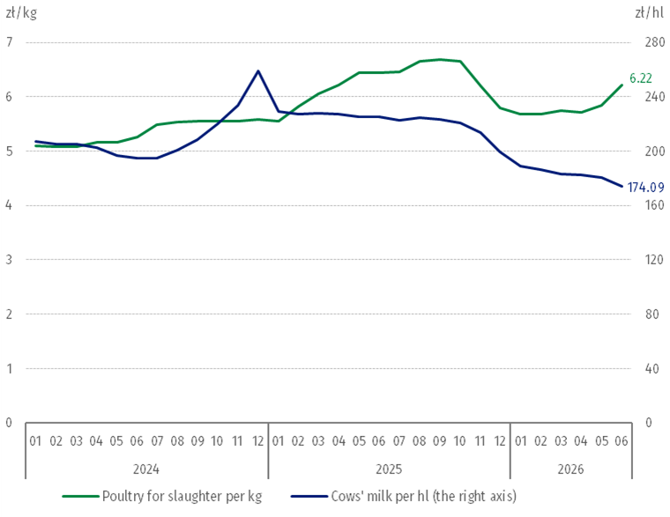
The differentiation of the level of prices of basic agricultural products in particular voivodships is presented in Table 2 for procurement prices and in Table 3 for prices obtained by farmers at the marketplaces (Excel sheet).
In case of quoting Statistics Poland data, please provide information: “Source of data: Statistics Poland”, and in case of publishing calculations made on data published by Statistics Poland, please include the following disclaimer: “Own study based on figures from Statistics Poland”.

Prepared by:  Prices and Services Department  Director Ewa Adach-Stankiewicz  Phone: (+48 22) 608 31 24 | Issued by:  Press Office  Mobile: (+48) 695 255 032  Phone: (+48 22) 608 38 04, (+48 22) 449 41 45,  (+48 22) 608 30 09  e-mail: obslugaprasowa@stat.gov.pl

stat.gov.pl/en/

@StatPoland

@GlownyUrzadStatystyczny

@gus_stat

@GłównyUrządStatystycznyGUS

@Glówny Urząd Statystyczny
Related information
Socio-economic situation of the country in 2026
Procurement and prices of agricultural products in 2025

Data available in databases
BDL – Prices - Prices in agriculture
Knowledge Databases – Economy - Prices – Producer prices - Agricultural prices

Terms used in official statistics
Procurement of agricultural products
Procurement prices
Marketplace
Marketplace prices

Wheat and rye grain, animals for slaughter: cattle, pigs and poultry, cow's milk
Data on procurement prices were calculated on the basis of information on value and quantity of procurement by legal persons and independent organizational entities without legal personality (excluding natural persons). Indices of procurement prices and prices received by farmers at marketplaces were calculated on the basis of absolute data expressed with more precision than in the tables.
In June 2025, the price of cattle for slaughter at marketplaces was classified as a statistical confidentiality due to the low number of quotations.

