Persons employed in the national economy living in Mazowieckie Voivodship in 2025
At the end of December 2025, residents of Mazowieckie Voivodship constituted 16.6% of the country's workforce. Their number amounted to more thab 2.5 million persons and increased by 0.7% during the year. There were 454 employed persons per 1,000 residents; this indicator higher for men than for women. The mean age of employed persons was 43.1 years.
0.7%
Increase in the number of employed persons compared to the previous year
Information on persons employed in the national economy is prepared based on administrative data sources. The use of official registers provides previously unavailable information, such as data on the gmina of residence of employed persons and their age. More information on the methodology can be found on the Statistics Poland website: Information from Statistics Poland on the change in the structure of data sources

Employed persons by sex
The number of employed persons in Mazowieckie Voivodeship increased year on year, while in the country it decreased in total
At the end of December 2025, the number of inhabitants of the Voivodship employed in the national economy amounted to 2,500.4 thousand and increased by 17.8 thousand, i.e. by 0.7% compared to the end of the previous year, with slightly higher increase in the number of women than men (0.8% compared to 0.7%). During the same period, the number of employed persons in Poland decreased (by 40.8 thousand, i.e. by 0.3%). The majority of employed persons were men; in Mazowieckie Voivodship, their share was 51.0%, compared to 52.2% nationally.
At the end of 2025, 37.6% of the voivodship's employed population lived in Warszawa
Warszawa is the largest local labour market. At the end of 2025, there were 941.2 thousand employed persons living there, which represents an increase of 9.7 thousand, or 1.0%, com-pared to the previous year. In Warszawa, unlike in the Voivodship, women predominated among the employed population, constituting 51.3%.
In December 2025, there were 454 employed persons per 1,000 inhabitants of the Voivod-ship (compared to 404 nationally). This indicator was higher among men than women, reaching 484 compared to 427, and a year earlier, 481 compared to 423.
In Warszawa, there were 504 persons employed in the national economy per 1,000 inhabit-ants in 2025 (in 2024 it was 500); for men the indicator was 531 and for women 481 (a year earlier it was 525 and 478, respectively).
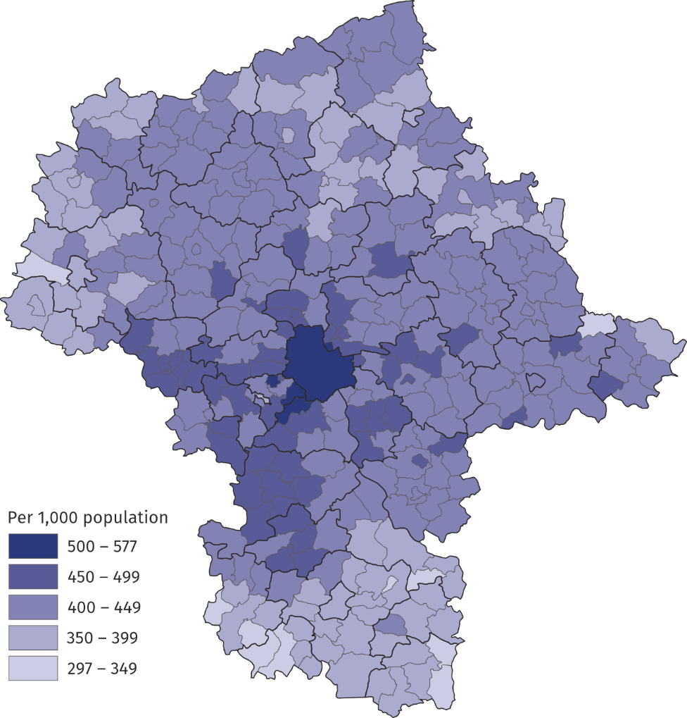
Map 1. Employed persons in gminas in 2025 (as of 31 December)
The highest number of employed persons per 1,000 inhabitants was recorded in the rural gmina of Raszyn
Among the gminas of Mazowieckie Voivodship, Warszawa ranked fifth in terms of the value of this indicator. More employed persons per 1,000 population were recorded in three rural gminas: Raszyn (577) and Lesznowola (537), and towns: Ząbki (509) and Pruszków (506). The fewest employed persons per 1,000 inhabitants were in the rural gmina of Chlewiska (297).

Employed persons by employment status, type of activity and size of the workplace
The majority of persons employed in the national economy are employees. At the end of 2025, their share of the total employed population was 78.1% (nationally 78.8%). In the Voivodship, this form of employment concerned 73.1% of employed men and 83.3% of employed women. The majority of employees were women (52.2%).
Employees constitute over 3/4 of persons employed in the national economy
The self-employed population (including contributing family workers) constituted 21.7% of the total employed population in Mazowieckie Voivodship (compared to 21.0% in Poland). This type of work was performed by 26.6% of employed men and 16.6% of employed women. The vast majority of self-employed persons were men (62.6%).

Chart 1. Employed persons by employment status and sex in 2025 (as of 31 December)
Among the self-employed, men had a large majority

The largest number of employed residents of Mazowieckie Voivodship were located in es-tablishments operating in the field of trade; repair of motor vehicles; this sector employed 366.4 thousand persons at the end of 2025. Next in line were manufacturing (296.1 thousand persons) and professional, scientific and technical activities (226.0 thousand).
Chart 2. Employed persons by sections of PKD in 2025 (as of 31 December)
Trade; repair of motor vehi-cles and manufacturing accounted for over 1/4 of the total number of employed inhabitants of the Voivodship

Note. Symbol Δ indicates that categories of applied classification are presented in an abbreviated form;
The structure of employment by type of economic activity varies depending on employment status. While the largest number of employees, similar to those employed in the national economy as a whole, was recorded in trade; repair of motor vehicles (16.0%), among the self-employed (including contributing family workers), the largest share was in agriculture, forestry, and fishing (26.1%).
More than 1/4 of the self-employed conducted activity in the agriculture, forestry and fishing section

At the end of 2025, the largest number of Mazovian residents worked in the smallest enti-ties, i.e. up to 5 employed persons (697.0 thousand), followed by the largest ones, i.e. at least 1,000 employed persons (519.4 thousand).
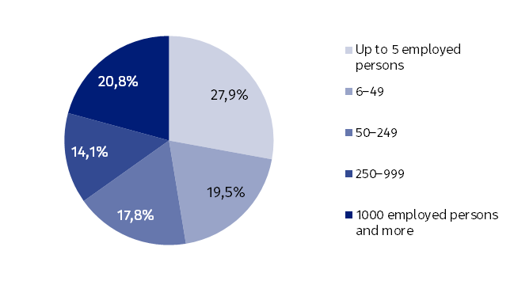
Chart 3. Employed persons by size of the entity in 2025 (as of 31 December)
Almost half of the surveyed population consisted of enti-ties employing fewer than 50 persons

In Warszawa, the percentage of persons employed in the smallest entities was lower than in the Voivodship (26.6%), and in the largest entities – higher (24.8%).
The use of administrative data sources also provides information on the age of employed persons and allows for the identification of retirees and pensioners, persons with disabili-ties and foreigners in the surveyed population.
At the end of December 2025, in Mazowieckie Voivodship (as in Poland), the average age of employed residents was 43.1 years, and the median age was 43.0 years; in Warszawa it was 42.3 years and 41.0 years, respectively.
Among the residents of Mazowieckie Voivodship employed in the national economy, a negli-gible share (0.3%) in 2025 was of pre-working age, i.e., 15-17 years of age. The percentage of men in this age group was 0.3%, and women 0.2%. Population of post-working age, i.e., men 65 and over and women 60 and over, constituted a total of 5.8% of the total. Men in this age group accounted for 4.2%, and women for 7.5%. A relatively large percentage of the em-ployed were persons aged 50 and over; in Mazowieckie Voivodship it was 29.9%, in Warszawa 26.6%, and for comparison, 30.9% in Poland.
29.9% of employed residents of Mazowieckie Voivodship are over 50 years old
The number of working retirees and pensioners decreased by 0.4% compared to the previous year, reaching 127.0 thousand at the end of 2025; the majority were women (53.9%). There were 44.5 thousand employed persons with disabilities, which is 1.8% more than at the end of 2024; this subpopulation also included more women (52.7%). The number of employed foreigners increased by 10.3% over the year, reaching 171.2 thousand, with women accounting for 39.6%. It is worth noting that 25.2% of the total number of foreigners working in Poland lived in Mazowieckie Voivodship.
Mazowieckie was the place of residence for 1/4 of all for-eigners working in the coun-try
When quoting Statistics Poland data, please provide the information: "Source of data: Stati-stics Poland", and when publishing calculations made on data published by Statistics Po-land, please include the following disclaimer: "Own study based on figures from Statistics Poland”.

Prepared by:  Statistical Office in Warszawa  Director Agnieszka Ajdyn  Phone (+ 48 22) 464 23 15 | Issued by:  Statistical Information Centre  Marcin Kałuski  Mobile (+48) 783 940 141
Press office in the Statistical Office in Warszawa  Mobile (+48) 783 940 141  e-mail: m.kaluski@stat.gov.pl |   warszawa.new.stat.gov.pl/en/

@Warszawa_STAT

@UrzadStatystycznywWarszawie

gus_stat

glownyurzadstatystycznygus

glownyurzadstatystyczny
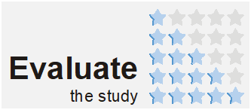
Related information
Methodological report. Employment in the national economy according to the administrative data sources
Employment in national economy in Poland in December 2025
Persons employed in the national economy in Mazowieckie Voivodship in 2024
Data available in databases
Local Data Bank - Labour market
Terms used in official statistics
Employed persons in the national economy
Paid employee
Self-employed persons including contributing family workers

