Residential construction in Mazowieckie Voivodship in 2025
16.9%
Y/y increase in the number of dwellings completed

In 2025, more dwellings were completed in Mazowieckie Voivodship than in the previous year. The number of dwellings in which construction had begun and for which permits have been granted or which have been registered with a construction project decreased.

New residential buildings completed
5.5% more new residential buildings were completed
In Mazowieckie Voivodship, in 2025, 15272 new residential buildings were completed (i.e. by 5.5% more than a year before). Most of them were completed in rural areas – 10381 (68.0%). Taking into account the number of storeys, the majority were 2-story (64.7%) and 1-story buildings (27.2% of new buildings). The average duration of construction of a new residential building amounted to 38.8 months and was 6.1 months shorter than in 2024. In urban as well as in rural areas, their construction time decreased by 4.4 months and 6.5 months, respectively.
In 2025, private investors built – 9581 new residential buildings (in 2024 – 9634 buildings). Their share in the total number of new residential buildings completed was 62.7% (in 2024 - 66.5%). In terms of the number of dwellings built by private investors, mainly single-dwelling buildings predominated, which in 2025 accounted for 97.3%.
Private investors completed nearly 63% of the total num-ber of new residential build-ings

Dwellings completed
In 2025, 45020 dwellings were completed in Mazowieckie Voivodship (i.e. by 16.9% more than in the previous year). The largest number of dwellings was completed in December – 6051, and the least in April – 2788. The share of dwellings completed in the Voivodship accounted for 21.6% of the total construction output in the country.
The largest group of completed dwellings was built in new residential buildings (98.7%). The rest are dwellings created as a result of enlarging already existing residential buildings (1.0%), created as a result of reconstructing and adapting non-residential spaces in residen-tial buildings (0.3%), as well as in non-residential buildings (0.02%).

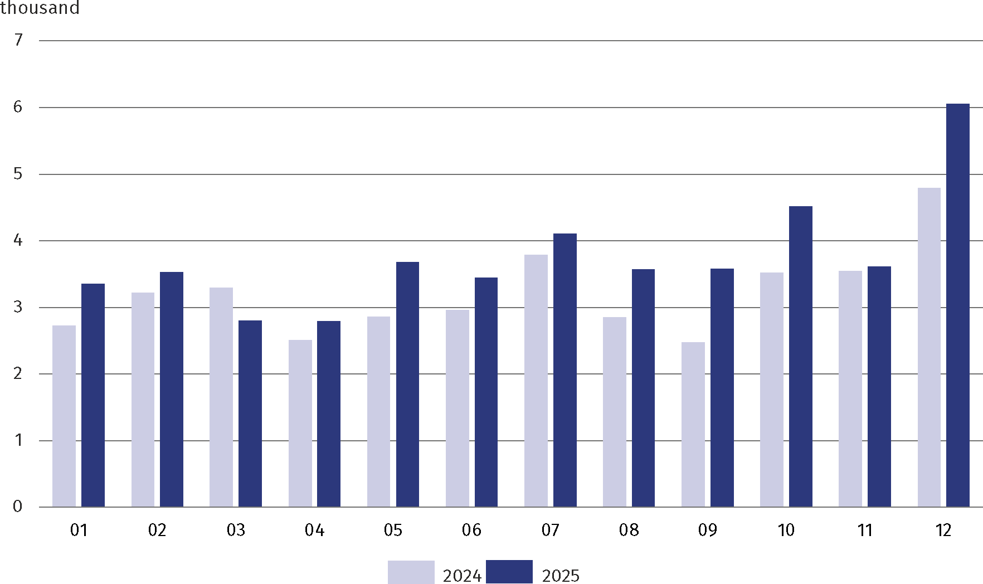
Chart 1. Dwellings completed
In the urban areas of the Voivodship, 31831 dwellings were completed (by 18.6% more than a year before), and their share in the total number of dwellings in the Voivodship increased by 1.0 pp 2024. Dwellings completed in m.st. Warszawa accounted for 44.1% of the effects of housing construction in the Voivodship and 62.3% of effects achieved in urban areas (in 2024, respectively 38.6% and 55.4%). In rural areas of the Voivodship, the number of dwellings completed rose by 12.8% in annual terms.
In urban areas, 87.9% of dwellings were built for sale or rent (in m.st. Warszawa 93.0%). In rural areas, nearly 58% of dwellings completed were dwellings built by private investors.
In 2025, in Mazowieckie Voivodship, there was an increase in the number of dwellings com-pleted in construction for sale or rent (by 5822), in cooperative construction (by 468), in buildings built by public building societies (by 234), and in company construction (by 59). Less dwellings than a year before were completed in municipal construction (by 61), and in private (by 23).

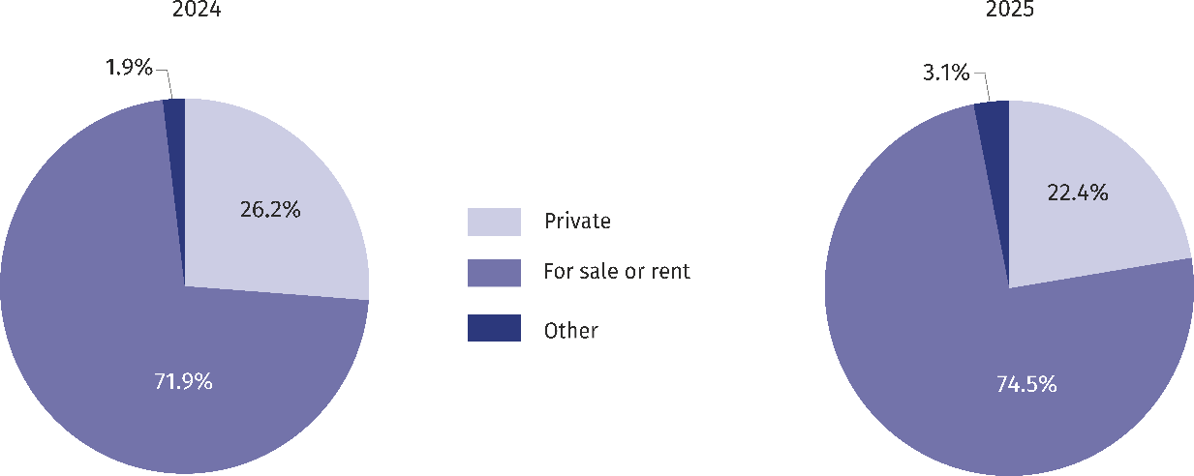
Chart 2. Structure of dwellings completed by form of residential construction

Table 1. Dwellings completed by form of construction in 2025
Specification | Dwellings | Rooms | Useful floor area of dwell-ings in m²
Specification | Dwellings | Rooms | total | average per dwelling
Grand total | 45020 | 155806 | 3715559 | 82,5
urban areas | 31831 | 93196 | 2108362 | 66,2
of which m.st. Warszawa | 19844 | 53418 | 1193568 | 60,1
rural areas | 13189 | 62610 | 1607197 | 121,9
Private | 10062 | 53494 | 1475820 | 146,7
For sale or rent | 33531 | 98659 | 2167809 | 64,7
Cooperative | 650 | 1691 | 34589 | 53,2
Municipal | 338 | 804 | 14341 | 42,4
Public building society | 379 | 908 | 18958 | 50,0
Company | 60 | 250 | 4042 | 67,4

Standard of dwellings completed
In 2025, the average useful floor area per dwelling completed was 82.5 m² which was lower by 4.2 m² than in the previous year. In urban areas, it was 66.2 m² (in 2024 – 68.7 m²), and in rural areas, it was almost twice as large.
Among powiats, the largest average useful floor area per dwelling completed was in siedlecki powiat – 146.4 m² , followed by ostrołęcki – 146.3 m², białobrzeski – 146.2 m² and it was almost twice as large as the average in the Voivodship. Dwellings with the smallest area were built in Płock – 56.6 m², Warszawa – 60.1 m² and in Ostrołęka – 64.8 m².
Dwellings with the largest average useful floor area were completed in private construction — 146.7 m²
Dwellings with the largest average useful floor area were completed in private construction – 146.7 m² (in 2024 – 147.2 m²), and the smallest dwellings in municipal construction – 42.4 m² (in 2024 – 39.7 m²).
The average dwelling completed consisted of 3.5 rooms

In 2025, dwellings completed in Mazowieckie Voivodship consisted on average of 3.5 rooms (3.6 in 2024). The largest dwellings were completed by investors who built private dwellings — 5.3 rooms, and the smallest by investors who built municipal dwellings — 2.4 rooms.

Table 2. Dwellings completed by the number of rooms in 2025
Specification | Total | Dwellings – in % – with specified number of rooms
Specification | Total | 1 | 2 | 3 | 4 | 5 | 6 | 7 | 8 and more
Residential construction
Total | 10062 | 0,1 | 1,3 | 5,2 | 17,5 | 34,2 | 26,4 | 10,3 | 5,0
Urban areas | 2439 | 0,2 | 1,5 | 4,2 | 16,7 | 33,9 | 24,5 | 11,4 | 7,6
of which m.st. Warszawa | 583 | 0,2 | 2,2 | 7,0 | 18,2 | 33,3 | 19,4 | 9,4 | 10,3
Rural areas | 7623 | 0,1 | 1,2 | 5,5 | 17,8 | 34,3 | 27,1 | 10,0 | 4,2
In addition to private construction
Total | 34958 | 7,4 | 35,5 | 29,9 | 15,5 | 8,5 | 2,5 | 0,4 | 0,3
Urban areas | 29393 | 8,5 | 39,7 | 31,9 | 13,5 | 4,7 | 1,2 | 0,3 | 0,2
of which m.st. Warszawa | 19261 | 10,4 | 42,2 | 29,8 | 12,7 | 3,5 | 1,0 | 0,2 | 0,1
Rural areas | 5566 | 2,1 | 13,6 | 19,1 | 25,7 | 28,3 | 9,0 | 1,3 | 1,0
The quality of dwellings completed determines their equipment in technical and sanitary installations. In 2025, nearly 95% of the dwellings were fitted with water supply system, al-most 83% with sewage system with the connection to the network, nearly 43% with central heating from the network as well as hot water centrally provided and nearly 30% with gas from gas supply system.

Intensity of housing construction
In 2025, 8.2 dwellings were completed per 1,000 population (an annual increase of 1.2 points; in urban areas an increase of 1.4 points, and in rural areas by 0.8 points).

Table 3. Selected indicators on dwellings completed in 2025
Specification | Voivodship | Urban areas | Rural areas
Dwellings per 1,000 population | 8,2 | 8,9 | 6,8
Dwellings per 1,000 contracted marriages | 2171 | 2234 | 2034
Rooms per 1,000 population | 28,3 | 26,1 | 32,3
Most dwellings per 1,000 population were completed in piaseczyński powiat — 15.3 (compared to 9.2 in 2024), nowodworski — by 13.4 (compared to 5.2), legionowski – 11.0 (compared to 9.7), wołomiński 10.3 (compared to 9.6), while the lowest in lipski powiat – 1.6 (the same as in 2024), makowski – 1.7 (compared to 2.4). In 8 powiats (grodziski, legionowski, nowodworski, piaseczyński, pruszkowski, warszawski zachodni, wołomiński, żyrardowski) and in Warszawa, the rate adopted a value higher than the voivodship average — 8.2.
In 2025, the number of dwellings completed per 1,000 newly contracted marriages increased and amounted to 2171 (compared to 1836 in 2024); in urban areas – 2234, in rural areas – 2034. In 32 out of 42 powiats of the Voivodship more dwellings were completed than marriages were contracted. The highest rate was recorded in piaseczyński powiat – 4350, the lowest in makowski powiat – 519.
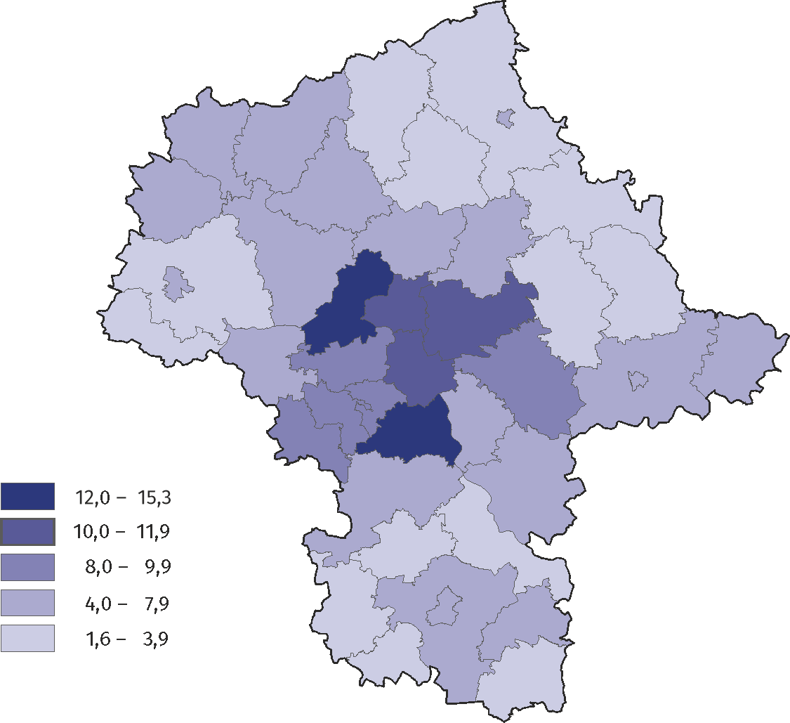
Map 1. Dwellings completed per 1,000 population in 2025
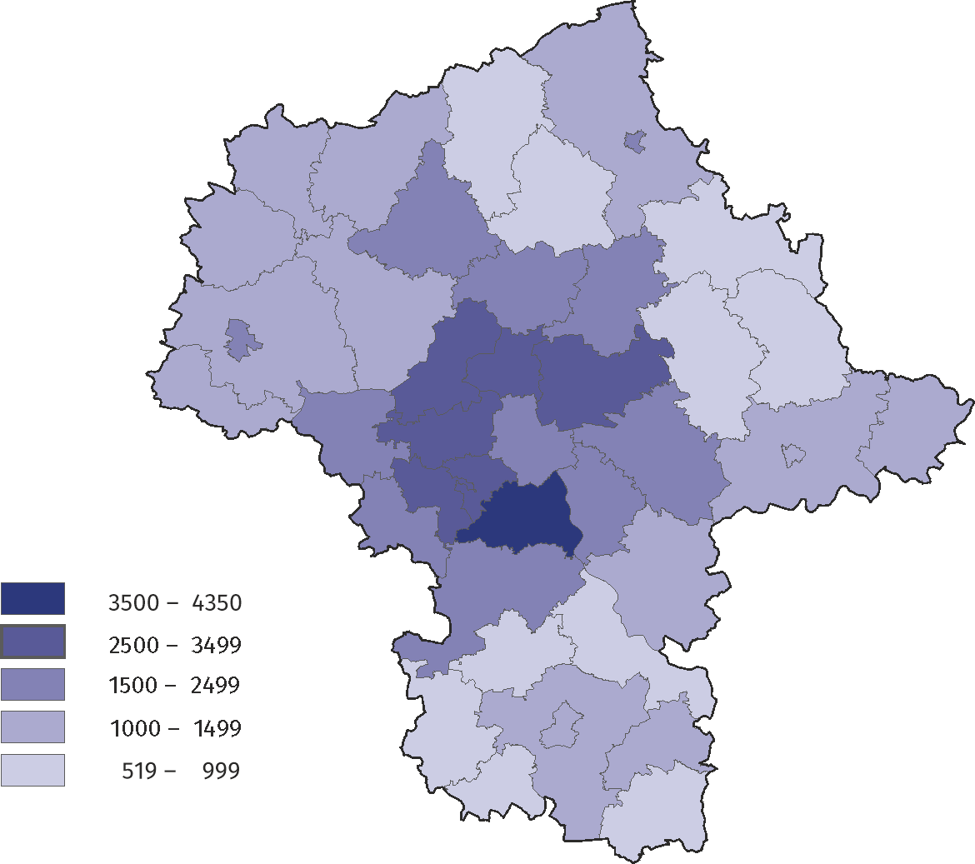
Map 2. Dwellings completed per 1,000 contracted marriages in 2025

Dwellings in which construction has begun
Nearly 73% made up dwellings in which construction has begun intended for sale or rent

In 2025, the construction of 44139 dwellings has begun in Mazowieckie Voivodship (i.e. 2.3% less than in 2024). Dwellings in which construction has begun intended for sale or rent accounted for 72.5%, and dwellings in private construction 27.3%. The remaining 0.2% were investments started by investors in cooperative, municipal and public building society construction.

Permits granted or registrations with a construction project
In 2025, in Mazowieckie Voivodship the number of dwellings for which permits have been granted or which have been registered with a construction project amounted to 52682 (i.e. 11.3% less than in 2024) with an average area of 88.9 m². 52095 dwellings will be built in new residential buildings (compared to 59120 dwellings in 2024). The remaining dwellings will be built in new non-residential buildings, collective accommodation buildings and in ex-tended and reconstructed residential and non-residential buildings. Of all the dwellings for which permits were granted or which were registered with a construction project 26.8% (compared to 20.7% in 2024) will be implemented by private investors.
The number of dwellings for which permits have been granted or which have been registered with a construction project decreased by 11.3%
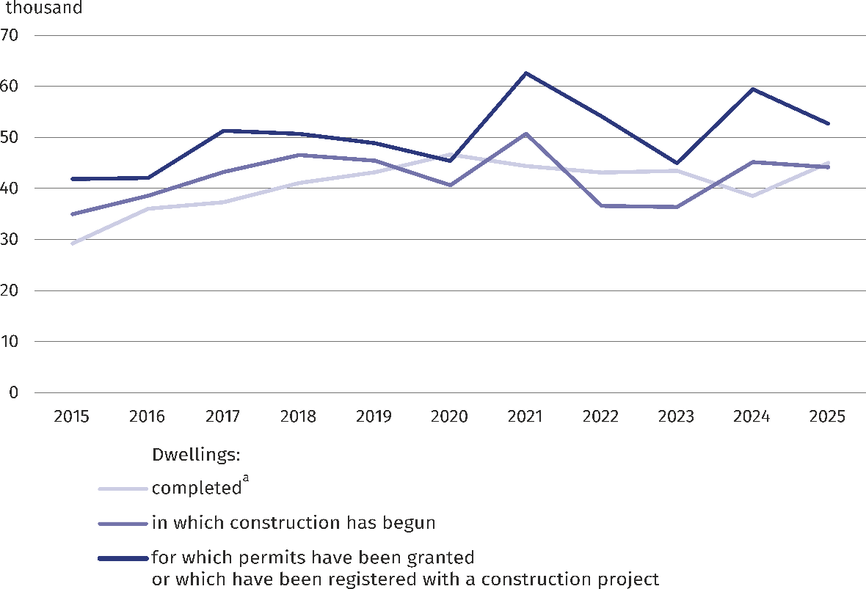
Chart 3. Residential construction
a Including dwellings obtained from reconstruction and adaptation of non-residential spaces as well as dwellings in collective accommodation buildings and non-residential buildings.

Table 4. Mazowieckie Voivodship against the country in 2025 — selected data
Specification | Poland | Voivodship
Specification | total |  | Poland=100
New residential buildings completedª:
number | 88747 | 15272 | 17,2
cubic volume in thousand m³ | 92357,7 | 20274,0 | 22,0
Dwellings completed^{b}:
number | 208297 | 45020 | 21,6
per 1,000 population | 5,6 | 8,2 | .
per 1,000 marriages contracted | 1564 | 2171 | .
Rooms^{b}:
number | 765243 | 155806 | 20,4
average number of rooms per dwelling | 3,7 | 3,5 | .
Useful floor area per dwelling^{b}
in thousand m² | 18112,3 | 3715,6 | 20,5
average per dwelling in m² | 87,0 | 82,5 | .
Dwellings completed by forms of residential construction^{b}:
private | 67241 | 10062 | 15,0
for sale or rent | 133906 | 33531 | 25,0
cooperative | 958 | 650 | 67,8
municipal | 1644 | 338 | 20,6
public building society | 4383 | 379 | 8,6
company | 165 | 60 | 36,4
a Applies to buildings completed as a whole or as first parts of new buildings; it does not apply to collective accommodation buildings and single-family buildings not adapted to permanent residence (summer houses and bungalows as well as country residences). b Including dwellings obtained from reconstruction and adaptation of non-residential spaces as well as dwellings in collective accommodation buildings and non-residential buildings.

Table 4. Mazowieckie Voivodship against the country in 2025 — selected data (cont.)
Specification | Poland | Voivodship
Specification | total |  | Poland=100
Dwellings in which construction has be-gun | 212424 | 44139 | 20,8
private | 78778 | 12056 | 15,3
for sale or rent | 129714 | 32006 | 24,7
cooperative | 319 | – | .
municipal | 1049 | – | .
public building society | 2525 | 77 | 3,0
company | 39 | – | .
Dwellings for which permits have been granted or which have been registered with a construction project | 266445 | 52682 | 19,8
Of which private construction | 85591 | 14113 | 16,5
When quoting Statistics Poland data, please provide the information: "Source of data: Stati-stics Poland", and when publishing calculations made on data published by Statistics Po-land, please include the following disclaimer: "Own study based on figures from Statistics Poland”.

Prepared by:  Statistical Office in Warszawa  Director Agnieszka Ajdyn  Phone: (+48 22) 464 23 15 | Issued by:  Statistical Information Centre  Marcin Kałuski  Mobile: (+48) 783 940 141
Press office in the Statistical Office in Warszawa  Mobile: (+48) 783 940 141  e-mail: m.kaluski@stat.gov.pl |   warszawa.new.stat.gov.pl/en/

@Warszawa_STAT

@UrzadStatystycznywWarszawie

gus_stat

glownyurzadstatystycznygus

glownyurzadstatystyczny
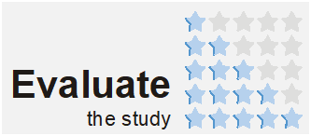
Related information
Residential construction in Mazowieckie Voivodship in 2025 – infogrphics
Socio-economic situation of Mazowieckie Voivodship. December 2025
Statistical bulletin of Mazowieckie Voivodship quarter 4/2025
Report on the socio-economic situation of Mazowieckie Voivodship in 2026
Data available in databases
Local Data Bank, Industry and construction
Knowledge Databases, Construction
Terms used in official statistics
Private construction
Municipal construction
Construction for sale or rent
Public building society
Cooperative construction
Company construction
Rooms completed
Dwellings completed
Useful floor space of a dwelling completed

Applies to buildings completed as a whole or as first parts of new buildings; does not apply to collective accommodation buildings and single-family buildings not adapted to perma-nent residence (summer houses and bungalows as well as country residences). 2 Including dwellings obtained from reconstruction and adaptation of non-residential spaces as well as dwellings in collective accommodation buildings and non-residential buildings.

