Emergency rescue services activity in 2025
In 2025, fire brigades intervened in 483.2 thousand events, of which 316.3 thousand related to local threats, 117.3 thousand – fires and 49.6 thousand – false alarms. Water life rescue services carried out 2 445 rescue operations in which 1 578 drawning persons were saved. The Mountain Volunteer Rescue Service carried out 2 744 rescue operations, encompassing 2 952 persons, while the Tatra Volunteer Rescue Service intervened 1 098 times, saving 1 256 persons.
12.4%
Decrease in the number of interventions of fire brigades in 2025 compared to 2024

Events involving fire brigades
The biggest number of interventions of fire brigades per one thousand persons recorded in Zachodniopomorskie Voivodeship (16.3)
In 2025, fire brigades intervened in 483.2 thousand events across the whole country (decrease by 12.4% in comparison with 2024). The biggest number of interventions of fire brigades was recorded in Śląskie Voivodeship (66.1 thousand), and the lowest number in Podlaskie Voivodeship (12.0 thousand). The index of the number of events requiring intervention of fire brigades per one thousand persons, reached the highest level in Zachodniopomorskie Voivodeship (16.3), and the lowest one in Mazowieckie Voivodeship (9.8).
The interventions referred to 316.3 thousand local threats (19.9% less than in 2024), 117.3 thousand fires (13.2% more) and 49.6 thousand false alarms (7.1% less). Small fires (112.4 thousand) accounted for 95.8% of the total number of fires (an increase of 12.7 thousand, i.e. by 12.7%, compared to 2024). Very large fires (93) accounted for 0.1% of the total number of fires (an increase of 15 fires, i.e. 19.2%, compared to 2024).
In 2025, 95.8% of all fires were categorised as small fires

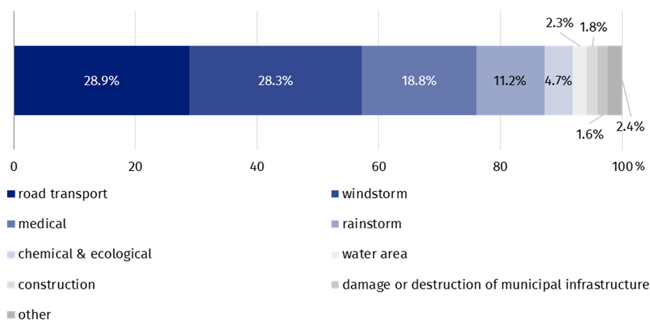
Chart 1. Local threats by type in 2025
The incidents in road transport accounted for most local threats requiring the intervention of fire brigades (28.9% of cases)
Attention. The total number of local threats is not an exact sum up of subtotals because not all data regarding the type of threat has been entered into the National Headquarters of the State Fire Service.
Source: National Headquarters of the State Fire Service.
In 2025, 3 779.9 thousand firefighters were involved in interventions of fire brigades, including 1 990.7 thousand volunteer firefighters, which account for a decrease of 12.9% and 9.7%, respectively, in comparison with the previous year. There were 872.0 thousand vehicles used, including 734.8 thousand fire engines.
As a result of fires and local threats, 12.9 thousand persons died
As a result of fires and local threats, 12.9 thousand persons died i.e. by 8.1% more than in 2024, and 56.6 thousand were injured – an increase by 2.8%.

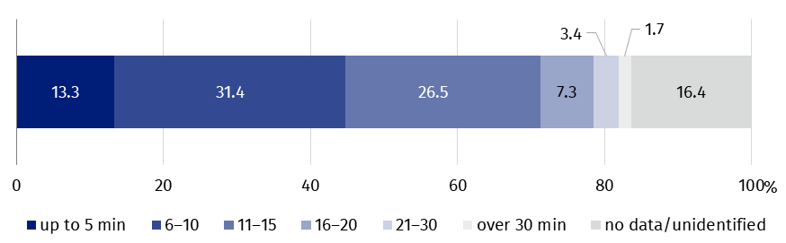
Chart 2. Events requiring intervention of fire brigades by drive time in 2025
The percentage of arrivals at the location of the accident within 10 minutes fell from 52.5% in 2024 to 44.7% in 2025, with the proportion of arrivals within 5 minutes falling from 16.9% to 13.3%
Source: National Headquarters of the State Fire Service.
The biggest number of interventions of fire brigades was recorded in Śląskie Voivodeship (13.7%), of which local threats (14.6%) and false alarms (15.9%). Yet, the largest number of fires was occurred in Mazowieckie Voivodeship (14.5%). The lowest number of events involving fire brigades occurred in Podlaskie Voivodeship (2.5%), including local threats (2.4%) and false alarms (1.4%). The lowest number of fires occurred in Opolskie Voivodeship (2.7%).
The biggest number of interventions of fire brigades was recorded in Śląskie Voivodeship (13.7%) and the least in Podlaskie Voivodeship (2.5%)
The index of the number of local threats requiring intervention of fire brigades per one thousand persons reached the highest value in Podkarpackie and Śląskie Voivodeship (10.8), and the lowest one in Mazowieckie Voivodeship (5.7). Most local threats requiring intervention of fire brigades occurred in road traffic incidents (62.9 thousand), which number increased by 2.5%.in comparison with 2024.

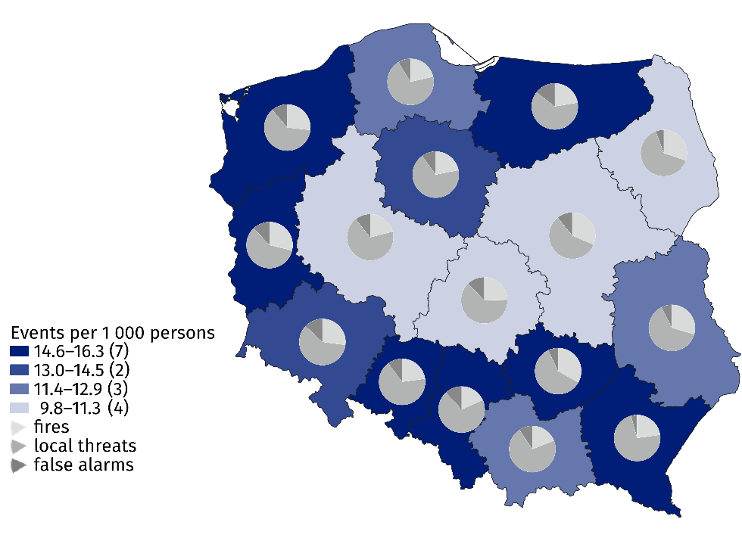
Map 1. Events requiring intervention of fire brigades units in 2025
Source: the data of the National Headquarters of the Police.
Table 1. Events involving fire brigades by voivodeships in 2025
Specification | Total | Fires | Local threats | False alarms
Poland | 483 186 | 117 349 | 316 254 | 49 583
Dolnośląskie | 39 724 | 10 777 | 23 784 | 5 163
Kujawsko-pomorskie | 28 096 | 6 164 | 19 127 | 2 805
Lubelskie | 25 046 | 7 370 | 15 798 | 1 878
Lubuskie | 15 202 | 4 376 | 9 005 | 1 821
Łódzkie | 24 832 | 6 127 | 15 663 | 3 042
Małopolskie | 41 130 | 7 849 | 29 395 | 3 886
Mazowieckie | 54 215 | 16 989 | 31 433 | 5 793
Opolskie | 13 721 | 3 135 | 9 199 | 1 387
Podkarpackie | 30 587 | 6 996 | 22 276 | 1 315
Podlaskie | 11 997 | 3 635 | 7 683 | 679
Pomorskie | 30 310 | 6 496 | 21 132 | 2 682
Śląskie | 66 127 | 12 080 | 46 149 | 7 898
Świętokrzyskie | 17 062 | 5 653 | 10 199 | 1 210
Warmińsko-mazurskie | 20 517 | 4 599 | 12 942 | 2 976
Wielkopolskie | 38 281 | 8 060 | 26 123 | 4 098
Zachodniopomorskie | 26 339 | 7 043 | 16 346 | 2 950
Source: National Headquarters of the State Fire Service.

Actions of water rescue services
As of 31 December 2025, 126 entities employed 15 169 water lifeguards (an increase of 5.3%). During 2025 they carried out 2 445 rescue operations (increase by 28.5%), in which they saved 1 578 lives (an increase of 1.2%)
As of 31 December 2025, 126 entities was granted a permission to water rescue service and they employed 15 169 water lifeguards (an increase of 5.3% in the number of rescuers compared with the previous year). Water lifeguards carried out 2 445 rescue operations (increase by 28.5% i.e. 542 operations in comparison with 2024), most of them in inland and coastal water area (1 690) and least of them in places occasionally used for swimming (16). They saved 1 578 lives.

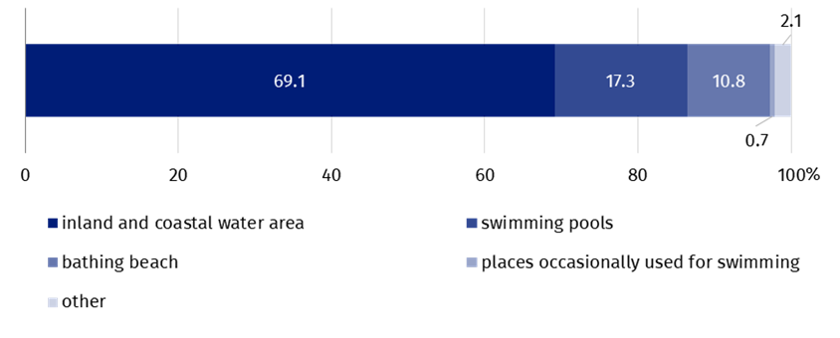
Chart 3. Rescue operations to save drowning people by place of rescue in 2025
Source: Ministry of the Interior and Administration.
The highest share of water rescue operations involving professional first aid (47.6 %) took place at swimming pools
Water lifeguards carried out 7 255 actions requiring professional first aid, which is a decrease by 17 cases in comparison with 2024. Most rescue actions occurred during swimming (3 453), such interventions occurred in the least cases in places occasionally used for swimming (139).
In 2025 the units of the State Medical Emergency executed 742 actions dealing with transporting victims of the incidents or in danger of losing health or life in water area to a location where it was possible to perform medical rescue actions. Water lifeguards took part in 554 actions of searching for missing persons.

Drowning events
In 2025, 327 drowning events were reported to the Police (by 33.0% less than in 2024). There were 292 fatal drowning (a decrease by 34.2%)
In 2025, 327 drowning events were reported to the Police (by 33.0% less than in 2024), resulting in 292 deaths (by 34.2% less), including 25 women (57.6% less than in 2024). Most victims of drowning events were recorded in Pomorskie Voivodeship (49), while the smallest number of them in Świętokrzyskie Voivodeship (3).

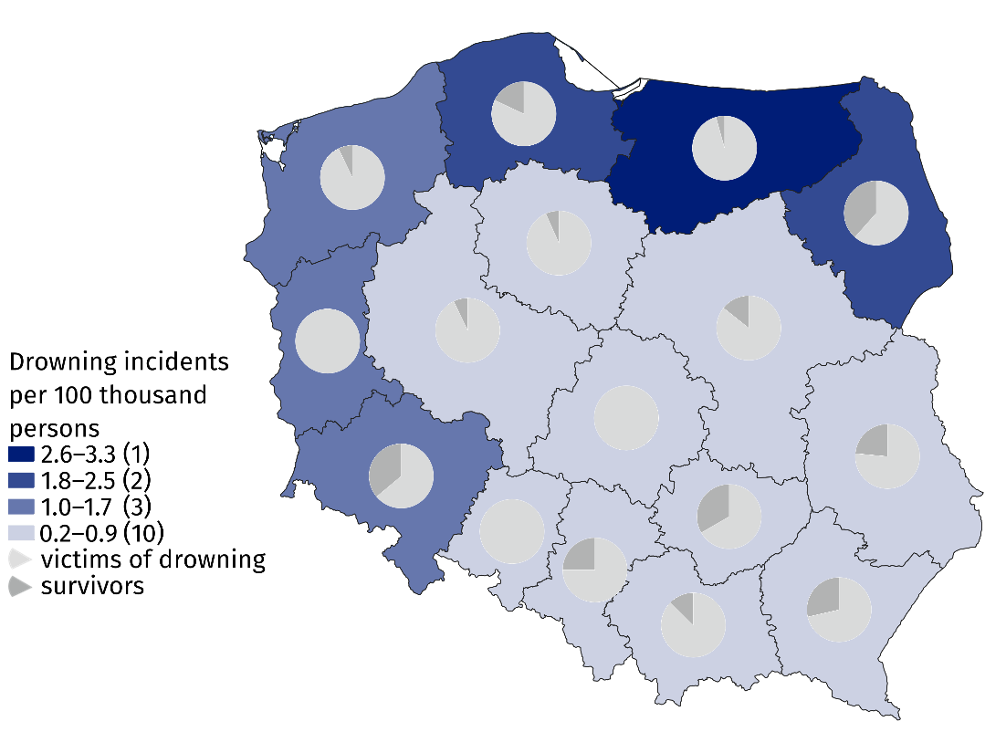
Map 2. Drowning incidents in 2025
Source: the data of the National Headquarters of the Police.
Of the drowning victims, 137 persons were over 50 years old
Persons over 50 years of age were the largest group of drowning victims (137 persons), while children under 7 years of age were in the smallest group (one person).

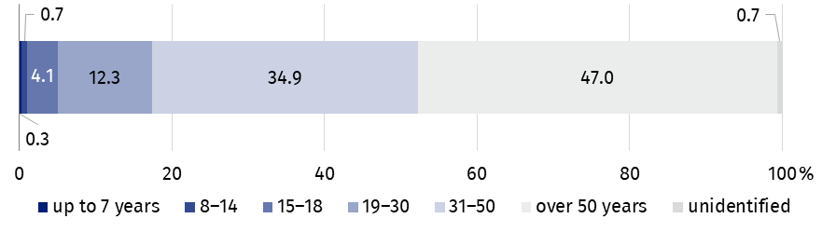
Chart 4. Victims of drowning by age in 2025
Source: National Headquarters of Police.
Most of victims drowned in lakes – 77. The biggest number of victims of drowning in lakes was recorded in Warmińsko-mazurskie Voivodeship (30), while the smallest number of such victims was in Śląskie Voivodeship (1). There were no victims of drowning in lakes in Małopolskie, Dolnośląskie, Łódzkie, Świętokrzyskie, Lubelskie and Podkarpackie Voivodeship. There were 76 persons who drowned in rivers. The biggest number of victims of drowning in rivers was in Mazowieckie Voivodeship (14), while the smallest number of such victims was in Opolskie, Łódzkie and Świętokrzyskie Voivodeships (one person in each). There were no victims of drowning in rivers in Śląskie Voivodeship. 14 persons drowned in the sea, 9 in Pomorskie and 5 in Zachodniopomorskie Voivodeship.
Most of victims drowned in lakes (77) and the least in the sea (14)
The highest numbers of drowning accidents were recorded on Saturdays (60), while the lowest numbers of them were recorded on Mondays and Thursdays (29 in each).
At the time of the incident, 58 drowning victims were intoxicated whereas 22 persons were not found to be under the influence of alcohol. In 212 events of drowning (72.6%) state of consciousness (i.e. sober, intoxicated or under influence of drugs) could not be determined.
The biggest percentage of drowning incidents was recorded in Pomorskie Voivodeship (15.0%) and the smallest in Świętokrzyskie Voivodeship (0.9%). In regard to drowning victims, the highest percentage was recorded in Warmińsko-Mazurskie Voivodeship (15.4%) and the lowest one in Świętokrzyskie Voivodeship (0.7%). The highest share of people saved was recorded in Dolnośląskie Voivodeship (23.2%) and the lowest in Kujawsko-Pomorskie, Świętokrzyskie and Wielkopolskie Voivodeships (1.8% in each).

Expeditions, operations and interventions of the Mountain Volunteer Rescue Service (GOPR) and the Tatra Volunteer Rescue Service (TOPR)
GOPR carried out 2 744 rescue operations, involving 3 002 persons (1.6% less than in 2024). There were 50 deaths (by 12.3% less than in the previous year).
GOPR rescuers carried out 2 744 rescue operations (1.1% less than in 2024), including: expeditions (338), operations (1 967), interventions (397) and teleinterventions (42). They helped 1 726 injured persons (3.8% less than in 2024) and 430 persons whose health deteriorated quickly (9.1% less). A rescue service (GOPR) was also called upon by 796 persons who gave other reasons for needing help (an increase of 9.6%). During the operations, 50 persons died (a decrease of 12.3%) Among the rescued there were 176 foreigners (5.9% of all rescued). Most people requiring assistance were found in open mountainous terrain (2 098), and least in caves (4). The use of helicopter was necessary in 65 rescue expeditions and operations (2.8% of the total).

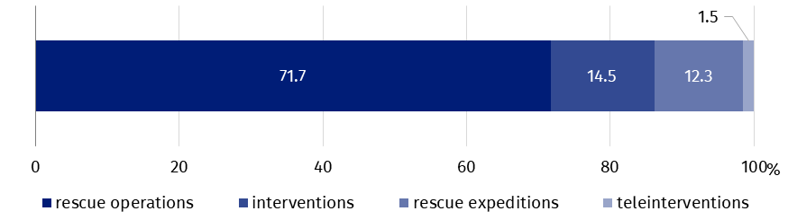
Chart 5. Rescue operations of the Mountain Volunteer Rescue Service in 2025
Source: Mountain Volunteer Rescue Service.
TOPR rescuers saved 1256 people (i.e. 5.1% less than in 2024). It was not possible to save 19 persons (17.4% less)
TOPR rescuers carried out 1 098 rescue operations (5.1% less than in 2024). They included: expeditions (355), operations (719) and interventions (24). They carried out 283 operations using a helicopter (25.8% of all operations). In total, they saved 1 256 persons, including 161 (12.8%) foreigners. The rescue was provided for 527 persons due to serious injury or illness (22.6% more than in 2024), for 446 persons due to minor injury or illness (less by 3.5%) and 264 persons without injuries (less by 43.6%). There were 19 deaths (17.4% less than in 2024).
The most events were caused by falls (535), and the least number by high fever (5). There were no events caused by lightning. Most persons requiring help were hikers (1 016), while the smallest group consisted of cave climbers and hang-gliders or paragliders (one person each).

Suicide attempts
In 2025, 14 935 people attempted suicide (0.3% less than in the previous year), including 4 776 deaths (1.4% less than in 2024)
In 2025, 14 935 persons attempted suicide, resulting in 4 776 deaths. In comparison with 2024, the number of suicide attempts decreased by 45, and the number of deaths by 69, this is respectively by 0.3% and 1.4%. In municipal areas 9 870 suicide attempts were recorded i.e. by 25 less cases than in 2024.
The index of suicide attempts per 10 thousand population reached the highest value in Łódzkie Voivodeship (6.7) while the lowest value was recorded in Mazowieckie Voivodeship (2.6), while on a national scale, the value was 4.0. Most of suicide attempts were caused by mental illness or mental disorders (4 512 cases). Most people attempted suicide by hanging (5 008 cases), while the lowest by self-immolation (51 cases).
When quoting this publication, please provide its title and identify Statistics Poland as the author. When publishing your calculations based on the data from the publication, please include the following disclaimer: “Own study based on data from the Statistics Poland publication “Emergency rescue services activity in 2025”.

Prepared by:  Statistical Office in Kraków  Director Agnieszka Szlubowska  Phone: (+48 12) 420 40 50 | Issued by:  Press Office  Mobile: (+48) 695 255 032  Phone: (+48 22) 608 38 04, (+48 22) 449 41 45,  (+48 22) 608 30 09  e-mail: obslugaprasowa@stat.gov.pl

stat.gov.pl/en/

@StatPoland

@GlownyUrzadStatystyczny

@gus_stat

@GłównyUrządStatystycznyGUS

@Glówny Urząd Statystyczny
Related information
Emergency rescue services activity in 2024
Fire safety in 2024
The Volunteer Mountain Rescue Service activities in ski areas in 2024
Mountain Rescue of the Volunteer Mountain Rescue Service in Poland in 2024
Mountain rescue of the Volunteer Tatra Mountains Rescue Service in 2024
Data available in databases
Database Local Data Bank – organisation of the state and justice
Geostatistics Portal – Analysis Panel – resource catalog – US Krakow
Terms used in official statistics
False alarm
Drive time to the event site
Period of action
Local threat
Fire
Drowned
Drowning
GOPR interventions and rescue operations
TOPR interventions and rescue operations

Population as of 30 June.
The same firefighter might take part in more than one intervention.
The same vehicle might be used in more than one intervention.
Data based on reports of entities possessing concessions to water life savings reported to the Ministry of the Interior and Administration as referred to in Article 32(1) Act of 8 September 2006 on Medical State Emergency. Journal of Laws 2026, pos. 141 and further amendments.
There are different rescue services involved in different rescue operations; the police are not involved in every water rescue operation.
All data are related to the events reported to the Police.
All data derive from the Mountain Volunteer Rescue Service Information System and the Tatra Volunteer Rescue Service Information System.
All data are related to events reported to the Police.

