Inland waterways transport in Poland in 2025
The layout and total length of inland waterways
in Poland have remained largely unchanged for many years. In 2025, the total volume of goods transported by Polish inland waterways operators by inland waterways remained at a level comparable to the previous year. The main factors limiting the volume
of goods transported and transport performance
in inland waterways transport were the inadequate development of inland waterways and variable navigational conditions. These factors affect the utilisation of the transport capacity of the fleet and the scale of transport operations. Given the relatively low share of inland waterways transport in the transport sector, the volume of goods transported is characterised by considerable fluctuations resulting, inter alia, from the seasonal or irregular nature of transport.
26.1%
Increase in national transport of goods compared with 2024

Inland waterways
The efficiency of inland waterways transport depends on the condition of hydraulic engineering infrastructure and the navigational parameters of inland waterways. The extent
to which this mode of transport can be utilised is primarily determined by the availability
of waterways meeting the standards applicable to inland waterways of international
importance.
Chart 1. Structure of inland waterways in use in Poland in 2025

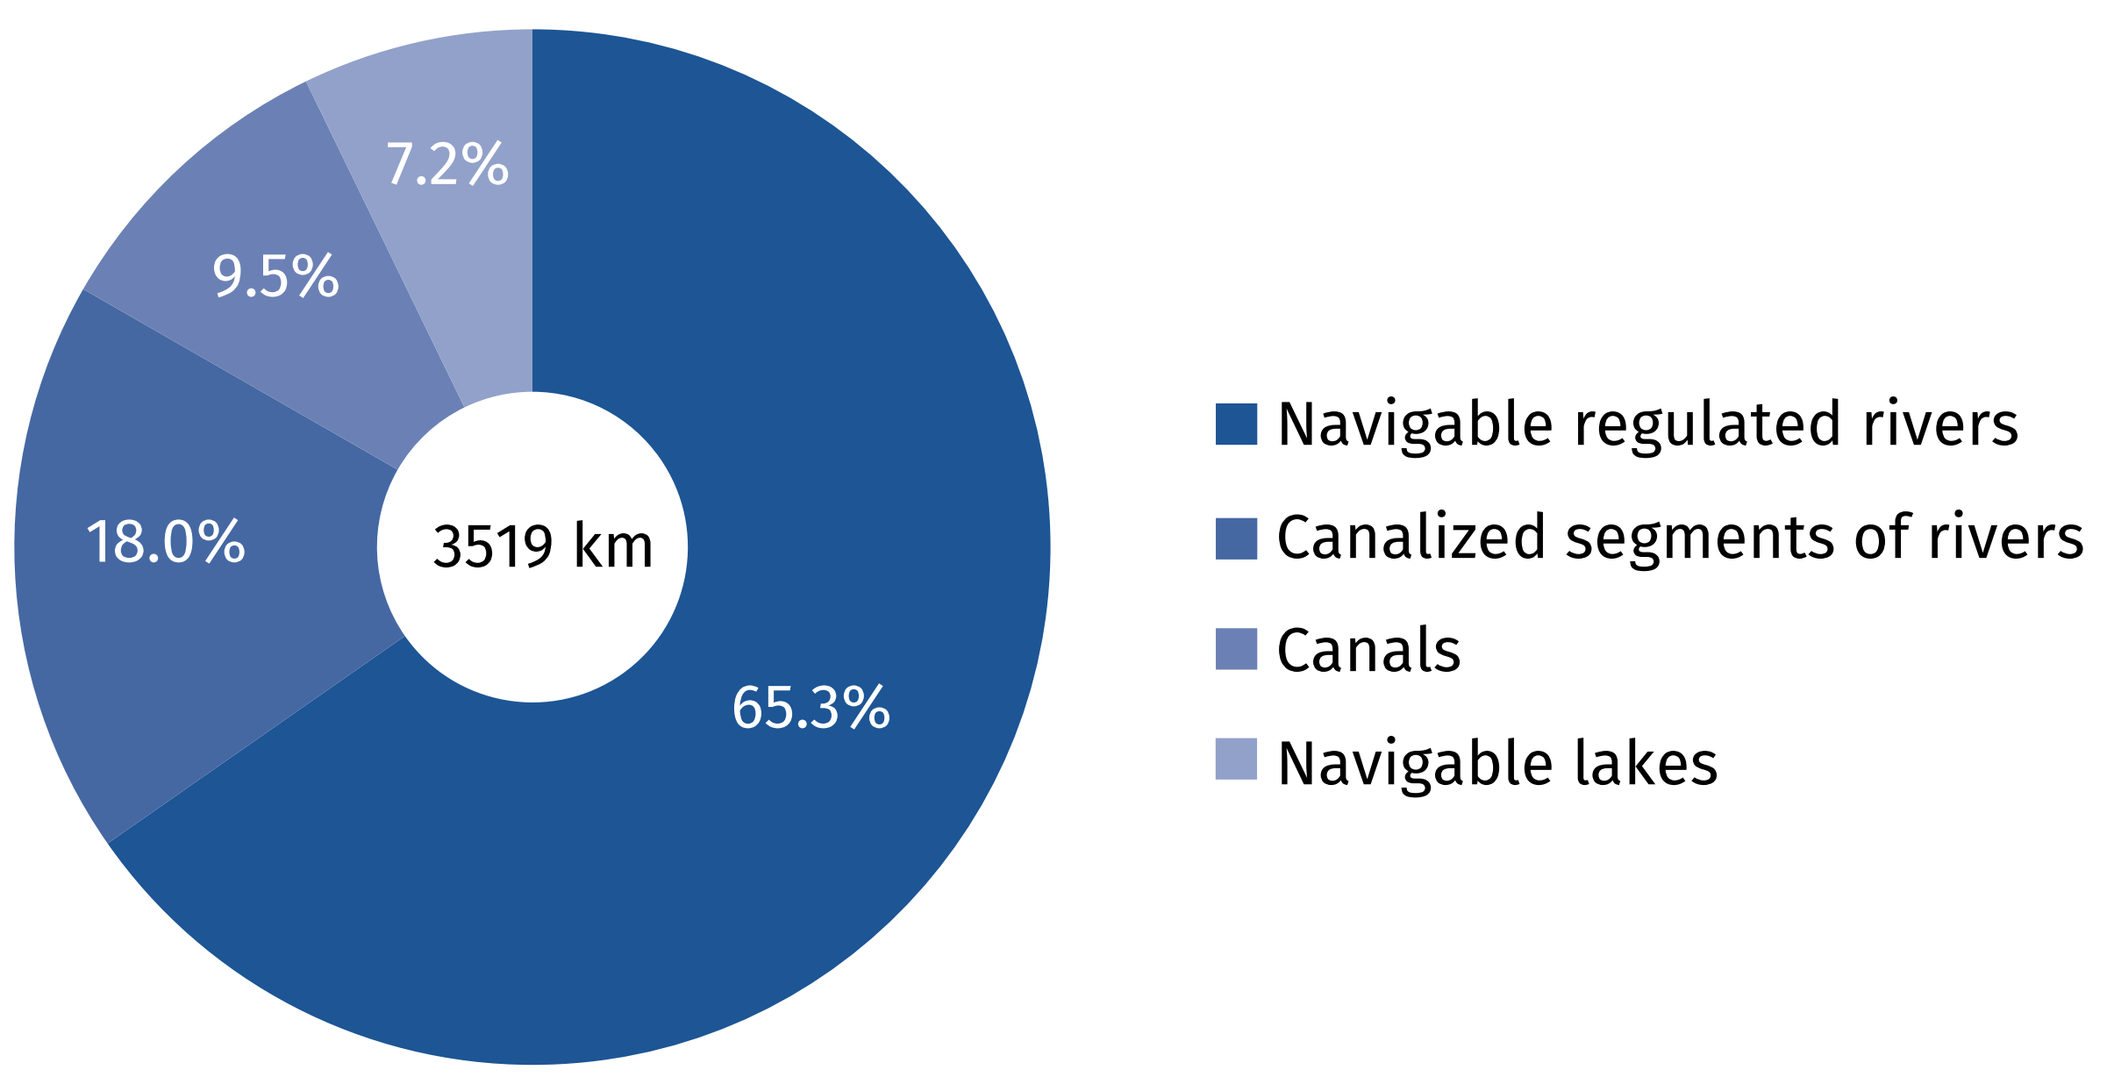

In 2025, the length of the inland waterways network in Poland amounted to 3,767.4 km.
Of this total, 2,522.2 km represented navigable regulated rivers, 655.7 km – canalized segments of rivers, 334.7 km – canals, and 254.8 km – navigable lakes. In 2025, only 5.5% of the total length of waterways in Poland (205.9 km) met the requirements for routes of international importance (classes IV and V). The remaining part of the network consisted of waterways
of regional importance (classes I, II and III), whose total length in 2025 was 3,561.5 kilometers.
A total of 3,519.2 km (93.4%) of the waterways were in use for navigation.

Inland waterways transport fleet
Nearly 81% of the barge fleet consisted of non-self-propelled vessels, more than half of them manufactured between 1949–
–1979
In 2025, the inland waterway towing fleet in Poland consisted of 136 pushers and tugs, i.e.
2 more than in the previous year. At the same time, the number of self-propelled barges was decreased by 7 units (to 44), while the number of non-self-propelled barges (pushed and towed) increased by 6 units (to 186). The number of passenger fleet increased by 12 units
(to 121). The barge fleet was dominated by vessels with limited operational characteristics, adapted to variable hydrological conditions, and vessels operating in the pushed system, which accounted for 80.9% of the total barge fleet. In 2025, these vessels transported
857.3 thousand tonnes of goods, representing 51.3% of the total volume of goods transported by inland waterways.

Chart 2. Structure of inland waterway barges fleet by load capacity groups in 2025

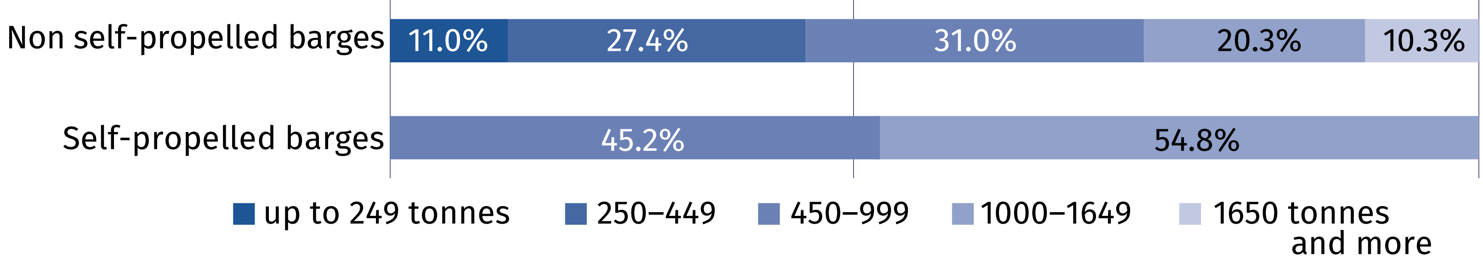
The inland waterway transport fleet is characterised by a high degree of technical wear and requires renewal. The age of many vessels exceeds their normative service life, and their continued operation is possible thanks to ongoing modernisation and repair works. Data for 2025 indicate that the majority of pushers (69.8%), more than half of push barges (54.8%) and all self-propelled barges currently in service were built between 1949 and 1979.

Chart 3. Structure of inland waterway fleet by age in 2025

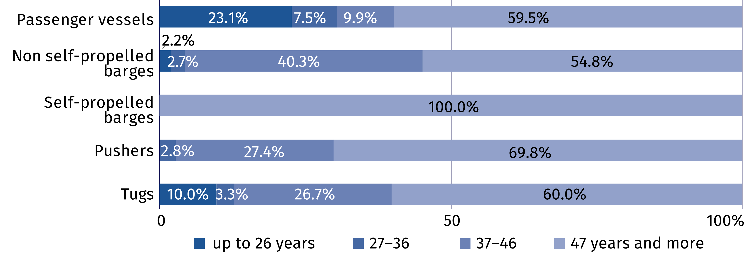

Inland waterways carriages
In 2025, the share of inland
waterways transport in the
total transport of goods amounted to 0.07%
In 2025, the volume of goods transported by inland waterways amounted to 1,672.0 thousand tonnes, while with a transport performance amounted to 364.5 million tonne-kilometres,
representing decreases of 0.1% and 5.3%, respectively, compared with the previous year.
Although the total volume of goods transported and transport performance were lower than in the previous year, quarterly trends varied. In the first quarter, the volume of goods transported increased by 27.9% and transport performance by 3.6%, compared with the corresponding period of the previous year. The largest decrease in the volume of goods transported occurred in the second quarter (by 15.7%), while the largest decrease in transport performance occurred in the fourth quarter (by 12.1%).

Chart 4. Inland waterways transport of goods by quarters

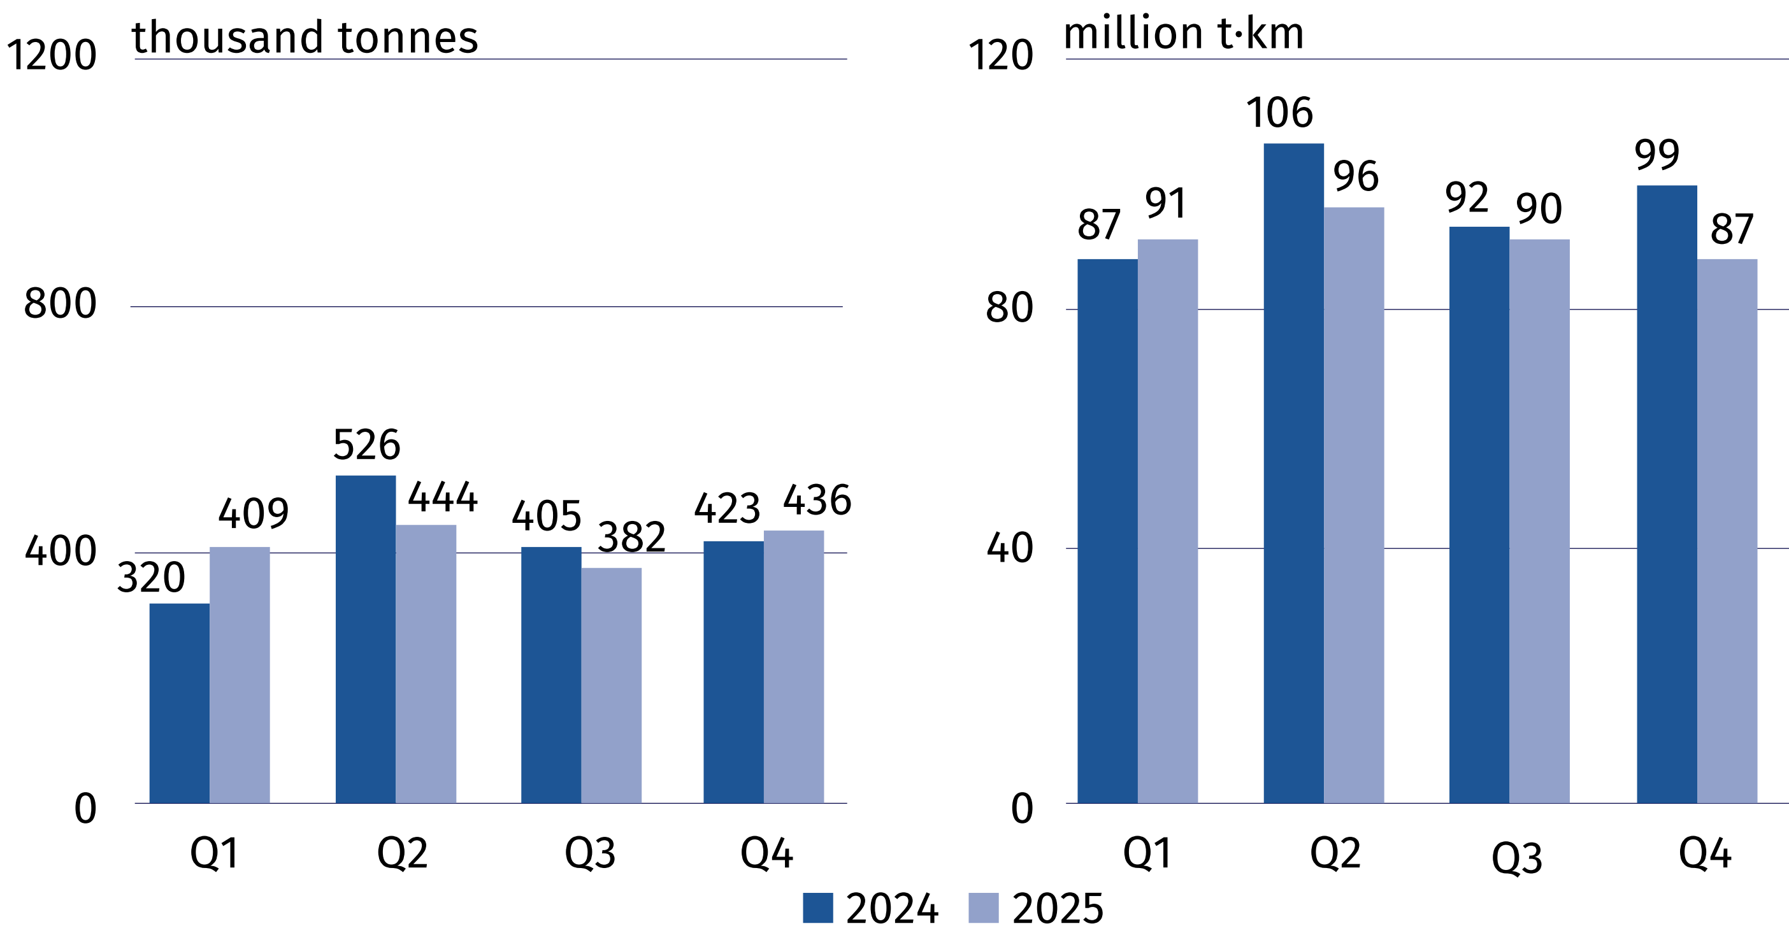
In 2025, the average distance per tonne of cargo increased
in national and international transport
The average distance per tonne of goods carried in international transport amounted
to 317.2 km (compared with 307.7 km in 2024) while national amounted 40.2 km (compared with 33.2 km in 2024).
In 2025, international transport accounted for the largest share of the total volume of goods transported by Polish inland waterway operators, with a share of 64.2% of the total volume of goods transported. Compared with the previous year, the volume of transport between foreign ports decreased by 4.1%. Nevertheless, it continued to account for the largest share of international transport, representing 85.7% of its total volume in 2025 (increased of 5.7 percentage points). Exported and imported goods decreased by 39.3% and 10.3%. Germany was the only destination for exports transported by inland waterways. Compared with the previous year, the volume of goods transported in national transport increased by 26.1%
(to 598.8 thousand tonnes), while transport performance increased by 52.5% (to 24.1 million tonne-kilometres).
Chart 5. Structure of inland waterways transport of goods by directions in 2025 and changes compared to the previous year
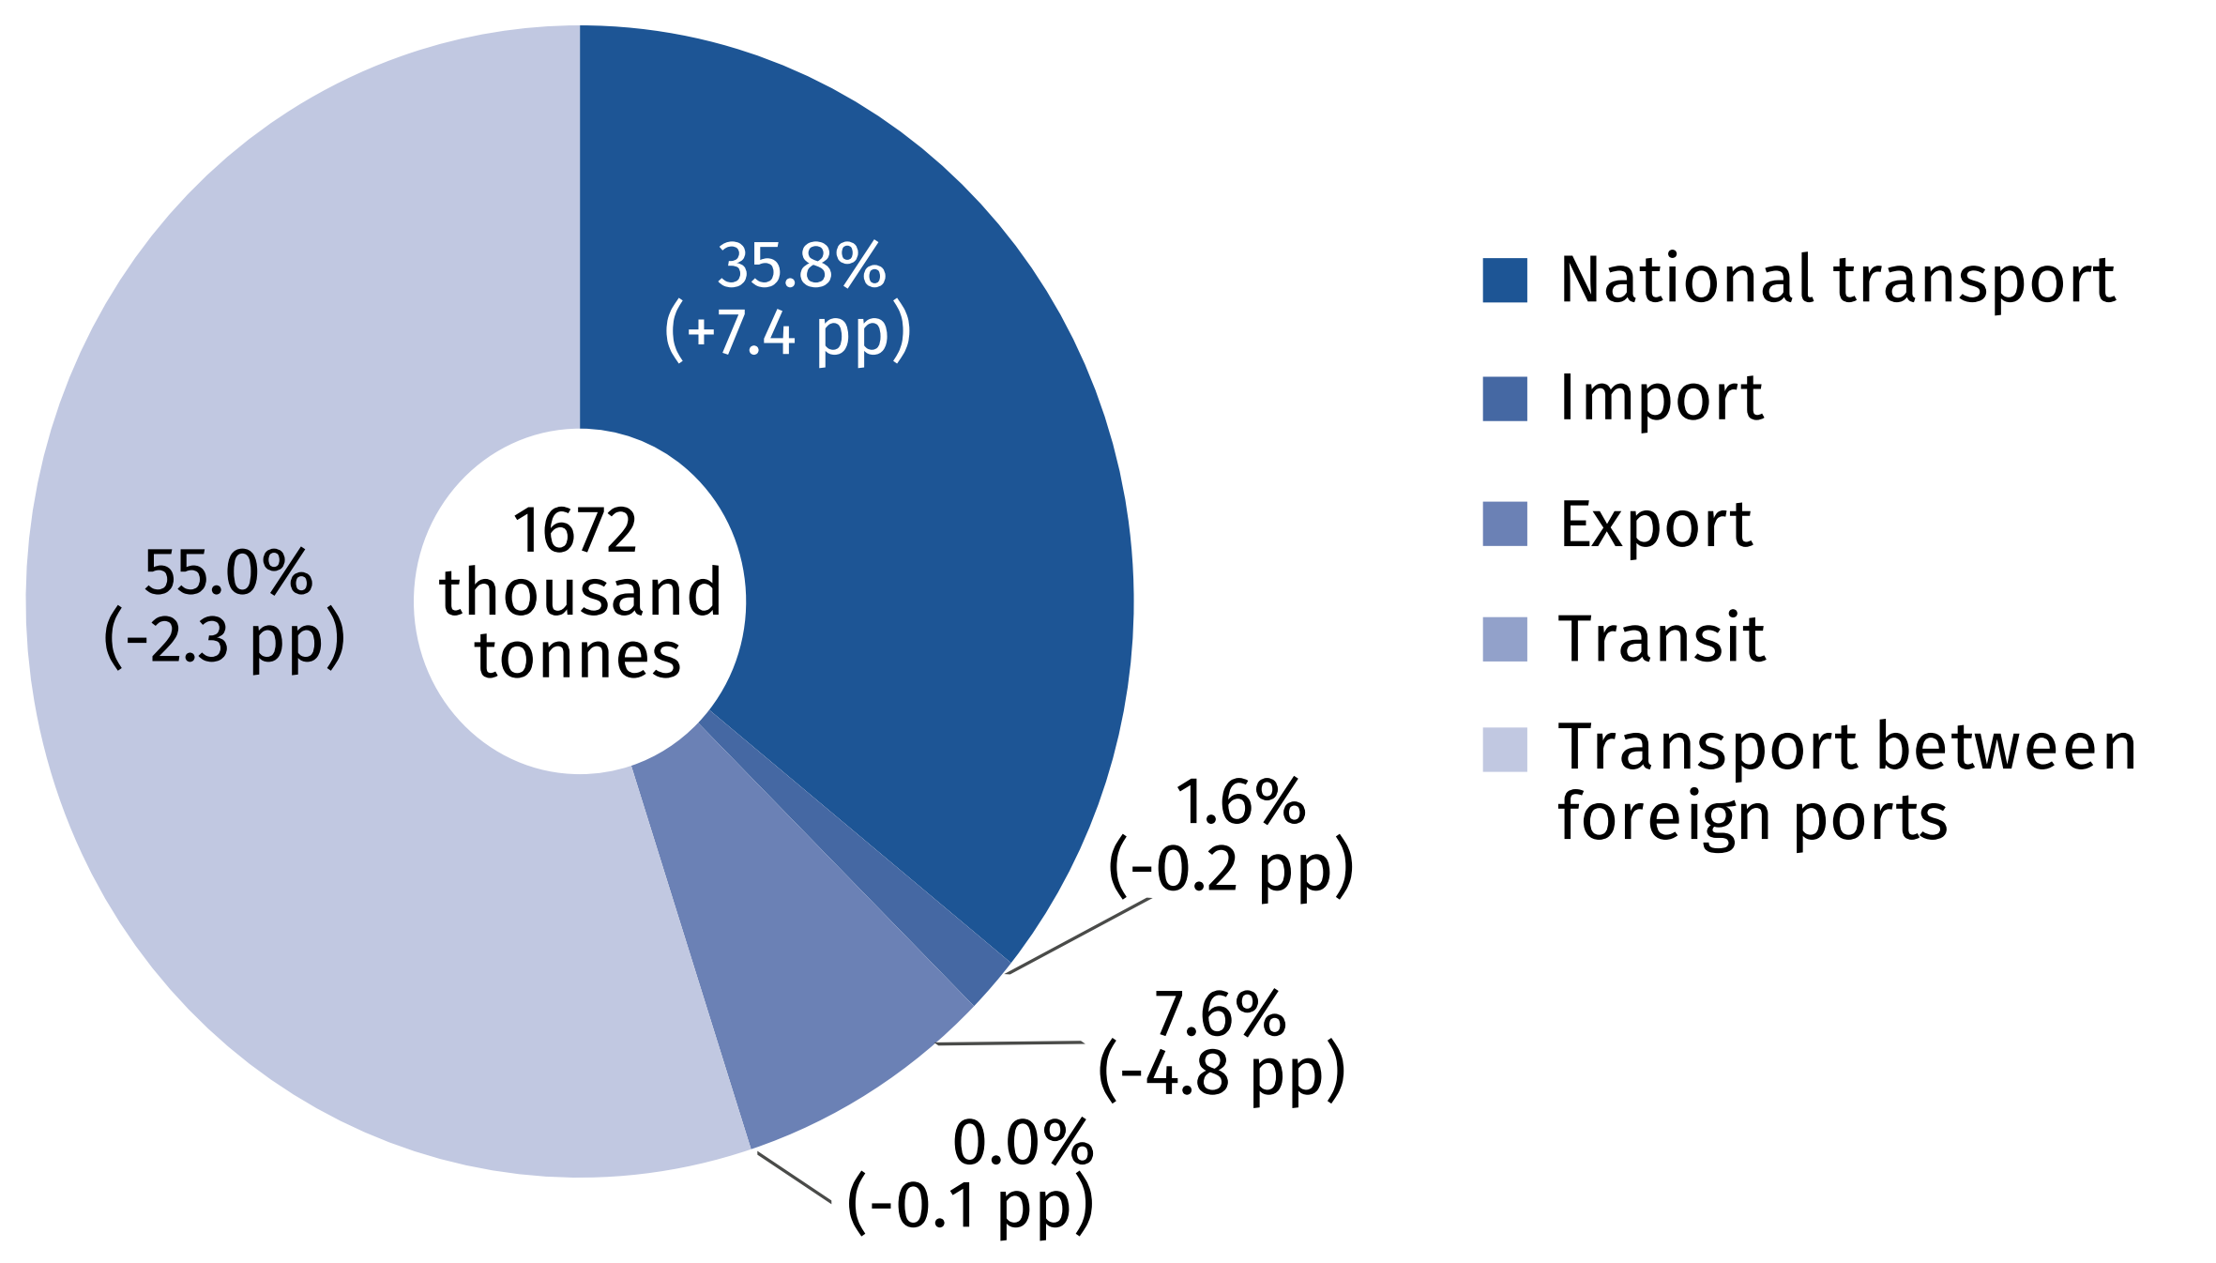

Similarly to the previous years, the structure of goods transported in 2025 was dominated
by metal ores and other mining and quarrying products, peat; uranium and thorium (41.7%). The next largest group was products of agriculture, hunting, and forestry; fish and other
fishing products (21.5%).

Chart 6. Structure of inland waterways transport by main group of goods in 2025
and changes compared to the previous year

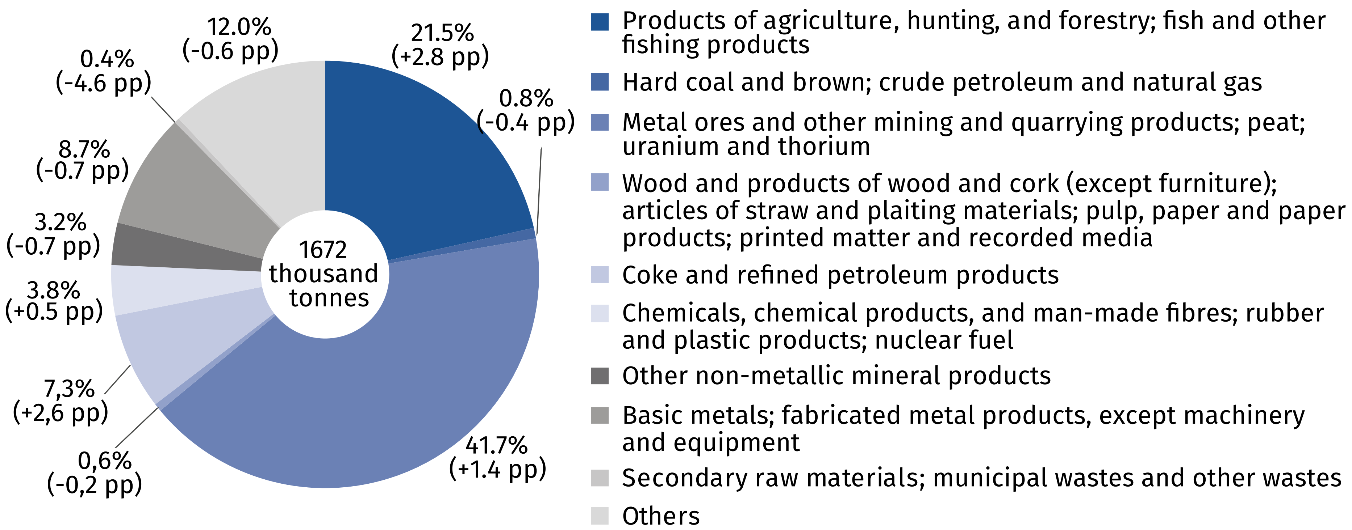
In comparison to 2024, the number of inland waterways passenger decreased by 8.1%
In 2025, 121 inland waterway passenger vessels operating tourist services carried a total
of 1,007.6 thousand passengers, with a transport performance amounting to 12,558.4 thousand passenger-kilometers. Compared to the previous year, the number of passengers transported decreased (by 8.1%) while transport performance increased (by 6.2%).
Table 1. Inland waterways transport of passengers
Specification | 2024 | 2025
Number of passenger seats | 9,871 | 11,501
Number of passengers | 1,096,890 | 1,007,575
Number of passenger-kilometres | 11,830,725 | 12,558,439
Average distance travelled, per 1 passenger  in km | 11 | 12

Inland waterway transport remains one of the safest modes of transportation. In 2025, three accidents were recorded in the navigation registers maintained by the competent inland
waterways authorities, none of which involved the transport of dangerous goods.

When quoting Statistics Poland data, please provide the information: “Source of data: Statistics Poland”, and when publishing calculations made on data published by Statistics Poland, please include the following disclaimer: “Own study based on figures from Statistics Poland”.

Prepared by:  Statistical Office in Szczecin  Director Magdalena Wegner  Phone: (+48 91) 459 77 00 | Issued by:  Press Office  Mobile: (+48) 695 255 032  Phone: (+48 22) 608 38 04, (+48 22) 449 41 45,  (+48 22) 608 30 09  e-mail: obslugaprasowa@stat.gov.pl

stat.gov.pl/en/

@StatPoland

@GlownyUrzadStatystyczny

@gus_stat

@GłównyUrządStatystycznyGUS

@Glówny Urząd Statystyczny
Related information
Inland water transport in Poland in 2024
Inland waterways transport in Poland in 2022-2023
Transport – activity results in 2024
Data available in databases
Knowledge Databases (DBW) – Economy – Maritime and inland economy
Terms used inn official statistics
Inland waterways
Inland waterways transport fleet
Tugs fleet
Barges fleet
Inland waterways transport of goods
International inland waterways transport of goods
Inland waterways transport of passengers
Tonne-kilometres by inland waterways
Passenger-kilometres by inland waterways

Classification of inland waterways accepted by the European Economic Commission of the UN and ECMT in 1992.

