Health care expenditure in 2023-2025

This statistical release presents data on health expenditure from two distinct analytical perspectives:
- National Health Accounts for 2023–2025 provide a comprehensive analysis of all current health expenditure incurred by public sector, businesses, and households.
The accounts are compiled by Statistics Poland (GUS) using an internationally recognised methodology that enables cross-country comparisons.,
- Public Expenditure on Health Care in 2025 is statistical summary on public expenditure on health care prepared by the Ministry of Health with the support of Statistics Poland. It presents both current and capital expenditure incurred in accordance with Article 131c of the Act on Health Care Services Financed from Public Funds. However, it does not include expenditure by local government units.
National Health Account for 2023-2025

According to preliminary estimates, national current expenditure on health care in 2025 amounted to PLN 348.0 billion, representing
8.9% of gross domestic product. Compared
to 2024, they increased by PLN 60.4 billion,
i.e. by 21.0%. Expenditures from the compulsory contributory health insurance system had the highest dynamics (an increase of PLN 42.3 billion,
this is 24.6%).
21.0%
Estimated increase in current health expenditure in 2025 compared to 2024

According to preliminary estimates, current health expenditure (public and private) in Poland amounted to PLN 348.0 billion in 2025, accounting for 8.9% of the preliminarily estimated gross domestic product (GDP). A comparison of this last figure with the relevant indicator representing for 26 European OECD countries, as well as with selected countries representing the highest and lowest levels of health expenditure as a share of GDP and those closer to the OECD average, indicates a relatively strong increase in the value of health care services and medical goods consumed in Poland in recent years.
Until 2021, current health expenditure in Poland fluctuated between 6.3% and 6.5% of GDP, placing the country among the two to five lowest-ranking of the 26 European OECD countries and more than 2 percentage points below the average for this group.

During the COVID-19 pandemic (2020-2022), health expenditure increased in many countries, whereas in Poland it remained at a comparatively low level. A marked increase in current health expenditure has been observed in Poland in three years.
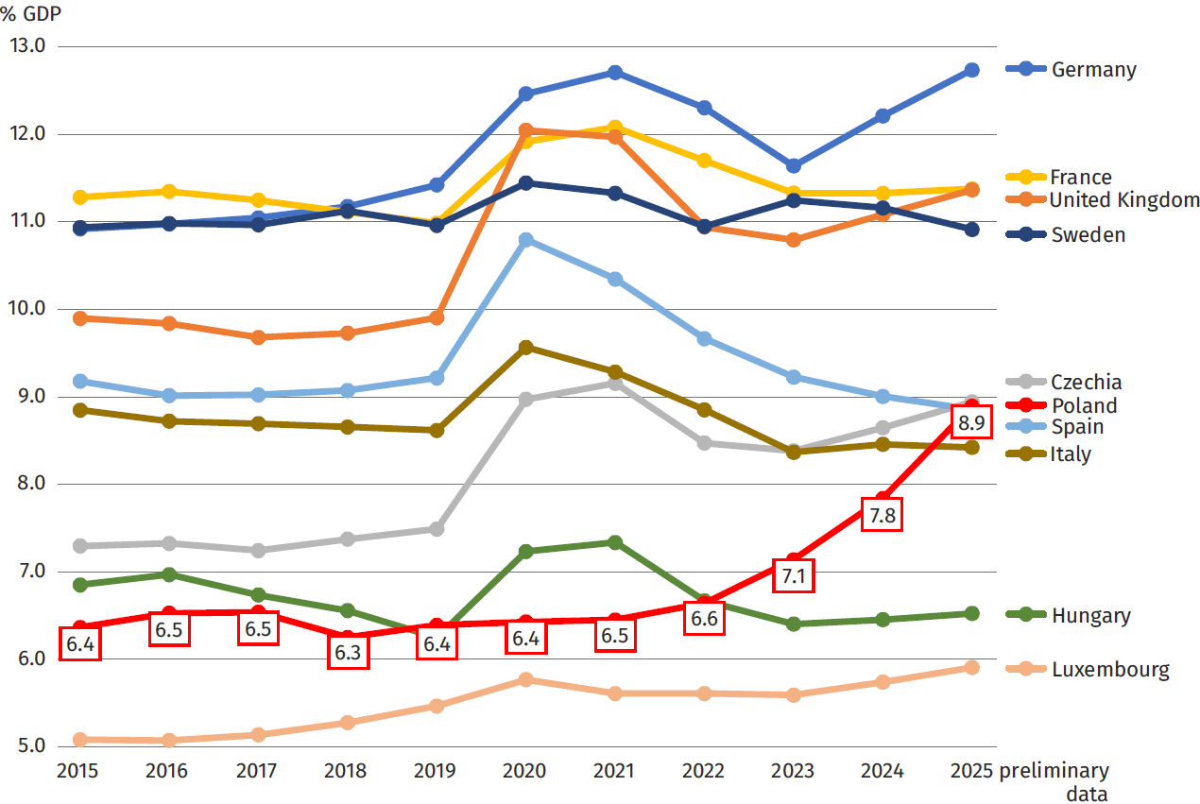
Chart 1. Current expenditure on health care in selected European OECD countries
Based on OECD Data Explorer (https://data-explorer.oecd.org/); accessed on 27.07.2026.
If the preliminary estimates are confirmed, current health expenditure as a share of GDP
in Poland would be only 0.5 percentage points below the average for the European OECD countries. This would bring Poland closer to countries such as the Czech Republic, Spain
and Italy in terms of the share of current health expenditure in GDP.
Current expenditure on health care 2013-2025
Chart 1 shows that an increase in national current expenditure on health care in relation to GDP was associated with a very dynamic increase in these expenditures expressed in PLN.
Between 2015 and 2025, this expenditure (in current prices) increased by 130.9% or more than 2 times.
National current expenditure on health increased by 202.1% between 2015 and 2025.
Taking into account preliminary data for 2024 and preliminary estimates for 2025, current health expenditure increased by 202.1%, or more than 3 times, between 2015 and 2025.
The largest year-on-year increases were recorded between 2022 and 2025 (by 19.9%, 18.4%, 18.0%, 21.0%, respectively). However, it should be taken into account that 2022 and 2023 saw the highest inflation in last 20 years (an increase in the prices of consumer goods and services by 14.4% and 11.4%, respectively).
Chart 2. National current expenditure on health care
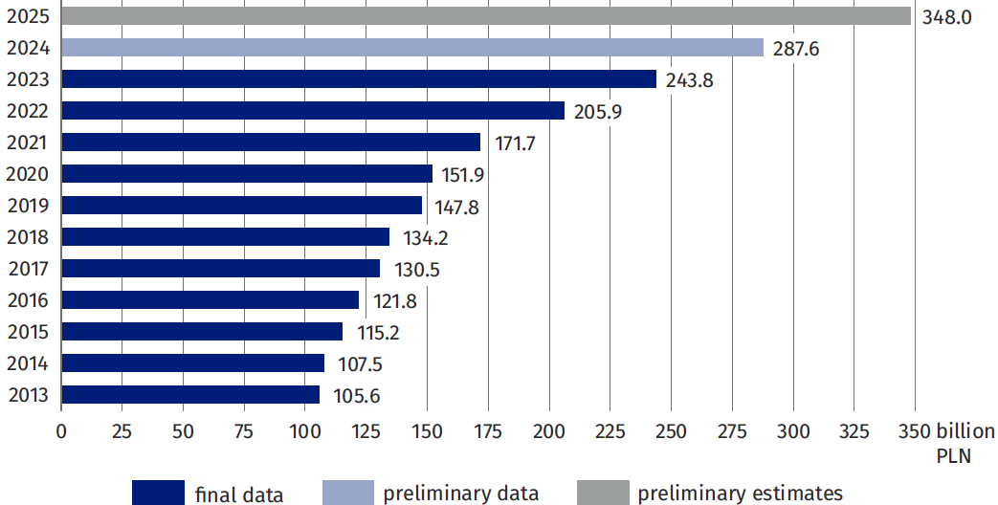
Main components of national expenditure on health in relation to GDP
In 2025, public current spending on healthcare reached 271.8 billion PLN, which is 50.6 billion PLN more than in 2024 (an increase of 16.9%).
The largest share of national current expenditure on health care is held by the public sector, whose expenditure incurred in 2025 was initially estimated at PLN 271.8 billion, i.e. PLN 50.6 billion more than in 2024. The value of public expenditure on health care in relation to GDP reached 6.9%, i.e. 0.9% p.p. more than in the previous year.
The largest component of public health care spending were transfers from compulsory health insurance schemes which have been estimated at PLN 214.2 billion, i.e. 5.5% in relation to GDP (4.7% in 2024). Funding in 2025 from compulsory health insurance year-on-year increased by 24.6%, which is more dynamic than national current expenditure on health care (21.0%). The rest of public expenditure on health care was financed by the government
and local self-government sector in the total amount estimated at PLN 57.6 billion, which corresponded to 1.5% of GDP. This share of public health expenditure increased by 16.9% compared to 2024.
Table 1. Current expenditures on health care and their share in GDP

Specification |  | 2023 |  | 2024  (preliminary data) ^{c} |  | 2025  (preliminary estimate)
 |  | in PLN million | %  GDP | in PLN million | %  GDP | in PLN million | %  GDP
Financing  scheme | Gross domestic product ª | 3 415 274 | 100 | 3 669 531 | 100 | 3 912 673 | 100
HF.1+HF.2+  HF.3 | Total current expenditure on health care ^{b} | 243 798.9 | 7.1 | 287 565.5 | 7.8 | 348 009.9 | 8.9
HF.1 | Public expenditure | 189 109.8 | 5.5 | 221 187.8 | 6.0 | 271 801.7 | 6.9
HF.1.1 | Government schemes | 26 752.7 | 0.8 | 49 268.1 | 1.3 | 57 569.9 | 1.5
HF.1.2 | Compulsory contributory health insurance schemes | 162 357.1 | 4.8 | 171 919.6 | 4.7 | 214 231.8 | 5.5
HF.2+HF.3 | Private expenditure | 54 689.1 | 1.6 | 66 377.7 | 1.8 | 76 208.2 | 1.9
HF.3 | of which household  out-of-pocket expenditure | 38 633.2 | 1.1 | 47 640.5 | 1.3 | 54 743.1 | 1.4
ª Source: CSO data: Macroeconomic indicators (https://stat.gov.pl/macroeconomic indicators/) – update 17.04.2026.
^{b} The sum of all public and private spendings; the total numbers given in this row may differ slightly (in the first decimal place) from the result of adding the components listed in the table, due to rounding of the source data).
^{c} See p. 1 footnote 3.
Current expenditures on health care by funding schemes
In 2024, public sector
spendings on health care
accounted for 76.9% of total current health care expenditure, with most of it (59.8%) going to mandatory health insurance systems.
The structure of current expenditure on health care by financing schemes (HF) continued to be dominated by public expenditure, which accounted for 76.9% in 2024, compared with 77.6% in 2023. Within public expenditure, the vast majority was financed through compulsory health insurance schemes; however, its share declined substantially in the last year, from 66.6% in 2023 to 59.8% in 2024. Correspondingly, the role of government schemes increased, from 11.0% in 2023 to 17.1% in 2024. Household out-of-pocket payments (16.6%) and voluntary health insurance schemes (4.7%) also accounted for a significant share.

Chart 3. Current expenditures on health care by financing schemes
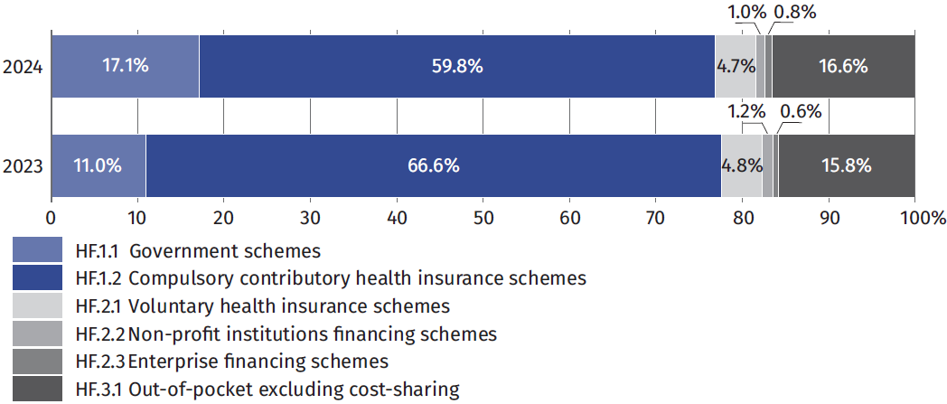
Current expenditures on healthcare by function
In 2024, spending on medical services made up the largest share of current health care expenditures (60.2%). Coming in second were costs for purchasing medicines and other medical products (16.7%), and third were expenses for long-term care (8.4%).
In the structure of current expenditure on health according to the classification of functions (HC), the dominant position in 2024 was medical services, which accounted for 60.2% of total current expenditure. Expenditure on medicines and other medical products came second (16.7%) and expenditure on long-term care came third (8.4%).

Chart 4. Current expenditures on health care by functions
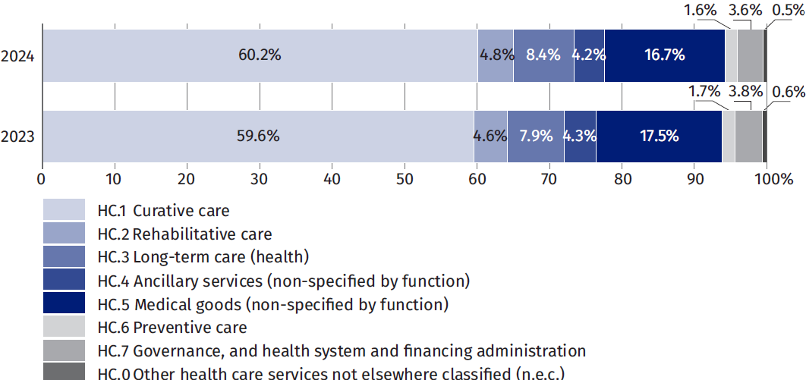
Current expenditures on healthcare by type of healthcare provider
In 2024, the biggest chunk of health care spending went to hospitals (42.4%). The second largest group of providers in terms of costs were outpatient medical facilities (26.6%), and third were pharmacies and other medical goods suppliers (16.1%).
In 2024, as part of the classification of healthcare providers (HP), the largest expenditure stream went to hospitals and accounted for 42.4% of national current expenditure on healthcare (43.5% in 2023). The second most cost-intensive type of healthcare provider was outpatient healthcare providers (26.6%), followed by pharmacies and other providers of medical goods (16.1%).
Chart 5. Current expenditures on health care by providers
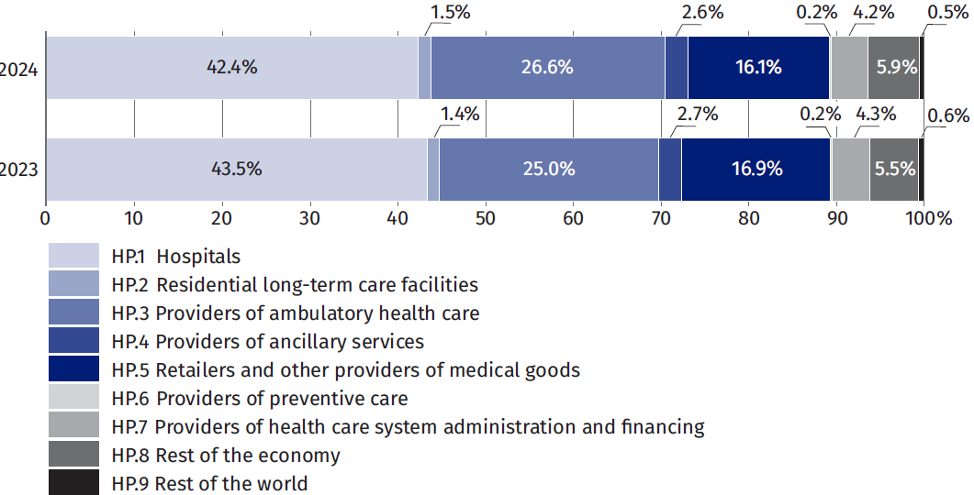
Public expenditure on health care in 2025
In accordance with Article 131c of the Act of 27 August 2004 on publicly funded health care services, funds of not less than 6.50% of GDP should be used to finance public health care in 2025. Therefore, expenditure on financing health care in 2025 is planned at PLN 221.7 billion (i.e. 6.52% of GDP), while the implementation of the plan amounted to PLN 232.2 billion (i.e. 6.81% of GDP).
10.3%
Increase in public expenditure on health in 2025 compared to 2024
In 2025, public expenditure
on health care increased
by PLN 21.6 billion, i.e.
by 10.3%.
While implementing the assumptions of the Act on health care services financed from public funds (hereinafter referred to as the Act), the budget act for 2025 and the corresponding draft financial plan of the National Health Fund (NHF) planned funds of PLN 222.3 billion for health care, which were additionally increased during 2025, and their final implementation amounted to PLN 232.2 billion, representing 6.81% of GDP (from year N-2). As a result, the public expenditure on health protection referred to in the Act in 2025 was PLN 21.6 billion higher (10.3%) than the corresponding expenditure incurred in 2024.
Table 2. Public expenditures on health and their share of GDP ^{b}
Year | GDP N-2  accordance  the Law | GDP  for the year  current (N) ^{a, c} | Plan ^{b} |  | Implementation
Year | in billion PLN |  |  | % of GDP  N-2 | in billions  PLN | % of GDP  N-2 ^{b} | % of GDP  N ^{c}
2024 | 3 078.3 | 3 641.2 | 193.3 | 6.28 | 210.6 | 6.84 | 5.79
2025 | 3 410.1 | 3 912.7 | 222.3 | 6.52 | 232.2 | 6.81 | 5.93

ª The year covered by the health expenditure data (Plan and Implementation) is marked with letter N.
^{b} According to Art. 2 of the Publicly Funded Healthcare Benefits Act, for 2024 expenditure the reference point is the 2022 GDP and for 2025 the reference point is the 2023 GDP.
^{c} Source: Assumptions for the 2024 Budget Act – Ministry of Finance – Gov.pl portal and Assumptions for the 2025 Budget Act – Ministry of Finance – Gov.pl website.

Public expenditure on health care by categories specified in the Act
The structure of expenditure on health care by categories resulting from the Act on health care services financed from public funds shows that the largest share was accounted for by the costs of the National Health Fund (77.1%), while the second largest share was accounted for by budget expenditures financed from the part managed by the minister competent for health (19.9%). Compared to 2024, it can be seen that the share of NHF costs decreased by
5.5 percentage points and was replaced by an increased share of budget funds at the disposal of the Minister of Health (an increase of 5.7 percentage points).
Table 3. Structure of expenditures on health care by categories resulting from the Act
In 2025, the implementation of budget expenditure financed from the part managed by the minister responsible for health was PLN 16.3 billion (54.6%) higher than in 2024,
and their share in the total expenditures specified in the Act on health care services financed from public funds increased from 14.2% to 19.9%.
No. | Categories according to the Act on health care services financed from public funds | 2024 |  |  | 2025
No. |  | plan ª | Implementation |  | plan ª | Implementation
No. |  | million PLN | million PLN | structure of inputs in %^{b} | million PLN | million PLN | structure of inputs in %^{b}
I | Budgetary expenditure in the part of the state budget held by the minister responsible for health | 28 563 | 29 842 | 14.18 | 37 182 | 46 129 | 19.87
II | Expenditure on the budget of European funds  under Healthcare | 649 | 568 | 0.27 | 842 | 523 | 0.23
III | Budgetary expenditure of ‘Healthcare’ in other parts of the State budget | 6 962 | 5 589 | 2.65 | 7 033 | 6 031 | 2.60
IV | Costs of the National Health Fund included in the financial plan of the Fund excluding funds from the Medical Fund transferred to the Fund | 156 546 | 174 021 ^{b} | 82.61 | 176 504 | 178 867 ^{c} | 77.05
V | Costs of the Medical Studies Loan Fund included in the Fund’s financial plan | 0 | 0 | 0.00 | 0 | 0 | 0.00
VI | Costs included in the financial plan of the Immunisation Compensation Fund | 4 | 0.09 | 0.00 | 3 | 0.07 | 0.00
VII | Costs included in the financial plan of the Gambling Resolution Fund | 12 | 23 | 0.01 | 13 | 11 | 0.00
VIII | Write-off for the Agency for Health Technology Assessment and Tariffs in question  in Article 31t para. Laws 5-9 included in the Fund’s financial plan | 82 | 82 | 0.04 | 84 | 0 | 0.00
IX | Copy for the Medical Research Agency,  referred to in Article 97 para. 3e, captured  the Financial Plan of the Fund | 460 | 460 | 0.22 | 520 | 520 | 0.22
X | Costs included in the annual financial plan of the Clinical Trials Compensation Fund | 7 | 7 | 0.00 | 7 | 0 | 0.00
XI | Write-off for the Medical Events Compensation Fund included in the Fund’s financial plan | 0 | 31 | 0.01 | 69 | 43 | 0.02
XII | Budgetary expenditure in the part of the state budget held by the Patients’ Rights Ombudsman (part 66, division 750) | 27 | 27 | 0.01 | 38 | 35 | 0.02
TOTAL ^{d} |  | 193 312 | 210 650 | 100 | 222 295 | 232 159 | 100
ª According to the Budget Act.
^{b} Including PLN 747 million from the Aid Fund.
^{c} Including PLN 765 million from the Aid Fund.
^{d} The totals in the columns are calculated on rounded values.
The third largest item among public expenditures on health protection indicated in the Act were budget expenditures falling within the competence of holders other than the minister competent for health (e.g. the minister competent for internal affairs or the minister competent for national defence). Such expenditure accounted for 2.6% of public health expenditure.
Chart 6. Structure of outlays in health care expenditures by categories resulting from the Act
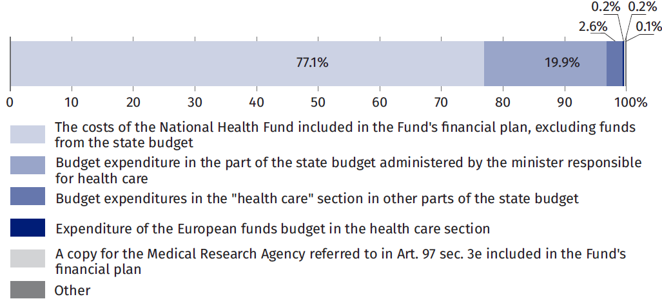
Public health expenditure 2015-2025
There has been a steady increase in health spending between 2015 and 2025.
There has been a steady increase in health spending between 2015 and 2025. This applies both to annual expenditure plans under the Act and to their implementation, which has almost always been greater than the plan. Between 2015 and 2025, health expenditures as planned increased by 197.6%, while implementation increased by 200.8%. The largest annual increase in health expenditure by implementation was recorded in 2023, by 22.4%.
Chart 7. Public expenditure on health care
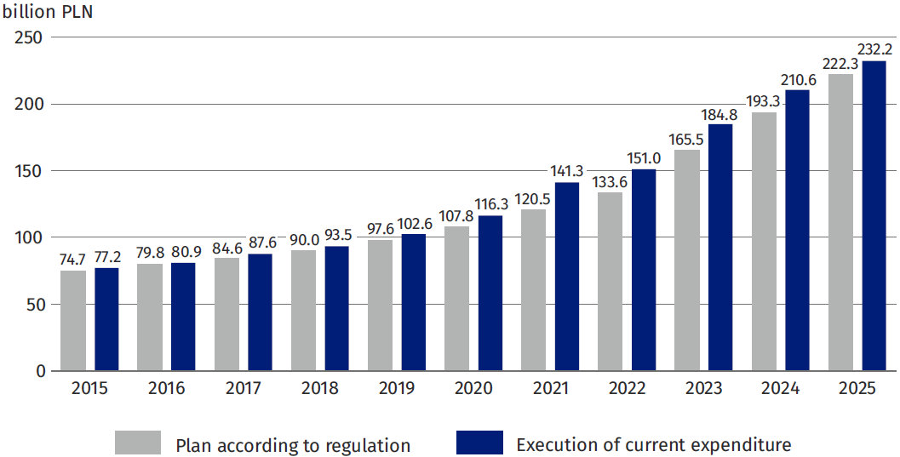
Summary
Regardless of the broader or narrower scope of the analysis – according to national current expenditure included in the National Health Account or only in the scope of public expenditure listed in Article 131c of the Act on health care services financed from public funds – there has been a continuous and relatively large increase in health care expenditure over the last dozen or so years.
The time series of national current health expenditures (public and private) showed an increase of more than 202% between 2015 and 2025, and these public health expenditures increased by more than 200% over the same period.
The increase in public spending on healthcare as a percentage of GDP was driven by the indicators set out in the law, which were supposed to gradually rise by 1.64 percentage points over the last six years, starting in 2019 from 4.86% of GDP. The target set in the law for 2025 of 6.50% of GDP was more than met, reaching 6.81%, as the actual costs of the public healthcare system turned out to be higher than planned, once again.
At the same time, in 2025, the total current spending on healthcare (both public and private) reached – according to the estimated data of the National Health Account – 348 billion PLN, which corresponded to 8.9% of GDP. A significant increase in this indicator was noted: over the past 3 years, it went up by 2.3 percentage points.
If the preliminary data and estimates for 2024 and 2025 hold true, it would mean that current spending on healthcare as a share of GDP in Poland would be only 0.5 percentage points lower than the average for European OECD countries, and at the same time, the value of medical services and products consumed in Poland relative to GDP would be close to the level seen in countries like the Czech Republic, Spain, or Italy.

Methodological notes
Method of estimating the National Health Account
The results of selected indicators of the National Health Account (NHA) presented in this signal information were developed in accordance with the international standard for the collection and analysis of health care expenditures known as the System of Health Accounts (SHA 2011). The aim is a comprehensive and internationally comparable analysis of the value and financial flows associated with the consumption of health care goods and services. Due to the lengthy, multi-month process of preparing and verifying the final data, they are preceded by preliminary data and even earlier preliminary estimates, which, when published, are accompanied by appropriate warnings about significant corrections that may still take place. It is also worth emphasizing that even after obtaining the status of final data, the results may be subject to further updates resulting from changes in the methodology (so-called revisions).
Statistics Poland (GUS) prepared the National Health Account for the first time in 2015 with data covering also 2014 and 2013.
NHA is compiled according to the International Classification for Health Accounts (ICHA) and included in four tables (HCxHF, HPxHF, HCxHP and HFxFS), which are transmitted, including preliminary estimates and methodological notes, to the OECD, Eurostat and WHO in the form of a Joint Health Accounts Questionnaire.
Health expenditure is classified according to the following breakdowns: HF – funding schemes, HC – health functions and HP – health care providers. An additional cross-section of the FS describes the types of revenues under funding schemes.
The sources of information for NHA in the field of public expenditure (HF.1), consisting of government and compulsory contributory health insurance systems, are mainly administrative systems of institutions (FA - financing agents, i.e. payers), which collect data on health care expenditure. These are the Ministry of Health, the National Health Fund, the Social Insurance Institution, the Agricultural Social Insurance Fund, the Ministry of the Interior and Administration, the Ministry of National Defence, the Ministry of Justice, the Ministry of Family, Labour and Social Policy and the State Fund for the Rehabilitation of the Disabled. Data from the Financial Supervision Commission, the National Health Fund, the Social Insurance Institution and the Agricultural Social Insurance Fund, as well as the results of other surveys carried out within the framework of the programme of statistical surveys of official statistics, such as surveys of enterprises, non-commercial entities and surveys of household budgets and other available sources of information, are used to estimate non-public expenditure, including expenditure incurred by private sector operators (HF.2) and households (HF.3).
As health systems around the world evolve, their organisational structures and funding systems are changing. makes it necessary to constantly adapt the methodology of health accounts, both at international level (subsequent revisions of the SHA), as well as to adapt this methodology to national conditions (NHA). Internationally, the substantive supervision over the modernization of the methodology is carried out by a team of experts composed of representatives of: Eurostat, OECD and WHO – IHAT (International Health Account Team).
The National Health Account shall be drawn up each year for the year T-2. In addition, GUS is also preparing preliminary estimates for the previous year (T-1). In the current edition of the National Health Account, the forecasting method based on the trend model was used for the first time to estimate expenditure for the previous year. The expenditure forecast for 2025 is based on data from 2013-2024.
Statistics Poland submits preliminary data for the year T-1 for verification by the international team, and only after all doubts have been clarified, preliminary data for that year can be published as preliminary data. The data will become final in the following year, i.e. after the completion of fundamental GDP adjustments and in the accounting of the budgets of the main institutions financing health expenditure.
Current expenditure on health care, refers to the current data on the value of GDP generated at the date of preparation of this signal information and refers to the value of GDP for the same year.
Methodology for compiling data presented in Public Expenditure on Health in 2025
The methodology for calculating expenditure on health care is set out in Article 131c of the Act of 27 August 2004 on health care services financed from public funds (consolidated text: Journal of Laws of 2004, No. Journal of Laws of 2025, item 1461, as amended) and is not related to the SHA 2011 methodology, according to which the National Health Account is being compiled.
In accordance with the provisions of the Act, financial resources of not less than 7% of GDP are allocated annually to financing health care, with the proviso that the amount of public expenditure allocated to financing health care in 2018-2026 may not be lower than:
1) 4.86%of gross domestic product in 2019
2) 5.03% of gross domestic product in 2020
3.) 5.30% of gross domestic product in 2021
4) 5.75% of gross domestic product in 2022.
5) 6.00% of gross domestic product in 2023.
6) 6.20% of gross domestic product in 2024.
7) 6.50% of gross domestic product in 2025.
8) 6.80% of gross domestic product in 2026.
The above limits, in accordance with paragraph. 4 Article 131c of this Act shall be taken into account by the Council of Ministers in draft budget laws or draft provisional budget laws.
The method of calculating the percentage of the value of public expenditure on health care in relation to the value of gross domestic product is indicated in Art. 2 of the Act, according to which the value of GDP specified in the notice of the President of the Statistics Poland
issued pursuant to Article 5 of the Act of 26 October 2000 on the method of calculating the value of annual gross domestic product, as at 31 August, is used to calculate this indicator. This notice shall be issued by 15 May of the relevant year for the previous year. Thus, when planning expenditure on health care for the following year, in accordance with the Act, the Council of Ministers in draft budget laws or draft budget provisional acts prepared for year N takes into account the value of GDP that is available for year N-2.
The Act on Publicly Funded Healthcare Benefits (Article 131c, para. 3), defines a strict catalogue of expenses or costs that are included in public expenditure on health care. This catalogue includes:
1) budget expenditures in the part of the state budget held by the minister competent for health;
2) budgetary expenditure under the heading "health care" in other parts of the state budget;
3) costs of the National Health Fund included in the financial plan of the Fund, excluding funds from the Medical Fund transferred to the Fund;
4) a copy for the Agency for Health Technology Assessment and Tariffs referred to in Article 31t para. 5-9, included in the financial plan of the Fund;
5) the costs of the Medical Studies Credit Fund included in the financial plan of this
the Fund;
6) costs included in the financial plan of the Gambling Resolution Fund referred to in Article 88 of the Gambling Act of 19 November 2009;
7) a copy for the Medical Research Agency referred to in Art. 3e, included in the plan
the financial strength of the Fund;
8) costs included in the financial plan of the Immunisation Compensation Fund referred to in Art. 1 of the Act of 5 December 2008 on the prevention and control of infections and infectious diseases in humans;
9) costs included in the annual financial plan of the Clinical Trials Compensation Fund referred to in Art. 5 of the Act of 9 March 2023 on clinical trials on medicinal products for human use (Journal of Laws, item 605);
10) write-off for the Compensation Fund referred to in Article 97 para. 3i and 3j;
11) budget expenditures in the part of the state budget held by the Patients' Rights Ombudsman
– after excluding planned transfers of funds received from the sources referred to in points 1 to 11.

When quoting Statistics Poland data, please provide the information: “Source of data: Statistics Poland”, and when publishing calculations made on data published by Statistics Poland, please include the following disclaimer: “Own study based on Charts from Statistics Poland”.

Prepared by:  Social Research Department  Director  Izabela Grabowska, PhD  Tel: 22 608 31 22 | Issued by:  Press Office  Mobile: (+48) 695 255 032  Phone: (+48 22) 608 38 04, (+48 22) 449 41 45,  (+48 22) 608 30 09  e-mail: obslugaprasowa@stat.gov.pl

stat.gov.pl/en/

@StatPoland

@GlownyUrzadStatystyczny

@gus_stat

@GłównyUrządStatystycznyGUS

@Glówny Urząd Statystyczny
Related information
Health and healthcare in 2024
Announcement of the President of Statistic Poland on the NHA for 2023
SHA Manual 2011
Commission Regulation (EU) 2021/1901
Data available in databases
OECD database
Terms used in official statistics
Inpatient health care
Hospital
Health
Healthcare facility

OECD, Eurostat and World Health Organization (2017), A System of Health Accounts 2011: Revised edition, OECD Publishing, Paris. http://dx.doi.org/10.1787/9789264270985-en
Types of public expenditure listed in Article 131c of the Act of 27.08. 2004 on health care services financed from public funds (Journal of Laws of 2025, item 1461, as amended) are described in the Methodological Notes at the end of the text.
Source: https://stat.gov.pl/macroeconomic indicators/; Update 17.04.2026
The preliminary results of the National Health Account for 2024 (the final results will be published on 30 September 2026 in the form of a Notice of the President of the Central Statistical Office) correspond to the data provided to Eurostat, OECD and WHO under the Joint Health Accounts Questionnaire.
Stat.gov.pl - Thematic areas - Prices. Trade - Price indices - Consumer price indices (pot. inflation) - Annual consumer price indices since 1950 (https://stat.gov.pl/thematic areas/price-trade/price-indicators/price-indicators-of-goods-and-consumer-services-pot-inflation-/annual-price-indicators-of-goods-and-consumer-services/)
Due to the preliminary nature of the estimates for 2025, a comparison of the composition of expenditure is presented for 2023-2024.
Chapter developed by the Ministry of Health in cooperation with the Statistics Poland on the basis of data from the Ministry of Health.
The catalogue of types of public expenditure is set out in Article 131c para. 3 of the Act on Publicly Funded Health Care Benefits (Journal of Laws No. Journal of Laws of 2025, item 1461, as amended).
The value specified in the announcement of the President of the Statistics Poland of 12 May 2026 on the first estimate of the value of gross domestic product in 2025.
The letter N indicates the current year, and N-2 indicates the year two years earlier. In accordance with Art. 2 of the Publicly Funded Healthcare Benefits Act, for 2024 expenditure the reference point is GDP in 2022 and for 2025 GDP in 2023.
Amounts after the amendment of the 2024 budget law.
Amounts after the amendment of the 2024 budget law.
Art. 131c sec. 4 of the Act on Health Care Services Funded from Public Funds (Journal of Laws of 2025, item 1461, as amended).
This indicator shows the public expenditure listed in Art. 3 of the Publicly Funded Healthcare Benefits Act in relation to GDP for the year N-2, where N is the year for which expenditure was calculated.
NHA calculates a percentage of the value of current expenditure on health care in relation to the value of GDP, both of which relate to the same year.
Data on the value of GDP are subject to change in accordance with the revision policy applied in national accounts.

