Higher education in Mazowieckie Voivodship in the
2025/26 academic year
As of 31 December 2025, 287.8 thousand persons were studying at Masovian higher education institutions, 0.1% less than a year earlier. In 2025, 65.6 thousand graduates received their diplomas (13.7% more than in 2024). 110.9 thousand students were enrolled in postgraduate studies, and 5.3 thousand were enrolled in doctoral schools.
0.1%
Decrease in the numer of students compared to the 2024/25 academic year
According to the POL-on register, in the 2025/26 academic year, there were 88 higher education institutions operating in Mazowieckie Voivodship (345 in Poland). This report presents data from 77 HEIs which submitted statistical reports (328 in Poland).
There were 21 public and 56 private higher education instiutions in Mazowieckie Voivodship
Students
Between the 2015/16 and 2019/20 academic years, the number of students systematically decreased from 280.7 thousand to 247.5 thousand, before beginning to increase until the 2024/25 academic year, when it reached 288.0 thousand. It is worth noting that the decline in student numbers affected public higher education institutions (from 188.2 thousand in the 2015/2016 academic year to 138.4 thousand in 2023/24). During the same period, private higher education institutions recorded an increase in student enrollment from 92.6 thousand to 147.1 thousand. Starting in the 2024/25 academic year, this trend has reversed. At the end of December 2025, 287.8 thousand students were enrolled in higher education institutions, with public institutions outnumbering private ones (148.4 thousand versus 139.4 thousand). Persons studying at Masovian higher education institutions constituted 21.8% of students in the country.
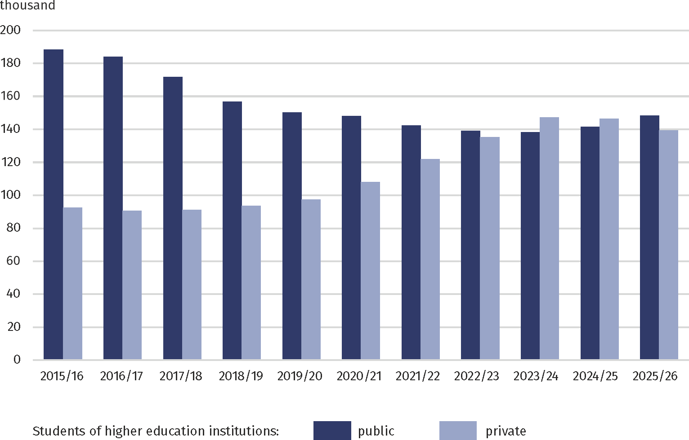
Chart 1. Studentsª of public and private higher education institutions
a As of 31 December.
Compared to the previous academic year, the number of students at higher education institutions located in Mazowieckie Voivodship was lower by 0.1%, at public and private higher education institutions by 4.8% more and by 4.8% less, respectively.
Chart 2 Students ª of higher education institutions
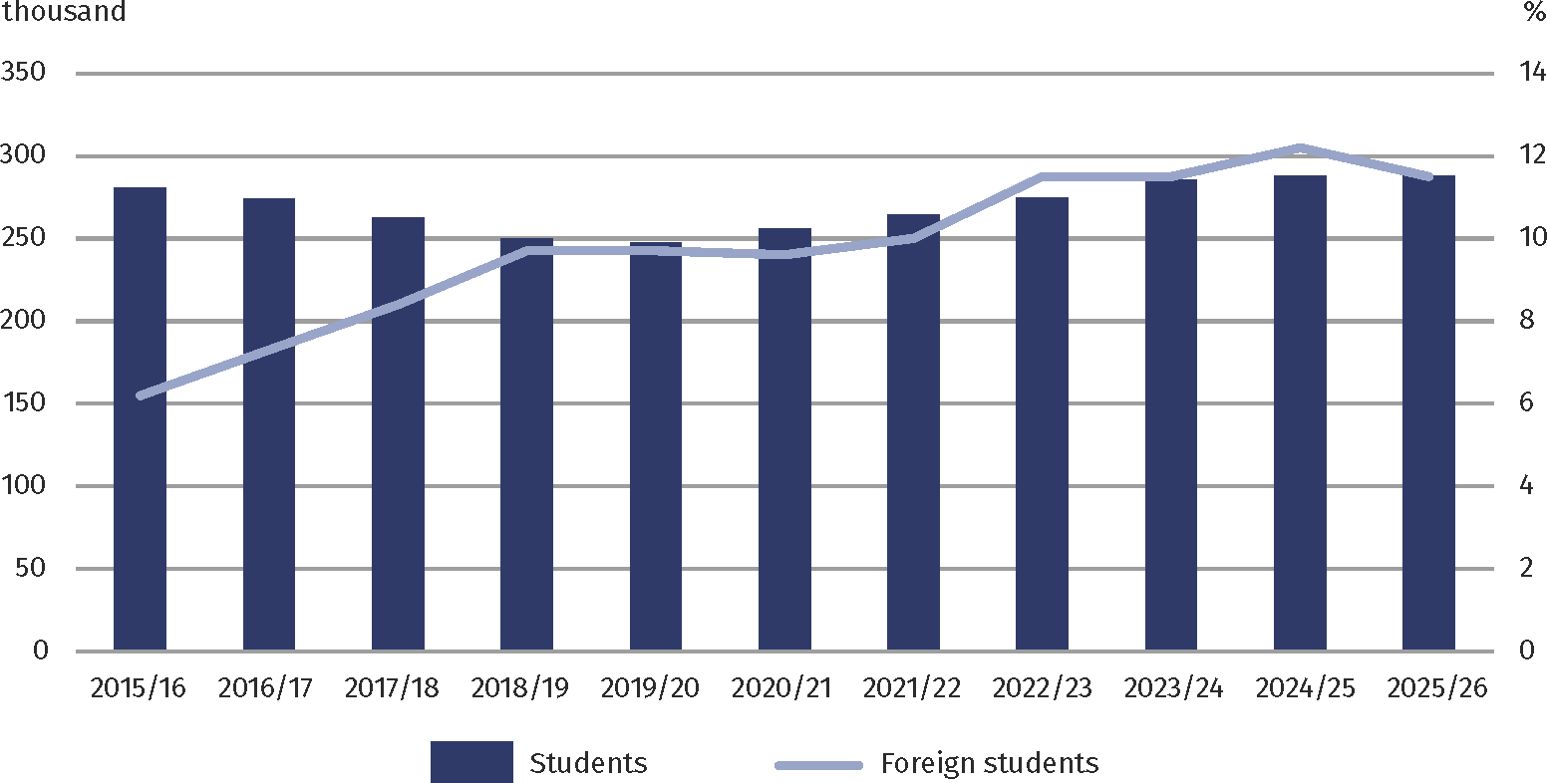
a As of 31 December.
First-year students constituted 25.2% of all students in the Voivodship
In the 2025/26 academic year, the percentage of women among all students was 57.1%. Full-time programmes were chosen by 166.8 thousand students, and part-time programmes by 121.0 thousand. First-cycle programmes (engineering and bachelor's degrees) comprised 155.0 thousand students (53.9%), while second-cycle programmes comprised 58.6 thousand students (20.4%). Long-cycle master's degree programmes were chosen by 24.8% of students.
The most frequently chosen groups of fields of study included: Business, administration and law, which were studied by 23.4% of all students, Social sciences, journalism and information (20.6%), Health and welfare (11.0%) and Engineering, industry, construction (10.3%).
The percentage of foreigners at Masovian HEIs in the academic year 2025/26 was 11.5%
In the 2025/26 academic year, a total of 33.0 thousand foreigners (32.5% of all foreign students in the country) enrolled at HEIs in Mazowieckie Voivodship, compared to 35.1 thousand in the 2024/25 academic year and 17.4 thousand in 2015/16. Their share in the total number of students was 11.5%, which was 0.7 pp lower than a year earlier and 5.3 pp higher than 10 years earlier. The largest groups were from Ukraine (36.8% of all foreigners), Belarus (11.7%), and Turkey (9.0%).
Table 1. Students and graduates of higher education institutions in the 2025/26 academic year
58.0% of students were studying full-time
Specification | Total | Of which  women | Of total numer in
Specification | Total | Of which  women | full-time programmes | part-time programmes
Students ª | 287763 | 164197 | 166804 | 120959
of which foreigners | 33029 | 15988 | 28021 | 5008
In first-cycle programmes | 157924 | 78763 | 101533 | 56391
of which with bachelor’s degree | 108461 | 65031 | 67127 | 41334
Second-cycle programmes | 58615 | 34405 | 27573 | 31042
Long-cycle master's degree programmes | 71224 | 51029 | 37698 | 33526
Graduates ^{b} | 65643 | 39885 | 36662 | 28981
of which foreigners | 7217 | 3948 | 6192 | 1025
a As of 31 December. b Graduates who obtained higher education diplomas in the period from 1 January to 31 December 2025.
The largest academic centre in the Voivodship and in Poland is m.st. Warszawa, home to 59 higher education institutions, including the largest in the country in terms of student enrollment – ​​the University of Warsaw. As of 31 December 2025, 260.7 thousand students studied at HEIs located in Warszawa, representing 90.6% of all students in the Voivodship and 19.7% of the total national enrollment. One in eight students at the capital city's institutions was a foreigner. Outside the capital, other major academic centres in the Voivodship included Radom, Siedlce, and Płock, which together accounted for 6.8% of the voivodship's students.
Graduates
At universities with parent institutions located in Maszowieckie Voivodship, 65.6 thousand persons (21.4% of the total number of graduates nationwide) received their higher education diplomas between 1 January and 31 December 2025, including 33.2 thousand graduates from public HEIs. The number of graduates was 3.5% lower than in the 2015/16 academic year, but increased by 13.7% compared to the previous year.
36.7 thousand persons completed full-time programmes, i.e. 55.9% of graduates
Among the total number of graduates, the majority were those with first-cycle vocational degrees (51.0% of all graduates) and second-cycle degrees (33.1%). Graduates of long-cycle master's degree programmes constituted 15.9%.
Table 2. HEI graduates by broad fields of educationª in 2025
Specification | Total | Of which
Specification | Total | women | foreigners
Total | 65643 | 39885 | 7217
Education | 4851 | 3786 | 216
Arts and humanities | 6209 | 4464 | 664
Social sciences, journalism and information | 12513 | 8920 | 1363
Business, administration and law | 17210 | 9960 | 3115
Natural sciences, mathematics and statistics | 1446 | 818 | 58
Information and Communication Technologies (ICTs) | 3632 | 613 | 477
Engineering, manufacturing and construction | 6518 | 2463 | 378
Agriculture | 862 | 531 | 49
Health and welfare | 6780 | 5584 | 322
Services | 4612 | 2426 | 298
Individual inter-field studies | 1010 | 320 | 277
a According to the International Classification of Fields of Education (ISCED-F 2013).
Among those who completed higher education, the majority were graduates of fields related to business, administration and law (26.2%), followed by social sciences, journalism and information (19.1%) and health and welfare (10.3%).
In 2025, 58.8 thousand graduates left Warsaw higher education institutions, i.e. 89.6% of all graduates in the Voivodship and 19.2% in the country.
Postgraduate and doctoral studies
As of 31 December 2025, 110.9 thousand persons were enrolled in postgraduate studies in Mazowieckie Voivodship, which is 16.4% more than in the previous year. Their share nationally was 54.9%. Women accounted for 65.6% of the total number of postgraduate students.
Nearly two-thirds of postgraduate students were women
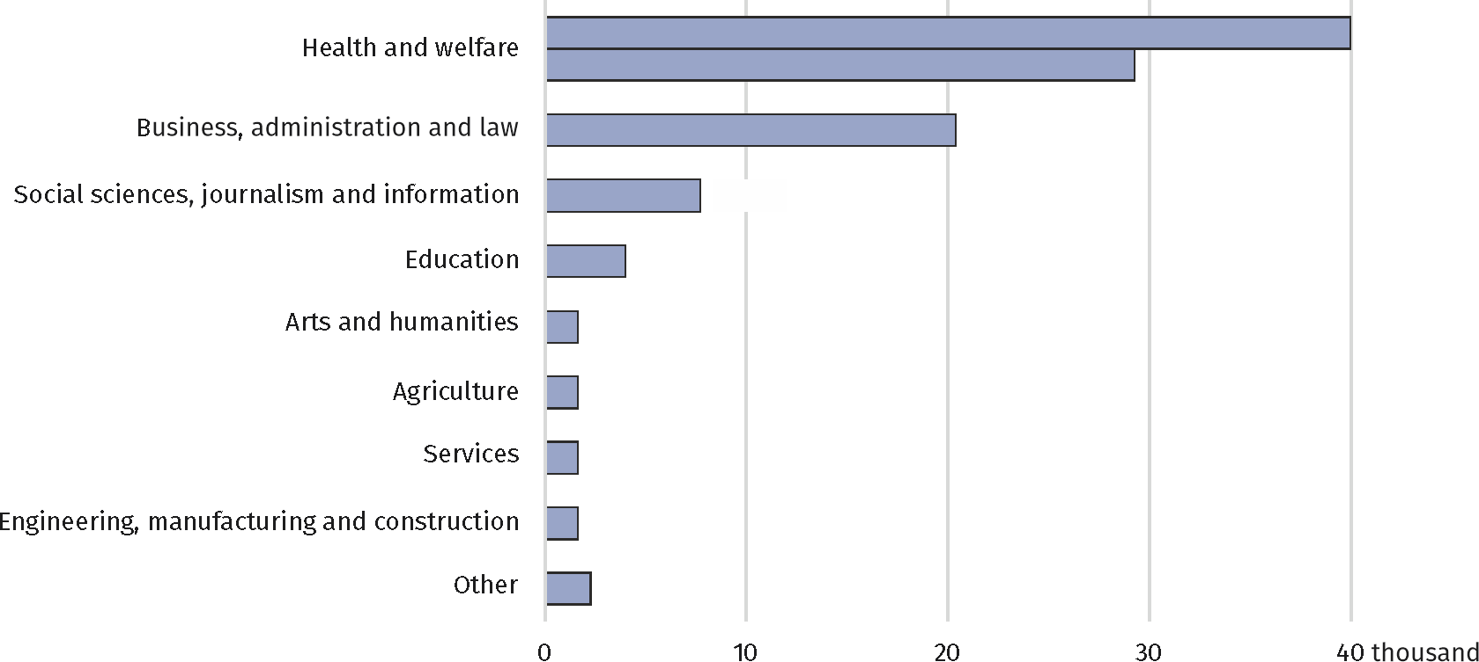
Chart 3. Participants of postgraduate studies by fields of educationª in the 2025/26 academic year

a According to the International Classification of Fields of Education (ISCED-F 2013).
In the 2024/25 academic year, 42.7 thousand students received certificates of completion of postgraduate studies (13.1% less than a year earlier), including 30.1 thousand women.
At the end of 2025, 5.3 thousand doctoral students were enrolled in doctoral schools, including 2.5 thousand women. In 2025, 398 prsons earned doctoral degrees, 46.7% of whom were women.
Methodological notes
Students and graduates by voivodships are presented according to the seat of higher education institutions together with their branches.
Students were counted as many times as the number of programmes they were enrolled in. If a graduate completed two or more programmes in the academic year, they were also counted multiple times.
Information on foreign students in total concerns foreign students planning to study in Poland for at least one academic year.
Participants in postgraduate studies and doctoral students were presented as many times as they completed the studies.

When quoting Statistics Poland data, please provide the information: "Source of data: Statistics Poland", and when publishing calculations made on data published by Statistics Poland, please include the following disclaimer: "Own study based on figures from Statistics Poland".

Prepared by:  Statistical Office in Warszawa  Director Agnieszka Ajdyn  Phone: (+48 22) 464 23 15 | Issued by:  Statistical Information Centre  Marcin Kałuski  Mobile: (+48) 783 940 141
Press office in the Statistical Office in Warszawa  Mobile: (+48) 783 940 141  e-mail: m.kaluski@stat.gov.pl |   warszawa.new.stat.gov.pl/en/

@Warszawa_STAT

@UrzadStatystycznywWarszawie

gus_stat

glownyurzadstatystycznygus

glownyurzadstatystyczny

Related information
Higher education and its finance in 2024
Higher education in the 2025/2026 academic year
Data available in databases
Local Data Bank – Higher education
Terms used in official statistics
Higher education student
Degree programmes
Full-time programmes
Part-time programmes
Non-degree postgraduate programmes
Doctoral student
Doctoral school

