Business services in 2023
In 2023 the turnover value of enterprises conducting activities related to business services amounted to PLN 705.7 billion. In comparison to the previous year, the increase in turnover with the simultaneous growth of the number of enterprises and persons employed were observed.
10.9%
Increase in turnover compared to 2022

Business services in 2023
The upward trend in the value of turnover, number of persons employed and enterprises conducting business services was maintained
In the analyzed year on the domestic market, there were more than 707 thousand enterprises which provided business services as their basic business activity. These entities constituted 25.8% (a growth of 1.0 pp in comparison to the previous year) out of over 2.7 million enterprises conducting business activities. As compared to the previous year, the number of enterprises providing business services increased by 6.4%, while total number of enterprises grew by 2.6%.
In 2023, more than 1.9 million persons were employed in the business service sector which constituted 16.6% of total persons employed in total enterprises² (an increase of 0.3 pp as compared to 2022). In comparison to the previous year, the number of persons employed in this sector increased by 1.8% compared to an increase of 0.1% in the number of persons employed in total enterprises².
Turnover of enterprises classified to service sector related to business support activities, reached in the analyzed year PLN 705.7 billion which constituted 8.3% of the total turnover of enterprises². As compared to the year before, the turnover value grew by 10.9% (a growth of 3.8% was recorded in total enterprises sector).
Among the enterprises providing business services, entities conducting business activity related to computer programming, consultancy and related activities were the most important in terms of turnover and in 2023 they generated 23.0% of turnover in the business services segment (share increased by 0.9 pp as compared to the previous year). Enterprises conducting activities related to real estate generated 20.2% of total turnover (share remained at the same level as compared to 2022) and 7.8% each for enterprises conducting management consultancy activities (a decrease of 0.5 pp as compared to 2022) and enterprises conducting architectural and engineering activities; technical testing and analysis (a decrease of 0.1 pp as compared to 2022).

Chart 1. Turnover structure in the sector of enterprises providing business activities by primary kind of activity in 2023
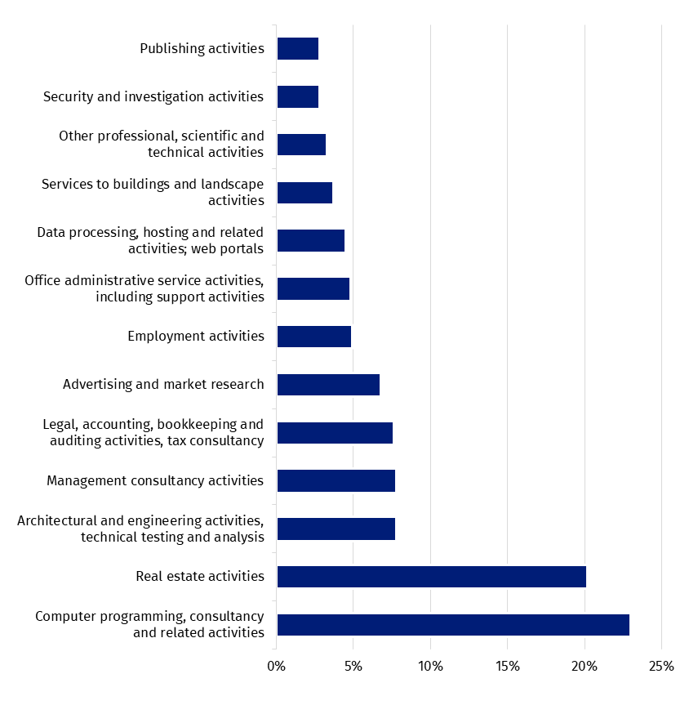In terms of the enterprises size, both in the analyzed year and in the year before, enterprises with the number of persons employed 9 and less constituted the most numerous group (98.0%; a share increase of 0.1 pp as compared to 2022). These entities employed 50.0% of the total number of persons employed in the business services sector (a share increase of 1.1 pp as compared to 2022) and generated 46.4 % of these enterprises’ turnover (a share decrease of 0.4 pp as compared to the previous year).
Entities with the number of persons employed 9 and less had the greatest importance in other professional, scientific and technical activities. In 2023, the share of entities with the number of persons employed 9 and less which declared this activity as the main in the total number of enterprises accounted for 99.4%. Simultaneously they gave jobs for 83.8% of total persons employed in this activity and achieved 74.5% of turnover generated by the whole population of these enterprises. For comparison, the share of enterprises with the number of persons employed 9 and less in security and investigation activity constituted 84.3% of all enterprises in this business. However 5.9% of total persons were employed in these entities whose turnover accounted for 12.2% of total turnover of this activity.

Chart 2. Structure of number of enterprises, number of persons employed and turnover in enterprises providing business activities by the enterprises’ size class determined by the number of persons employed in 2023
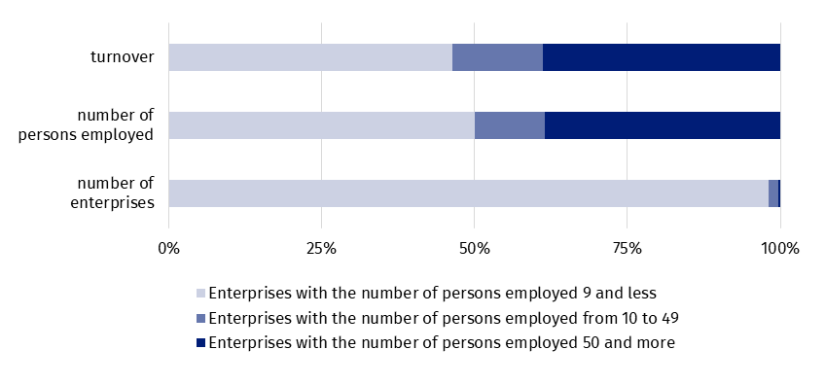Enterprises conducting activities included in the business services segment focused their activities mainly on the domestic market. In 2023, 57.8% of total turnover of entities with the number of persons employed 10 and more originated from providing services for entities with their registered offices in the Republic of Poland (a share increase of 0.2 pp). Transactions with consumers with their registered offices in the European Union Member States were the source of 21.0% of turnover (a share decrease of 0.6 pp) and for the remaining 21.2% - entities with their registered offices located outside EU.
In 2023, the value of services provided to non-residents by enterprises carried out business activities amounted to PLN 95.8 billion (an increase of 7.7% compared to the previous year) which accounted for 21.0% of total services provided to non-residents. While the value of services acquired from non-residents by these units amounted to PLN 25.8 billion (an increase of 16.4%) which accounted for 9.3% of total services acquired from non-residents.
The main trading partners in the international trade in services of enterprises carrying out business services in 2023 were – in the case of provided services to non-residents – entities located in the United States (21.3% of the services value; an increase of 0.2 pp compared to the previos year), while – in the case of acquired services from non-residents - entities located in Ireland (20.0% of the services value; an increase of 1.6 pp compared to the previous year).

Chart 3. Geographical structure of services provided and acquired in international trade by entities providing business services in 2023
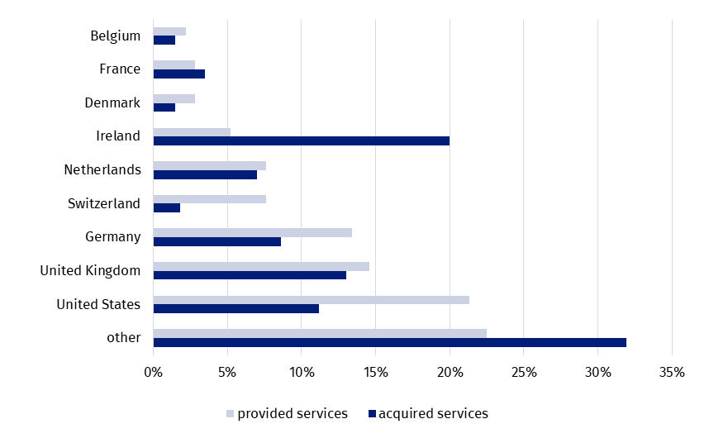The main source of revenues and expenditures from international trade in services of entities carrying out business services were computer services. Their share in the structure of services provided to non-residents³ accounted for 45.3% (an increase of 1.8 pp compared to year 2022), while acquired – 35.6% (an increase of 2.2 pp compared to the previous year).
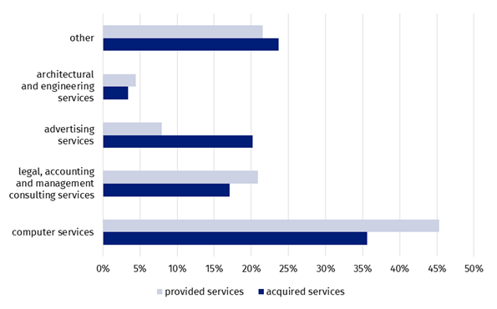
Chart 4. Structure of services provided and acquired in international trade by entities providing business services by kind of provided services in 2023

IT industry activities
In 2023, turnover generated by enterprises conducting IT activities amounted to PLN 203.4 billion (a growth of 16.3% compared to 2022) with a simultaneous increase in the number of enterprises of 13.9% to the level of 190.2 thousand and number of persons employed of 8.1% (446.6 thousand persons in 2023). The increase was observed in both the gross turnover profitability rate (from 7.6% in 2022 to 8.1% in 2023) and the net turnover profitability rate (from 5.7% in 2022 to 6.6% in 2023). Also the cost level indicator increased and amounted to 92.2% in 2023 against 92.7% in the previous year.
Increase of gross and net turnover profitability rates and cost level indicator of entities conducting IT activities was recorded
Entities with the number of persons employed 10 and more sold their services mainly on the domestic market with the value share of 47.0% of total turnover (a decrease of 1.1 pp in comparison with 2022). Transactions with residents of intra-EU countries accounted for 24.3% of total turnover (a decrease of 1.5 pp). The sale of computer programming services constituted the highest share in the total sale – 43.6% (a share increased by 1.3 pp compared to the previous year). The following positions in the structure of services sale value were taken by web portals with the share of 11.0% and other information technology and computer service activities with the share of 10.9%
In 2023, the value of services provided to non-residents³ amounted to PLN 56.2 billion (an increase of 12.3%), while the value of services acquired from non-residents – PLN 13.7 billion (an increase of 19.6%).
Entities located in the United States were the main trading partners in export of services (a share accounted for 26.5%) while entities located in Ireland were the main trading partners in import of services (a share was 19.7%). Computer services were the main sources of revenues and expenditures of these entities which was in line with their main activity (a share in the structure of provided services constituted 72.2%, while acquired – 52.6%).
Chart 5. Geographical structure of services provided and acquired in international trade by entities operating in the IT industry in 2023
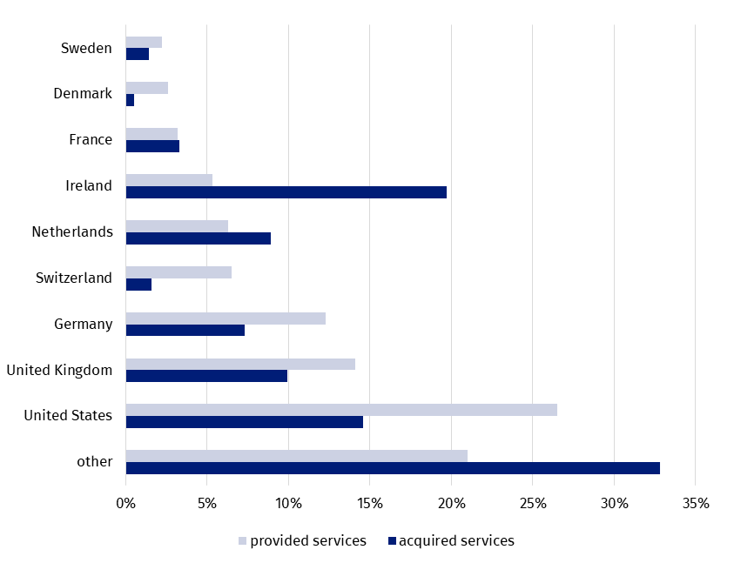

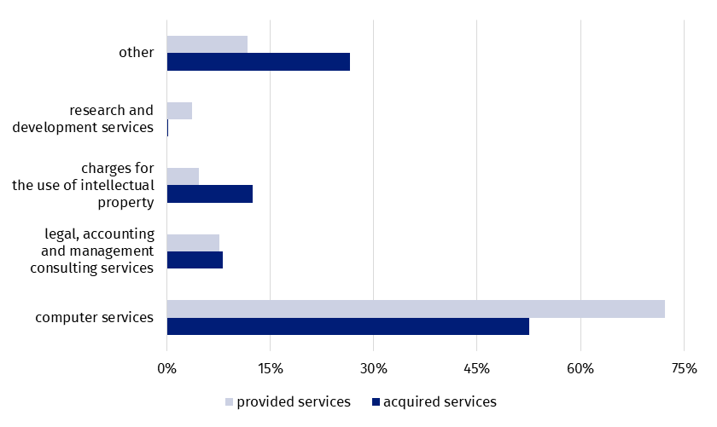
Chart 6. Structure of services provided and acquired in international trade by entities operating in the IT industry by kind of provided services in 2023

Legal, accounting and management consultancy activities
In the analyzed period, entities carrying out legal, accounting and management consultancy activities generated turnover at the level of PLN 108.8 billion (an increase of 8.8% compared to the year before). An increase in the number of enterprises by 3.4% was recorded while the number of persons employed increased by 0.1%. In 2023, almost 175 thousand enterprises were registered in which over 378 thousand persons were employed. A further decrease was observed in both the gross turnover profitability rate⁵ (from 13.3% in 2022 to 12.6% in 2023) and the net turnover profitability rate⁶ (from 11.6% in 2022 to 10.5% in 2023). The cost level indicator⁷ also decreased and accounted for 88.5% in 2023 compared to 87.8% in the previous year.
In 2023 the turnover share of entities with the number of persons employed 10 and more from the sale of services on the domestic market reached the level of 52.8% (an increase of 2.1 pp in comparison to the year before). An increase in the share of services sold to entities from EU countries was also recorded – from 21.7% in 2022 to 22.8% in 2023. Business and other management consulting services were the main kind of services offered to clients. Accounting services were the second category of services in terms of the turnover share size.
Turnover share of entities conducting legal, accounting and management consultancy activities related to the provision of services to entities located abroad increased by 2.1 pp
In 2023, entities carrying out legal, accounting and management consultancy activities provided to non-residents³ services of value of PLN 15.7 billion (an increase of 4.1%) and acquired from non-residents services worth more than PLN 3.4 billion (an increase of 3.6%).
Entities which had their registered offices in the United Kingdom were the main business partners in the international trade in services (a share in the structure of provided services accounted for 23.8%, while acquired – 21.1%). Legal, accounting, management consulting and public relations services were the main source of both revenues and expenditures, which was consistent with their basic business activity (a share in the structure of provided services accounted for 80.2%, while acquired – 50.6%).

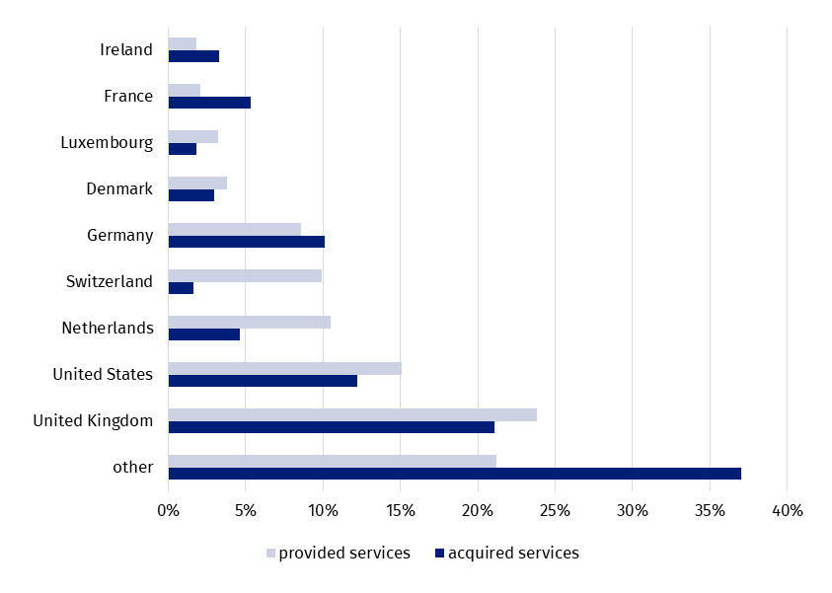
Chart 7. Geographical structure of services provided and acquired in international trade by entities conducting legal, accounting and management consultancy activities in 2023
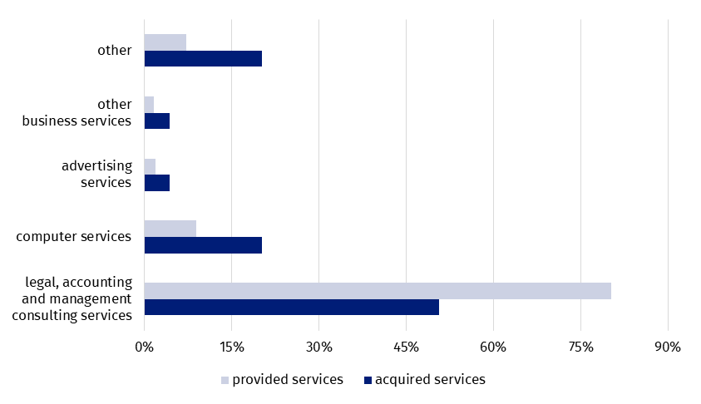
Chart 8. Structure of services provided and acquired in international trade by entities conducting legal, accounting and management consultancy activities by kind of provided services in 2023

Architectural and engineering activities; technical testing and analysis
Improvement of profitability rates of entities conducting architectural and engineering activities; technical testing and analysis while improvement of the cost level indicator
The turnover value of entities conducting architectural and engineering activities; technical testing and analysis, as compared to 2022, increased by 9.0% to the level almost of PLN 55.0 billion. The acivitie was conducted by 81.4 thousand entities (an increase of 4.2% in comparison to the year before) which provided workplaces for over 167 thousand persons (a decrease of 1.0% compared to 2022). An increase was observed both in the gross^{5, 9} and the net turnover profitability rate6^{6, 9}. The cost level indicator⁷ also slightly increased⁹.
Activity of providers of architectural and engineering services; technical testing and analysis focused on the domestic market. In the case of entities with the number of persons employed 10 and more the share of turnover from domestic sales accounted for 74.3% of total turnover (an increase of 5.4 pp in comparison to the previous year). The share of services provided to consumers from the EU Member States decreased by 2.4 pp to the level of 17.4%. The highest share of turnover achieved by these enterprises constituted engineering services - 44.5% (a decrease of 0.3 pp as compared to 2022), while technical testing and analysis services - 12.3%.
In the analyzed year, the value of services provided to non-residents³ in the international trade in services amounted to PLN 3.9 billion (a decrease of 12.5%), while they acquired from non-residents PLN 1.1 billion (a decrease of 3.8%).
Entities which had their registered offices in Germany were the main business partners in the international trade in services (shares in the structure of services provided and acquired constituted 25.8 % and 17.9% respectively). The highest share of international trade in services (in the case of both revenues and expenditures) were architectural, engineering, scientific and other technical services i.e. 69.6% of value of services provided to non-residents and 45.8% of value of services acquired from non-residents. The largest share in this group had engineering services, amounting to 78.7% for provided services and 75.7% for acquired services.
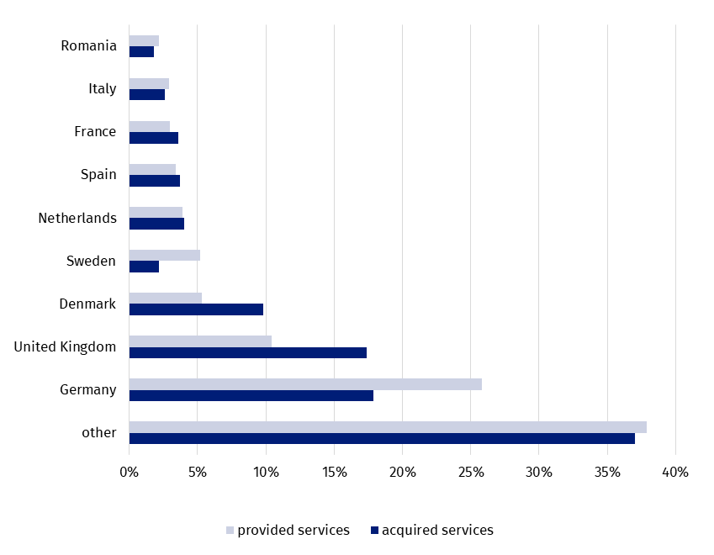
Chart 9. Geographical structure of services provided and acquired in the international trade by entities conducting architectural and engineering activities; technical testing and analysis in 2023

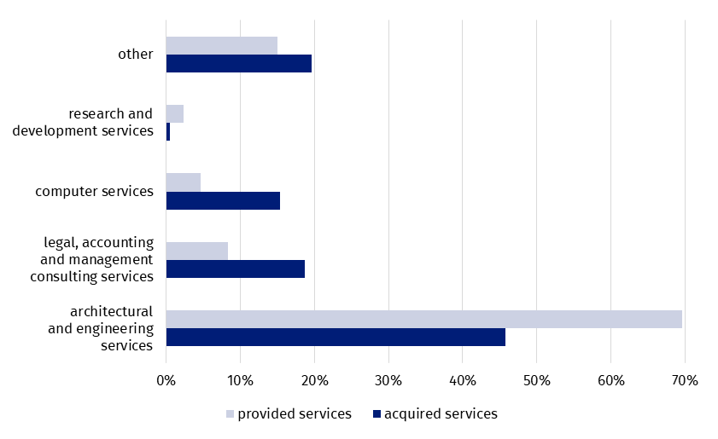
Chart 10. Structure of services provided and acquired in the international trade by entities conducting architectural and engineering activities; technical testing and analysis by kind of provided services in 2023

Advertising, market research and public opinion polling
In 2023, as compared to the year before, it was recorded an increase in turnover of 8.3% to PLN 48.3 billion. Advertising and market research activity was conducted by 39.5 thousand entities (an increase of 2.8% in comparison to the year before) which provided workplaces for over 84 thousand persons (an increase of 0.4% compared to 2022). A further decrease was recorded in both the gross^{5, 9} and the net turnover profitability rate^{6, 9}. While the cost level indicator⁷ slightly increased against the previous year⁹.
Entities with the number of persons employed 10 and more focused their basic activity mainly on the domestic market. The value share of services sold to domestic customers accounted for 77.6% of total turnover (an increase of 2.5 pp as compared to the year before). The share of services provided to clients from the EU Member States decreased by 0.4 pp to the level of 12.8%. Services provided by advertising agencies and media representation services and sale of advertising space or time on a fee or contract basis were the main kinds of services delivered to contractors⁹.
In 2023, sale of advertising and market research services focused mainly on the domestic market
In 2023, the value of services provided to non-residents³ by entities conducting advertising, market research and public opinion polling services amounted to PLN 6.7 billion (an increase of 4.6%) and they acquired from non-residents services worth PLN 3.7 billion (an increase of 22.2%).
Entities conducting advertising and market research activities provided their services mainly to contractors from the United States (19.3%), while the highest services value was acquired from Ireland⁹ . Advertising, market research and public opinion polling constituted the main source of both revenues and expenditures of these entities (a share in the structure of provided services accounted for 70.0%, while acquired – 69.0%).

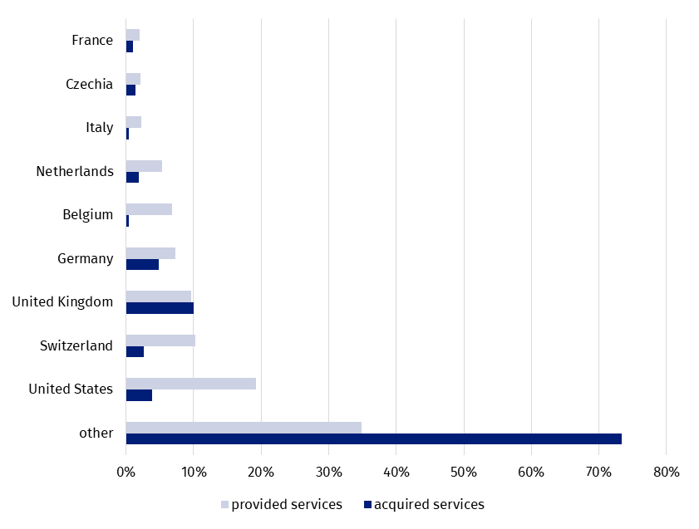
Chart 11. Geographical structure of services provided and acquired in the international trade by entities conducting advertising and market research activities in 2023

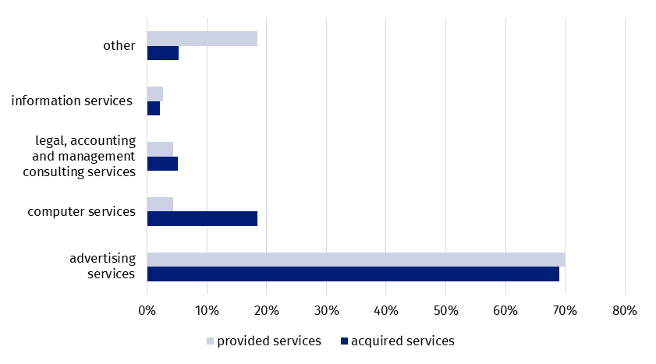
Chart 12. Structure of services provided and acquired in the international trade by entities conducting advertising and market research activities by kind of provided services in 2023

Employment activities
Turnover value generated by entities conducting employment activities amounted to PLN 34.6 billion in 2023 and as compared to the year before it increased by 7.9% with simultaneous growth in the number of enterprises by 4.6% to the level of 8.2 thousand. The number of persons employed decreased by 4.1% to 146.7 thousand for this activity. A deterioration was observed in both the gross turnover profitability rate⁵ (from 4.7% in 2022 to 3.4% in 2023) and the net turnover profitability rate⁶ (from 3.9% in 2022 to 2.7% in 2023). The cost level indicator⁷ also decreased and amounted to 97.8% in 2023 against 96.8% in the year before.
In case of entities with the number of persons employed 10 and more than 81.2% of total turnover derived from sales on the domestic market (a decrease of 2.0 pp in comparison with the year before). The share of sales to contractors from EU Member States increased by 1.4 pp to the level of 14.5%. The highest share in sales i.e. 52.3% constituted temporary employment agency services (an increase of 1.1 pp in comparison with 2022). Other human resources provision services were the next most important type of provided services. Its share accounted for 22.9% and decreased by 3.5 pp as compared to the year before.
In the analyzed year, entities conducting employment activities provided to non-residents³ services worth PLN 3.5 billion (an increase of 4.7%) and acquired from non-residents services worth more than PLN 0.6 billion (a decrease of 0.1%).
Entities conducting employment activities provided their services mainly to contractors from Germany to (a share accounted for 42.1%) while the highest services value was acquired from United Kingdom (15.7% of the service value acquired by these entities from non-residents). In the case of revenues from the international trade in services, employment services provided by employment agencies constituted the most important share (66.7%). At the level time, these services acquired from non-residents accounted for 25.2%.
The enterprises having their headquarters in Germany were the main trading partners in the field of employment services
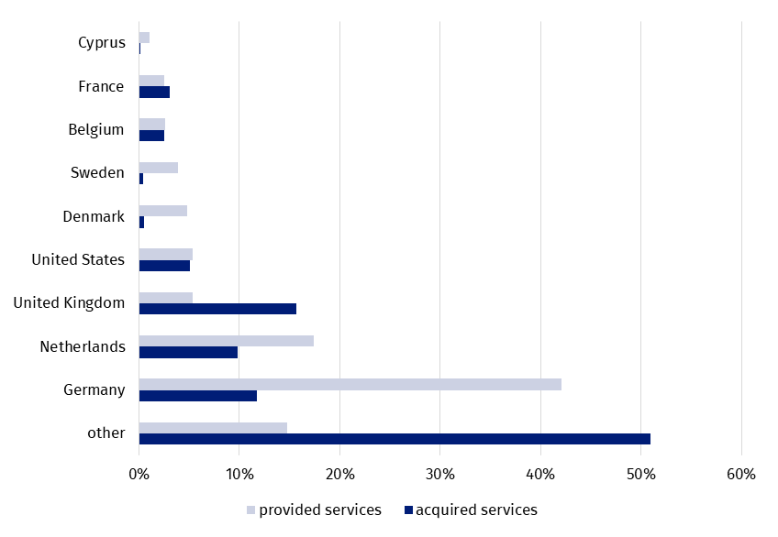
Chart 13. Geographical structure of services provided and acquired in the international trade by entities conducting employment activities in 2023

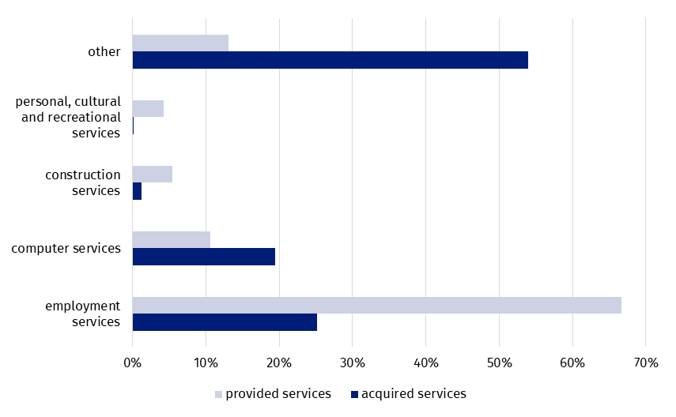
Chart 14. Structure of services provided and acquired in the international trade by entities conducting employment activities by kind of provided services in 2023

Methodological note
Within the surveys conducted by Polish official statistics, business services include the following activities according to NACE Rev. 2.0:
- from Section J Information and communication: publishing activities (58), computer programming, consultancy and related activities (62), data processing, hosting and related activities; web portals (63.1);
- Section L Real estate activities (68);
- from Section M Professional, scientific and technical activities: legal and accounting activities (69), management consultancy activities (70.2), architectural and engineering activities; technical testing and analysis (71), advertising and market research (73), other professional, scientific and technical activities (74);
- from Section N Administrative and support service activities: employment activities (78), security and investigation activities (80), services to buildings and landscape activities (81), office administrative, office support and other business support activities (82).
Data from the structural business statistics for 2023, which are compiled in accordance with Commission Implementing Regulation (EU) 2020/1197 of 30 July 2020 laying down technical specifications and arrangements pursuant to Regulation (EU) 2019/2152 of the European Parliament and of the Council on European business statistics repealing 10 legal acts in the field of business statistics, were the source of data for this news release.
In the case of information on the number of enterprises, the number of persons employed and the total turnover for all entities conducting business activity, the data was compiled in accordance with the requirements of the above-mentioned regulation. These data applies to entities conducting activities classified according to NACE Rev. 2.0 to Sections from B Mining and quarrying to S Other service activities, excluding Section O Public administration and defence; compulsory social security and Division 95 Activities of membership organisations from section S.
Information on the structure of turnover by residence of client and product were prepared on the basis of the survey outcomes Assessment of enterprises providing support service activities for 2023, which is conducted in accordance with the requirements of table 23 of the above-mentioned regulation. The data refer to enterprises with the number of persons employed 10 and more, carrying out activities classified, according to NACE Rev. 2.0, into divisions: 62, 69, 71, 73 and 78 and groups: 58.2, 63.1 and 70.2.
International trade in services survey was the main source of data on services provided to non-residents and acquired from non-residents in 2023. The survey is conducted in accordance with Commission Regulation (EU) No 555/2012 of 22 June 2012 amending Regulation (EC) No 184/2005 of the European Parliament and of the Council on Community statistics concerning balance of payments, international trade in services and foreign direct investment, as regards the update of data requirements and definitions.
Information on turnover values from the structural business statistics and values of services provided to non-residents and acquired from non-residents are presented in current prices. While structures of services provided to non-residents and acquired from non-residents in international trade refer to values of those services.
In connection with the introduction of methodological requirements resulting from Regulation (EU) 2019/2152 of the European Parliament and of the Council on European business statistics repealing 10 legal acts in the field of business statistics, since 2018, the basic statistical unit for which structural business statistics (SBS) data are compiled is "enterprise" (ENT). Under this regulation, since 2022 “enterprise” is also the main statistical unit for international trade in services by enterprise characteristics.
Definitions of statistical units, including “enterprise” (ENT), are defined in Council Regulation (EEC) No 696/93 of 15 March 1993 on the statistical units for the observation and analysis of the production system in the Community.

When quoting Statistics Poland data, please provide the information: “Source of data: Statistics Poland”, and when publishing calculations made on data published by Statistics Poland, please include the following disclaimer: “Own study based on figures from Statistics Poland”.
Prepared by:  Trade and Services Department  Director Ewa Adach-Stankiewicz  Phone: (+48 22) 608 31 24 | Issued by:  Press Office  Mobile: (+48) 695 255 032  Phone: (+48 22) 608 38 04, (+48 22) 449 41 45,  (+48 22) 608 30 09  e-mail: obslugaprasowa@stat.gov.pl

stat.gov.pl/en/

@StatPoland

@GlownyUrzadStatystyczny

gus_stat

glownyurzadstatystycznygus

glownyurzadstatystyczny
Related information
Yearbook of Foreign Trade Statistics of Poland 2023

Data available in databases
Knowledge Databases Foreign Trade

Terms used in official statistics
residents - international trade in services
international trade in services
enterprise (ENT)

See Methodological note page 12.
Applies to entities conducting activities classified according to NACE Rev. 2.0 to Sections from B “Mining and quarrying” to S “Other service activities“, excluding Section O “ Public administration and defence; compulsory social security” and Division 95“ Activities of membership organisations” from section S (regardless of the number of persons employed).
Pursuant to the Act of 27 July 2002, The Law on Foreign Exchange, non-residents are: - natural persons having their place of residence abroad and legal persons having their seat abroad, as well as other entities having their seat abroad which have the capacity to incur obligations and acquire rights in their own name; non-residents shall also be branches, agencies and enterprises established by residents abroad, - foreign diplomatic representation offices, consular offices and other foreign representation offices and special missions which enjoy diplomatic or consular immunities and privileges.
Applies to entities conducting the following activities: software publishing (group 58.2), computer programming, consultancy and related activities (division 62) and data processing, hosting and related activities; web portals (group 63.1).
Relation of gross financial result to revenues from total activity.
Relation of net financial result to revenues from total activity.
Relation of the costs of obtaining revenues from total activity to revenues from total activity.
Applies to entities conducting the following activities: legal and accounting activities (69) and management consultancy activities (70.2).
Due to the statistical confidentiality, data are not disseminated.
Applies to entities conducting the following activities: architectural and engineering activities and related technical consultancy (71.1) and technical testing and analysis (71.2).
Applies to entities conducting the following activities: advertising (73.1) and market research and public opinion polling (73.2).
Applies to entities conducting the following activities: employment activities (78).

