Foreigners performing work in Poland in February 2026
On the last day of February 2026, there were 1 132.4 thousand foreigners performing work in Poland, i.e. 7.1% (75.0 thousand) more than at the end of February 2025. Compared with 31 January 2026, their number increased by 1.2% (13.4 thousand).
At the end of February 2026 women accounted for 40.1% of the population of foreigners performing work in Poland
1.1 million
number of foreigners performing work in Poland as at 28 February 2026
Foreigners performing work in Poland by sex
As at 28 February 2026, among foreigners performing work in Poland, men constituted the majority. Their share was 59.9% ‒ 0.1 percentage points (pp) more than a year before and the same as at the end of January 2026.
Compared with the end of February 2025, the number of women increased by 6.9% and the number of men – by 7.2%. Compared with 31 January 2026, the number of both women and men increased by 1.2%.
Chart 1. Indices of the number of foreigners performing work in Poland
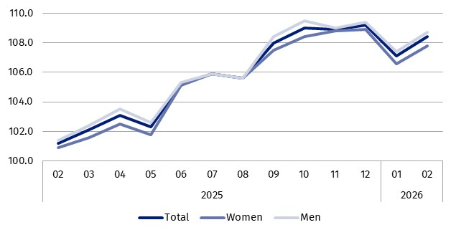
01.2025 = 100
Foreigners working under contracts of mandate and related contracts
As at the end of February 2026, among foreigners performing work 37.9% (429.1 thousand) worked only under contracts of mandate and related contracts. Compared with 28 February 2025, there was an increase of 6.6% in the number of foreigners working under contracts of mandate and related contracts and compared with 31 January 2026 – an increase of 0.9%.
Citizenship of foreigners performing work in Poland
As at the end of February 2026, foreigners performing work in Poland came from over 150 countries

Ukrainian citizens were the most numerous group of foreigners performing work in Poland. As at 28 February 2026, there were 769.3 thousand of them, i.e. 8.5% (60.4 thousand) more than in the same month of the previous year and 1.5% (11.6 thousand) more than at the end of January 2026.
As at 28 February 2026, Ukrainian citizens accounted for 67.9% of the total number of foreigners performing work in Poland. Their share increased by 0.9 pp compared with 28 February 2025 and by 0.2 pp compared with 31 January 2026.
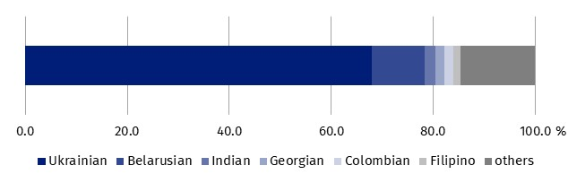
Chart 2. Structure of foreigners performing work in Poland by citizenship in February 2026
As at the end of the month
***
In tables attached to this news release the additional data were presented, inter alia on PKD 2025/NACE Rev. 2.1 sections and the place of residence of foreigners performing work in Poland.
During the transitional period related to the reclassification of national economy entities from PKD 2007/NACE Rev. 2 to PKD 2025/NACE Rev. 2.1 (which lasts until 31 December 2026), the data on foreigners performing work in Poland are presented using, amongst other things, the correspondence tables between NACE Rev. 2 and NACE Rev. 2.1 – available on the Eurostat website:
https://ec.europa.eu/eurostat/web/nace/correspondence-tables
***

Methodological notes
The data refer to ‘persons performing work’, i.e. employed persons in the national economy and persons working under contracts of mandate and contracts of a related nature. According to the definition in force in the official statistics system, persons working under civil law contracts are not included in the population of employed persons in the national economy.
Contracts of mandate are counted together with contracts of a related nature to which the provisions of the Civil Code apply and which involve the obligation to be covered by social or health insurance with the Social Insurance Institution (ZUS) (i.e. agency agreements, service contracts, nanny agreements, appointment letters, contracts with members of supervisory boards and managerial contracts having the nature of a contract of mandate). Persons classified as employed who at the same time work under contracts of mandate and related contracts are counted only once and included in the group of employed persons.
The analysed population does not include:
- persons working under contracts to perform a specified task and harvest assistance contracts (farmer’s helpers);
- persons working under contracts of mandate and related contracts who made such a contract with their own employer or another entity, but on behalf of their own employer;
- post-primary schools students and students under the age of 26.
In the case of quoting Statistics Poland data, please provide information: ‘Source of data: Statistics Poland’, and in the case of publishing calculations made on data published by Statistics Poland, please provide information: ‘Own work based on Statistics Poland data’.

Prepared by:  Statistical Office in Bydgoszcz  Acting Director Katarzyna Klamrowska  Phone: (+48 52) 366 93 90 | Issued by:  Press Office  Mobile phone +48 695 255 032  Landline phones: +48 22 608 38 04, +48 22 449 41 45, +48 22 608 30 09  e-mail: obslugaprasowa@stat.gov.pl

stat.gov.pl/en/

@StatPoland

@GlownyUrzadStatystyczny

@gus_stat

@GłównyUrządStatystycznyGUS

@Glówny Urząd Statystyczny
Related information
Foreigners performing work in Poland in January 2026
Foreigners performing work in Poland in February 2025
Methodological report. Employment in the national economy
Terms used in official statistics
Employed persons in the national economy

