Education in Opolskie Voivodship in the 2025/2026 school year

1.0%
Increase in the number of
students in primary, post-primary and post-secondary schools compared to 2024/25 school year

In 2025/26 school year, in primary, post-primary
and post-secondary schools in Opolskie
Voivodship, there were a total of 119.5 thousand persons, i.e. more by 1.0% than the year before. They accounted for 12.9% of the total number
of inhabitants of Opolskie Voivodship.

Pre-primary education
Nursery schools accounted
for 80.7% of pre-primary
establishments
In Opolskie Voivodship, in 2025/26 school year, there were 497 pre-primary education establishments which was fewer by 0.4% than in the previous school year. Pre-primary education establishments included 401 nursery schools, 83 pre-primary sections organised in primary schools and 13 pre-primary centres. Compared with the previous school year the number of pre-primary centres and pre-primary sections organised in primary schools decreased: by 13.3% and by 6.7%, respectively, while the number of nursery schools increased – by 1.5%.
The largest share of the total of pre-primary education establishments consisted of nursery schools (80.7%), followed by pre-primary sections organised in primary schools (16.7%), which were mostly located in rural areas (89.2% of these establishments).
Table 1. Pre-primary education
as of 30 September
Specification |  | Establishments |  | Sections |  | Children
 |  | total | of which in rural areas | total | of which in rural areas | total | of which in rural areas
T o t a l | 2024/25 | 499 | 279 | 1662 | 677 | 33184 | 12879
 | 2025/26 | 497 | 278 | 1593 | 667 | 31184 | 12306
of which:
Nursery schools | 2024/25 | 395 | 197 | 1484 | 528 | 29948 | 10217
 | 2025/26 | 401 | 201 | 1431 | 529 | 28382 | 9970
Pre-primary sections in primary schools | 2024/25 | 89 | 76 | 163 | 143 | 2974 | 2544
Pre-primary sections in primary schools | 2025/26 | 83 | 74 | 149 | 135 | 2603 | 2283
Among pre-primary education establishments, in the 2025/26 school year, public establishments were a majority – 83.1%, and their share decreased during the year by 0.1 percentage point. Local government units ran 79.6% of nursery schools and 71,1% of pre-primary sections organised in primary schools.
In 2025/26 school year pre-primary education covered 31184 children, i.e. less by 6.0% than
The number of children in
nursery schools decreased
compared to 2024/25 school year
the year before. Most children (60.5%), similarly to the previous years, attended establishments in urban areas. The number of children in nursery schools in the 2025/26 school year accounted for 91.0% of the total number of children in establishments and amounted to 28382 (less by 5.2% than the year before). Pre-primary sections organised in primary schools were attended by 2603 children, of which 87.7% were children from rural areas. The number of children in pre-primary sections decreased by 12.5% in relation to the previous school year.
Chart 1. Children by age in pre-primary establishments
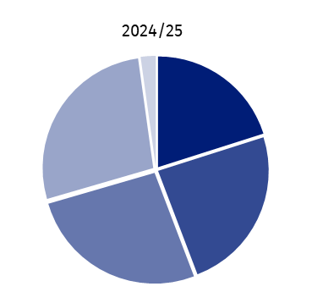
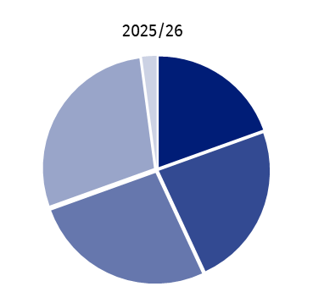
as of 30 September

Children aged:
3 years
4
5
6 years
others

Per 1000 children aged 3–6 years, 994 children attended classes in pre-primary establishments, of which in nursery schools – 905. Higher value of this indicator is characteristic to urban areas – 1228 than for rural areas – 769 (of which, in nursery schools: 1199 and 623, respectively).
The popularisation rate of pre-primary education expressed as the number of children aged 3-4 years attending pre-primary education establishments in % of all children of this age amounted to 94.5% and decreased by 1.2 percentage points compared to the previous school year.
In 2025/26 school year pre-primary establishments were attended by 8853 six-year-olds. Per 1000 children aged 6, pre-primary establishments were attended by 1034 children from this age group (in 2024/25 – 1027). In relation to the previous year, in pre-primary establishments, there was a decrease in the number of three-year-olds – by 9.0%, four-year-olds – by 7.9%, five-year-olds – by 5.5% as well as six-year-olds – by 2.3%.
In 2025/26 school year there were 8 special nursery schools, similarly to the previous year, which were attended by 139 children (in 2024/25 – 149).
In 2025/26 school year, per 1 pre-primary there were, on average, 63 children, in urban areas – 86, in rural areas – 44, of which in nursery schools: 71, 92 and 50, respectively.
The number of places in nursery schools amounted to 32354. Per 100 places in nursery schools, there were on average 88 children, in urban areas – 90, while in rural ones – 83.
In territorial terms, the highest number of children per 100 places in nursery schools marked Brzeski Powiat (94), while the lowest Głubczycki Powiat (76).
Primary schools
In 2025/26 school year there
were 394 primary schools
In 2025/26 school year in Opolskie Voivodship there were 394 primary schools (of which
23 special and 1 school for adults). Compared to the previous school year, the number
of primary schools decreased by 0.5%. Considering the location of the school, there were
141 primary schools in urban areas (as in the previous school year), and 253 schools in rural areas (less by 0.8%).
Majority of primary schools are public schools (92.4%). The largest share of primary schools was subordinated to local government units (83.8%), while the rest was ran by social organisations and associations as well as religious organisations (14.5%) and other units (1.8%).
The most primary schools operated in powiats: Nyski (57) and Opolski (56), while the least
in powiats: Głubczycki (18) and Namysłowski (20).
Table 2. Primary schools
as of 30 September
Specification |  | Total | Students |  |  |  |  |  | Graduatesª
 |  | Total | total | of  which  girls | of the total |  |  |  | total | of  which  girls
 |  |  |  |  | in first grade |  | In eight grade |  | total | of  which  girls
 |  |  |  |  | total | of  which  girls | total | of  which  girls | total | of  which  girls
Primary schools | 2024/25 | 372 | 70821 | 34468 | 9604 | 4702 | 8011 | 3851 | 3735 | 1692
 | 2025/26 | 370 | 71989 | 35139 | 9155 | 4478 | 8622 | 4287 | 7927 | 3815
of which branch | 2024/25 | 8 | 325 | 157 | 90 | 41 | 9 | 3 | – | –
 | 2025/26 | 8 | 330 | 153 | 81 | 38 | 12 | 8 | 9 | 3
Special primary  schools | 2024/25 | 23 | 1134 | 363 | 89 | 25 | 188 | 70 | 161 | 45
Special primary  schools | 2025/26 | 23 | 1216 | 396 | 95 | 31 | 227 | 82 | 128 | 49
Primary schools  for adults | 2024/25 | 1 | 10 | 3 | – | – | 10 | 3 | 35 | 13
Primary schools  for adults | 2025/26 | 1 | 11 | 3 | – | – | – | – | 9 | 1
a From the previous school year.
In 2025/26 school year, in primary schools there were 73216 students of which 44906 (61.3%) in urban areas and 28310 (38.7%) in rural areas. The number of students increased by 1.7% in comparison to the previous school year.
Full-time compulsory
education in primary schools
was fulfilled by 73216 students
Special primary schools were attended by 1216 students, i.e. more by 7.2% than in the previous school year.
In urban areas, there were
over 3 times more students per primary school for children and youth than in rural areas
In 2025/26 school year in Opolskie Voivodship, per 1 primary school for children and youth (excluding special schools) there were 195 students. In urban areas this rate was higher and amounted to 362 students versus 113 in rural areas. There were 17 students per section on average in primary school. In rural areas classes were less numerous, as there were 13 students on average per one section, while in urban areas there were 21 students.
In June 2025, the number of primary schools graduates amounted to 8064, i.e. more by 105.1% compared with 2024. In urban areas 5035 persons graduated from this level of education and 3029 in rural areas. In the structure of all primary schools graduates, the dominant share was held by graduates of primary schools for children and youth (98.3%), while graduates of special primary schools accounted for 1.6%, and of primary schools for adults – 0.1%.
Post-primary schools (including special)
Post-primary schools include: special job-training schools, stage I sectoral vocational schools, stage II sectoral vocational schools, general secondary schools, technical secondary schools, general art schools leading to professional certification. Moreover, in accordance with The Act on the Education System, post-secondary schools are included in post- primary schools, however they are presented separately due to higher degree of education.
In 2025/26 school year in Opolskie Voivodship there were 203 post-primary schools and
it was by 1.0% more than in the previous school year. Most of post-primary schools were schools for youth (181) and their number increased by 2.8% compared with 2024/25 school year.
Over 89% of post-primary
schools were schools for youth
Table 3. Post-primary schools
as of 30 September
Specification |  | Total | Students |  |  |  | Graduatesª
 |  | Total | total | of which women | of the total in first grade |  | total | of which women
 |  |  |  |  | total | of which women | total | of which women
Stage I sectoral  vocational schools | 2024/25 | 48 | 6338 | 2110 | 1739 | 565 | 1348 | 436
Stage I sectoral  vocational schools | 2025/26 | 47 | 5732 | 1915 | 1960 | 625 | 2037 | 657
Stage II sectoral  Vocational schools | 2024/25 | 8 | 395 | 106 | 272 | 71 | 220 | 25
Stage II sectoral  Vocational schools | 2025/26 | 12 | 802 | 211 | 597 | 159 | 113 | 34
General secondary schools | 2024/25 | 73 | 16265 | 9998 | 2007 | 1172 | 3162 | 1970
General secondary schools | 2025/26 | 70 | 16909 | 10258 | 3780 | 2283 | 3738 | 2271
Technical secondary schools | 2024/25 | 49 | 17188 | 6933 | 1704 | 614 | 2884 | 1204
Technical secondary schools | 2025/26 | 51 | 17068 | 6821 | 3459 | 1299 | 2797 | 1114
Special  job training schools | 2024/25 | 21 | 345 | 119 | 82 | 29 | 49 | 18
Special  job training schools | 2025/26 | 21 | 340 | 125 | 74 | 33 | 49 | 14
General art schools  leading to professional certification | 2024/25 | 2 | 373 | 342 | 46 | 41 | 66 | 62
General art schools  leading to professional certification | 2025/26 | 2 | 387 | 351 | 81 | 72 | 55 | 51
a From the previous school year.
In post-primary schools there were 41238 students. In relation to 2024/25 school year, the number of students increased by 0.8%. The most popular among students of post- primary schools were schools, which gave the possibility to obtain matriculation certificate and thus continue education at universities. These schools were attended by 85.3% of the total number of post-primary students, i.e. more by 1.6 percentage point in relation to 2024/25 school year.
Students of technical
secondary schools accounted
for 41.4% of students of post-primary schools ponadpodstawowych
Most of students of post-primary schools (92.4%) attended schools for youth.
Public schools accounted for 83.3% of the total number of post-primary schools and 37316 students attended them (i.e. 90.5%).
In 2025/26 school year the net enrolment rate expressed as a relation of the number of students aged 15–17 years to the number of population in this age group in stage I sectoral vocational schools (including special job-training schools) amounted to 17.9%, while in general secondary school expressed by the number of students aged 15–18 years amounted to 38.2% and in technical secondary schools (including general art schools leading to professional certification) expressed as a relation of the number of students aged 15–19 years to the number of population in this age group – 37.2%.
Among persons attending post-primary schools, sex is an important determinant of school choice. In 2025/26 school year women accounted for 60.7% of the total number of students of general secondary schools, they less often chose technical secondary schools (including general art schools leading to professional certification), where their share accounted for 41.1%, while their lowest percentage was among students of stage I sectoral vocational schools (including special job-training school) – 33.6% and stage II sectoral vocational schools – 26.3%.
Chart 2. Students of post-primary schools for youth
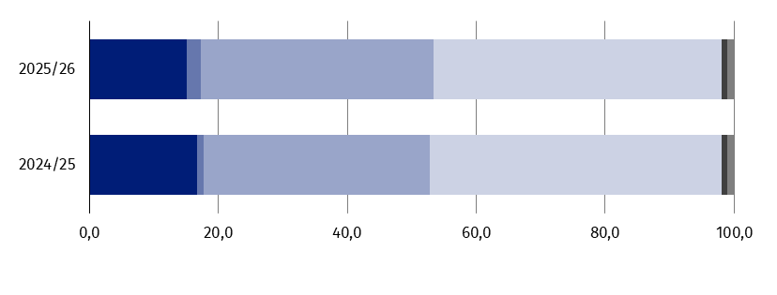
as of 30 September

%
Schools:
stage I sectoral vocational
stage II sectoral vocational general secondary schools
technical secondary schools
special job-training schools
general art leading to professional
certification schools

In June 2025, 8789 persons graduated from post-primary schools, of which the most numerous group were general secondary school graduates – 42.5% and technical secondary school (including general art schools leading to professional certification) graduates – 32.4%, while the share of graduates of stage I sectoral vocational schools (including special job- training schools) as well as stage II was: 23.7% and 1.3%, respectively. In comparison with the previous school year the number of post-primary school graduates increased by 13.7%. The increase was noted among graduates of stage I sectoral vocational schools including special job- training schools (by 49.3%) as well as general secondary school graduates (by 18.2%).
Stage I sectoral vocational schools (including special job-training schools) and stage II sectoral vocational schools
In 2025/26 school year in Opolskie Voivodship there were 47 stage I sectoral vocational schools and 21 special job-training schools. The number of stage I sectoral vocational schools decreased by 2.1% compared with 2024/25 school year, while the number of special job-training schools remained the same. In the group of stage I sectoral vocational schools including special job-training schools, 48.5% of them were special schools.
In 2025/26 school year there were 68 stage I sectoral vocational schools (including special job training schools)
The largest number of stage I sectoral vocational schools were located in the city of Opole as well as in powiats: Nyski and Strzelecki (8 each), while the fewest in powiats: Głubczycki, Krapkowicki and Namysłowski (3 each).
Public schools (85,3%) were predominant among stage I sectoral vocational schools in the 2025/26 school year.
Stage I sectoral vocational schools were attended by 6072 students, of which 89.7% studied in mainstream schools, while 10.3% in special schools. Compared to the previous school year there was an decrease in the total number of students of 9.1%, of which in mainstream schools – by 10.2%, while in special schools – increase of 0.8%.
The share of women among students of these schools in 2025/26 school year accounted for 33.6% and increased on a yearly basis by 0.2 percentage point.
Among students of stage I sectoral vocational schools (excluding special job-training schools) the most popular were occupations in the narrow fields of engineering and engineering trades (39.0% of the total number of students) as well as of personal services (25.5%). Sex played an important role in choosing the field of vocational education. Men were mostly educated in occupations in the narrow field of engineering and engineering trades (57.7% o of the total number of men attending stage I sectoral vocational schools), while among women majority chose education in occupations in the narrow field of personal services (54.5% of the total number of woman attending stage I sectoral vocational schools).
Students of stage I sectoral
vocational schools most often
chose narrow fields of
education: engineering and
engineering trades as well as
personal services
Chart 3. Students and graduates of stage I sectoral vocational schools for youth by sex and chosen narrow fields of educationª in 2025/26 school year
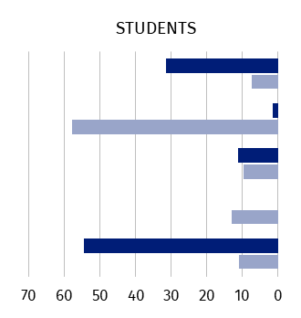
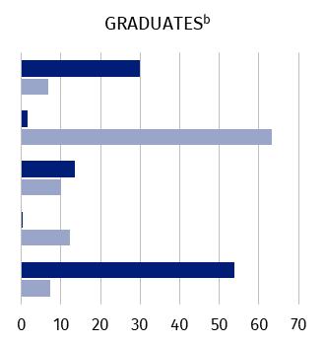
as of 30 September
Business and administration
Engineering and engineering trades
Manufacturing and processing
Architecture and construction
Personal services
Absolwenci

%
%

Women Men
00000000000

a According to International Standard Classification of Education (ISCED-F 2013). b From the previous school year.
In June 2025, there were 2086 graduated of sectoral vocational schools, of which 94.7%
were graduates of mainstream schools and 5.3% – of special schools. Compared to the previous year there was an increase in the total number of graduates of 49.3%, of which in mainstream schools of 52.5%, and in special school 8.8%.
In 2024/25 school year graduates of stage I sectoral vocational schools (excluding special job-training schools) graduated mostly from the narrow fields of engineering and engineering trades (43.3% of the total number of graduates) and from personal services (22.3%). Among men, the most graduates were recorded in occupations from the narrow field of engineering and engineering trades (63.2%), while among women in occupations from the narrow field of personal services (53.9%).
In Opolskie Voivodship in 2025/26 school year there were 12 stage II sectoral vocational schools. Their number increased by 50.0% in comparison with the previous school year.
Among them 66.7% were public schools.
In 2025/26 school year 802 persons attended stage II sectoral vocational schools, i.e. more by 103.0% than the year before. Women accounted for 26.3% of students and their share decreased by 0.5 percentage point on a yearly basis.
The largest number of students of stage II sectoral vocational schools in 2025/26 school year studied in narrow fields of engineering and engineering trades (55.4%) as well as personal services (21.1%).
In June 2025 there were 113 graduates of stage II sectoral vocational schools, i.e. less by 48.6% compared with June 2024.
Most of the students graduated in narrow fields of engineering and engineering trades (47.8% of the total number of graduates).
General secondary schools
In 2025/26 school year, in Opolskie Voivodship there were 70 general secondary schools. Compared to the previous school year, the number of these schools decreased by 4.1%. Among general secondary schools 68.6% were general secondary schools for youth.
The most of general secondary schools operated in the city of Opole (17) and Nyski Powiat (12), while the least in powiats: Krapkowicki and Namysłowski (2 each).
In 2025/26 school year among general secondary schools for youth, public schools had a predominant share (79.2%). In the group of general secondary schools for adults 31.8% were non-public schools with public school competences.
16909 persons studied in general secondary schools (increase compared with the previous school year by 4.0%), of which in general secondary schools for youth – 13764 persons.
The number of students of general secondary schools increased compared to 2024/25 school year
The majority of students of general secondary schools were women (60.7%). However a significant share concerned general secondary schools for youth, in which they accounted for 64.2%, while in case of general secondary schools for adults only 45.1%. Compared with 2024/25 school year, a decrease of 0.8 percentage point was recorded in the share of women in general secondary schools.
In 2025/26 school year, per 1 general secondary school (excluding special schools) in Opolskie Voivodship there were 248 students on average, of which in schools for youth – 299, while for adults – 143, however per section there were: 27, 26 and 32 students, respectively.
In June 2025, education in general secondary schools was completed by 3738 graduates
(i.e. more by 18.2% than the year before), of which 2857 persons completed school for youth, and 881 – for adults.
Technical secondary schools (including general art schools leading to professional certification)
In 2025/26 school year in Opolskie Voivodship there were 53 technika. Compared with the previous school year their number increased by 3.9%.
The most of technical secondary schools operated in the city of Opole (13) and Nyski Powiat (7), while the least in powiats: Głubczycki, Krapkowicki, Namysłowski and Strzelecki (2 each).
Among technical secondary schools during the 2025/26 school year, public schools were predominant – 94.3%.
The total number of students of technical secondary schools decreased compared to 2024/25 school year
Total of 17455 students attended technical secondary schools in the 2025/26 school year of which 97.8% attended technical secondary schools, while 2.2% general art schools leading to professional certification. Compared to the previous school year, there was a decrease in the total number of students by 0.6%, of which in technical secondary schools of 0.7%, while in general art schools leading to professional certification – increase of 3.8%.
In 2025/26 school year women accounted for 40.0% of students of technical secondary schools and 90.7% of general art schools leading to professional certification (the year before: 40.3% and 91.7%, respectively).
In 2025/26 school year there were 335 students on average per 1 technical secondary school (special schools excluding) in Opolskie Voivodship, while per section – 24 students.
Students of technical
secondary schools most often
chose education in narrow
fields from information and
communication technologies
as well as engineering and
engineering trades
Students of technical secondary schools most often chose narrow fields of education: information and communication technologies (22.8% of the total number of students) and engineering and engineering trades (21.7%). Among men, occupations from narrow field of information and communication technologies were most popular (32.5% of the total number of man attending technical secondary schools), while among women education in the narrow field of personal services (21.4% of the total number of women attending technical secondary schools).
Chart 4. Students and graduates of technical secondary schoolsª for youth by sex and selected narrow fields of education^{b} in 2025/26 school year
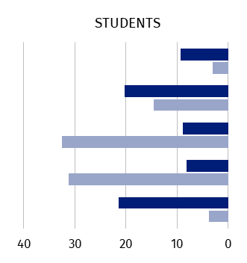
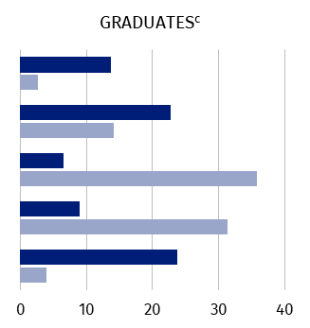
as of 30 September
Social and behavioural sciences
Business and administration
Information and communi- cation technologies
Engineering and engineering trade
Personal services
%
%

Women Men
00000000000

a Including students and graduates of general art schools leading to professional certification.
b According to International Standard Classification of Education (ISCED-F 2013). c From the previous school year.
The number of graduates of technical secondary schools in June 2025 amounted to 2852 and decreased by 3.3% compared to the previous year.
Graduates of technical secondary schools most often finished education from narrow field of information and communication technologies (23.9% of the total number of graduates) as well as engineering and engineering trades (22.3%). Among men predominant were graduates from occupations from narrow fields of information and communication technologies (35.9%), while for women the most graduates were from narrow group of personal services (23.7%).
Post-secondary schools
In 2025/26 school year there were 30 post-secondary schools in Opolskie Voivodship. Their number decreased by 3.2% compared with the previous school year.
The spatial distribution of post-secondary schools is not even in the voivodship. Their clear concentration can be noted in the city of Opole (8 schools) and Nyski Powiat (7). On the other hand, in powiats: Krapkowicki and Opolski there are no schools of that type.
The majority of post-secondary schools were run by private sector entities – 76.7% of this type of schools (in 2024/25 school year – 74.2%).
Post-secondary schools educated total of 5028 persons, i.e. less by 7.6% compared with the previous school year.
Majority, i.e. 76.2% of persons studying in the post-secondary schools were women (versus 73.9% in 2024/25 school year).
In 2025/26 school year the biggest number of students of post-secondary schools were educated in occupations from health narrow field (53.3% of the total number of students) as well as hygiene and occupational health services (11.1%). Men took up education mostly in occupations from narrow field of health (45.1% of the total number of men attending post-secondary schools), similarly to women (55.9% of the total number of women attending post-secondary schools).
Most students from post-secondary schools chose education from narrow fields of health as well as hygiene and occupational health services
Chart 5. Students and graduates of post-secondary schools by sex and selected narrow fields of educationª in 2025/26 school year
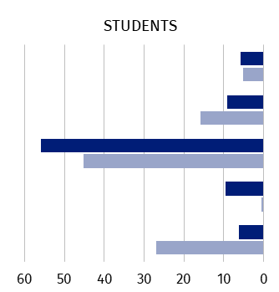
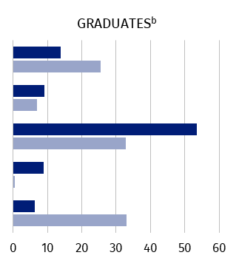
as of 30 September
%
%
Arts
Business and administration
Health
Personal services
Hygiene and occupational health services
Absolwenci

Women Men
00000000000

a According to International Standard Classification of Education (ISCED-F 2013). b From the previous school year.
In June 2025, 2063 persons graduated from post-secondary schools, i.e. more by 9.7% than in the previous year.
In 2024/25 school year the largest number of graduates of post-secondary schools completed education in occupations from the narrow field of health (48.4% of the total number of graduates) as well as arts (16.7%). Among men, the majority graduated in occupations from hygiene and occupational health services narrow field (33.0% of the total number of men graduating from the post-secondary schools), on the other hand among women in occupations form health narrow field (53.5%).

***
In case of quoting Statistics Poland data, please provide information: “Source of data: Statistics Poland” and
in case of publishing calculations made on data published by Statistics Poland, please include information:
“Own study based on figures of Statistics Poland”
Issued by:
Opolski Centre for Regional Surveys

Statisctical Information Centre
Phone: 77 423 10 00, 510 993 218

Prepared by:
Statistical Office in Opole
Director Renata Wasilewska
Phone: 77 453 14 52




Media contact person
in Statistical Office in Opole
Phone. 514 901 001
e-mail: H.Sterniuk-Moscicka@stat.gov.pl
opole.stat.gov.pl
@USOpole
@Opole_STAT

Related information
Edukacja w województwie opolskim w roku szkolnym 2024/2025

Data available in databases
Local Data Bank - Education

