Average paid employment and average wage and salary in the enterprise sector in July 2026
In July 2026, the average paid employment in the enterprise sector was 0.1% higher than in June this year, whilst compared with July 2025 it was 0.8% lower.
6.4 million FTE
Average paid employment in the enterprise sector

The average monthly gross wage and salary in the enterprise sector in July 2026 was 1.1% higher in nominal terms than in June this year, and 6.8% higher than in July 2025.
PLN 9 509.02
Average monthly gross wage and salary in the enterprise sector
The presented data refer to entities from the enterprise sector, which is part of the national economy.

Table 1. Average paid employment and average gross wage and salary in the enterprise sector
In January 2026, the statutory minimum salary
increased to PLN 4 806, i.e., by 3.0% compared with 2025 (PLN 4 666). This also affected the change in the average monthly gross wage and salary in the enterprise sector
Specification | 07 2026 |  |  | 01-07 2026
Specification | in absolute numbers | 06 2026=  =100 | 07 2025=  =100 | in absolute numbers | 01-07 2025=  =100
Average paid employment  in thousand full-time equivalents | 6 378.9 | 100.1 | 99.2 | 6 387.7 | 99.0
Total average gross wage and salary in PLN | 9 509.02 | 101.1 | 106.8 | 9 366.10 | 105.9
of which excluding payments from profit | 9 505.91 | 101.1 | 106.8 | 9 365.14 | 105.9

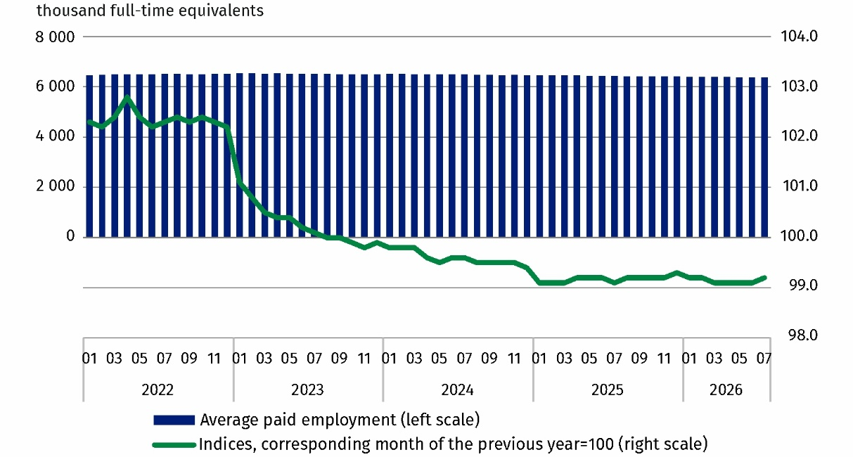
Chart 1. Average paid employment in the enterprise sector
The increase in the average monthly wage and salary in July 2026 compared with the previous month was due to additional payments, such as awards and bonuses – including quarterly, annual and discretionary payments – as well as awards for Forester’s Day, service anniversary awards and retirement severance pays (which, in addition to basic wages and salaries, are also included among the components of wages and salaries).
The average monthly gross wage and salary in the enterprise sector includes the basic wage and salary and additional components of wages and salaries, including bonuses, awards, overtime pay and retirement severance pays

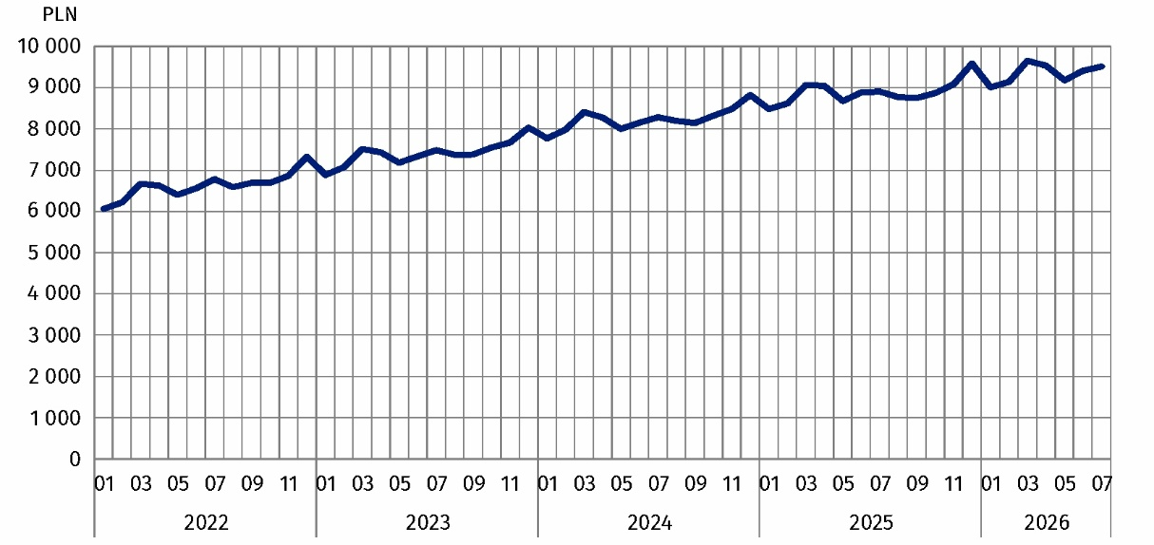
Chart 2. Average monthly gross wage and salary in the enterprise sector

Methodological notes
The enterprise sector is part of the national economy and includes units with 10 or more employed persons, conducting business activities in the field of: forestry and logging; marine fishing; mining and quarrying; manufacturing; electricity, gas, steam and air conditioning supply; water supply; sewerage, waste management and remediation activities; construction; wholesale and retail trade; repair of motor vehicles and motorcycles; transportation and storage; accommodation and food service activities; information and communication; real estate activities; activities of head offices; management consultancy activities; architectural and engineering activities; technical testing and analysis; advertising and market research; other professional, scientific and technical activities; administrative and support service activities; arts, entertainment and recreation; repair of computers and personal and household goods; other personal service activities.
Data for the national economy are published quarterly, e.g. in Statistical bulletin.
Due to the short deadline for units to provide data as part of the survey with the use of DG-1 form, the results presented are preliminary. In the absence of complete records at the date of preparation of the report, it is permissible to report estimated data, and if data reported in previous periods need to be corrected, the changes are included only in the cumulative data.
When quoting Statistics Poland data, please provide the information: ‘Source of data: Statistics Poland’, and when publishing calculations made on data published by Statistics Poland, please include the following disclaimer: ‘Own study based on figures from Statistics Poland’.
Prepared by:  Statistical Office in Bydgoszcz  Acting Director Katarzyna Klamrowska  Phone: (+48 52) 366 93 90 | Issued by:  Press Office  Mobile phone: (+48) 695 255 032  Landline phones: +48 22 608 38 04, +48 22 449 41 45, +48 22 608 30 09  e-mail: obslugaprasowa@stat.gov.pl

stat.gov.pl/en/

@StatPoland

@GlownyUrzadStatystyczny

@gus_stat

@GłównyUrządStatystycznyGUS

@Glówny Urząd Statystyczny
Related information
Communications and Announcements
Statistical Bulletin No 6/2026
Socio-economic situation of the country
Seasonal adjustment – Average paid employment and average monthly gross wages and salaries
Methodological report. Statistics on labour market, wages and salaries
Data available in databases
Local Data Bank – Labour market
Macroeconomic Data Bank – Labour market
Knowledge Databases – Labour market
Terms used in official statistics
Enterprise sector in the labour market and wages and salaries statistics
Average paid employment
Wages and salaries to calculate average monthly wages and salaries

Average paid employment after converting part-time employees into full-time equivalents.
See: Methodological notes.
Annex to the explanatory notes on reporting on paid employment, wages and salaries: https://form.stat.gov.pl/formularze/2026/objasnienia/zalacznik_do_objasnien.pdf
More information: Methodological report. Monthly activity report of enterprises

