Construction and assembly production in July 2026
According to preliminary data construction and assembly production (in constant prices) carried out domestically was in July 2026 lower by 2.4% an annual. Compared to June 2026 a decrease was noted by 7.6%.
2.4%
Decrease of construction and assembly production compared to July 2025

After seasonally adjusted, the decrease was noted in construction and assembly production of 2.2% an annual

In July 2026, after eliminating the seasonal factors, construction and assembly production reached the level by 2.2% lower than in the corresponding month of the previous year and lower by 3.8% in comparison to June 2026.
Among the factors that influenced production results in July 2026, some companies pointed to the irregular nature of post-completion settlements, which were more severe than usual for this time of year. Construction and assembly production at current prices was 3.5% higher than in July 2025.
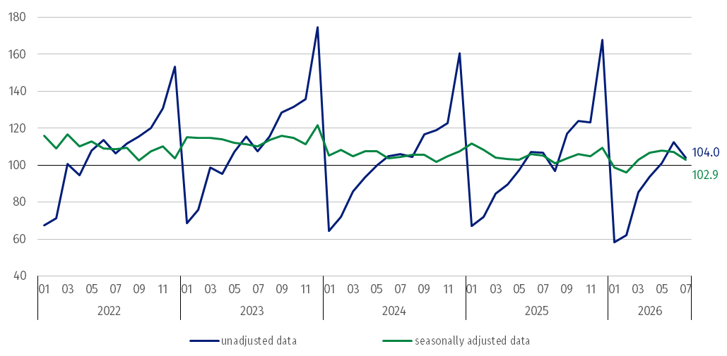
Chart 1. Construction and assembly production (constant prices; average monthly base 2021=100) ª
ª Preliminary data for July 2026.
Compared to the average monthly value of 2021 construction and assembly production in July 2026 (in constant prices), was higher by 4.0%, whereas after eliminating the seasonal factors was higher by 2.9%.
The construction and assembly production decreased in all divisions of construction
Construction and assembly production in July 2026 decreased in entities performing specialised construction activities of 6.4%, dealing mainly with construction of buildings of 1.8% and in entities whose basic type of activity was civil engineering works of 0.2%.
In July 2026 compared to June 2026, decreases in the sales of construction and assembly production were noted in entities dealing mainly with civil engineering works of 12.4%, in entities whose basic type of activity was construction of buildings of 3.9% and performing specialised construction activities of 3.0%.
Table 1. Construction and assembly production (constant prices) ª
Specification | 2026
Specification | 06 | 07 | 06 | 07 | 01-06 | 01-07
Specification | previous month = 100 |  | corresponding period of the previous year = 100
CONSTRUCTION | 111.5 | 92.4 | 105.2 | 97.6 | 97.1 | 97.5
Construction of buildings ^{Δ} | 99.8* | 96.1 | 97.0* | 98.2 | 93.4* | 95.5
Civil engineering works ^{Δ} | 128.9 | 87.6 | 118.7 | 99.8 | 100.2 | 99.0
Specialised construction activities | 100.0* | 97.0 | 94.3 | 93.6 | 97.1 | 97.5
ª Data including final information on production and prices in June and preliminary data in July 2026.
* The data has been changed compared to what was previously published.
^{Δ} Abbreviated form according to PKD 2007.
In the period January-July 2026 construction and assembly production decreased of 2.5%

In the period January-July 2026, in relation to the same period of the previous year, decreases in the sales of construction and assembly production were noted of 4.5% in entities whose basic type of activity was construction of buildings, in entities performing specialised construction activities of 2.5% and dealing mainly with civil engineering works of 1.0%.
Analyzing the value of construction and assembly production in July 2026 in terms of construction works (investment and restoration works) were observed:
In July 2026, investment works increased by 10.5% an annual

- an annual decrease for restoration works by 29.8% and an increase for investment works by 10.5% (in July 2025, a decrease for restoration of 6.1% and an increase for investment of 4.2%),
- compared to June 2026, a decrease for investment works by 9.6% and for restoration works by 0.2%.
In the period January-July 2026, in relation to the same period of the previous year, a decrease in the sales of construction and assembly production was noted for restoration works by 28.3% and an increase for investment works by 9.3% (in 2025, a decrease for restoration works of 1.8% and for investment works of 0.9%).

In case of quoting Statistics Poland data, please provide information: “Source of data: Statistics Poland” and in case of publishing calculations made on data published by Statistics Poland, please include the following disclaimer: “Own study based on figures from Statistics Poland”.

Prepared by:  Statistical Office in Lublin  Director Krzysztof Markowski, Ph.D.  Phone: (+48) 695 255 301 | Issued by:  Press Office  Mobile: (+48) 695 255 032  Phone: (+48 22) 608 38 04, (+48 22) 449 41 45,  (+48 22) 608 30 09  e-mail: obslugaprasowa@stat.gov.pl

stat.gov.pl

@GUS_STAT

@GlownyUrzadStatystyczny

@gus_stat

@GłównyUrządStatystycznyGUS

@Główny Urząd Statystyczny
Related information
Statistical Bulletin
Socio-economic situation of the country
Data available in databases
Knowledge Database - Construction
Macroeconomic Data Bank
Macroeconomic indicators
Local Data Bank

Terms used in official statistics
Sale of construction and assembly production
Seasonally unadjusted index of sale of construction and assembly production in constant prices
Seasonally adjusted index of sale of construction and assembly production
Sale of construction works with an investment character
Sale of construction works with a restoration character and other works

Preliminary data; comprise enterprises employing over 9 persons, whose the main type of activity is included in the section F “Construction” in accordance with the Polish Classification of Activities (PKD 2007).

