Distribution of wages and salaries in the national economy in Mazowieckie Voivodship in December 2025
In December 2025, the average gross monthly wages and salaries for residents of Mazowieckie Voivodship was PLN 11,701.77, an 8.1% increase compared to December 2024. Women's wages and salaries grew faster, though they were still lower than men's. The median salary was PLN 8,988.56, meaning that half of all employees were paid no more than this amount. The median increase was 9.3%.
8.1%
Annual increase in average monthly wages and salaries

The data presented here are based entirely on administrative registers. The primary source of data for statistics on wages and salaries is the Social Insurance Institution (ZUS) information systems. Data from ZUS contain information on individuals covered by social security and health insurance, their payers, and the characteristics of these individuals and payers. In this study, the data were compiled according to the place of residence of employed persons.

Average monthly wages and salaries by territory
In December 2025, in Mazowieckie Voivodship, the average wages and salaries in the national economy by place of residence amounted to PLN 11,701.77, and were higher by 19.2% from the national average. Compared to December 2024, wages and salaries in the Voivodship increased by 8.1%, and by 7.7% nationally. The wages and salaries of Warsaw residents amounted to PLN 14,205.76, which was 7.2% higher compared to the end of the previous year.
Average wages and salaries among Masovian residents vary significantly by region. In December 2025, the highest were recorded in the urban gmina of Podkowa Leśna (PLN 16,425.86, which constituted 140.4% of the average wages and salaries in the Voivodship), and the lowest in the rural gmina of Potworów (PLN 7,191.04, i.e. only 61.5%). Compared to December 2024, wages and salaries in Podkowa Leśna increased by 2.8%, and in Potworów by 10.0%.
Warszawa ranked fourth in the Voivodship in terms of the level of earnings of its residents; higher earnings, apart from the aforementioned Podkowa Leśna, were also recorded in the rural gminas of Michałowice (PLN 15,637.54) and Stare Babice (PLN 14,789.23).
In December 2025, the average wages and salaries higher than the average in the Voivodship were recorded only in 26 gminas (out of 314).

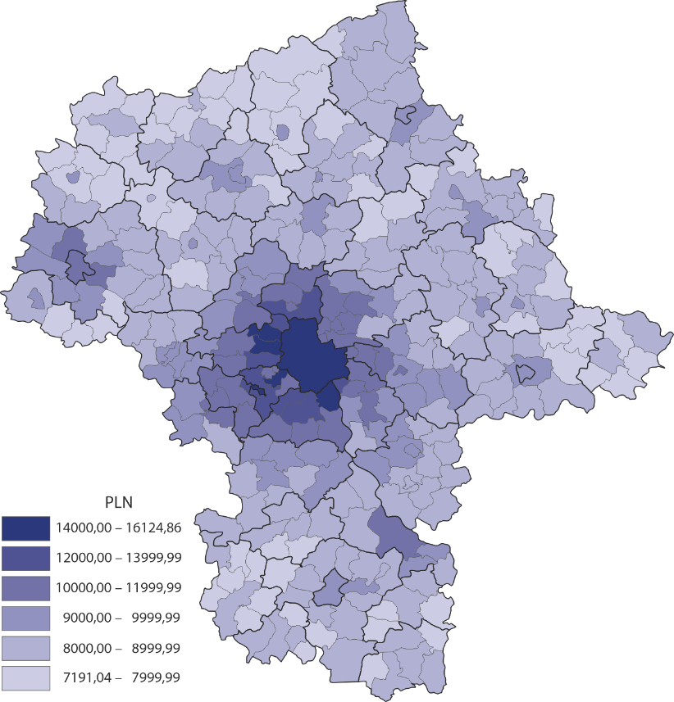
Map 1. Average monthly gross wages and salaries in December 2025

Average monthly wages and salaries by sex and economic section
Wages and salaries vary depending on sex. Men's earnings were higher than women's and grew slower in the presented period. The average wages and salaries for men were higher than the average by 3.2%, and for women – lower by 3.0%; the increase during the year was 7.5% for men and 8.6% for women. For comparison, in the country men's earnings exceeded the average by 2.8%, and women's earnings were lower by 2.9%; the increase was 6.4% and 9.2%, respectively.
Women’s wages and salaries grew faster than men’s wages and salaries
In Warszawa, men's wages and salaries were higher than the average by 7.2%, and women's wages and salaries were lower by 6.1%; men's earnings also grew slower (6.6% vs. 7.7%).
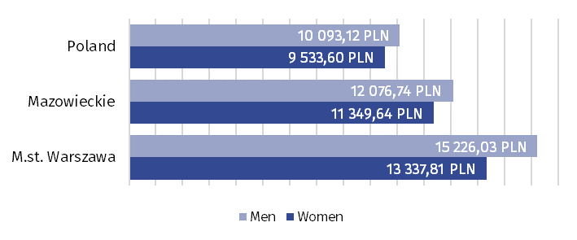
Chart 1. Average monthly gross wages and salaries in the national economy by sex in December 2025
In Mazowieckie Voivodship, the average gross wages and salaries of men were higher than that of women by PLN 727.10;

Clear differences in wages and salaries are observed depending on the section of the national economy, i.e. the type of activity of the entity that is the place of work.
The highest average wages and salaries were recorded in the service section; in December 2025, in Mazowieckie Voivodship, it was PLN 12,201.20, representing an 8.1% annual increase. The lowest wages and salaries were recorded in the agricultural section (PLN 9,013.32), but the increase compared to the end of the previous year was the highest (11.7%). In the industrial section, the average gross wages and salaries were PLN 9,923.86, an increase of 7.9% over the year.
The highest average monthly wages and salaries were recorded in the service section
Chart 2. Average monthly gross wages and salaries by sections of the national economy and sex in December 2025
The greatest disproportions between the average earnings of men and women were found in the service section
In the Voivodship, the most equal earnings by sex were found in the industrial section; men's earnings were 0.3% higher than the average, while women's were 0.6% lower (men earned PLN 82.18 more). In Poland, however, these disparities were greatest in entities included in the industrial section; men's earnings were 3.3% higher than the average, while women's earnings were 8.2% lower (PLN 1,035.04 to the advantage of men).

Median wages and salaries by territory
When analysing wages and salaries, it's not worth limiting them to the mean value. Wages and salaries variation is well illustrated by the median (i.e., the middle value). Median wages and salaries are a positional measure that divides salaried individuals into two equal groups. One half comprises employees earning less than the median, while the other half earns more. A characteristic feature of the median is that its value is not influenced by extreme values ​​(very low or very high wages and salaries), therefore, it provides a different picture of the distribution of wages and salaries than the average (mean) wages and salaries.
Median wages and salaries in Mazowieckie Voivodship in December 2025 amounted to PLN 8,988.56, meaning half of employees received wages and salaries at most this amount, and half received wages at least this amount. Compared to December 2024, median wages and salaries for residents of the Voivodship increased by 9.3%. In Poland, the median was PLN 7,909.17, an increase of 8.8%.

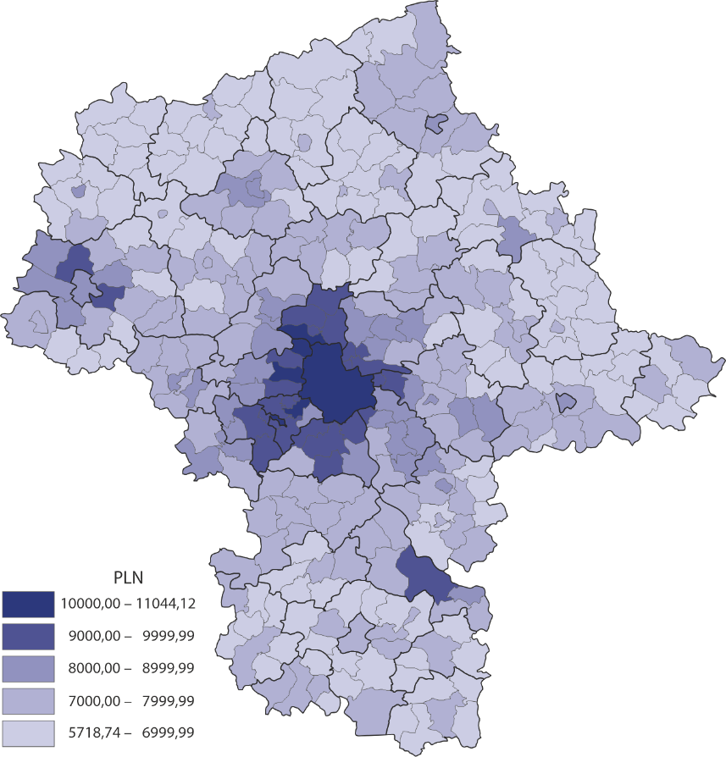
Map 2. Median gross wages and salaries in December 2025
In December 2025, a median higher than the voivodship average was recorded in 34 gminas in Mazowieckie Voivodship. The highest value was recorded in the urban gmina of Podkowa Leśna (PLN 11,044.12), and the lowest in the rural gmina of Potworów (PLN 5,718.74). Median wages and salaries of Podkowa Leśna residents were 122.9% of the voivodship average, and that of Potworów residents were 63.6%, respectively. In Warsaw, median wages and salaries were PLN 10,810.00 (second place in the Voivodship).

Median wages and salaries by sex and economic secions of employd persons
In Mazowieckie Voivodship, the median gross wages and salaries for men were PLN 218.10 lower than for women; in Warsaw, however, it was PLN 485.71 higher
The discussed measure confirms the gender pay gap, but unlike the average wages and salaries, the median wages and salaries of men were lower than that of women.
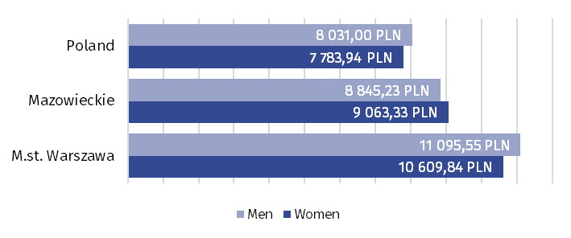
Chart 3. Median gross wages and salaries in the national economy by sex in December 2025

In December 2025, the median value of men's wages and salaries was PLN 8,845.23, which was 1.6% lower than the voivodship's total, while for women they were PLN 9,063.33, i.e. 0.8% above the average. In Warsaw, the median gross wages and salaries for men reached PLN 11,095.55 (2.6% more than in Warsaw overall), and for women PLN 10,609.84 (1.9% less, respectively).
For comparison, in Poland the median gross wages and salaries for men were PLN 8,031.00 and for women PLN 7,783.94 (respectively 1.5% more and 1.6% less than the overall median for the country).
Chart 4. Median gross wages and salaries by sections of the national economy and sex in December 2025
In Mazowieckie Voivodship, the median wage and salary of men and women are the least differentiated in the agricultural section
In Mazowieckie Voivodship in December 2025, in each section of the national economy, the median wages and salaries of men were higher than that of women, but these differences were smaller than those calculated on the basis of average wages and salaries.
The median also showed that wages and salaries across the national economy for residents of Mazowieckie Voivodship are more equal across genders than nationally. Data for the industrial section illustrates this well. Men's median wages and salaries were 0.2% higher than the total, while women's were 0.3% lower, resulting in a median wage gap of PLN 34.06. In Poland, in this section, men's median earnings exceeded the total by 4.1%, while women's earnings were lower by 7.7%, a difference of PLN 865.64. It is also noteworthy that in the agricultural section in Mazowieckie Voivodship, women's median wages and salaries were PLN 5.89 lower than men's, while the national average was PLN 338.99 higher.
In the case of quoting data from the Statistics Poland, please provide information “Statis-tics Poland data source”, and in the case of publishing calculations made on data published by the Statistics Poland, provide information: “Own study based on Statistics Poland data”.

Prepared by:  Statistical Office in Warszawa  Directo Agnieszka Ajdyn  Phone: (+48 22) 464 23 15 | Issued by:  Statistical Information Centre  Marcin Kałuski  Mobile: (+48) 783 940 141
Press office in the Statistical Office in Warszawa  Mobile: (+48) 783 940 141  e-mail: m.kaluski@stat.gov.pl |   warszawa.new.stat.gov.pl/en/

@Warszawa_STAT

@UrzadStatystycznywWarszawie

gus_stat

glownyurzadstatystycznygus

glownyurzadstatystyczny

Related information
Methodological report. Distribution of wages and salaries in the national economy
Distribution of wages and salaries in the national economy in December 2025
Average wages and salaries in the national economy in Mazowieckie Voivodship in 2024
Employed persons in the national economy living in Mazowieckie Voivodship in 2025
Data available in databases
Local Data Bank – wages and salaries
Terms used in official statistics
Average monthly gross wages and salaries
Median wage and salary

