Care services for children under age of 3 in 2025
19.3%
Increase in the number of places in children’s clubs in comparison with 2024

At the end of 2025, there were 5.1 thousand nurseries, 1.1 thousand children’s clubs and 2.4 thousand day carers providing in total 256.2 thousand places. In nurseries there were 163.5 thousand children, 16.8 thousand in children’s clubs and 12.4 thousand at day carers’.

Nurseries
As of 31 December 2025, in Poland there were 5 122 nurseries (in 2024 – 4 776). Most nurseries operated in Mazowieckie voivodeship (869) and the lowest number was recorded in Lubuskie voivodeship (112). The facilities were run mainly by physical persons (2 333).

Chart 1. Nurseries by type of supervising body in 2025

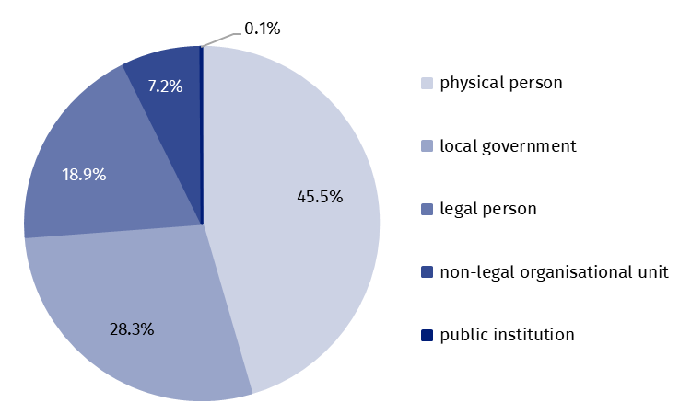
As of 31 December
45.5% nurseries were run by physical persons
Source: The data from the Ministry of Family, Labour and Social Policy.
The care for 7 to 10 hours a day was offered by 62.8% nurseries, the care over 10 hours a day – by 36.5% facilities, while other nurseries operated for less than 7 hours a day.
The amenities for children with disabilities were located in 47.1% nurseries. Most facilities were equipped with architectural amenities for children with motor disabilities (37.4%). Professional personnel was reported by 21.5% nurseries, while 12.9% facilities used professional instruments to identify development and educational needs. Other facilities (52.9%) did not have any amenities.
The total number of places in nurseries amounted to 218.9 thousand (by 6.6% more than in 2024). Most places were located in Mazowieckie voivodeship (37.6 thousand) and the lowest number was recorded in Świętokrzyskie voivodeship (4.9 thousand). Considering the number of places in nurseries per 1 thousand children up to age of 3, the biggest value referred to Dolnośląskie voivodeship (389) and the lowest one to Warmińsko-mazurskie voivodeship (225).
Nurseries provided 218.9 thousand places

Map 1. Nurseries and places in nurseries in 2025
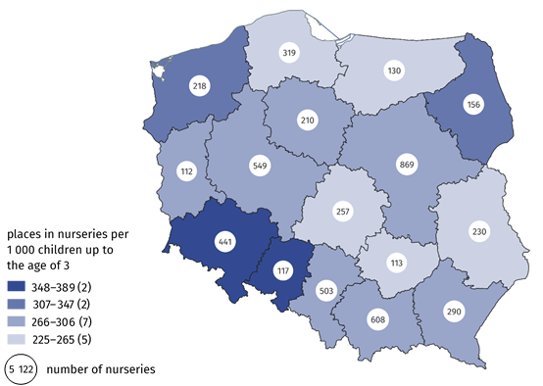
As of 31 December
Source: Own study based on the data from the Ministry of Family, Labour and Social Policy.
At the end of the year 163.5 thousand children attended the nurseries (by 1.4% less than in 2024), of which the biggest group was two-year olds – 53.5% and the smallest one was children at age of 4 – 0.2%. The share of one-year old children accounted for 38.1%, at age of 3 – 6.2. Out of all children staying in nurseries boys accounted for 51.4%. The index of the number of children staying in nurseries per 1 thousand children under age of 3 amounted to 216 (in 2024 – 201).

Children’s clubs
At the end of 2025, there were 1 056 children’s clubs (in 2024 – 896). Most clubs were in Pomorskie voivodeship (129) while the smallest number was recorded in Opolskie voivodeship (12). The facilities were run by physical persons (583), local government (259), legal persons (158), non-legal organisation units (53) and by public institutions (3).
The care for 7 to 10 hours a day was offered by 79.6% children’s clubs, the care for over 10 hours a day – 15.2% units, while the others operated for less than 7 hours a day.
Nearly 62% children’s clubs did not have any amenities for disabled children
30.7% of clubs were equipped with architectural amenities for motor disabled children, 14.4% clubs reported professional personnel, the special instruments to identify development and educational needs in 9.1%. Nearly 62% facilities were not equipped with any amenities.
The number of places in children’s clubs amounted to 22.0 thousand (by 19.3% more than in 2024). The biggest number of places in children’s clubs was recorded in Pomorskie voivodeship (2.8 thousand) and the lowest one in Opolskie voivodeship (0.2 thousand). The number of places per 1 thousand children at age up to 3 oscillated from 11.6 in Opolskie voivodeship to 58.2 in Lubuskie voivodeship.

Map 2. Children’s clubs and places in children’s clubs in 2025

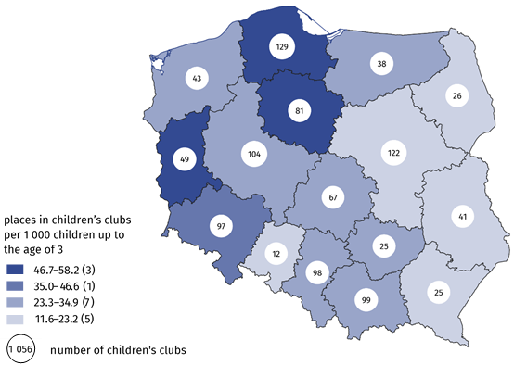
As of 31 December
Source: Own study based on the data from the Ministry of Family, Labour and Social Policy.
The two year olds constituted the largest group of children in children’s clubs – 55.9%
At the end of the year 16.8 thousand children attended the children’s clubs (by 12.9% more than in 2024). Two-year olds accounted for the biggest group – 55.9%, while the smallest group included children at age under 1 year and up to 4 years – 0.3%. Boys accounted for 52.0% of all children staying in the clubs. The index of the number of children in children’s clubs per 1 thousand children at age up to 3 amounted to 22.2.

Chart 2. Children in children’s clubs by age in 2025

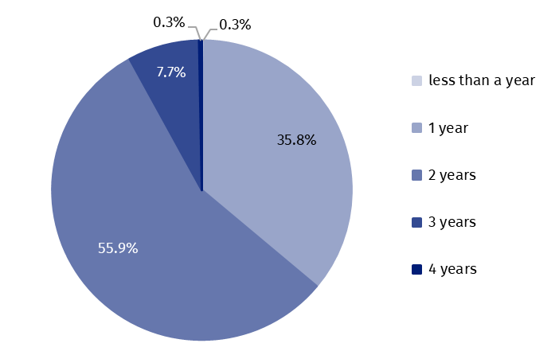
As of 31 December
Source: The data from the Ministry of Family, Labour and Social Policy.

Day carers
As of 31 December 2025 in Poland the care was provided by 2 395 day carers (in 2024 – 2 152). The physical persons employed 1 468 day carers, legal persons employed 573 carers, non-legal organisation units employed 205 day carers, local government – 148 day carers and public institution employed one day carer.

Chart 3. Day carers by daily working hours in 2025

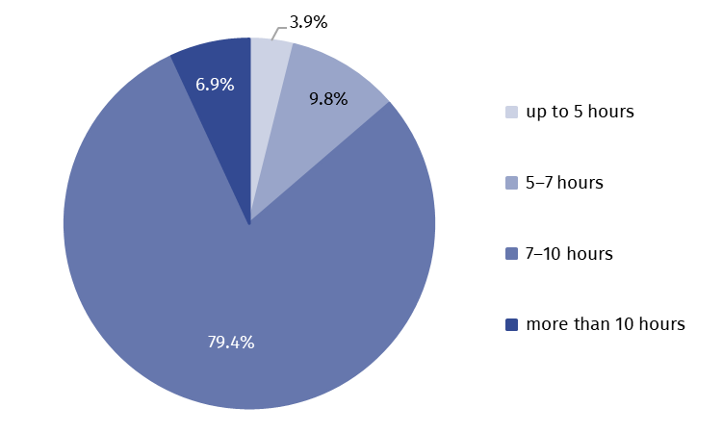
As of 31 December
Note. The sections are right side closed.
Source: The data from the Ministry of Family, Labour and Social Policy.
The care for 7 to 10 hours a day was offered by 79.4% day carers, the care for over 10 hours a day – 6.9% units, while the others operated for less than 7 hours a day.

Map 3. Day carers and places in day carers’ in 2025

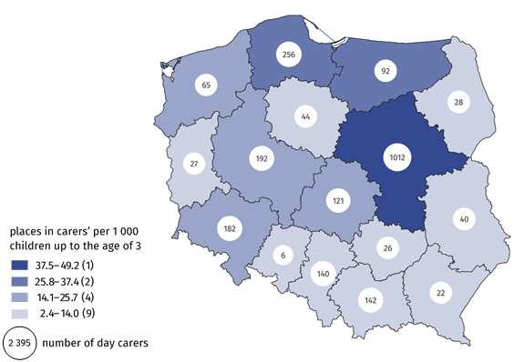
As of 31 December
Source: Own study based on the data from the Ministry of Family, Labour and Social Policy.
In Mazowieckie voivodeship the care was provided by 1 012 day carers
The total number of places provided by day carers amounted to 15.3 thousand (by 13.0% more than in 2024). Day carers in Mazowieckie voivodeship (6.3 thousand) had the biggest number of places, while the smallest number of places was recorded in Opolskie voivodeship (39). Considering the number of places per 1 thousand children at age up to 3, the biggest value referred to Mazowieckie voivodeship (49.2) and the lowest one to Opolskie voivodeships (2.4).
Day carers provided 15.3 thousand places of care
At the end of 2025 the services of day carers were provided for 12.4 thousand children (by 9.1% more than in 2024). Likewise in nurseries and children’s clubs two-year olds were the largest group – 55.3%. The share of one-year olds and children at age of 3 accounted for 31.7% and 11.8% respectively. The children at age of 4 constituted the smallest group – 0.5%. Other children were less than one year old – 0.7%. Boys accounted for 50.5% of all children in care of day carers. The index of the number of children in care of day carers per 1 thousand children at age up to 3 amounted to 16.3.

Nannies
4 469 nannies were registered in Social Insurance Institution
According to the Social Insurance Institution data, at the end of 2025 there were 4 469 registered nannies employed on the basis of activation contract (by 10.2% more than in 2024). Women accounted for 96.9% of all nannies. Most of nannies were employed in Mazowieckie voivodeship (1 001) and the smallest number was recorded in Opolskie voivodeship (33).

Chart 4. Nannies by age in 2025

As of 31 December

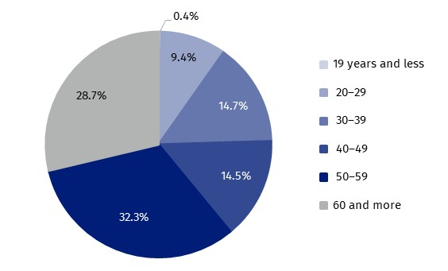
Source: The data from the Social Insurance Institution.
The persons from 50 to 59 years old amounted to the biggest group (32.3%) and the smallest group was the persons at age of 19 and less (0.4%).
When quoting this publication, please provide its title and identify Statistics Poland as the author. When publishing your calculations based on the data from the publication, please include the following disclaimer: “Own study based on data from the Statistics Poland publication Care services for children under age of 3 in 2025”.

Prepared by:  Statistical Office in Kraków  Director Agnieszka Szlubowska  Phone: (+48 12) 420 40 50 | Issued by:  Press Office  Mobile: (+48) 695 255 032  Phone: (+48 22) 608 38 04, (+48 22) 449 41 45,  (+48 22) 608 30 09  e-mail: obslugaprasowa@stat.gov.pl

stat.gov.pl/en/

@StatPoland

@GlownyUrzadStatystyczny

@gus_stat

@GłównyUrządStatystycznyGUS

@Glówny Urząd Statystyczny
Related information
Social assistance, child and family services in 2024
Data available in databases
Database Local Data Bank – health care, social welfare and benefits to the family
Knowledge Databases – Society – Social assistance and social benefits
Terms used in official statistics
Day carer
Nanny
Nursery, children's club

The number of population (at age of 0–2 years) as of 31 December 2025.
The care can still be performed when a child is over 3 years of age in case of incapacities or difficulties to include a child in pre-school education (not for longer than up to the end of the school year, in which a child is over 4 years old).
^{,4} The number of population (at age of 0–2 years) as of 31 December 2025.
The number of population (at age of 0–2 years) as of 31 December 2025.
Day carer is a person employed by local government units, public institutions, physical persons or non-legal organisation units. Day carer may run own business (so called self-employment).
The number of population (at age of 0–2 years) as of 31 December 2025.
The number of population (at age of 0–2 years) as of 31 December 2025.

