Human resources
in selected medical professions
based on administrative sources in 2025
2025 was another year of growth in the number of medics performing the most widely practiced medical professions. The number of nurses increased by 3.1 thousand (by 1.4%) reaching the level of 223.0 thousand people, the number of physicians increased by 2.4 thousand (by 1.7%) and amounted to 143.6 thousand, the number of physiotherapists increased by 2.5 thousand (by 4.0%) and reached 64.6 thousand. Less dynamic growth was noted in number of dentists and midwives (their numbers increased by 0.1 thousand and 0.2 thousand respectively) and consequently these two professional groups reached 37.0 thousand and 29.0 thousand people).
4,0%
Increase in the number of physiotherapists working with patients
compared to 2024

This news release presents data on the number and structure of medical staff involved in the treatment of patients in Poland as physicians, dentists, nurses, midwives and physiotherapists. The results are presented as December 31, 2025, against the background of data from previous years and in comparison, with indicators showing the situation in other European Union (EU) countries. In addition, information was also presented on the wider population of people residing in Poland and having the right to practise the above-mentioned medical professions – regardless of whether they currently pursue a profession outside the health care system or are currently not working at all (e.g. retired or temporarily inactive).
The study was prepared on the basis of an analysis of integrated administrative data from various sources – a list of data sources can be found in the methodological notes at the end of the news release.
The sizes of the occupational groups covered in this publication are expressed in thousands, to one decimal place. Due to rounding, the sums of the component figures may differ slightly (in the last decimal place) from the values reported in the text or presented in the charts.

Physicians
Number of medical practitioners in 2025
amounted to 143.6 thousand, of which 59.2% were women
In 2025, the number of physicians working directly with a patient amounted to 143.6 thousand. This was 2.4 thousand more people than in 2024 (an increase of 1.7%), but much larger increases were recorded over the previous two years. Compared to 2022, the number of practising physicians has increased by 12.1 thousand, i.e. by 9.2%. The number of female physicians increased slightly faster, bringing their share of the total number of physicians from 58.6% in 2022 to 59.2% in 2025.

Chart 1. Number of practising physicians total and by gender
As of 31 December
In 2025, almost 2.7 thousand physicians with Ukrainian citizenship worked in Poland (1.9% of all physicians working with patients)

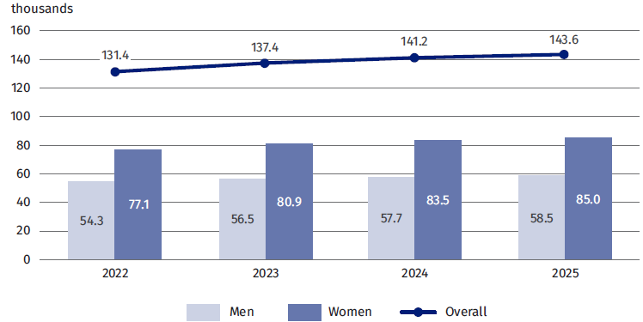
Ukrainian citizens contributed significantly to the increase in the number of practitioners in Poland. At the end of 2025, there were almost 2.7 thousand people, compared to 1.1 thousand in 2022. This represents an increase of 1.5 thousand people in three years, i.e. 132.5%. As a result, the share of Ukrainian citizens among physicians working directly with the patient in Poland has increased in the last 3 years from 0.9% to 1.9%.
The standard indicator of the potential availability of services provided by physicians is their number per 10 thousand population of the analyzed country or region. Applying the national definition of population, in 2025 the highest values of this indicator were recorded in the Mazowieckie (46.9) and Łódzkie (45.4) voivodeships, and the lowest in the Lubuskie (27.1), Opolskie (28.1), Warmińsko-Mazurskie (28.3) and Podkarpackie (30.5) voivodeships, while the national average value of this indicator was 38.5.

Map 1. Number of practising physicians per 10 thousand population by voivodeship in 2025
As of 31 December
The highest rates of physicians per 10 thousand population were recorded in the Mazowieckie and Łódzkie voivodeships, and the lowest in the Lubuskie, Opolskie, Warmińsko-Mazurskie and Podkarpackie voivodeships
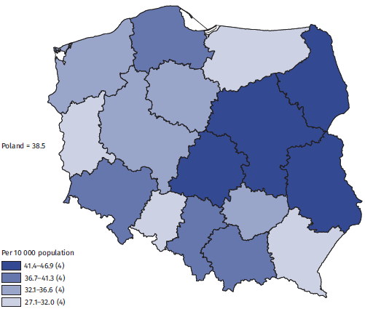
Eurostat’s 2024 rate of physicians per 10 thousand resident population shows that the potential availability of physicians in our country is much lower than the average for the European Union (excluding Slovakia): the indicator value for Poland was 38.6, while the EU average value was 45.2. Against the background of 26 countries compared, the indicator of the potential availability of physicians places Poland in 19th place.
In 2024, Poland ranked 19th out of 26 EU countries compared in terms of the number of medical practitioners per 10 thousand resident population
Chart 2. Number of practising physicians per 10 thousand resident population in European Union countries in 2024
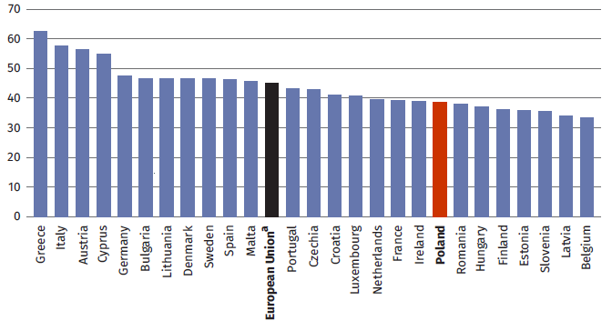
ª EU weighted average calculated taking into account the population of each country; Slovakia was not included due to lack of data.
Source: Own calculations based on Eurostat data, accessed 7.08.2026, https://ec.europa.eu/eurostat/databrowser/view/hlth_rs_prs2/default/
table?lang=en&category=hlth.hlth_care.hlth_res.hlth_staff
Of the total number of physicians working in Poland, 63.9% had at least one specialization
In 2025, 63.9% of physicians working in Poland had at least one specialization. Thus, the number of specialist physicians amounted to 91.8 thousand (in 2024 it was 91.1 thousand, i.e. 64.5% of the total number of physicians).
As in the previous year, most physicians had a specialization in internal medicine (18.3 thousand). Family medicine came second (11.0 thousand, up 0.2 thousand), followed by pediatrics (7.6 thousand, up 0.2 thousand).

Table 1. The most common specializations of practising physicians
As of 31 December
Name of specialisation | 2024 |  | 2025
Name of specialisation | Number of doctors specialist  (thousands) | % of doctor specialists who hold specialization in a given field ª | Number of doctors specialist  (thousands) | % of doctor specialists who hold specialization in a given field ª
Internal diseases | 18,2 | 20,0 | 18,3 | 19,9
Family medicine | 10,8 | 11,9 | 11,0 | 12,0
Pediatrics | 7,4 | 8,2 | 7,6 | 8,3
Obstetrics and gynecology | 6,2 | 6,8 | 6,2 | 6,7
General surgery | 5,8 | 6,4 | 5,8 | 6,3
Anesthesiology and intensive therapy | 5,6 | 6,2 | 5,7 | 6,2
Cardiology | 5,1 | 5,6 | 5,2 | 5,7
Trauma and orthopedic surgery | 3,9 | 4,3 | 4,0 | 4,3
Psychiatry | 3,8 | 4,2 | 3,9 | 4,3
Radiology and diagnostic imaging | 3,7 | 4,1 | 3,9 | 4,2
Ophthalmology | 3,6 | 4,0 | 3,7 | 4,0
Neurology | 3,5 | 3,9 | 3,5 | 3,8
Diseases of the lungs | 2,3 | 2,5 | 2,4 | 2,6
Otorhinolaryngology | 2,1 | 2,3 | 2,1 | 2,3
Dermatology and venereology | 1,9 | 2,1 | 1,9 | 2,1
ª One physician may have more than one specialization.
When analyzing the number of physicians as medical staff, on which the appropriate level of meeting the health care needs of Polish residents depends, it is worth considering not only practising physicians, but also people who, despite having permissions do not currently work with patients (e.g. are not professionally active at all), but under favorable circumstances they could perform the profession of physician.
The number of people who in 2025 had the right to practice the profession of physician and lived in Poland amounted to 171.2 thousand, which is 27.7 thousand more than the number of practising physicians
In 2025, the number of people living in Poland who have the right to practice the profession of physician amounted to 171.2 thousand, which is 27.7 thousand more (by 19.3% more) than the number of practising physicians. Compared to the previous year, the number of persons authorised to practice the profession of physician increased by 4.7 thousand, i.e. by 2.8%. So it was almost twice the increase observed in the group of practising physicians. The population of physicians was slightly more feminized than the subpopulation of practising physicians (60.2% vs. 59.2%). The population of people entitled to practice physician was also on average 3 years older than the subgroup of physician working with patients (the average age was 51 and 48 years, respectively).
Dentists
In 2025, 37.0 thousand dentists worked with patients in Poland, the vast majority of whom were women (73.5%)
In 2025, 37.0 thousand dentists worked with patients, 593 of whom were physicians at the same time. Although the number of dentists has increased by less than 0.1 thousand in the last year, there have been bigger increases in the preceding years: by 1.1 thousand in 2023 and 1.0 thousand in 2024, respectively.
People with Ukrainian citizenship contributed significantly to the increase in the number of dentists working with the patient. They increased by 0.3 thousand in 2023 and 0.2 thousand in 2024, while in 2025 their number decreased by less than 0.1 thousand people. The share of Ukrainian citizens among those working as dentists in Poland increased from 0.8% in 2022 to 2.1% in 2024 and decreased to 1.9% in 2025.
The profession of dentist is mostly performed by women, although their percentage has been decreasing slightly in recent years (from 74.0% in 2022 to 73.5% in 2025).

Chart 3. Number of practising dentists total and by gender
As of 31 December

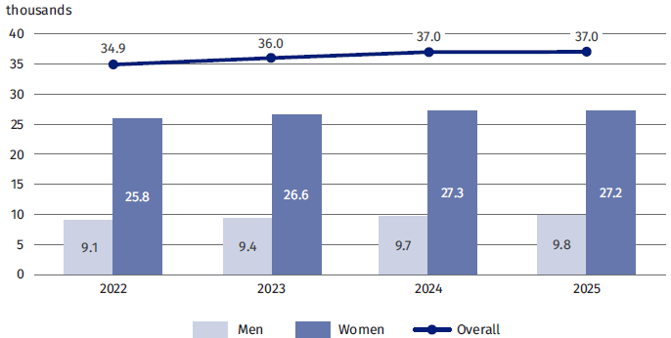
Taking into account the number of dentists practising in individual voivodeships and data on the number of inhabitants of these voivodeships (according to the national definition of the population), in 2025 the value of the ratio of the number of dentists per 10 thousand of the population was 9.9 on a national scale. Relatively high potential availability of dentists was recorded in the Łódzkie, Mazowieckie and Podlaskie voivodeships (indicator values were 11. 9, 11.7 and 11.5 respectively), while relatively low index values were recorded in the following voivodeships: Kujawsko-Pomorskie (6.8), Warmińsko-Mazurskie (7.3), Opolskie (7.5) and Lubuskie (7.8).

Map 2. Number of practising dentists per 10 thousand population by voivodeship in 2025
As of 31 December
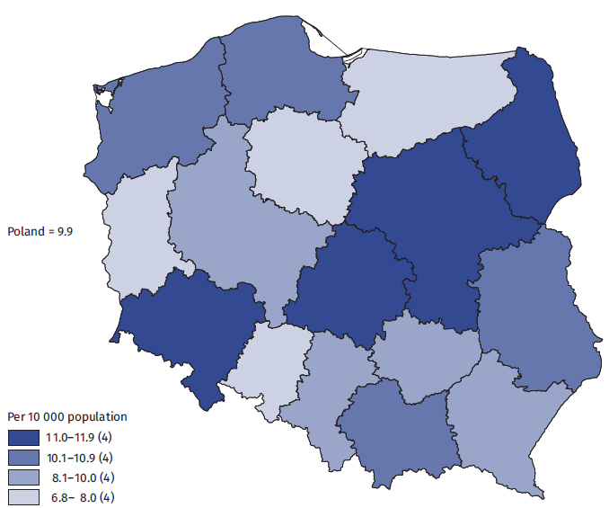

In terms of the potential availability of dentists, Poland ranks 9th among the 26 European Union countries. The index of the number of dentists per 10 thousand resident population calculated by Eurostat for 2024 also shows that the availability of dentists in our country is higher than the average for the European Union (excluding Slovakia): the indicator value for Poland was 10.1 compared to 8.3 for the EU.
Poland ranks 9th among the 26 European Union countries in terms of the number of dentists per 10 thousand resident population
Chart 4. Number of practising dentists per 10 thousand resident population in European Union countries in 2024
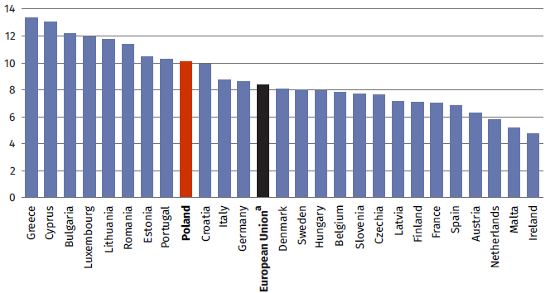
ª EU weighted average calculated taking into account the population of each country; Slovakia was not included due to lack of data.
Source: Own calculations based on Eurostat data, accessed 7.08.2026, https://ec.europa.eu/eurostat/databrowser/view/hlth_rs_prs2/default/
table?lang=en&category=hlth.hlth_care.hlth_res.hlth_staff
In 2025, among 37.0 thousand dentists working in Poland, 6.7 thousand (i.e. 18.1%) were people with specialization. Compared to the previous year, the number of dentists with at
In 2025, the number of people living in Poland who had the right to practice dentistry amounted to 46.8 thousand, i.e. 9.8 thousand more (i.e. 26.4% more) than the number of practising dentists. Compared to the previous year, the number of people with the right to practice the profession of dentist increased by only 0.8 thousand, but it was still a much greater increase than that recorded among practising dentists (an increase of less than 0.1 thousand people).
The population of people with the right to practice as dentists was slightly more feminized than its subpopulation of practising dentists (75.8% vs 73.5%). The population of people entitled to practise as dentists was also, on average, older than practising dentists (average ages of 51 and 46 years, respectively).

Nurses
In 2025, 223.0 thousand nurses worked with patients in Poland
In 2025, the number of people who practiced the profession of nurse amounted to 223.0 thousand. This was 3.1 thousand more than in 2024 (an increase of 1.4%) and at the same time it was a continuation of the increases recorded in the previous two years. In total, the number of people working as a nurse increased by 8.7 thousand, i.e. by 4.0% - compared to year 2022.
Although the vast majority of the profession of nurse is carried out by women, over the last three years the number of men working as nurses has increased slightly faster than the number of women and, as a result, the share of women has decreased from 96.8% in 2022 to 95.8% in 2025.

Chart 5. Number of practising nurses total and by gender
As of 31 December
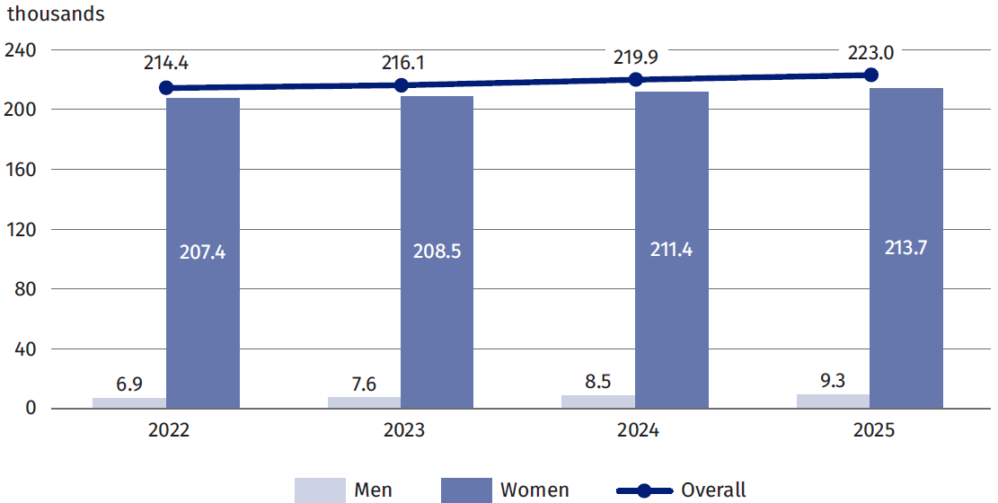
The share of people with Ukrainian citizenship in the number of practising nurses in Poland was relatively small and in 2025 amounted to 0.7%, i.e. 1.6 thousand people. However, it is worth noting that this was much more than in 2022, when the corresponding data amounted to 0.2% and 0.3 thousand people.
Taking into account the number of people working as nurses, taking into account the voivodship of their main place of work and data on the population in these voivodeships (according to the national definition of the population), in 2025 the ratio of the number of nurses per 10 thousand population was 59.7 on a national scale. Relatively high values of this indicator were recorded in the Świętokrzyskie (73.5) and Lubelskie (71.1) voivodeships, and the lowest in the Pomorskie (48.1), Lubuskie (48.4), Zachodniopomorskie (48.6) and Wielkopolskie (48.8) voivodeships.

Map 3. Number of practising nurses per 10 thousand population by voivodeship in 2025
As of 31 December
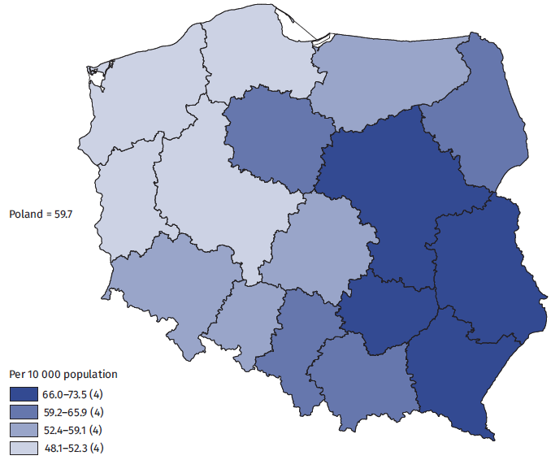
In 2024, Poland ranked 15th out of 24 compared EU countries in terms of the number of nurses per 10 thousand resident population
Among 24 European Union countries, the value of the potential availability of nursing services index places Poland on 15th position. Eurostat’s indicator of the number of nurses per 10 thousand resident population for 2024 also shows that their potential availability in our country is much lower than the average for the European Union (excluding Slovakia, France and Belgium): the indicator value for Poland was 60.1 vs. 80.7 for the EU.
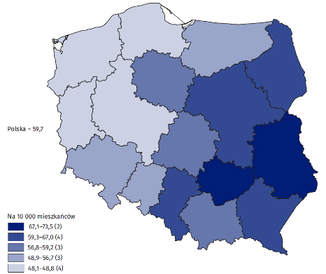
Chart 6. Number of practising nurses per 10 thousand resident population in European Union countries in 2024.
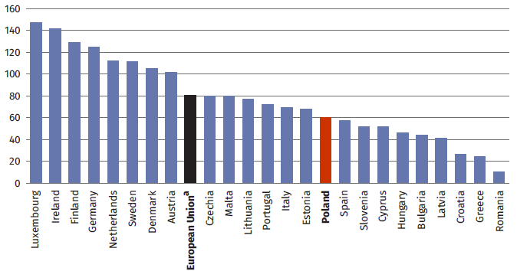
ª EU weighted average calculated taking into account the population of each country; Slovakia, France and Belgium not included due to lack of data
Source: Own calculations based on Eurostat data, accessed 7.08.2026, https://ec.europa.eu/eurostat/databrowser/view/hlth_rs_prs2/default/
table?lang=en&category=hlth.hlth_care.hlth_res.hlth_staff
In 2025, the number of nurses living in Poland and holding the right to practice the profession amounted to 330.9 thousand. (in 2024 it was 323.6 thousand). This profession was strongly dominated by women (319.4 thousand people, i.e. 96.5%), and the number of nurses men was relatively small (11.5 thousand).
The group of persons entitled to practise the profession of nurse was also, on average, older than practising nurses (average age was 54 and 49 years, respectively).

Midwives
In 2025, the number of practising midwives amounted to 29.0 thousand
The number of practising midwives in 2025 amounted to 29.0 thousand (in 2024 – 28.8 thousand). This was 0.6% more than in 2024, and at the same time it was a continuation of a long-term but low-growth upward trend. In total, the number of people working as midwives increased by almost 0.6 thousand, i.e. by 2.0% - comparing to year 2022.

Chart 7. Number of practising midwives total and by gender
As of 31 December
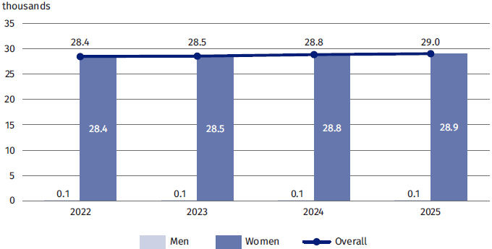
The occupation of midwife is 99.8% performed by women, and the number of men remains at the level of less than 0.1 thousand.
In 2025, the rate of potential availability of midwifery services, measured as the number of people performing the profession of midwife per 10 thousand women, reached the value of 15.0 on a national scale. The highest values of the index were recorded in the Mazowieckie (17.6) and Łódzkie (17.4) voivodeships, and the lowest value - in the Lubuskie (10.8) voivodeship.

Map 4. Number of practising midwives per 10 thousand women by voivodeship in 2025
As of 31 December

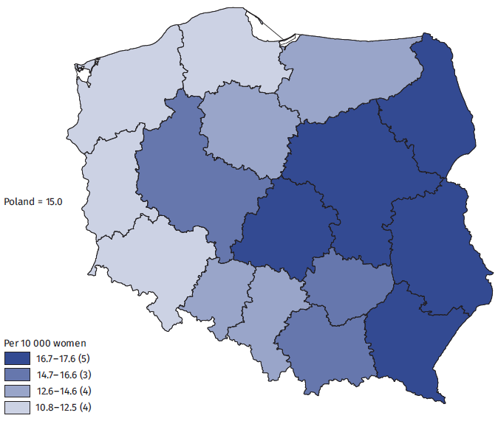
In 2024, Poland ranked 3rd among the 25 EU countries compared in terms of midwives per 10 thousand resident population
In turn, the indicator of the number of midwives per 10 thousand resident population calculated by Eurostat shows that the potential availability of maternity benefits places Poland in the third place among the 25 countries of the European Union compared. In 2024, the value of this indicator for Poland was 7.9, while the average value of the indicator for the EU (excluding Slovakia and Belgium) was 3.8.
Chart 8. Number of practising midwives per 10 thousand resident population in European Union countries in 2024
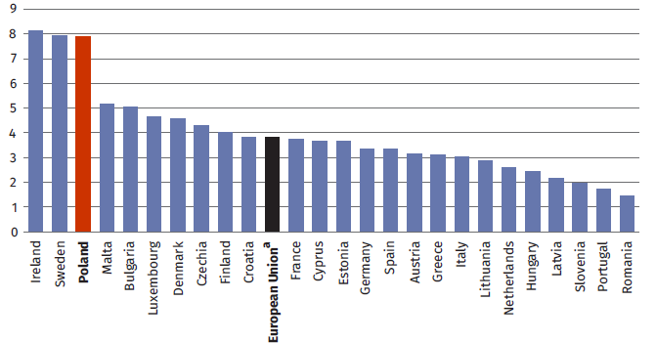
ª EU weighted average calculated taking into account the population of each country; Slovakia and Belgium were not included due to lack of data.
Source: Own calculations based on Eurostat data, accessed 7.08.2026, https://ec.europa.eu/eurostat/databrowser/view/hlth_rs_prs2/default/
table?lang=en&category=hlth.hlth_care.hlth_res.hlth_staff
In 2025, the number of persons with the right to practise the profession of midwife and living in Poland amounted to 43.7 thousand (42,9 thousand in the previous year). This was 14.7 thousand more people (i.e. 50.7% more ) than the number of midwives currently working in their profession. As in the case of the sub-group of people working directly with patients, 99.8% of those authorised to practice this profession were women.
On average, the persons forming the group entitled to practise the profession of midwife were 5 years older than those in the sub-group currently practising the profession of midwife (the average age was 51 and 46 years, respectively).

Physiotherapists
In 2025, the number of practising physiotherapists was 64.6 thousand, of which 71.7% were women
In 2025, the number of people who practiced the profession of physiotherapist in Poland amounted to 64.6 thousand This was by 2.5 thousand people more than in 2024, with a percentage increase of 4.0%.
The increase in the number of physiotherapists in 2025 continued the long-term upward trend. Compared to 2022, the number of people working as physiotherapists increased by
8.8 thousand, i.e. by 15.7%.
The profession of physiotherapist is largely carried out by women, although their share has been decreasing slightly in recent years (from 72.8% in 2022 to 71.7% in 2025).

Chart 9. Number of practising physiotherapists total and by gender
As of 31 December

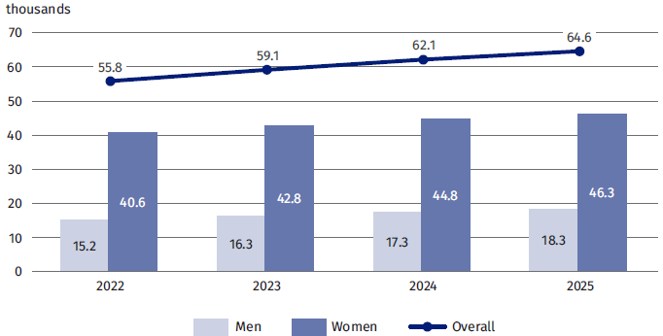
In 2025, the ratio of the number of physiotherapists per 10 thousand population (calculated using the national definition of the population) reached 17.3 at the national level. The Podkarpackie voivodeship (22.5) ranked first in terms of the potential availability of physiotherapists’ services measured by this indicator, followed by Świętokrzyskie voivodeship (22.2). The lowest value of the indicator was recorded in the Lubuskie voivodeship (11,6).

Map 5. Number of practising physiotherapists per 10 thousand population by voivodeship in 2025
As of 31 December
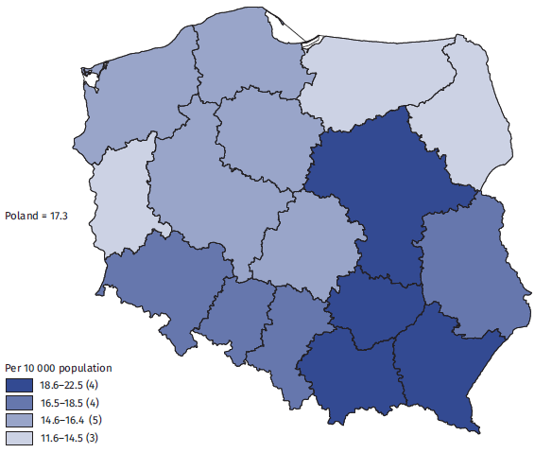
Poland ranks 7th among the 26 European Union countries in terms of the number of physiotherapists per 10,000 resident population
Compared to 26 European Union countries, the index of potential availability of physiotherapist's services places Poland in 7th place. The Eurostat index of the number of physiotherapists per 10 thousand resident population also shows that in 2024 the potential availability of physiotherapists in our country was higher than the EU average (excluding Portugal): the indicator value for Poland was 17.0 vs. 15.1 for the EU.
Chart 10. Number of practising physiotherapists per 10 thousand resident population in the European Union countries in 2024
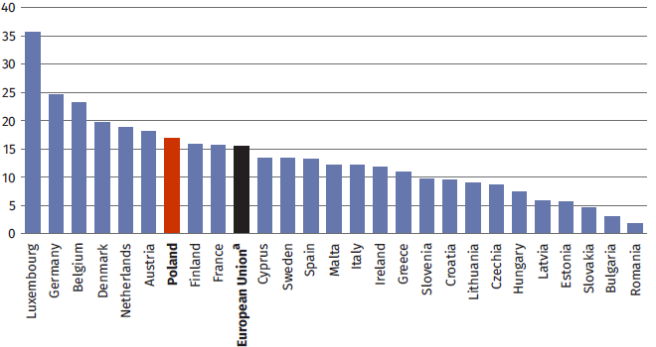
ª EU weighted average calculated taking into account the population of each country; Portugal was not included due to lack of data.
Source: Own calculations based on Eurostat data, accessed 7.08.2026, https://ec.europa.eu/eurostat/databrowser/view/hlth_rs_prs2/default/
table?lang=en&category=hlth.hlth_care.hlth_res.hlth_staff
In 2025, the number of persons with the right to practise the profession of physiotherapist and living in Poland amounted to 84.6 thousand (81.2 thousand in the previous year). This was 20.0 thousand more people (i.e. 31.0%) than the subset of physiotherapists currently working in their profession counted. The percentage of women was slightly higher in the group having the right to practise the profession of physiotherapist (72.8%) than in the sub-group of people currently practising this profession (71.7%).
On average, the persons forming the group entitled to practise the profession of physiotherapist were one year older than those in the sub-group currently practising the profession of physiotherapist (the average age was 39 and 38 years, respectively).

Methodological notes
For the purpose of determining the size and structure of the population of persons having the right to practise the profession of physician, dentist, nurse, midwife and physiotherapist, as well as to determine the characteristics of the subpopulation of persons who, having the above rights, worked with patients, data from the following sources were integrated and analyzed:
- General Electronic System of Population Records (PESEL) run by the Ministry of Digital Affairs,
- the Central Insured List (CWU) maintained by the National Health Fund,
- List of Contribution Payers maintained by the Social Insurance Institution,
- The Register of Entities Performing Medicinal Activities (RPWDL) including, among others, individual practices: physicians, dentists, nurses, midwives and physiotherapists (data of e-Health Centre),
- List of physicians entered into contracts with the National Health Fund – data from the National Health Fund,
- Central Register of Nurses and Midwives maintained by the General Chamber of Nurses and Midwives,
- Central Register of Physicians, including dentists, kept by the Supreme Medical Chamber,
- National Register of Physiotherapists maintained by the National Chamber of Physiotherapists,
- Datasets developed in Statistics Poland for the purposes of other statistical surveys.

When quoting this publication, please provide its title and indicate Statistics Poland as the author. When publishing your own calculations based on data from this publication, please include the following statement: Author’s work based on data from Statistics Poland’s publication entitled ‘Human resources for selected medical professions based on administrative sources in 2025’.

Substantive study:  Social Research Department  Director  Izabela Grabowska, PhD  Tel: 22 608 31 22 | Issued by:  Press Office  Mobile: +48 695 255 032  Fixed telephone: +48 22 608 38 04, +48 22 449 41 45, +48 22 608 30 09  e-mail: obslugaprasowa@stat.gov.pl

stat.gov.pl

@GUS_STAT

@GlownyStatistical Office

@gus_stat

@MainStatistics OfficeGUS

@Main Statistical Office
Related studies
Emergency and emergency medical assistance in 2025 –contains data on paramedics
Pharmacies and pharmacy outlets in 2025 – contains data on pharmacists
Health and healthcare in 2024
Human resources in selected medical professions based on administrative sources in 2024
Subject available in databases
OECD Data Explorer • Healthcare human resources
EUROSTAT - Health personnel
Important concepts available in the glossary of concepts used by Statistics Poland
Doctor
Dentist
Nurse
Midwife

Pharmacists and paramedics are not included in this news release. Data on the number of people working in these professions in 2025 have already been published in the news release available on stat.gov.pl: https://stat.gov.pl/en/topics/health/health/pharmacies-and-pharmaceutical-outlets-in-2025,8,10.html and https://publikacje.new.stat.gov.pl /en/publications-portal/first-aid-and-emergency-medical-services-2025
The data presented include both women and men: physicians and dentists, nurses and midwives and physiotherapists residing in Poland. The names of professions are consistent with the provisions cited in the legal acts: Act of 5 December 1996 on the professions of physician and dentist (Journal of Laws 2026, item 37 as amended); Act of 15 July 2011 on the professions of nurse and midwife (Journal of Laws 2026, item 15 as amended); Act of 25 September 2015 on the profession of physiotherapist (Journal of Laws 2026, item 584).
These are people who obtained Ukrainian citizenship at the time of their birth and even if they later also obtained Polish citizenship, they are counted here as Ukrainian citizens.
The national population was used to calculate the value of the indicator; source: Population. Size and structure and vital statistics in Poland by territorial division in 2025. As of 31 December, p. 13 table 1, https://stat.gov.pl/en/topics/population/population/ population-size-and-structure-and-vital-statistics-in-poland-by-territorial-division-in-2025-as-of-31-december,3,39.html
⁵ The figures for the number of physicians per 10 thousand population are calculated by Eurostat taking into account the resident population. The resident population does not include people who have left the country for more than 12 months, although they are still registered in Poland. At the same time, Poland commonly uses the national definition of population, which does not apply this exclusion, resulting in a resident population of 36.5 million at the end of 2024, while the national standard population was 37.5 million. As a result, the values of indicators in which the population of Poland is present in the denominator (e.g. the number of physicians per 10 thousand population) are slightly higher when the data are presented in international databases, where the resident population is used, than when the indicators are calculated for domestic purposes – using the national population definition.
The conditions for obtaining specialization are laid down in the Act of 5 December 1996 on the professions of physician and dentist (Journal of Laws 2026, item 37 as amended) and the Regulation of the Minister for Health of 4 May 2023 on the specialisation of physicians and dentists (Journal of Laws 2023, item 975). Data on specialists concern physicians with second-degree specialization and, since 2005, persons holding the title of specialist physician in the relevant field of medicine, in accordance with the Regulation of the Minister of Health of 4 May 2023 on the specialization of physicians and dentists (Journal of Laws 2023, item 975).
Age is given in full (completed) years.
See footnote 3.
See footnote 4.
See footnote 5.
See footnote 8.
See footnote 7.
See footnote 3.
See footnote 4.
See footnote 5.
See footnote 7.
For the calculation of the value of the indicator, the number of women according to the definition of the national population was used; Source: Population. Size and structure and vital statistics in Poland by territorial division in 2025. As of 31 December, appendix table no 2, https://stat.gov.pl/en/topics/population/population/population-size-and-structure-and-vital-statistics-in-poland-by-territorial-division-in-2025-as-of-31-december,3,39.html
See footnote 4.
See footnote 5.
See footnote 7.
See footnote 4.
See footnote 5.
See footnote 7.

