Economic aspects of environmental protection 2025

The amount of outlays on fixed assets for environmental protection in 2025 amounted to approx. PLN 18.1 billion (compared to PLN 15.1 billion in 2024), and outlays on fixed assets for water management reached the level of approx. PLN 4.8 billion (PLN 3.6 billion in 2024). In 2025, outlays on environmental protection and water management accounted for 0.46% and 0.12% of GDP, respectively (0.42% and 0.10% in 2024, respectively).
22.5%
Outlays on fixed assets for environmental protection and water management in relation to 2024.
In 2025, outlays on fixed assets for environmental protection amounted to approx. PLN 18.1 billion, and on water management to approx. PLN 4.8 billion
The biggest year to year increase in investments in 2025 was seen in relation to waste management (by 1.3 billion PLN), wastewater management and water protection (by 1.1 billion PLN) and air protection (by 0.3 billion PLN).
As in previous years, enterprises are the main investor in outlays on fixed assets for environmental protection, followed by gminas, and then budgetary units. The group of investors with the highest share of outlays in the field of water management were gminas, then enterprises and budgetary units.

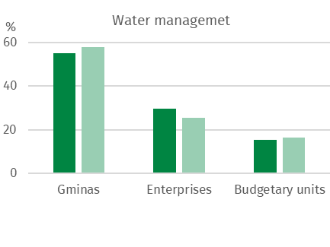
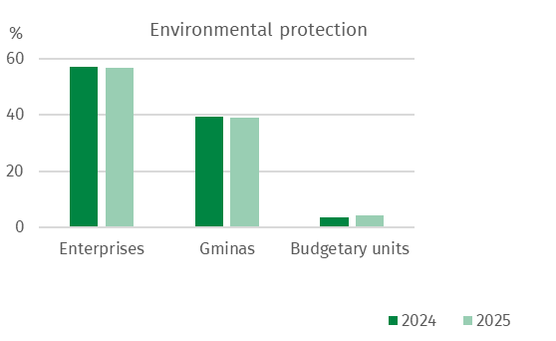
Chart 1. Structure of outlays on fixed assets for environmental protection and water management by groups of investors

The highest outlays on fixed assets for environmental protection were incurred in the following voivodships: Mazowieckie (14.0% of total outlays on fixed assets for environmental protection), Śląskie (11.5%) and Wielkopolskie (11.0%), while the lowest in Lubuskie (1.9%) as well as Zachodniopomorskie (2.6%) and Opolskie (2.6%).
In water management, the highest outlays were incurred in the following voivodships: Dolnośląskie (15.2% of total expenditure), Mazowieckie (13.1%), as well as Podkarpackie (9.0%), while the lowest in Opolskie (1.9%), Świętokrzyskie (2.1%) and Lubuskie (3.6%).
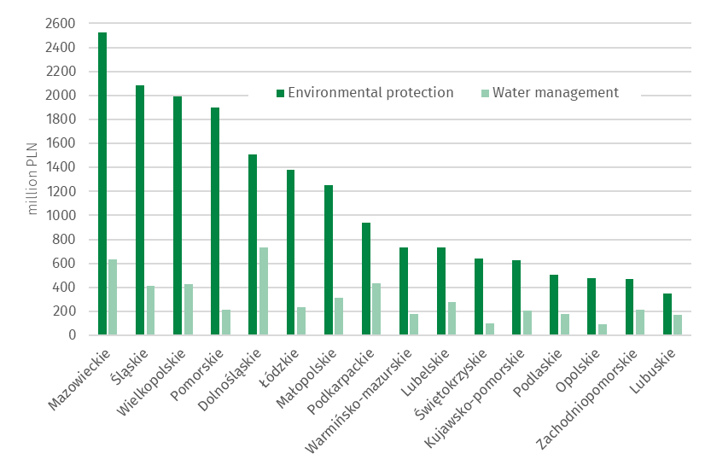
Chart 2. Outlays on fixed assets for environmental protection and water management by voivodship in 2025

Outlays on fixed assets for environmental protection

Outlays on fixed assets for environmental protection are classified according to 9 areas of environmental protection:

air and climate protection;

wastewater management and protection of water;

waste management;

protection and restoration of the utility value of soils and protection of groundwater and surface waters;

noise and vibration reduction;

protection of biodiversity and landscape;

protection against ionising radiation;

research and development activities;

other environmental protection activities (mainly energy saving).
In 2025, outlays on fixed assets for environmental protection amounted to approx. PLN 18.1 billion (PLN 15,1 billion in 2024).
The structure of outlays on fixed assets for environmental protection in Poland in 2025 was dominated by outlays on wastewater management and protection of water, as well as on air and climate protection, with a share of 47.4% and 29.8%, respectively. The remaining 22.8%
of outlays are outlays on waste management (14.3%), noise and vibration reduction (1.3%), protection of biodiversity and landscape (0.5%), protection of soil and ground and surface waters (0.4%), and other environmental protection activities (6.3%), respectively.
In 2025, outlays on fixed assets for wastewater management and protection of water amounted to PLN 8.6 billion
In 2025, outlays on fixed assets for wastewater management and protection of water amounted to PLN 8.6 billion. The highest outlays for this purpose were incurred in the following voivodships: Mazowieckie (12.4%), Śląskie (11.4%) and Małopolskie (9.9%), the lowest in Lubuskie (2.4%), Opolskie (2.6%), and Podlaskie (2.6%).

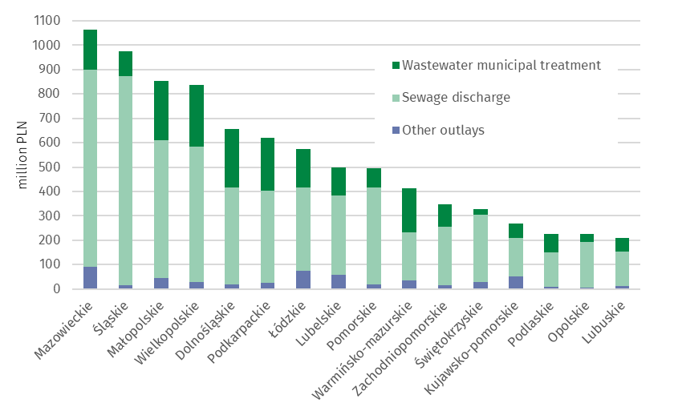
Chart 3. Outlays on fixed assets for wastewater management and protection of water by voivodship in 2025
In 2025, outlays on fixed assets for air and climate protection amounted to PLN 5.4 billion
Outlays on fixed assets for the protection of air and climate amounted to PLN 5.4 billion. The highest outlays were incurred in the following voivodships: Wielkopolskie (18.3%) and Śląskie (12.2%), the lowest in Lubuskie (0.5%), Zachodniopomorskie (1.0%), and Lubelskie (2.2%).
The largest part of outlays on air and climate protection were outlays on pollution prevention equipment (85.0% of the total expenditure), including modern fuel combustion technologies along with the modernisation of boiler and thermal energy plants (42.9%), unconventional energy sources (28.3%) and pollution reduction equipment (14.0%)
The highest outlays on unconventional energy sources were in Wielkopolskie (PLN 491 million) and Dolnośląskie (PLN 247 million), the lowest in Lubuskie (PLN 11 million) and Opolskie (PLN 15 million).
Outlays on waste management amounted to PLN 2.6 billion, on noise and vibration reduction PLN 0.2 billion, on protection of biodiversity and landscape PLN 0.1 billion, on soil, ground and surface water protection PLN 0.1 billion, and on other activities PLN 1.1 billion was spent in total, including 1.0 billion PLN on energy-saving projects related to central heating and hot water, as well as building insulation.
The increase in waste management outlays in 2025 was caused by, among other things, the introduction of the deposit-refund system and the construction and expansion of Municipal Waste Selective Collection Points. The highest outlays on waste management were in the Pomorskie and Mazowieckie voivodships (PLN 1.5 billion summed), on noise and vibration reduction in Mazowieckie and Pomorskie (PLN 128 million summed).
The lowest outlays on waste management were in Lubuskie and Opolskie (PLN 20 million summed), on noise and vibration reduction in Świętokrzyskie and Kujawsko-Pomorskie (PLN 0.8 million summed) and in Podlaskie voivodship there were no outlays incurred for this purpose.
In 2025 the Mazowieckie and Podlaskie voivodships were characterized amongst other voivodships by the highest outlays on protection of biodiversity and landscape (PLN 68 million summed), whereas the lowest outlays were in Pomorskie and Zachodnio-Pomorskie voivodships (PLN 0.03 million summed). In the Opolskie voivodeship there were no outlays incurred for this purpose.

Outlays on fixed assets for water management
Investments related to water management include water intakes and systems (including the main and distribution water network and construction of water quality control laboratories, including automatic water quality measurement stations), construction and modernization of water treatment plants, construction of water reservoirs (except fire and daily equalisation reservoirs), water, sailing and energy falls, as well as locks and weirs, regulation and management of rivers and mountain streams, construction of flood embankments and construction of pump stations behind embankments and in depression areas.
In 2025, the amount of outlays on water management amounted to approx. PLN 4.8 billion
In 2025, the amount of outlays on water management amounted to approx. PLN 4.8 billion (PLN 3.6 billion in 2024). The main stream of outlays were directed to the construction of drinking water infrastructure. Investments in water intakes and systems accounted for 53.2% of all outlays in water management.

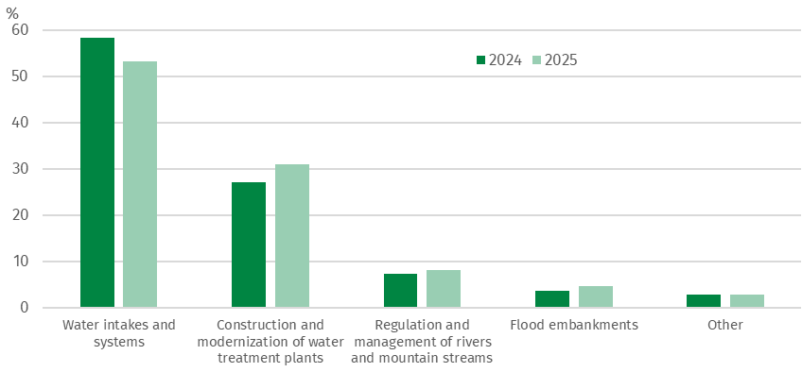
Chart 4. Structure of outlays on fixed assets for water management

The largest outlays on water intakes and systems were incurred in Śląskie (PLN 316 million) and Mazowieckie (PLN 266 million) voivodships. On the other hand, on water reservoirs and falls as well as flood embankments in Dolnośląskie (PLN 139 million) and Podkarpackie (PLN 58 million) voivodships. For the construction and modernization of water treatment plants, the greatest amount of funds was allocated in the Mazowieckie voivodship (PLN 341 million).

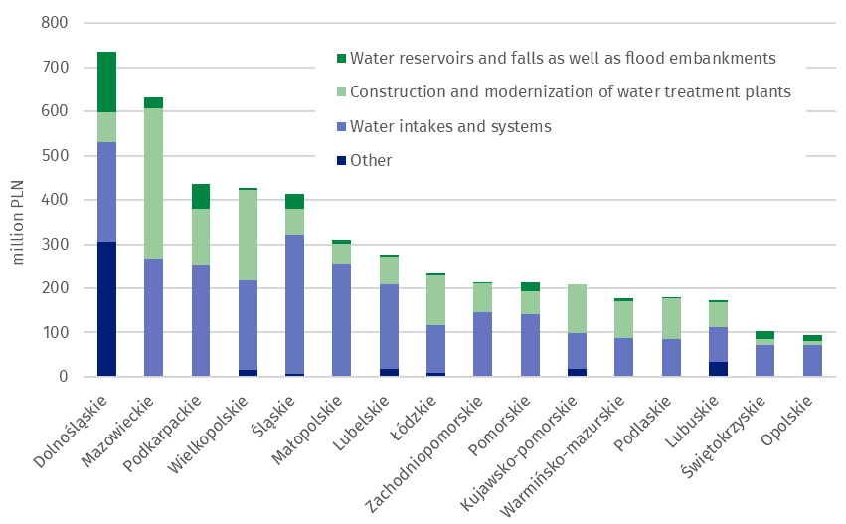
Chart 5. Outlays on fixed assets for water management by voivodship in 2025
Tangible effects of investments in environmental protection and water management
In 2025, as a result of the implementation of environmental protection investments, 93 wastewater treatment plants with a total capacity of 76 thousand m³/day
In 2025, as a result of the implementation of environmental protection investments,
93 wastewater treatment plants with a total capacity of 76 thousand m³/day (including
87 municipal wastewater treatment plants with a total capacity of 62 thousand m³/day) were completed. 4.6 thousand km of sewage network discharging wastewater and approx. 0.6 thousand km of sewage network discharging precipitation water were completed.
In the field of air protection, devices for reducing particulates pollutants with a capacity of approx. 93.6 thousand tons/year and equipment for neutralisation of gaseous pollutants with a capacity of approx. 10.8 thousand tons/year were completed.
In 2025, waste neutralisation equipment and installations with a total capacity of approx. 796 thousand tons/year were completed.
In 2025, in terms of the tangible effects of water management investments, the capacity of newly completed water supply devices amounted to approx. 91 thousand m³/day for water intakes, and approx. 132 thousand m³/day for water treatment plants. Seven water reservoirs were built with a total capacity of approx. 157 thousand m³. In addition, 3.9 thousand km of the water supply network were built, 97.5 km of rivers and mountain streams were regulated and management, and 39.7 km of flood embankments were built or modernised.

When quoting this publication, please provide its title and indicate Statistics Poland as the author. When publishing your own calculations based on data from this publication, please include the following statement: Author’s work based on data from Statistics Poland’s publication entitled ‘Economic aspects of environmental protection 2025’.

Prepared by:  Agriculture and Environment  Statistics Department  Director Marta Wojciechowska  Phone: (+48 22) 608 31 28 | Issued by:  Press Office  Mobile: (+48) 695 255 032  Phone: (+48 22) 608 38 04, (+48 22) 449 41 45,  (+48 22) 608 30 09  e-mail: obslugaprasowa@stat.gov.pl

stat.gov.pl/en/
@StatPoland
@GlownyUrzadStatystyczny
@gus_stat
@GłównyUrządStatystycznyGUS
@Glówny Urząd Statystyczny
Related information
Infographic - Economic aspects of environmental protection
Economic aspects of environmental protection 2025
Data available in databases
Local Data Bank - Environmental protection
Terms used in official statistics
Tangible effects of environmental protection and water management investments

Source: GDP data available at: Poland macroeconomic indicators – update as of April 17, 2026.
By investment location.
In accordance with the Polish Statistical Classification of Activities and Facilities Related to Environmental Protection, introduced by the Regulation of the Council of Ministers of March 2, 1999 (Journal of Laws 1999, No. 25, pos. 218).

