Intermodal transport in Poland in 2025
Intermodal transport allows to create modern transport chains that combine two or more modes
of transport into single system. It relies on a network
of nodes that connect the different modes of transport involved in the transport of goods without changing the loading unit. The greater the number of nodes including land and maritime terminals, the easier it is to access the transport network.
8.5%
Increase in transshipments
at intermodal terminals
compared to 2024
In 2025, there were 42 active terminals, i.e. 2 more than
in the previous year
An intermodal terminal is a facility that enables the quick and safe reloading of units between two different modes of transport. There were 42 active terminals located in Poland in 2025, including:
– 4 handled sea-rail, sea-road shipments (maritime terminals),
– 38 handled rail-road transports (land terminals).
Map 1. Location of intermodal terminals in 2025

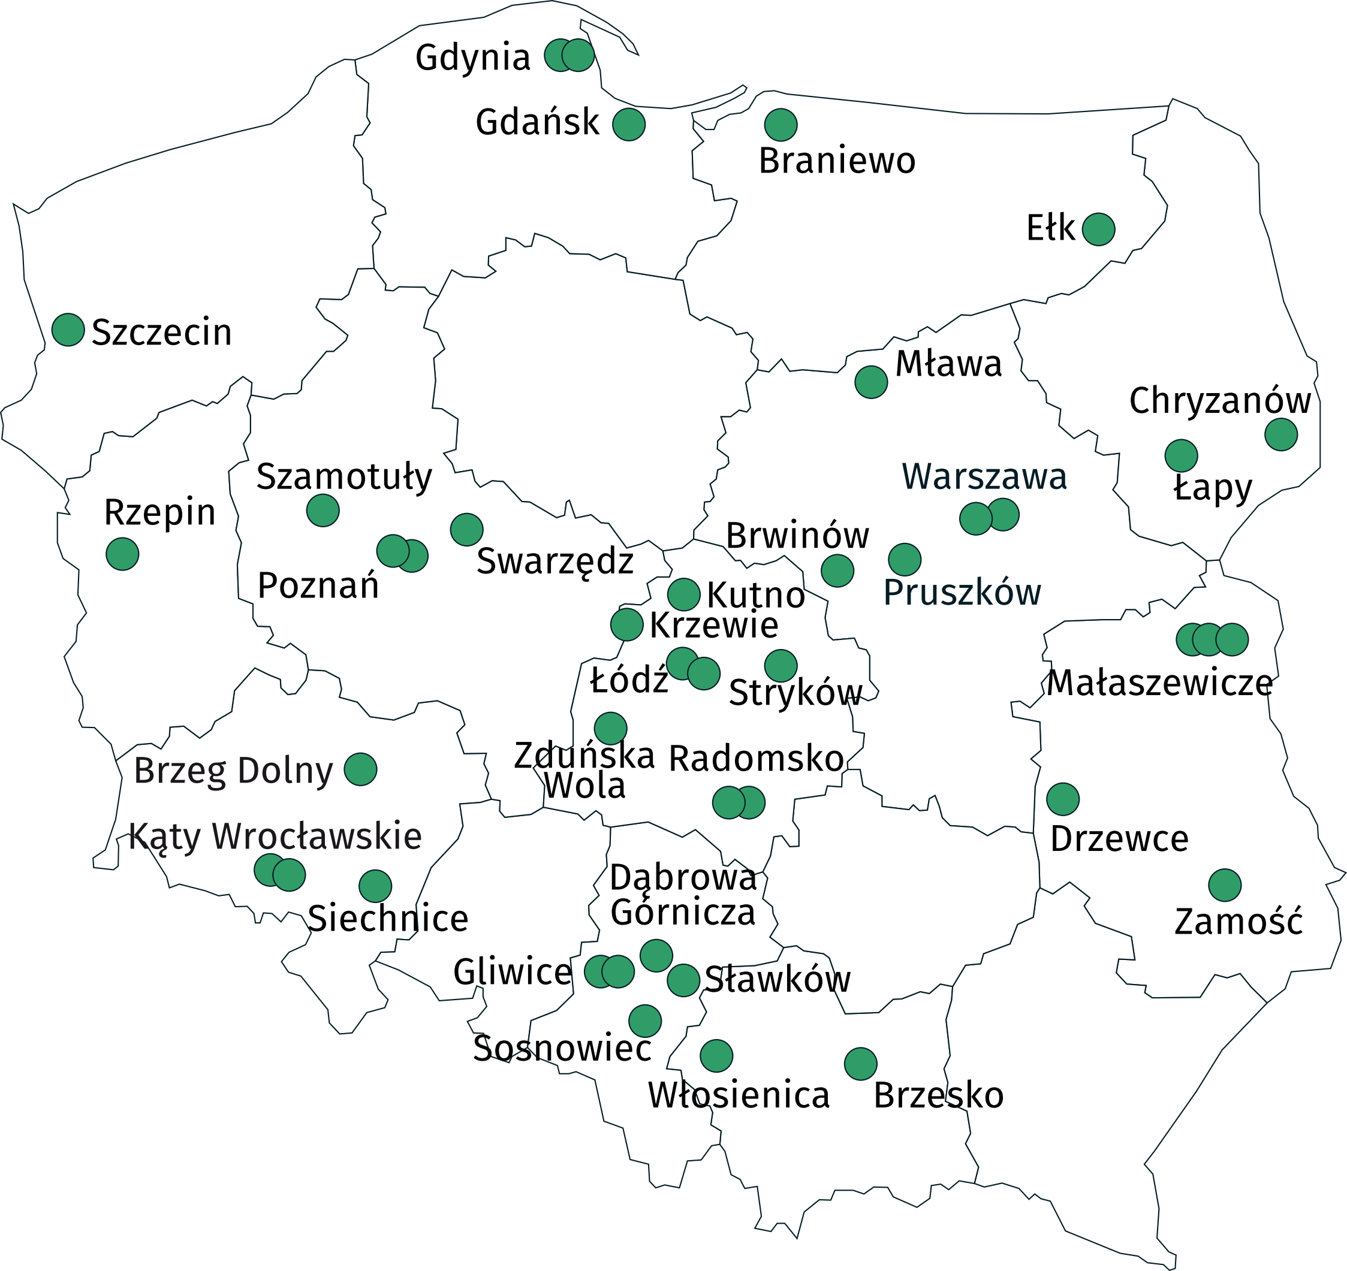

Maritime terminals infrastructure
The reloading quays at maritime terminals in 2025 had a total length of 6.2 km, of which 74.8% were used for handling cargo units in the lo-lo system.
The storage yards capacity at maritime terminals remained
at the same level, while that
at land terminals increased
by 6.1%
The parking and maneuvering area covered 6.1 ha, while the terminals had a total storage area of 172.8 ha, of which 95.5% was dedicated to containerized units. The capacity of the storage yards amounted to 115.2 thousand TEU.
Maritime terminals had a total of 17.0 km of track for standard gauge railways, 70.7% of which was dedicated directly to loading/unloading intermodal units. The average train set handled simultaneously at the maritime terminal consisted of 71 wagons.

Land terminals infrastructure
In 2025, the parking and maneuvering area at land terminals covered a total of 30.2 ha, and the total storage area of the terminals – 104.5 ha, of which 81.2% of the area was dedicated
to containerized units. The capacity of the storage yards amounted to 144.7 thousand TEU.
In 2025, land terminals had a total of 103.4 km of standard - gauge railways track, 38.9%
of which were dedicated directly to loading/unloading intermodal units. The average train set handled simultaneously at the land terminal consisted of 35 wagons.

Table 1. Handling equipment at intermodal terminals in 2025
Specification | Maritime terminals ª | Land terminals ^{b}
Specification | in units
Cranes | 133 | 18
wharf | 33 | –
gantry | 6 | 11
road container | 94 | 7
Coastal and mobile cranes | 6 | 3
Trucks | 43 | 124
front boom | 25 | 100
others ^{c} | 18 | 24
Technological tractors | 182 | 10
Low semi-trailers | 150 | 4
Others | 48 | 1
a Data for 4 maritime terminals.
b Data for 23 land terminals.
c Container shuttles, side containers, front stackers.

Transshipments at maritime and land intermodal terminals
The total annual throughput capacity of intermodal transport terminals was 10.8 million TEU, including 7.5 million TEU at maritime terminals, and at land terminals – 3.3 million TEU.
In 2025, a total of 89.6 million tonnes of containerized cargo were transhipped at intermodal terminals
In 2025, a total of 89.6 million tonnes of containerized cargo were transhipped at intermodal terminals, i.e. 8.5% more than in the previous year.
34.6 million tonnes were transported to/from intermodal terminals by sea (which amounted
to 38.6% of the total cargo transhipped at maritime and land terminals), by road – 30.3 million tonnes (33.9%), and by rail – 24.6 million tonnes (27.5%).
The transport structure was dominated by loaded containers, which accounted for 68.7%, while empty containers represented 31.3%. In terms of size, 40-foot containers clearly prevailed, accounting for 66.1%, whereas 20-foot containers represented 25.4%. 45-foot and larger containers accounted for 7.3%, while 30-foot containers made up only 1.2%.
Chart 1. Structure of containers transshipped at intermodal terminals by size in 2025
(based on the number of tonnes)

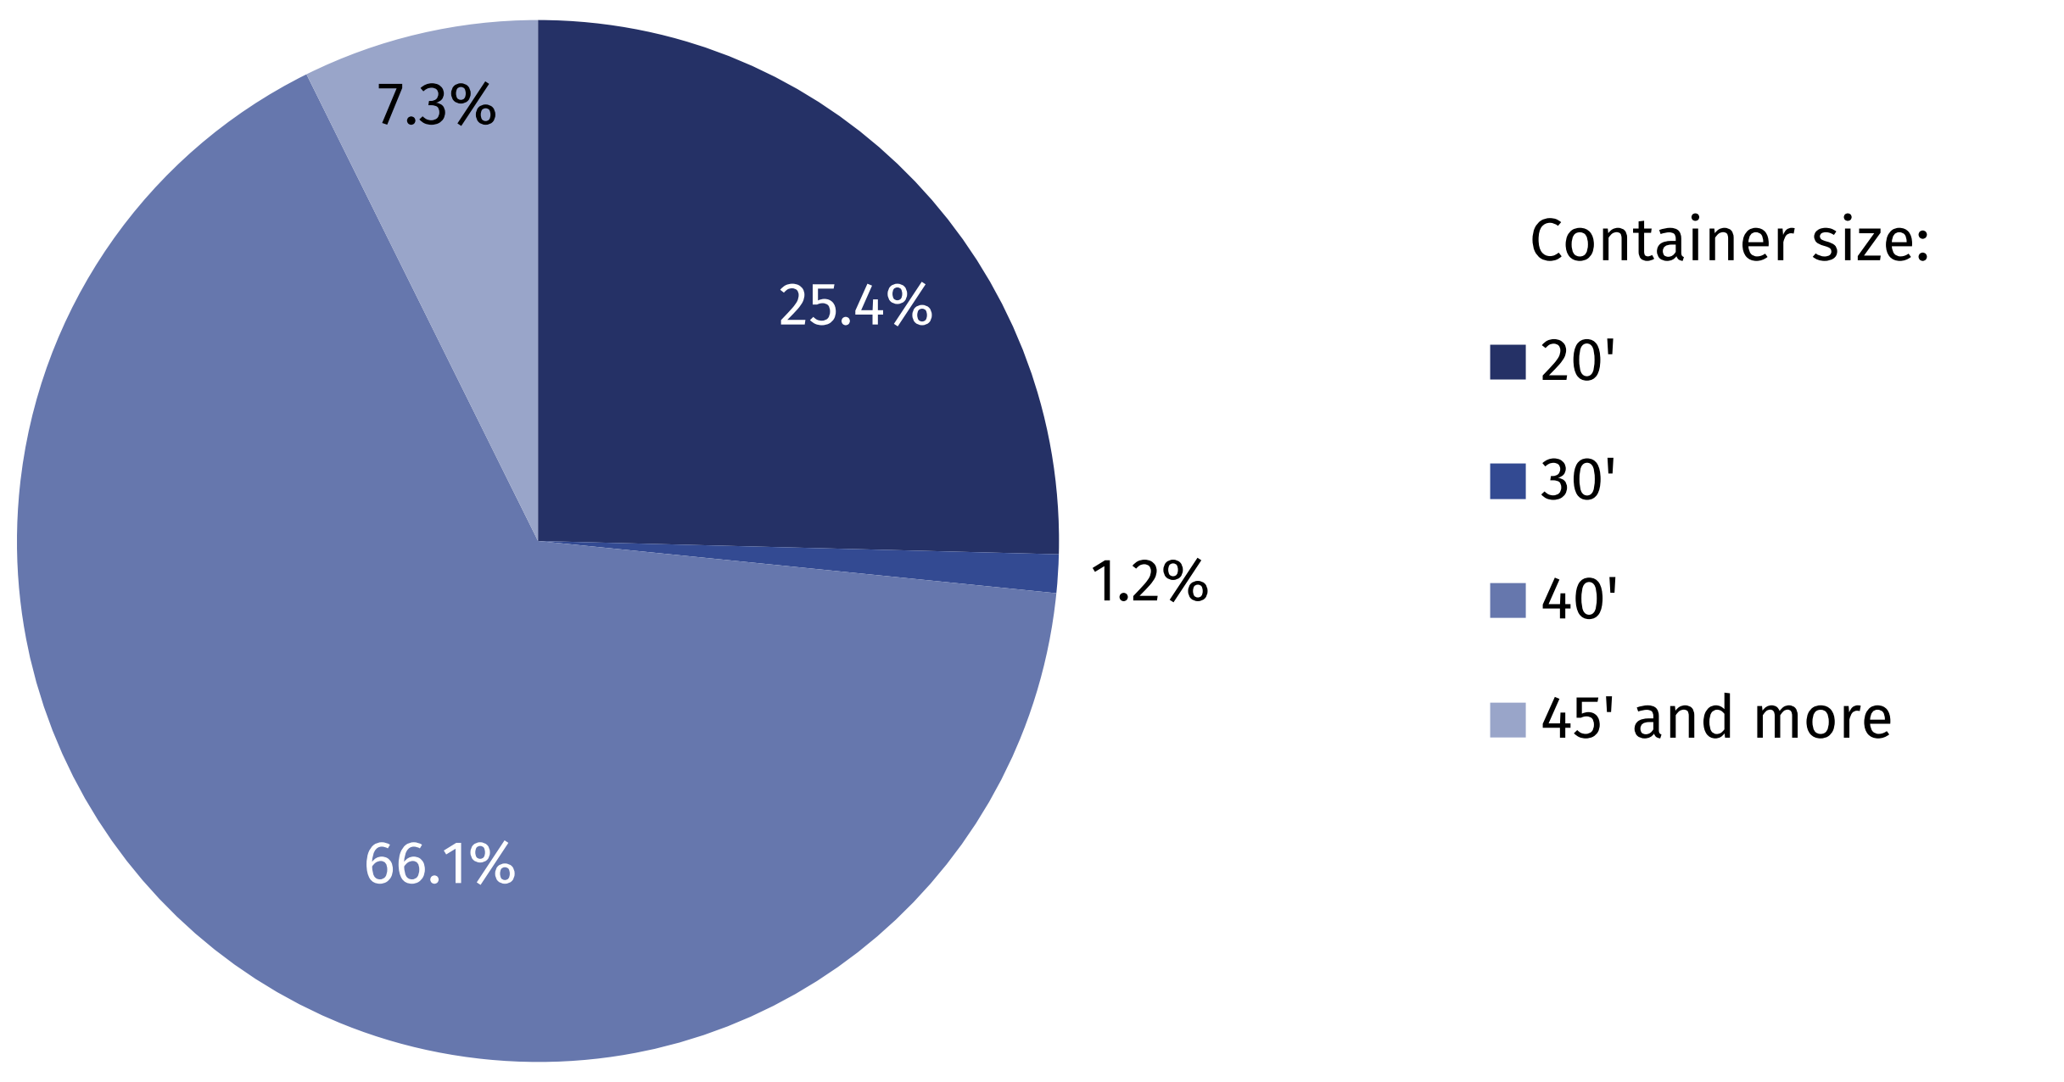

Transport of goods in containers by intermodal road transport
In intermodal road transport, the share of national transport amounted to 96.0%
In 2025, over 30.3 million tonnes of containerized cargo were transported by intermodal road transport. The share of domestic transport amounted to 96.0%. In national transport most cargo were transported to/from Voivodships: Wielkopolskie (17.0%), Podkarpackie (15.3%), Mazowieckie (14.7%) and Dolnośląskie (10.5%). An increase in the transported tonnes of containerized cargo compared to the previous year was recorded in the following Voivodships: Podkarpackie, Wielkopolskie, Podlaskie, Kujawsko-Pomorskie, Dolnośląskie, Zachodniopomorskie, Lubelskie, Opolskie, Świętokrzyskie and Lubuskie.

Chart 2. The share of transport of containerized goods by intermodal road transport in 2025 by voivodships (based on the number of tonnes) ^{ab}

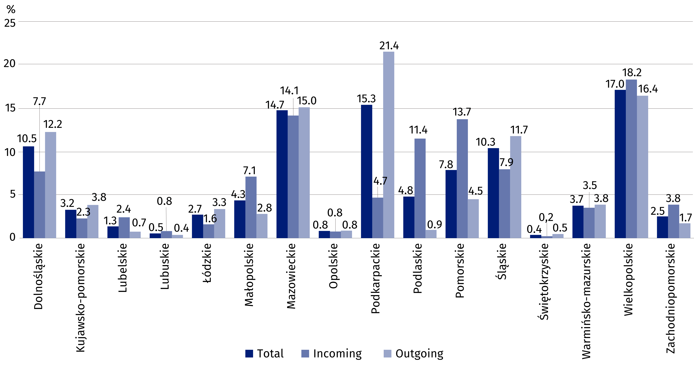

a The data includes transport to/from intermodal terminals located in Poland.
b Estimated data.

When quoting Statistics Poland data, please provide the information: “Source of data: Statistics Poland”, and when publishing calculations made on data published by Statistics Poland, please include the following disclaimer: “Own study based on figures from Statistics Poland”.

Prepared by:  Statistical Office in Szczecin  Director Magdalena Wegner  Phone: (+48 91) 459 77 00 | Issued by:  Press Office  Mobile: (+48) 695 255 032  Phone: (+48 22) 608 38 04, (+48 22) 449 41 45,  (+48 22) 608 30 09  e-mail: obslugaprasowa@stat.gov.pl

stat.gov.pl/en/

@StatPoland

@GlownyUrzadStatystyczny

@gus_stat

@GłównyUrządStatystycznyGUS

@Glówny Urząd Statystyczny
Related information
Transport – activity results in 2024
Data available in databases
Knowledge Databases (DBW) – Economy – Transport
Terms used in official statistics
Container ISO
Intermodal terminal

