Out-patient health care in Mazowieckie Voivodship in 2025
At the end of 2025, out-patient health care was carried out by 3834 out-patient departments and 205 medical and dental practices providing services funded by public sources. In 2025, 60.8 milllion out-patient consultations were provided — 53.9 million medical and 6.9 million dental consultations.
4.3%
Increase in the number of out-patient consultations compared to 2024

Out-patient departments and medical practices
At the end of 2025, 15% of out-patient departments were owned by public sector entities

At the end of 2025, there were 4039 providers of out-patient health care, of which 3834 out-patient departments as well as 20 medical practices and 185 dental practices providing services funded by public sources.

Table 1. Out-patient health care providers

As of 31 December
In 2025, the number of medi-cal and dental practices that signed contracts with the National Health Fund increased
SPECIFICATION | 2024 | 2025
SPECIFICATION | In absolute numbers |  | 2024=100
Total | 3889 | 4039 | 103,9
Departments | 3685 | 3834 | 104,0
urban areas | 3081 | 3217 | 104,4
rural areas | 604 | 617 | 102,2
Practicesa total | 204 | 205 | 100,5
medical | 22 | 20 | 90,9
dental | 182 | 185 | 101,6
urban areas | 113 | 118 | 104,4
rural areas | 91 | 87 | 95,6
a Data include practices that have signed contracts with the National Health Fund or out-patient departments.
Compared to 2024, the number of out-patient health care providers increased by 4.0%, with an increase both in urban and in rural areas. The number of medical practices i.e. those that signed contracts with the National Health Fund decreased by 9.1%, whereas dental practices increased by 1.6%.
At the end of 2025, there were 1363 persons per out-patient health care provider (by 53 persons fewer than a year before). The indicator in question was 2.5 times higher in rural areas (2757) than in urban areas (1069).
In Mazowieckie Voivodship, 92.6% of out-patient health care providers were adapted to the needs of the disabled. Most of the providers — 61.9% were equipped with ramps or platforms facilitating the entrance to the building, 36.2% had non-slip floors and 29.1% an elevator. 6.5% of out-patient health care providers had facilities for the visually impaired and the blind, and 6.71 for the hearing impaired and deaf.

Out-patient consultations
On average, there were four times more out-patient consultations per urban resident than per rural resident
In 2025, there were 60,847.4 thousand out-patient consultations provided, i.e. by 4.3% more than in 2024. The vast majority of consultations (88.2%) were provided in urban areas.

Table 2. Consultations provided ª in out-patient health care
12% of total out-patient con-sultation was provided via telephone

SPECIFICATION | 2024 | 2025
SPECIFICATION | In thousands |  | 2024=100
Consultations provided | 58356,1 | 60847,4 | 104,3
of which via telephone | 6936,9 | 7523,4 | 108,5
urban areas | 51284,2 | 53691,1 | 104,7
rural areas | 7071,9 | 7156,3 | 101,2
In primary health care | 23576,1 | 23626,4 | 100,2
of which:
at home | 179,0 | 186,7 | 104,3
via telephone | 2751,7 | 2720,7 | 98,9
Nighttime and holiday medical service ^{b} | 777,2 | 708,4 | 91,1
in the infirmary | 740,9 | 674,9 | 91,1
at the patient’s home | 23,0 | 18,3 | 79,6
via telephone | 13,3 | 15,1 | 113,5
In specialised care | 34002,8 | 36512,5 | 107,4
medical | 27759,2 | 29581,6 | 106,6
of which via telephone | 4170,1 | 4786,2 | 114,8
dental | 6243,7 | 6931,0 | 111,0
of which via telephone | 1,7 | 1,4 | 79,7
a Including consultations paid by patients (non public sources); without consultations from the admission rooms of general hospitals. b Primary health care services provided from Monday to Friday from 6.00 p.m. to 8.00 a.m. the following day and 24 hours a day on public holidays. including consultations under subcontracts with the hospital to carry out that consultations.
The average number of out-patient consultations per capita in 2025 was 11.1, with this indicator being 4 times higher in urban areas than in rural areas and amounting to 15.1 and 3.7, respectively.
Consultations via telephone, i.e. consultations provided remotely using a telephone con-nection or another ICT system, accounted for 12.4% of all out-patient consultations provided (in 2024 — 11.9%).

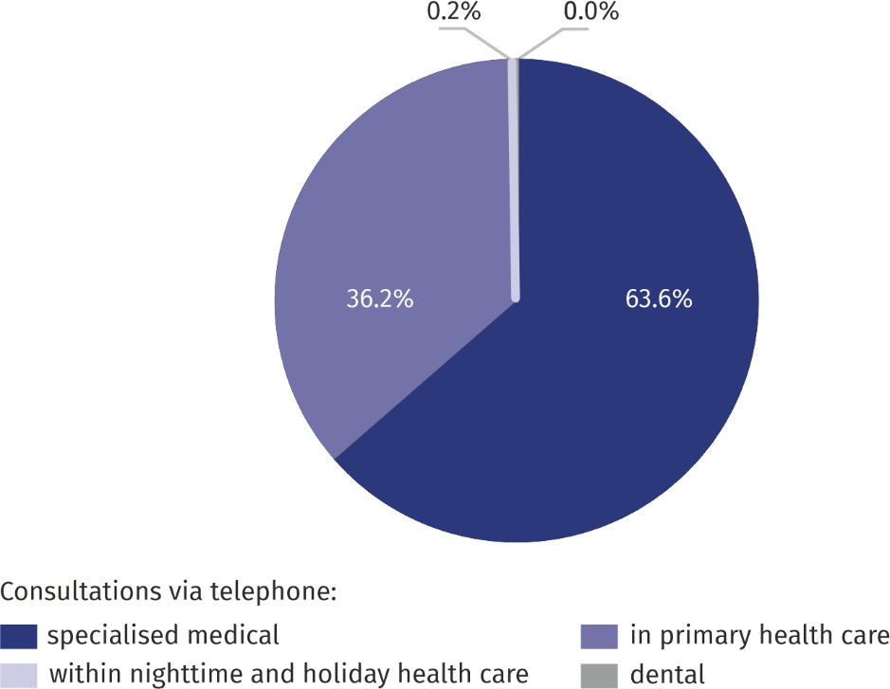
Chart 1. Structure of consultations via telephone by type of consultation in 2025

Most out-patient consultations were provided in specialised care – 36,512.5 thousand, i.e. 60.0% of the total, including 11.4% by dentists. Consultations via telephone accounted for 13.1% of all specialised consultations provided.
Consultations provided in primary health care accounted for 23,626.4 thousand consultations, i.e. 38.8% of all out-patient consultations. Primary health care doctors also provided 186.7 thousand, i.e. 0.8%, of consultations at the patient's home.
28% of consultations via telephone within nighttime and holiday medical services were provided to persons aged 65 and more

708.4 thousand consultations were provided within nighttime and holiday medical service, i.e. 1.2% of all out-patient consultations. Most of them were provided on an out-patient ba-sis — 95.3%, while telephone consultations constituted 2.1%, and consultations at the pa-tient's home — 2.6%.
Out-patient consultations were more often provided to women. In the field of specialist care they constituted 60.4%, in primary care — 57.8%, while within nighttime and holiday medical service — 55.8%
59% of total out-patient health care consultations were provided to women

In 2025, more than half — 54.3% of consultations were provided to persons aged 18-64, aged 65 years and more — 28.0%, and aged 0-17 years — 17.7%.
Children and youth in the age group 0-17 years were provided with 10,785.4 thousand consultations, of which 41.9% in primary health care (a decrease of 2.9 pp per year), 37.1% were specialised medical consultations (an increase of 0.3 pp), and 19.5% — dental consultations (an increase by 3.1 pp), and 1.6% — consultations within nighttime and holiday medical service (a decrease by o 0.4 pp).
In the age group of 65 and more, there were 17,036.2 thousand consultations provided, the most in primary health care — 49.9% (a decrease by 0.6 pp per year). Consultations of specialised medical care accounted for 43.1% (an increase of 0.4 pp)), dental consultations — 6.1% (a 0.3 pp increase), nighttime and holiday medical service consultations — 0.9% (no changes compared to 2024).
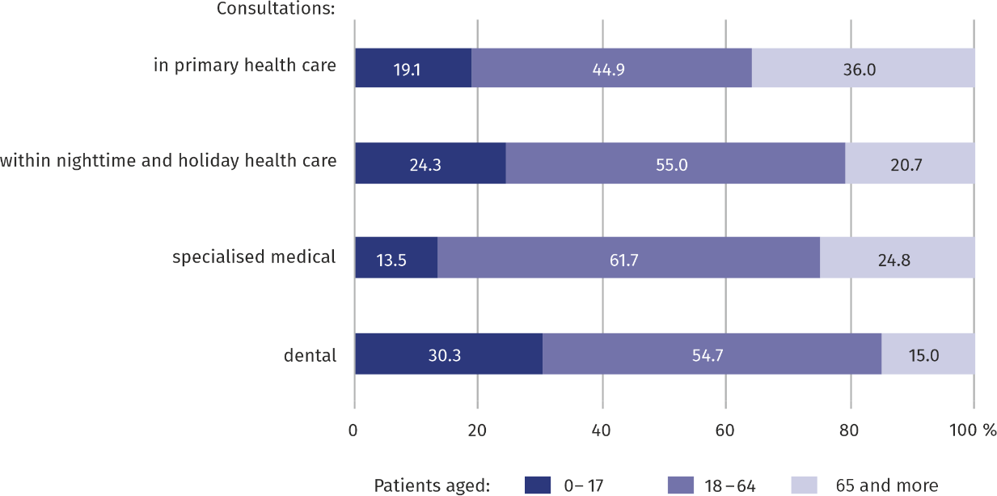
Chart 2. Structure of out-patient consultations by type of consultation and age of patients in 2025
Every third primary health care consultation was provided to persons aged 65 and over

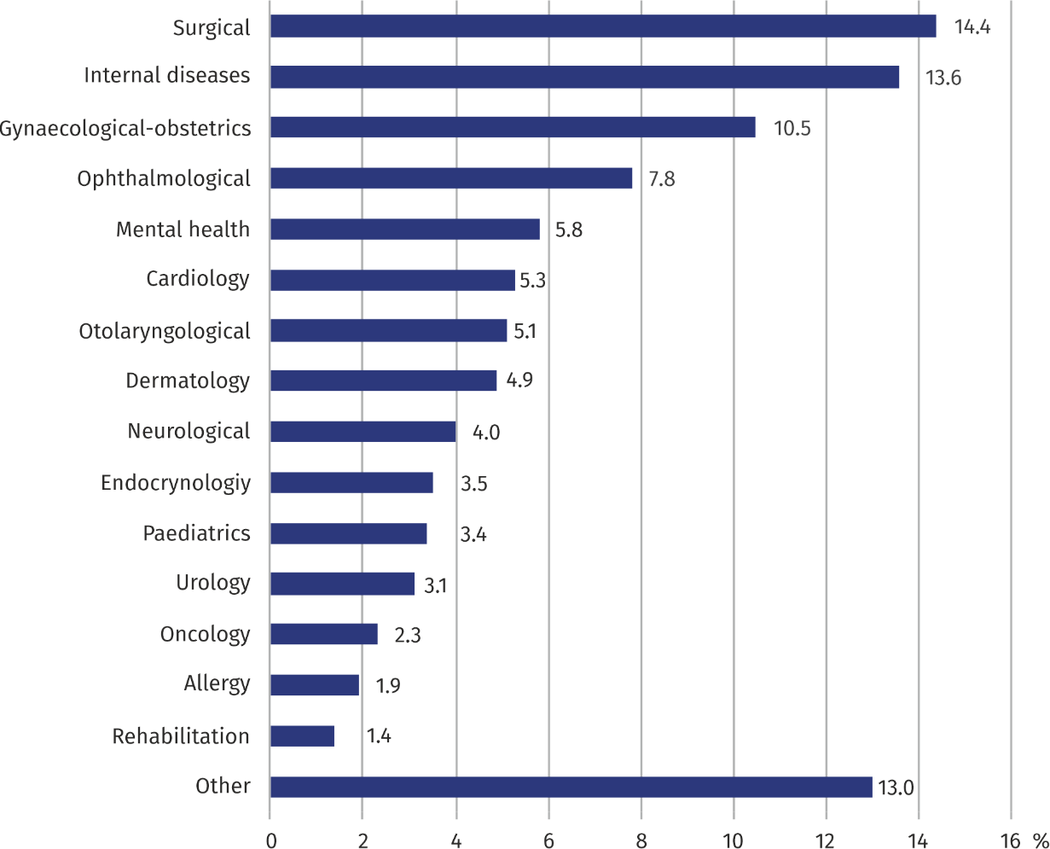
Chart 3. Structure of specialised medical consultations by type of clinic in 2025
Compared to 2024, the num-ber of specialised consulta-tions in mental health clinics increased by 6%
Most (4.3 million) medical consultations in specialised care were provided in surgi-cal out-patient clinics
In the case of quoting data from the Statistics Poland, please provide information “Statis-tics Poland data source”, and in the case of publishing calculations made on data published by the Statistics Poland, provide information: “Own study based on Statistics Poland data”.
Prepared by:  Statistical Office in Warszawa  Director Agnieszka Ajdyn  Phone: (+48 22) 464 23 15 | Issued by:  Statistical Information Centre  Marcin Kałuski  Mobile: (+48) 783 940 141
Press office in the Statistical Office in Warszawa  Mobile: (+48) 783 940 141  e-mail: m.kaluski@stat. gov.pl |   www.warszawa.stat.gov.pl/en/

@WARSZAWA_STAT

@UrzadStatystycznywWarszawie

gus_stat

glownyurzadstatystycznygus

glownyurzadstatystyczny

Related information
Out-patient health care in Mazowieckie Voivodship in 2024
Data available in databas
Local Data Bank -> Health care, social welfare and benefits to the family
Knowledge Databases -> Health and health care
Terms used in official statistics
Specialised out-patient services
Out-patient health care services
Primary health care
Consultation
Medical practice
An out-patient department

