Distribution of wages and salaries in the national economy in March 2026
In March 2026, the median monthly gross wage and salary was 22.4% lower than the average monthly gross wage and salary in that month
In March 2026, the median monthly gross wage and salary decreased by 2.1% in nominal terms compared with February 2026, whilst it increased by 7.6% compared with March 2025. During the same period, the average monthly gross wage and salary decreased by 2.7% in nominal terms compared with February 2026, whilst it increased by 6.6% compared with March 2025.
PLN 7 530.45
Median monthly gross wage and salary
PLN 9 698.95
Average monthly gross wage and salary

Median monthly gross wage and salary in the national economy
The median gross wage and salary in the national economy in March 2026 was PLN 7 530.45. It means that half of the employees received a wage or salary not higher than this amount, and the other half received a wage or salary not lower than this amount. The median wage and salary varied depending on sex – among men it was PLN 7 657.56 (101.7% of the total value), whilst among women it was PLN 7 407.10 (98.4% of the total value). In terms of entity size, the highest median wage and salary was recorded, as in previous periods, in entities with 1 000 or more employed persons – PLN 8 695.04 (115.5% of the total value), whilst the lowest was in entities with 9 or fewer employed persons – at the level of the minimum wage, i.e. PLN 4 806.00 (63.8% of the total value).
In entities with 9 or fewer employed persons, the median gross wage and salary remained at the level of the minimum wage
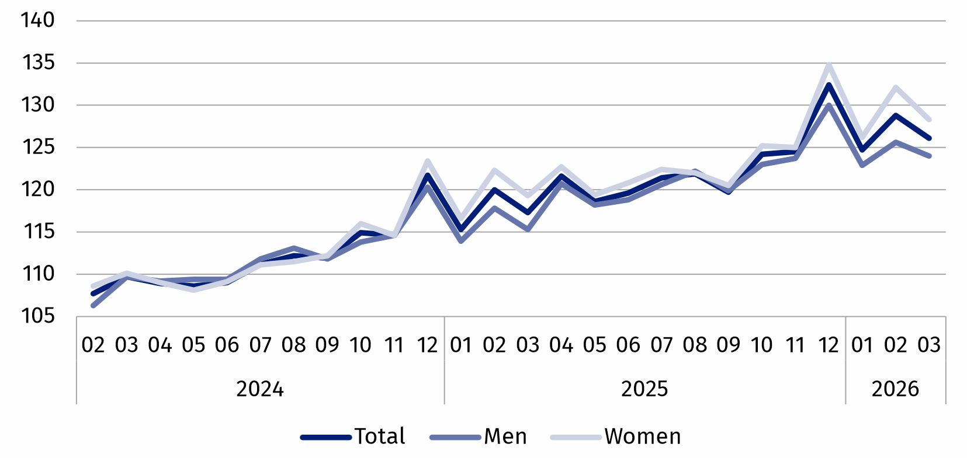
Chart 1. Indices of median monthly gross nominal wage and salary in the national economy
01.2024 = 100

In March 2026, only in the second decile wages and salaries of women were higher than those of men, the difference amounted to PLN 270.57

Deciles of monthly gross wages and salaries in the national economy
In March 2026, the lowest earning 10% of employees received a wage or salary of no more than PLN 4 806.00 (the first decile). In contrast, the highest earning 10% of employees received a wage or salary of at least PLN 15 424.85 (the ninth decile). In most deciles, wages and salaries varied by sex of the employees. The largest nominal difference in wages and salaries by sex occurred in the ninth decile and amounted to PLN 609.50 in favour of men.

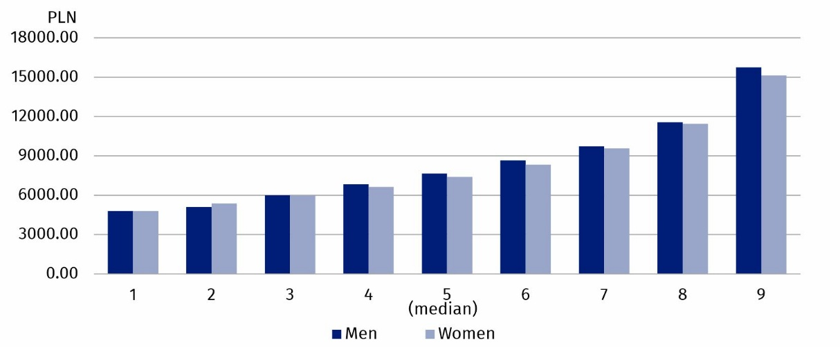
Chart 2. Deciles of monthly gross wages and salaries in the national economy by sex in March 2026
In March 2026, the highest earning 10% of men received a wage or salary of at least PLN 15 750.29. During the same period, the highest earning 10% of women received a wage or salary of at least PLN 15 140.79

Average monthly gross wage and salary in the national economy
The average wage and salary in the national economy in March 2026 was PLN 9 698.95, among men – PLN 9 994.19 (which represented 103.0% of the total average wage and salary), whilst among women – PLN 9 397.50 (96.9% of the total average wage and salary). In terms of entity size, the highest average wage and salary was recorded, as in previous periods, in entities with 1 000 or more employed persons – PLN 11 307.95 (116.6% of the total value), whilst the lowest was in entities with 9 or fewer employed persons – PLN 6 301.72 (65.0% of the total value).
In March 2026, in entities with 9 or fewer employed persons, women's average monthly gross wage and salary was PLN 271.14 higher than men's average monthly gross wage and salary

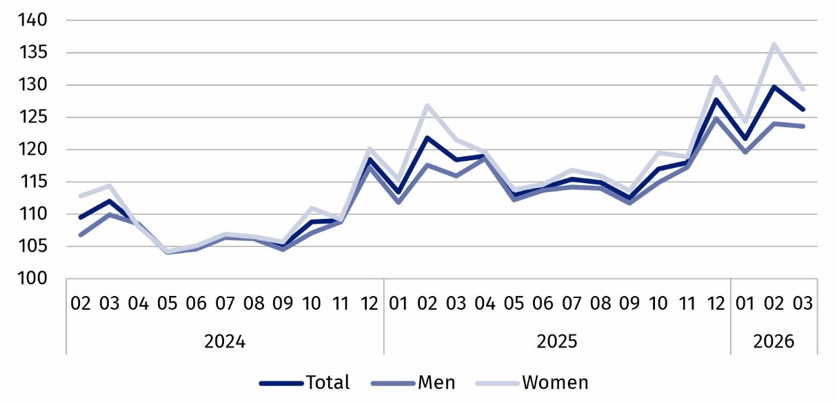
Chart 3. Indices of average monthly gross nominal wage and salary in the national economy
01.2024 = 100

Wages and salaries by PKD 2025/NACE Rev. 2.1 section
In the majority of the sections analysed, the average monthly gross wage and salary and the median wage and salary were higher among men than among women

Wages and salaries also varied by kind of activity. In March 2026, the highest median wage and salary, amounting to PLN 13 000.00, was recorded in the Telecommunication, computer programming, consulting, computing infrastructure and other information service activities section (section K). As in the previous month, in 14 out of the 20 PKD 2025/NACE Rev. 2.1 sections analysed, men’s median wage and salary was higher than women’s median wage and salary. The largest percentage difference occurred in the Financial and insurance activities section (section L) – men earned 43.4% more than women. In 6 sections, women’s median wage and salary was higher than men’s median wage and salary, and the largest percentage difference occurred in the Construction section (section F) – women earned 37.0% more than men.

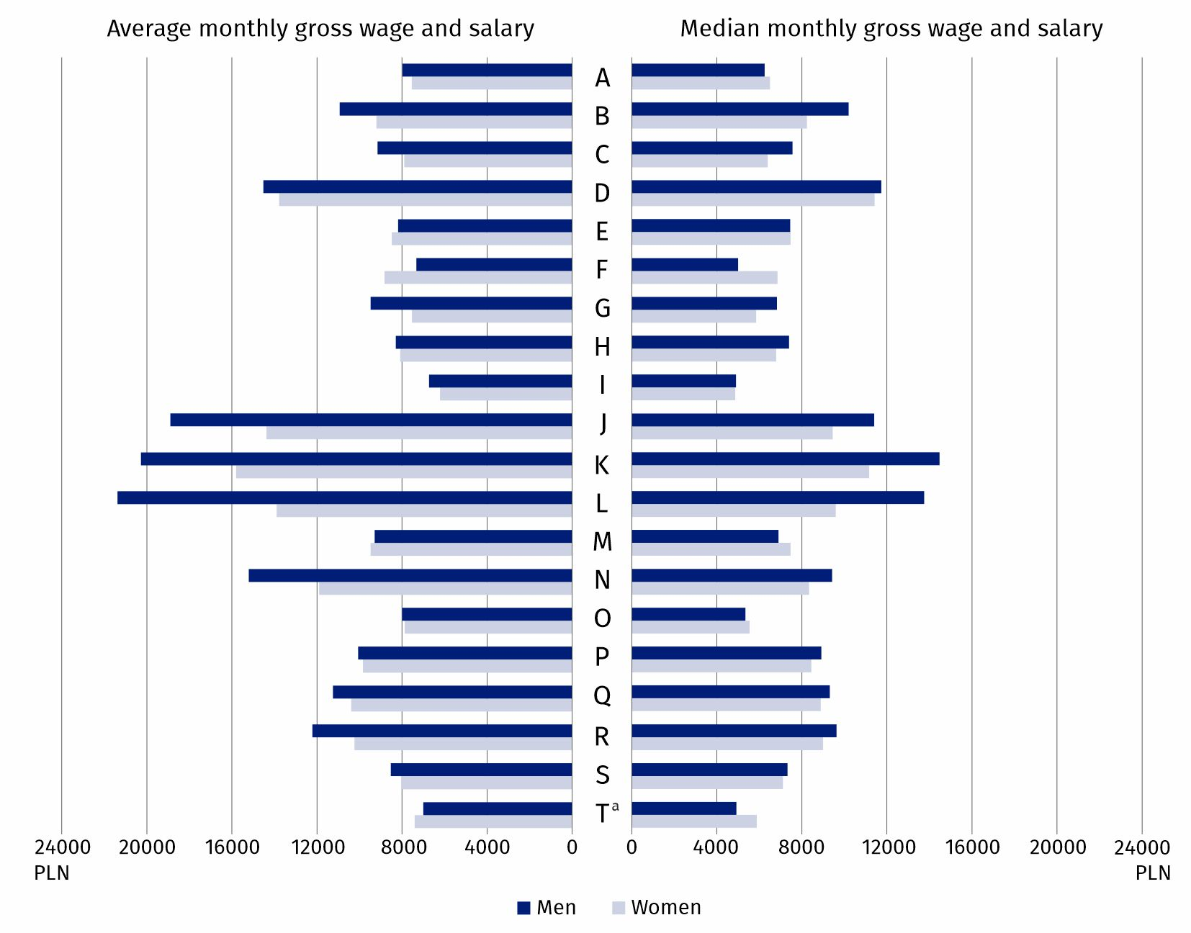
Chart 4. Average monthly gross wage and salary and median monthly gross wage and salary in the national economy by PKD 2025/NACE Rev. 2.1 section and sex in March 2026
a Data for the Other service activities (T) section also cover employees in the Activities of households as employers and undifferentiated goods- and service-producing activities of households for own use (U) and Activities of extraterritorial organisations and bodies (V) sections.
The highest average wage and salary in March 2026, as in February, was recorded in the Telecommunication, computer programming, consulting, computing infrastructure and other information service activities section (section K), where it stood at PLN 18 562.48. The largest percentage difference between men’s average wage and salary and women’s average wage and salary was in the Financial and insurance activities section (section L) – it stood at 53.9% in favour of men. In 4 sections, women’s average wage and salary was higher than men’s average wage and salary; the largest percentage difference, as in previous periods, occurred in the Construction section (section F) – it stood at 20.5% in favour of women.
In March 2026, in 16 PKD 2025/NACE Rev. 2.1 sections, men’s average monthly gross wage and salary was higher than women’s average monthly gross wage and salary

Minimum gross wage
In March 2026, 12.2% of employees received a gross wage or salary not exceeding the applicable minimum wage. This share was higher among men (14.0%) than among women (10.4%). Differences were also observed between age groups – the highest share was recorded in the 65 or over age group (14.8%), whilst the lowest was in the 55–64 age group (11.6%). Depending on entity size, this share ranged from 1.9% in entities with 1 000 or more employed persons to 46.5% in entities with 9 or fewer employed persons. In the breakdown by kind of economic activity, the highest share was recorded in the Accommodation and food service activities section (section I) – 38.9%, whilst the lowest was in the Public administration and defence; compulsory social security section (section P) – 0.6%.
In 2026, the minimum gross wage is PLN 4 806.00
***
Data source: results of the Survey on the Distribution of Wages and Salaries in the National Economy.
Starting with the data for January 2026, the survey results are compiled in accordance with the Polish Classification of Activities 2025, introduced by the Regulation of the Council of Ministers of 18 December 2024 (Journal of Laws of 2024, item 1936). Due to this change, data broken down by PKD/NACE section, as well as by sector of the national economy, are not fully comparable with results from previous periods.
The presented data on wages and salaries cover monetary payments under the title of an employment relationship or a service relationship to employees, as well as payments under contracts of mandate, contracts to perform a specified task and agency agreements, if these contracts were concluded with the same employer or to the benefit of the same employer with whom a given person is employed on the basis of an employment relationship.
There is a wider range of data on the distribution of wages and salaries in the publication tables.
Choropleth maps presenting data from the Survey on the Distribution of Wages and Salaries in the National Economy are available on the Geostatistics Portal.
Symbols of PKD 2025/NACE Rev. 2.1 sections:
A – Agriculture, forestry and fishing;
B – Mining and quarrying;
C – Manufacturing;
D – Electricity, gas, steam and air conditioning supply;
E – Water supply; sewerage, waste management and remediation activities;
F – Construction;
G – Wholesale and retail trade;
H – Transportation and storage;
I – Accommodation and food service activities;
J – Publishing, broadcasting, and content production and distribution activities;
K – Telecommunication, computer programming, consulting, computing infrastructure and other information service activities;
L – Financial and insurance activities;
M – Real estate activities;
N – Professional, scientific and technical activities;
O – Administrative and support service activities;
P – Public administration and defence; compulsory social security;
Q – Education;
R – Human health and social work activities;
S – Arts, sports and recreation;
T – Other service activities.
Data for the Other service activities (T) section also cover employees in the Activities of households as employers and undifferentiated goods- and service-producing activities of households for own use (U) and Activities of extraterritorial organisations and bodies (V) sections.

When quoting this publication, please provide its title and indicate Statistics Poland as the author. When publishing your own calculations, based on data from this publication, please include the following statement: Author’s work based on data from Statistics Poland’s publication entitled ‘Distribution of wages and salaries in the national economy in March 2026’.

Prepared by:  Statistical Office in Bydgoszcz  Acting Director Katarzyna Klamrowska  Phone: (+48 52) 366 93 90 | Issued by:  Press Office  Mobile phone: +48 695 255 032  Landline phones: +48 22 608 38 04, +48 22 449 41 45, +48 22 608 30 09  e-mail: obslugaprasowa@stat.gov.pl

stat.gov.pl/en/

@StatPoland

@GlownyUrzadStatystyczny

@gus_stat

@GłównyUrządStatystycznyGUS

@Glówny Urząd Statystyczny
Related information
Methodological report Distribution of wages and salaries in the national economy

The data refer to all wage and salaried jobs, i.e. both employees in total and those whose wage or salary does not exceed the applicable minimum wage, who hold more than one wage or salaried job are counted as many times as the number of wage and salaried jobs they hold.

