Producer price indices for business services in the second quarter of 2026

In the second quarter of 2026, the producer prices for business services increased compared to the previous quarter by 0.8% and compared to the second quarter of 2025 - by 3.0%.
0.8%
Increase in producer prices for business services compared to the first quarter of 2026

Table 1. Producer price indices for business services
SPECIFICATION | 2 quarter 2026 |  |  | 1 half year 2026
SPECIFICATION | 1 quarter 2026=100 | 4 quarter 2025=100 | 2 quarter 2025=100 | 1 half year 2025=100
Total | 100.8 | 101.9 | 103.0 | 102.8
Publishing activities | 100.8 | 101.8 | 102.2 | 101.6
Motion picture, video and television programme production, sound recording and music publishing activities | 100.4 | 101.3 | 102.3 | 102.3
Programming and broadcasting activities | 106.9 | 99.3 | 105.1 | 101.4
Computer programming, consultancy and related activities | 100.5 | 101.3 | 102.2 | 101.9
Information service activities | 100.3 | 101.4 | 103.7 | 103.9
Real estate activities | 101.4 | 103.3 | 104.2 | 104.0
Legal and accounting activities | 100.4 | 101.6 | 103.0 | 103.2
Management consultancy activities | 100.6 | 101.7 | 103.0 | 103.1
Architectural and engineering activities; technical testing and analysis | 101.0 | 102.0 | 102.4 | 102.1
Advertising and market research | 100.7 | 100.9 | 103.5 | 103.4
Other professional, scientific and technical activities | 100.7 | 102.3 | 104.1 | 104.2
SPECIFICATION | 2 quarter 2026 |  |  | 1 half year 2026
SPECIFICATION | 1 quarter 2026=100 | 4 quarter 2025=100 | 2 quarter 2025=100 | 1 half year 2025=100
Rental and leasing activities | 100.0 | 100.9 | 100.5 | 100.8
Employment activities | 100.3 | 102.4 | 103.6 | 104.1
Travel agency, tour operator and other reservation service and related activities | 102.2 | 101.0 | 102.5 | 100.8
Security and investigation activities | 100.5 | 102.3 | 102.5 | 103.1
Services to buildings and landscape activities | 100.1 | 102.3 | 103.2 | 103.2
Office administrative, office support and other business support activities | 99.9 | 101.2 | 101.6 | 102.0

In the 2nd quarter of 2026, the highest increase of prices compared to the previous quarter was recorded in programming and broadcasting activities
In the second quarter of 2026 the highest increase of prices compared to the previous quarter was recorded in programming and broadcasting activities (by 6.9%). Next, there was noticed the rise of prices in travel agency, tour operator and other reservation service and related activities (by 2.2%), real estate activities (by 1.4%), as well as architectural and engineering activities; technical testing and analysis (by 1.0%). The lowest growth in service prices was noticed in the case of services to buildings and landscape activities (by 0.1%). Prices of services in rental and leasing activities remained at the same level.
Price decrease compared to the previous quarter were recorded in the case of office administrative, office support and other business support activities (by 0.1%).
Compared to the second quarter of 2025, the highest increase of service prices occurred also in programming and broadcasting activities (by 5.1%). Next, there was noticed the rise of prices in real estate activities (by 4.2%) and other professional, scientific and technical activities (by 4.1%). The lowest increase of service prices were noticed in the case of rental and leasing activities (by 0.5%).

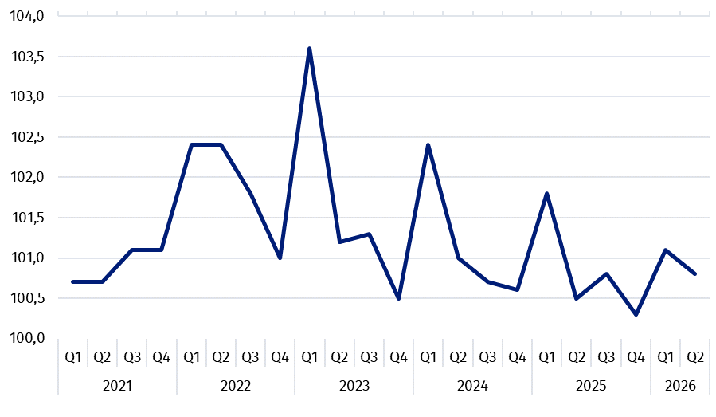
Chart 1. Producer price changes of business services in 2021-2026 (the previous quarter = 100)

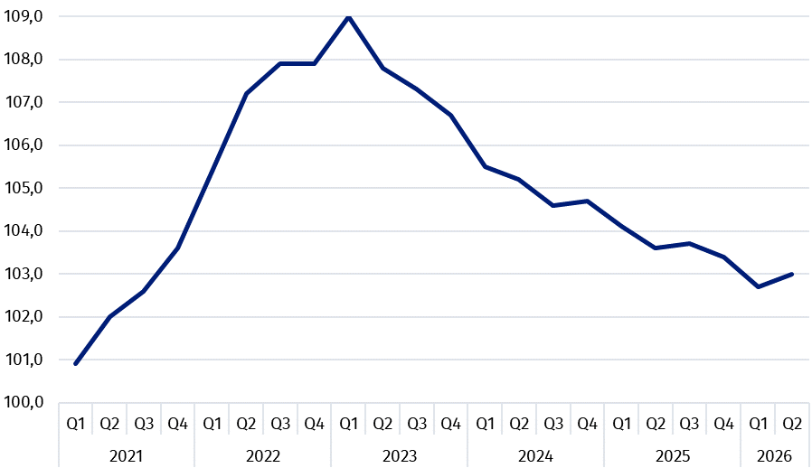
Chart 2. Producer price changes of business services in 2021-2026 (corresponding period of the previous year = 100)

In case of quoting Statistics Poland data, please provide information: “Source of data: Statistics Poland”, and in case of publishing calculations made on data published by Statistics Poland, please include the following disclaimer: “Own study based on figures from Statistics Poland”.

 | Prepared by:  Prices and Services Statistics Department  Director Ewa Adach-Stankiewicz  Phone: (+48 22) 608 31 24 |  | Issued by:  Press Office  Mobile: (+48) 695 255 032  Phone: (+48 22) 608 38 04, (+48 22) 449 41 45,  (+48 22) 608 30 09  e-mail: obslugaprasowa@stat.gov.pl

stat.gov.pl/en/

@StatPoland

@GlownyUrzadStatystyczny

@gus_stat

@GłównyUrządStatystycznyGUS

@Glówny Urząd Statystyczny
Related information
News releases

Prices in the national economy

Data available in databases
Knowledge Databases
Prices indices (Topics: Prices, Trade)

Terms used inn official statistics
Producer price indices for business services

,² Producer price indices for business services are presented using a weighting system prepared based on turnover in 2021.

