Statistics of Warszawa No. 7/2026
In July 2026, there was a decrease in the average employment and an increase in the number of unemployed persons compared to the corresponding period of previous year. Sold production of industry as well as construction and assembly production were higher than a year ago. Both retail and wholesale sales increased compared to the previous year. July 2026 was characterised by a significantly higher number of dwellings completed than a year earlier.

Average paid employment
Average paid employment in the enterprise sector in July 2026 amounted to 1107.6 thousand persons (converted into full-time equivalents) and was by 0.9 thousand persons, i.e. by 0.1% larger than in June 2026, and by 7.8 thousand persons, i.e. by 0.7% smaller than in July 2025.
Compared to June 2026, the increase in the average employment was recorded in the following sections: accommodation and catering (by 1.5%), professional, scientific and technical activities (by 0.3%), administrative and support service activities (by 0.2%), information and communication, real estate activities and industry (by 0.1% each).
Whereas a decrease in the average employment was recorded in the sections: construction (by 0.4%), trade; repair of motor vehicles and transportation and storage (by 0.1% each).

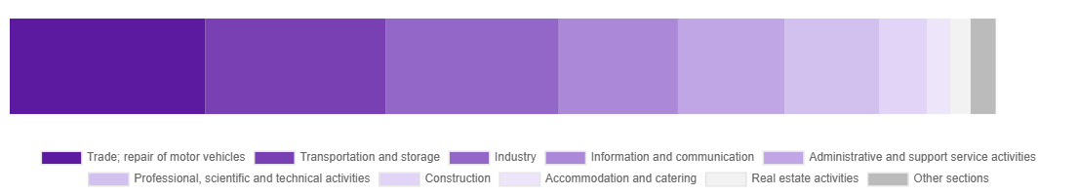
Chart 1. Structure of average paid employment by sections of PKD in July 2026

Compared to July 2025, a decrease in average employment was recorded in the sections: accommodation and catering (by 3.5%), real estate activities (by 3.0%), trade; repair of motor vehicles (by 2.2%), transportation and storage (by 1.5%), industry (by 0.3%), administrative and support service activities (by 0.2%).
An increase in average employment occurred in the sections: professional, scientific and technical activities (by 1.5%), construction and information and communication (by 0.5% each).

Registered unemployment*
At the end of July 2026, the number of registered unemployed persons amounted to 22179 and was by 90 persons, i.e. by 0.4% smaller than at the end of June 2026 and by 1018 persons, i.e. by 4.8% larger than in the corresponding period of 2025.
The number of registered unemployed women amounted to 10827, which accounted for 48.8% of the total unemployed (48.2% a month before, and 46.8% a year before) and 18.6% of unemployed women in Mazowieckie Voivodship. As compared to June 2026, the number of unemployed women increased by 93 persons, i.e. by 0.9%, and compared to July 2025 it increased by 922 persons, i.e. by 9.3%.
The registered unemployment rate amounted to 1.6% (as in the previous month and 1.5% in the previous year), in Mazowieckie Voivodship it was 4.5% (4.4% a month before and 4.2% a year before), while in the country at a level of 5.8% (as a month before and 5.4% a year before).
In July 2026, there were 3428 unemployed persons registered in labour offices (2758 in June 2026, and 2780 in July 2025). Registered unemployed persons accounted for 26.4% of the total registered unemployed in the Voivodship.
The number of persons registering for the first time amounted to 1295 (959 a month before), which accounted for 37.8% of the total unemployed who registered in July 2026 and 31.0% of persons registering for the first time in the Voivodship. The share of persons terminated due to company reasons among unemployed persons registered in July 2026 amounted to 3.9% (4.3% in Mazowieckie Voivodship), 3.6% a month before and 4.6% a year before.
In July 2026, 3518 persons were removed from unemployment rolls (3104 in June 2026, and 1670 in July 2025), which accounted for 30.5% of unemployed persons removed from unemployment rolls in Mazowieckie Voivodship. Out of the unemployed removed from unemployment rolls, 1613 persons took up work. Moreover, 1555 persons lost their status of the unemployed as a result of not maintaining contact with the labour office at least once every 90 days. The reason for removing from the register was also starting training or traineeship, acquisition of retirement or pension rights, acquisition of pre-retirement allowances and benefits, voluntary resignation from the unemployed status and others.

There were 19344 persons who were not entitled to the unemployment benefit, i.e. 87.2% of the total unemployed (18252 persons a year before, i.e. 86.3%), whereas 2835 unemployed persons were entitled to the unemployment benefit.
In July 2026, there were 1687 job offers* submitted to labour offices, which accounted for 35.9% of job offers in Mazowieckie Voivodship and at the end this month the labour offices had job offers for 1414 persons. At the end of July 2026, there were 16 persons per one job offer (16 in the previous month, 12 a year ago), while in Mazowieckie Voivodship, there were 25 persons (27 a month before, and 24 a year before) registered as unemployed.

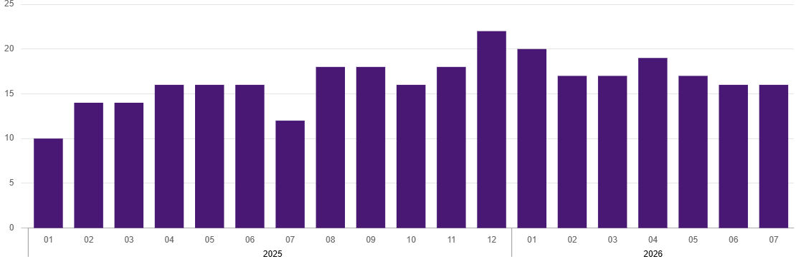
Chart 2. Number of unemployed persons per job offer (as of end of month)
* On 1 June 2025, the new Act on the Labour Market and Employment Services (Journal of Laws of 2025, item 620) entered into force, introducing changes to the rules for registering and recording unemployed persons. As a result, some published data has been adjusted to reflect the current legal status and statutory terminology, which may affect the comparability of current data with previous periods.
Wages and salaries
The average monthly gross wages and salaries in the enterprise sector in July 2026 amounted to PLN 11392.64 and were by 1.9% higher as compared to the previous month and by 7.2% higher than in the corresponding period of 2025.
Compared to June 2026, an increase in the average gross wages and salaries was recorded in the following sections: accommodation and catering (by 7.0%), administrative and support service activities (by 3.5%), transportation and storage (by 2.7%), trade; repair of motor vehicles (by 2.4%), construction (by 1.1%), industry (by 0.9%), information and communication (by 0.7%), real estate activities (by 0.1%).
Whereas a decrease in the average gross wages and salaries was recorded in the section of professional, scientific and technical activities (by 0.1%).
Compared to July 2025, an increase in the average gross wages and salaries was recorded in the sections: industry (by 8.9%), trade; repair of motor vehicles (by 8.7%), transportation and storage (by 7.4%), professional, scientific and technical activities (by 7.1%), accommodation and catering (by 6.9%), information and communication (by 6.8%), real estate activities (by 4.7%), construction (by 3.0%), administrative and support service activities (by 2.5%).

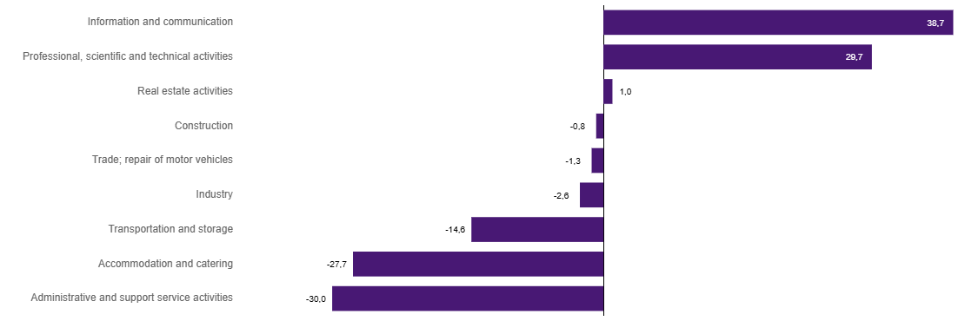
Chart 3. Relative deviations (in %) of monthly gross wages and salaries in selected sections from average wages and salaries in enterprise sector in Warszawa in July 2026

Construction
Sold production of construction in July 2026 amounted (at current prices) to PLN 6256.6 million and compared to June 2026 was smaller by 9.2% and compared to the corresponding period of previous year it decreased by 5.4%.
In January-July 2026, sold production of construction reached the value of PLN 40561.0 million, i.e. by 7.4% smaller than in the corresponding period of 2025.
Construction and assembly production in July 2026 amounted to PLN 1665.6 million (at current prices) and accounted for 26.6% of sold production of construction. Compared to the previous month, construction and assembly production decreased by 12.0%, and compared to July 2025 it was larger by 8.0%.
In January-July 2026, construction and assembly production amounted to PLN 9782.8 million and accounted for 24.1% of sold production of construction (21.6% a year before). Compared to the corresponding period of previous year, construction and assembly production was larger by 3.3%.
The increase in production in relation to the corresponding period of 2025 occurred in units dealing with construction of buildings (by 4.3%), civil engineering (by 3.7%) and specialised construction activities (by 0.9%).
Labour productivity measured by production per employed person in construction in July 2026 amounted to PLN 117.1 thousand and was by 8.8% lower than a month before and by 5.8% lower than in July 2025.

Trade
Retail sales in trade and non-trade enterprises in July 2026 (at current prices) were by 1.0% larger than in June 2026 and by 5.4% higher compared to July 2025.
Compared to June 2026, the largest increase was recorded in sales of pharmaceuticals, cosmetics, orthopedic equipment (by 12.1%), sales of food, beverages and tobacco (by 6.2%), sales of furniture, electronic goods and household equipment (by 4.8%), sales of solid, liquid and gas fuels (by 4.2%), sales in the “others” group (by 3.1%), sales motor vehicles, motorcycles, parts (by 1.2%).
Whereas a decrease was recorded in other retail sales in non-specialised stores (by 20.2%), sales of textiles, clothing and footwear (by 10.8%), sales of newspapers, books, 0ther retail sales in specialized stores (by 1.3%).
Compared to July 2025, the largest increase was recorded in sales of solid, liquid and gas fuels (by 11.4%), sales in the “others” group (by 11.2%), other retail sales in non-specialised stores (by 9.8%), sales of pharmaceuticals, cosmetics, orthopaedic equipment (by 8.4%), sales of newspapers, books, other retail sales in specialised stores (by 5.9%).
Whereas a decrease was recorded in sales of motor vehicles, motorcycles, parts (by 6.2%) and sales of food, beverages and tobacco (by 1.9%).
In January-July 2026, retail sales increased by 4.4% compared to the corresponding period of 2025.
Wholesale in trade enterprises in July 2026 (at current prices) was by 9.5% smaller as compared to the previous month and by 11.0% higher than in July 2025, and in wholesale enterprises it was lower by 10.3% and higher by 14.2%, respectively.
In January-July 2026, retail units achieved wholesale that was 12.1% higher than a year ago, while wholesale enterprises achieved wholesale that was 13.5% higher.

Industry
The sold production of industry in July 2026 amounted to (in current prices) PLN 15817.0 million and was (at constant prices) larger than in the corresponding month of 2025 by 8.9%. As compared to July 2025, an increase in sold production of industry was recorded in manufacturing by 9.6%.
In the period January-July 2026, sold production of industry amounted to PLN 112075.5 million (at current prices) and was (at constant prices) higher by 5.7% than that achieved in the same period of 2025. In manufacturing, an increase in production by 5.8% was recorded.
Among the divisions classified as manufacturing, the increase in sales was recorded, among others, in: manufacture of textiles (by 91.1%), manufacture of beverages (by 43.2%), manufacture of furniture (by 37.3%), repair and installation of machinery and equipment (by 23.3%), manufacture of computer, electronic and optical products (by 22.1%), manufacture of basic metals (by 16.5%), other manufacturing (by 13.3%), manufacture of rubber and plastic products (by 8.1%), manufacture of machinery and equipment n.e.c. (by 7.1%), manufacture of food products (by 4.8%), manufacture of pharmaceutical products (by 2.4%), manufacture of motor vehicles, trailers and semi-trailers (by 1.5%), manufacture of coke, refined petroleum products (by 0.7%), manufacture of chemicals and chemical products (by 0.4%).
The decrease in sales was recorded, among others, in: manufacture of wearing apparel (by 24.6%), manufacture of products of wood, cork, straw and wicker (by 20.6%), manufacture of metal products (by 16.4%), manufacture of electrical equipment (by 10.6%), printing and reproduction of recorded media (by 1.8%), manufacture of other non-metallic mineral products (by 1.0%), manufacture of paper and paper products (by 0.9%).
Labour productivity in industry measured by production per employed person, in January-July 2026 amounted to PLN 578.9 thousand (at current prices) and was – at constant prices – by 6.4% higher than in the previous year.

Residential construction
According to preliminary data, 1794 dwellings were completed in Warszawa in July 2026, i.e. by 41.3% more than in the previous year.
In the period January-July 2026, 8661 dwellings were completed (by 9.5% less than in the corresponding period of 2025), and 22871 dwellings in Mazowieckie Voivodship, i.e. 3.5% less than in January-July 2025. The number of completed dwellings decreased in cooperative construction from 64 to 48, i.e., 25.0% less, in private construction from 378 to 293, i.e., 22.5% less in construction intended for sale or rent from 9062 to 7975, i.e., 12.0% less. Meanwhile, there was an increase in public building societies from 66 to 245, i.e., 271.2% more. Furthermore, 100 dwellings were completed in company construction between January and July 2026.
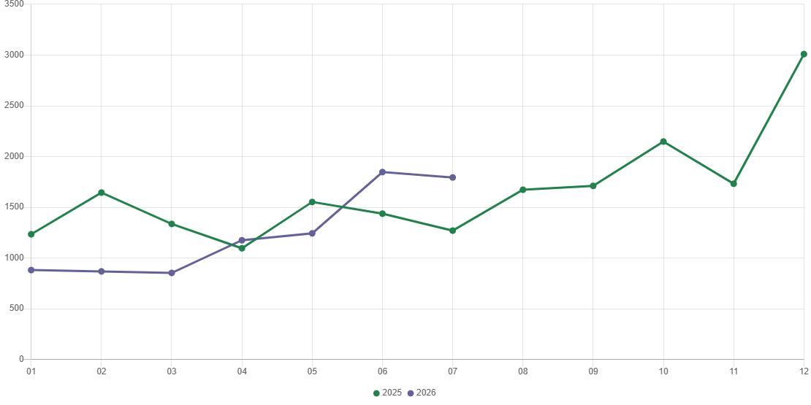
Chart 4. Dwellings completed

In January-July 2026, construction begun in 7971 dwellings (by 0.1% less than in the corresponding period of 2025) of which: 7674 in construction for sale or rent, 297 in private construction.
In January-July 2026, the number of dwellings for which permits have been granted or which have been registered with a construction project amounted to 9271 (by 10.1% more than in the corresponding period of 2025), of which 279 dwellings in buildings built by private investors.
The average useful floor area of a dwelling completed in January-July 2026, amounted to 62.2 m² and increased by 0.9 m² compared to the corresponding period of 2025. In private construction, the average useful floor area of dwellings amounted to 173.0 m² (by 6.3 m² less than in the corresponding period of 2025), in cooperative construction – 62.2 m² (by 12.8 m² more), in construction for sale or rent – 59.0 m² (by 2.5 m² more), in public building societies – 45.8 m² (by 4.1 m² less), in company construction – 35.8 m².

Entities of the national economy
At the end of July 2026, there were 610440 entities of the national economy registered in the REGON register in Warszawa, which accounted for 55.0% of the total in Mazowieckie Voivodship. Compared with June 2026, the number of entities of the national economy increased by 1517 (i.e. by 0.2%), and compared to July 2025 increased by 20822 (i.e. by 3.5%).
As of the end of June this year, there were 275966 legal persons and organisational units without legal personality registered in the REGON register, of which 200527 commercial companies. The number of these entities increased by 0.3% and 0.4%, respectively, compared to the previous month, by 3.8% and 4.3%, respectively, on an annual basis.
The number of registered natural persons conducting economic activity as of the end of July 2026 amounted to 334474 and compared to June 2026 it was higher by 0.2%, and compared to the corresponding period of the previous year increased by 3.3%.
In Warszawa, in July 2026, the most numerous were entities dealing with: professional, scientific and technical activities (19.4% of total registered units), trade; repair of motor vehicles (15.5%), as well as information and communication (13.1%).
Compared to June 2026, the number of entities increased, among others, in the sections: activities of extraterritorial organisations and bodies (by 0.6%), administrative and support service activities (by 0.5%), electricity, gas, steam and air conditioning supply, education, real estate activities, construction (by 0.4% each). However there was a decrease in the number of entities in the sections: mining and quarrying (by 0.3%), public administration and defence; compulsory social security (by 0.2%).
Compared to July 2025, the largest increase in the number of entities was recorded, among others, in the sections: administrative and support service activities (by 8.8%), human health and social work activities (by 6.3%), electricity, gas, steam and air conditioning supply (by 6.2%), education (by 5.8%), construction (by 5.1%), information and communication (by 4.4%), financial and insurance activities (by 4.1%).
Whereas a decrease in the number of entities was noted in the sections: mining and quarrying (by 2.1%), agriculture, forestry and fishing (by 1.6%), water supply; sewerage, waste management and remediation activities (by 0.5%), trade; repair of motor vehicles (by 0.3%).
In July 2026, 3292 new entities were entered into the REGON register, i.e. by 4.6% more than in the previous month. The newly registered entities were dominated by natural persons conducting economic activity – 1758 (by 1.3% less than in June 2026). The number of newly registered commercial companies was larger compared to the previous month by 13.2%, including limited liability companies – larger by 13.3%.

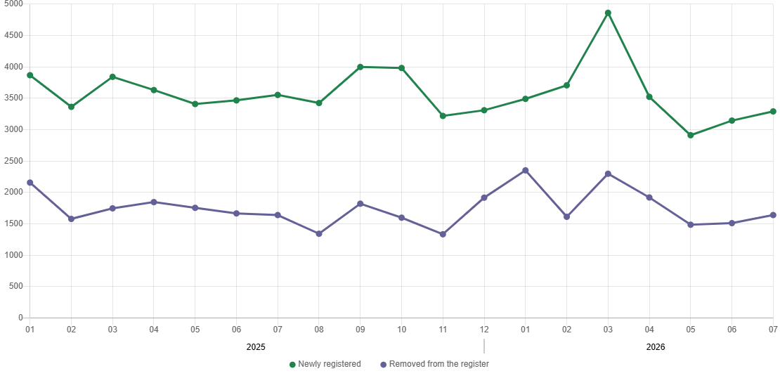
Chart 5. Entities newly registered and removed from the register

In July 2026, 1641 entities were removed from the REGON register (compared to 1512 in the previous month), including 997 natural persons conducting economic activity (by 3.3% more).
As of the end of July 2026, 78783 entities had suspended activity in the REGON register (by 2.8% more than a month before). The vast majority were natural persons conducting economic activity (90.7%).

When quoting this publication, please provide its title and indicate the Statistical Office in Warszawa as the author. When publishing your own calculations based on data from this publication, please include the following statement: Author’s work based on data from the publication entitled ‘Statistics of Warszawa No. 7/2026’ by the Statistical Office in Warszawa .

Prepared by:  Statistical Office in Warszawa  Director Agnieszka Ajdyn  Phone: (+48 22) 464 23 15 | Issued by:  Mazovian Centre for Regional Surveys  Information Centre  Mobile: (+48) 783 940 141
Press office in the Statistical Office in Warszawa  Mobile: (+48) 783 940 141  e-mail: m.kaluski@stat.gov.pl |   warszawa.stat.gov.pl/en/

@Warszawa_STAT

@UrzadStatystycznywWarszawie

gus_stat

glownyurzadstatystycznygus

glownyurzadstatystyczny

Related information
Communications and Announcements
Data available in databases
Local Data Bank → Labour market
Terms used in official statistics
Registered unemployed persons
Registered unemployment rate
Average paid employment
Average monthly gross wages and salaries
Dwellings completed

