Occupancy of tourist accommodation establishments in July and August 2026
Concerns tourist accommodation establishments with 10 or more bed places

In July and August 2026, 10.0 million tourists stayed at tourist accommodations in Poland. Compared to 2025, the number of tourists increased by 2.5%. The number of overnight stays amounted 29.4 million, an increase of 3.7% compared to the same period
in 2025.
⇧ 2.5%
Increase in the number of tourists accommodated in tourist accommodation establishments in July and August compared to the same period in 2025.

The data presented in this report were prepared as flash estimates to enable the early release of information on the occupancy of tourist accomodation establishments. The results were compiled based on partially collected reporting data, supplemented using imputation methods.
The data are preliminary and may be subject to revision once the full process of data collection, verification, and analysis is complete.
Tourists in tourist accommodation establishments
In July and August 2026, 10.0 million tourists stayed at tourist accommodations, which was 2.5% more than in the same period of 2025 and compared to 2022, it was 22.6% higher.
Chart 1. Tourists in tourist accommodation establishments in July and August
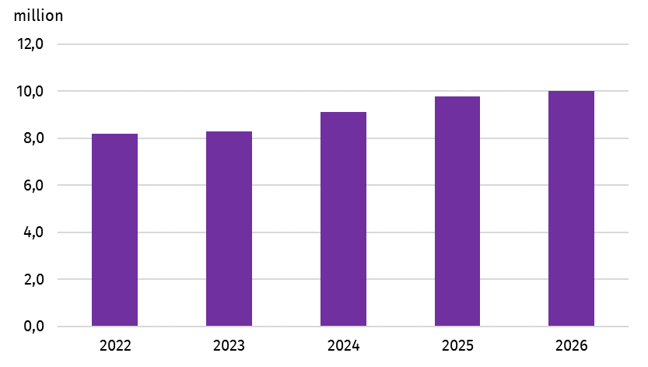
Since 2022, the number of tourists accommodated in tourist accommodation establishment has risen steadily - from 8.2 million in 2022 to 8.3 million in 2023. In 2024, this number increased to 9.1 million, and in 2025, to 9.8 million. In 2026, 10.0 million tourists stayed overnight.
In July and August 2026, the largest number of tourists stayed in tourist accommodations located in the Mazowieckie and Małopolskie Voivodship — by 1.5 million each, followed by the Zachodniopomorskie Voivodship with 1.3 million and the Pomorskie Voivodship with
1.2 million. The Opolskie Voivodship was visited by the fewest tourists — 0.1 million.
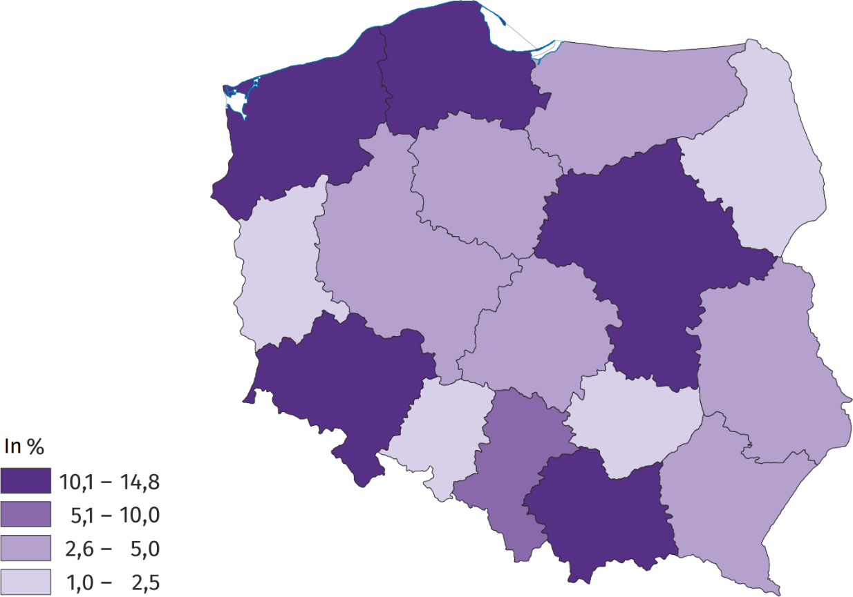
Map 1. Tourists accommodated in tourist accommodation establishments in July and August 2026

Overnight stays
In July and August 2026, 29.4 million overnight stays were recorded in tourist accommodation establishments in Poland. It was 3.7% more than in the same period of 2025 and 14.2% more compared to 2022..
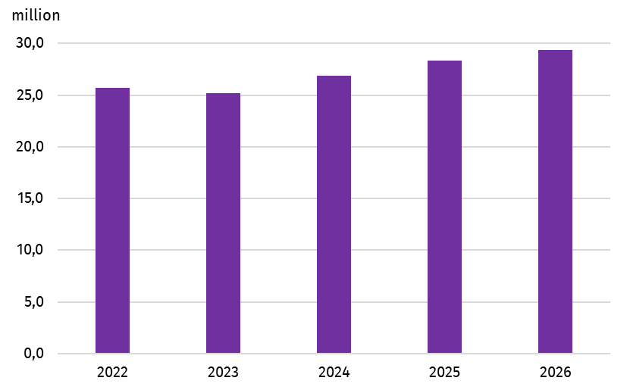
Chart 2. Overnight stays in tourist accommodation establishments in July and August

As in 2025, the highest number of overnight stays was recorded in the Zachodniopomorskie Voivodeship (5.8 million), followed by the Pomorskie Voivodship (4.4 million), Małopolskie Voivodship (4.2 million), Dolnośląskie Voivodship (2.9 million), and Mazowieckie Voivodship
(2.5 million). In July and August, these voivodeships accounted for nearly 70% of all overnight stays provided in tourist accommodation establishments in Poland.
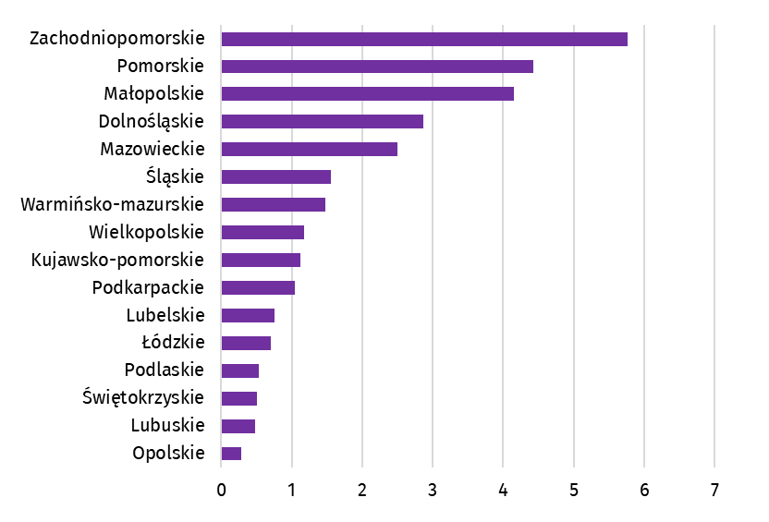
Chart 3. Overnight stays provided to tourists in tourist accommodation establishments in July and August 2026, by voivodeship
million

When quoting Statistics Poland data, please provide information: “Source of data: Statistics Poland”, and when publishing calculations made on data published by Statistics Poland, please provide information: “Own study based on Statistics Poland data”.

Prepared by:  Statistical Office in Rzeszów  Acting Director Andżelika Malinowska  Office: tel. (+48 17) 853 52 10 | Issued by:  Press Office  Mobile: (+48) 695 255 032  Phone: (+48 22) 608 38 04, (+48 22) 449 41 45,  (+48 22) 608 30 09  e-mail: obslugaprasowa@stat.gov.pl

stat.gov.pl/en/

@StatPoland

@GlownyUrzadStatystyczny

gus_stat

glownyurzadstatystycznygus

glownyurzadstatystyczny
Related information
Rental of tourist accommodation establishments in Poland via booking platforms in the first quarter of 2025.
Tourism in 2025
Data available in databases
Local Data Bank
Knowledge Databases
Turystyka+
Terms used in official statistics
Tourist
Tourist accommodation establishment
Bed places in tourist accommodation establishments
Foreign tourists in tourist accommodation establishments
Nights spent (overnight stays) in tourist accommodation establishments
Duration of the stay
Occupancy rate of bed places in tourist accommodation establishments

