Financial results of cultural institutions in the first half of 2026 (preliminary data)
In the first half of 2026, total revenues of cultural institutions increased by 8.3% compared to the corresponding period of the previous year, and total costs – by 9.0%. The gross financial result was higher by 1.2% than in the previous year. Investment outlays of cultural institutions increased by 25.2%.
8.3%
Increase in total revenues y/y
Total revenues of cultural institutions in the first half of 2026 amounted to PLN 9,642.3 million and were higher by 8.3% compared to the first half of 2025. In the structure of revenues, 93.0% were net revenues from sales of products, goods and materials, 6.8% – other operating revenues, and 0.2% – financial revenues. The highest share in total revenues was achieved by cultural institutions from the Mazowieckie Voivodship (24.7%).
The average total revenues per cultural institution amounted to PLN 2,052.0 thousand. The highest total revenues per institution were achieved by cultural institutions in the Mazowieckie Voivodship (PLN 3,674.7 thousand), and the lowest – in the Lubelskie Voivodship (PLN 999.0 thousand).
Total revenues of local government cultural institutions accounted for 82.6% of total revenues of cultural institutions
Total revenues of local government cultural institutions amounted to PLN 7,961.8 million (82.6%), and of national cultural institutions – PLN 1,680.5 million (17.4%). The largest share in the total revenues of cultural institutions was accounted for by revenues of entities conducting operation of art facilities – 41.4%.
Total costs of cultural institutions amounted to PLN 8,924.8 million and were 9.0% higher than those incurred a year earlier. In the structure of costs, operating costs accounted for 99.1%. Over 24% of the costs of cultural institutions were generated by entities from the Mazowieckie Voivodship. The largest share in the total costs of cultural institutions was accounted for by the costs of entities conducting operation of art facilities – 40.8%.
The gross financial result of the cultural institutions amounted to PLN 717.5 million (gross profit – PLN 800.1 million, and gross loss – PLN 82.6 million). The net financial result of the cultural institutions amounted to PLN 716.6 million (compared to PLN 708.0 million a year ago), with an increase in net profit by 3.2% and an increase in net loss by 24.9%.

Table 1. Financial results of cultural institutions
The net financial result of the cultural institution in the first half of 2026 amounted to PLN 716.6 million
Specification | 01–06 2025 | 01–06 2026
Specification | in PLN million |  | 01–06 2025=100
Total revenues | 8,900.5 | 9,642.3 | 108.3
Total costs | 8,191.5 | 8,924.8 | 109.0
Gross financial result | 709.0 | 717.5 | 101.2
Net financial result | 708.0 | 716.6 | 101.2
Net profit | 774.2 | 799.3 | 103.2
Net loss | 66.2 | 82.6 | 124.9
Investment outlays | 542.9 | 679.6 | 125.2
Outlays on intangible fixed assets | 12.6 | 17.0 | 135.0
In the first half of 2026, investment outlays incurred by cultural institutions amounted to PLN 679.6 million and were 25.2% higher than in the previous year. Over 38% of investment outlays were investments outlays of entities located in the Mazowieckie Voivodship.
Investment outlays incurred by local government cultural institutions in Poland amounted to PLN 417.9 million, i.e. 61.5% of the total amount of investment outlays.

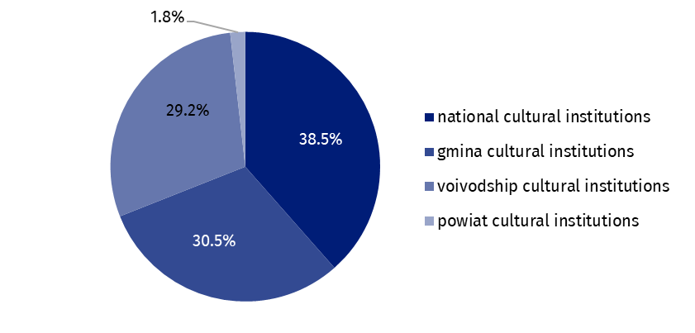
Chart 1. Investment outlays of cultural institutions by legal form in the 1st half of 2026
In the first half of 2026, outlays on intangible and legal assets incurred by cultural institutions increased by 35.0% compared to the first half of 2025 and amounted to PLN 17.0 million. Over 61% of all outlays on intangible and legal assets came from institutions in the Mazowieckie Voivodship.

Table 2. Total revenues and total costs of cultural institutions by selected divisions and classes of PKD 2007 in the 1st half of 2026
The largest share in the total revenues of cultural institutions was held by the revenues of entities conducting operation of art facilities – 41.4%
Specification | Number of cultural institutions | Total revenues | Total costs
Specification | Number of cultural institutions | in PLN million
Grand total | 4,699 | 9,642.3 | 8,924.8
local government units property | 4,623 | 7,961.8 | 7,406.8
government property | 76 | 1,680.5 | 1,518.0
of which:
creative, arts and entertainment activities | 2,339 | 5,888.4 | 5,450.8
of which:
performing arts activities | 153 | 1,778.6 | 1,720.4
operation of arts facilities | 2,177 | 3,989.4 | 3,637.6
libraries, archives, museums and other cultural activities | 2,354 | 3,631.7 | 3,357.3
of which:
libraries and archives activities | 1,944 | 1,582.3 | 1,458.4
museums activities | 402 | 1,993.1 | 1,842.7
Data presented in this study were compiled using the Finances of cultural institutions report (symbol F-01/dk). Information on the survey methodology can be found in the Methodological report. Culture Statistics.
When quoting this publication, please provide its title and indicate Statistics Poland as the author. When publishing your own calculations based on data from this publication, please include the following statement: Author’s work based on data from Statistics Poland’s publication entitled ‘Financial results of cultural institutions in the 1st half of 2026 (preliminary data)’.
Prepared by:  Statistical Office in Kraków  Director Agnieszka Szlubowska  Phone: (+48 22) 420 40 50 | Issued by:  Press Office  Mobile: (+48) 695 255 032  Phone: (+48 22) 608 38 04, (+48 22) 449 41 45,  (+48 22) 608 30 09  e-mail: obslugaprasowa@stat.gov.pl

stat.gov.pl/en/

@StatPoland

@GlownyUrzadStatystyczny

@gus_stat

@GłównyUrządStatystycznyGUS

@Glówny Urząd Statystyczny
Related information
Financial results of cultural institutions in the first quarter of 2026 (preliminary data)
Methodological report. Culture statistics
Terms used in official statistics
Total revenues
Total costs
Gross financial result
Net financial result
Investment outlays
Outlays on intangible fixed assets
Cultural institution

