Persons performing work only under civil law contracts in Poland in March 2026
On the last day of March 2026, 1 476.9 thousand persons in Poland were performing work only under contracts of mandate and related contracts, i.e. 5.9% (82.0 thousand persons) more than on 31 March 2025. Compared with 31 December 2025, their number decreased by 1.4% (by 20.9 thousand persons).
In March 2026, 20.3 thousand persons in Poland were performing work only under contracts to perform a specified task.
1.5 million
number of persons performing work only under contracts of mandate and related contracts in Poland as at 31 March 2026
20.3 thousand
number of persons performing work only under contracts to perform a specified task in Poland in March 2026

Persons performing work only under civil law contracts in Poland, broken down by sex
Amongst all persons performing work only under contracts of mandate and related contracts, men constituted the majority. At the end of March 2026, their share was 51.5%, which was 0.1 percentage points (pp) higher than a year earlier and 0.2 pp higher than at the end of December 2025.
In March 2026, women accounted for 48.0% of the population of persons performing work only under contracts to perform a specified task
Compared with the end of March 2025, the numbers of both women and men performing work only under contracts of mandate and related contracts increased by 5.6% and 6.1%, respectively. However, compared with 31 December 2025, their numbers decreased by 1.8% and 1.0%, respectively.
Men accounted for the majority of those performing work only under contracts to perform a specified task; their share stood at 52.0% in March 2026.
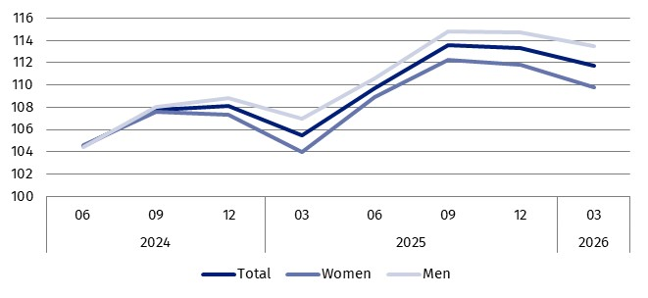
Chart 1. Indices of the number of persons performing work only under contracts of mandate and related contracts in Poland
03.2024 = 100
Persons performing work only under contracts of mandate and related contracts by PKD 2025/NACE Rev. 2.1 section
On the last day of March 2026, as in previous months, the largest number of persons performing work only under contracts of mandate and related contracts was recorded in the Administrative and support service activities section, which includes, amongst other activities, activities of employment placement agencies. As at 31 March 2026, this figure stood at 312.6 thousand persons, accounting for 21.2% of all persons performing work only under these types of contracts. The second-largest section in terms of the number of persons was Human health and social work activities, where 154.6 thousand persons were performing work only under contracts of mandate and related contracts, accounting for 10.5% of all persons performing work only under these types of contracts.
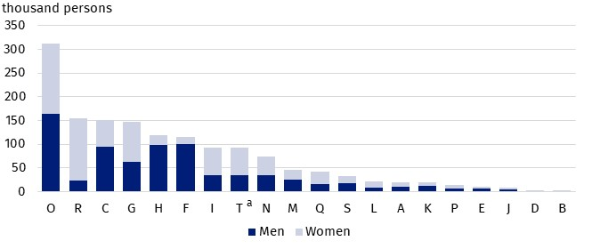
Chart 2. Persons performing work only under contracts of mandate and related contracts by sex and PKD 2025/NACE Rev. 2.1 section in March 2026
As at the end of the month
One in five persons performing work only under contracts of mandate or related contracts was engaged by an entity classified under the Administrative and support service activities section

a Data for the Other service activities (T) section also cover persons performing work in the Activities of households as employers and undifferentiated goods- and service-producing activities of households for own use (U) and Activities of extraterritorial organisations and bodies (V) sections.
***
The tables accompanying the news release present additional data, including data according to place of residence of persons performing work only under contracts of mandate and related contracts in Poland.
***
Methodological notes
Up to and including the data as at 31 December 2025, statistics on persons performing work only under contracts of mandate and related contracts were experimental in nature. Thanks to the refinement and consolidation of the methodology for identifying, in administrative sources, persons performing work under contracts of mandate and related contracts, as well as contracts to perform a specified task, these statistics have been official starting with the data for 2026.
Data on persons performing work under civil law contracts address the demand for information on the number of persons performing work in forms other than an employment relationship.
The source of the data presented here is the registers and information systems of the Social Insurance Institution (ZUS).
The population of persons performing work only under contracts of mandate and related contracts comprises persons performing work only under contracts of mandate and related contracts to which the provisions of the Civil Code apply and which entail an obligation to be covered by social insurance and/or health insurance with the Social Insurance Institution (ZUS), i.e.
- agency agreements,
- service contracts,
- nanny agreements,
- appointment letters,
- contracts with members of supervisory boards,
- managerial contracts having the nature of a contract of mandate.
According to the provisions of the Civil Code, in Poland, contracts of mandate and related contracts may be entered into by persons aged 13 or over.
The population does not include:
- persons classified as employed in the national economy – as defined by Statistics Poland,
- students under 26 years of age,
- persons performing a contract of mandate or a similar contract without remuneration.
Data on persons performing work only under contracts of mandate and related contracts are presented as the number of persons as at the last day of the month.
The population of persons performing work only under contracts to perform a specified task comprises persons performing work only under contracts to perform a specified task to which the provisions of the Civil Code apply. Under a contract to perform a specified task, the contractor undertakes to perform a specified task, while the commissioning party undertakes to pay remuneration.
The population does not include:
- persons classified as employed in the national economy – as defined by Statistics Poland,
- persons performing work under contracts of mandate and related contracts,
- persons entering into a contract to perform a specified task with an entity that is not a contribution payer and is not a natural person at the same time (some associations, legal persons and commercial partnerships and companies, etc.).
Data on persons performing work only under contracts to perform a specified task are presented as the number of persons who entered into such contracts during the month.
During the transitional period related to the reclassification of national economy entities from PKD 2007/NACE Rev. 2 to PKD 2025/NACE Rev. 2.1 (which lasts until 31 December 2026), the data on persons performing work only under contracts of mandate and related contracts are presented using, amongst other things, the correspondence tables between NACE Rev. 2 and NACE Rev. 2.1 – available on the Eurostat website: https://ec.europa.eu/eurostat/web/nace/correspondence-tables.
The study uses the alphabetical codes for PKD 2025/NACE Rev. 2.1 sections.
Names of PKD 2025/NACE Rev. 2.1 sections:
A – Agriculture, forestry and fishing;
B – Mining and quarrying;
C – Manufacturing;
D – Electricity, gas, steam and air conditioning supply;
E – Water supply; sewerage, waste management and remediation activities;
F – Construction;
G – Wholesale and retail trade;
H – Transportation and storage;
I – Accommodation and food service activities;
J – Publishing, broadcasting, and content production and distribution activities;
K – Telecommunication, computer programming, consulting, computing infrastructure and other information service activities;
L – Financial and insurance activities;
M – Real estate activities;
N – Professional, scientific and technical activities;
O – Administrative and support service activities;
P – Public administration and defence; compulsory social security;
Q – Education;
R – Human health and social work activities;
S – Arts, sports and recreation;
T – Other service activities;
U – Activities of households as employers and undifferentiated goods– and service–producing activities of households for own use;
V – Activities of extraterritorial organisations and bodies.
Data for the Other service activities (T) section also cover persons performing work in the Activities of households as employers and undifferentiated goods- and service-producing activities of households for own use (U) and Activities of extraterritorial organisations and bodies (V) sections.
When quoting this publication, please provide its title and indicate Statistics Poland as the author. When publishing your own calculations, based on data from this publication, please include the following statement: Author’s work based on data from Statistics Poland’s publication entitled ‘Persons performing work only under civil law contracts in Poland in March 2026’.
Prepared by:  Statistical Office in Bydgoszcz  Acting Director Katarzyna Klamrowska  Phone: (+48 52) 366 93 90 | Issued by:  Press Office  Mobile phone: +48 695 255 032  Landline phones: +48 22 608 38 04, +48 22 449 41 45, +48 22 608 30 09  e-mail: obslugaprasowa@stat.gov.pl

stat.gov.pl/en/

@StatPoland

@GlownyUrzadStatystyczny

@gus_stat

@GłównyUrządStatystycznyGUS

@Glówny Urząd Statystyczny
Related information
Methodological report Employment in the national economy
Employed persons in the national economy in Poland in March 2026
Persons performing work only under contracts of mandate and related contracts in Poland in March 2025
Persons performing work only under contracts of mandate and related contracts in Poland in December 2025
Terms used in official statistics
Employed persons in the national economy

Data on persons performing work only under contracts to perform a specified task are presented as the number of persons who entered into such a contract during the month.
The Act of 23 April 1964 – Civil Code (Journal of Laws of 2026, item 795, as amended).

