Social protection benefits in 2023
In 2023, expenditure on social protection benefits in Poland, calculated in accordance with the methodology of the European system of integrated social protection statistics (ESSPROS), amounted to 757.2 bn PLN. Compared with 2022, expenditure increased by 18.6%.
18.6%
Increase in expenditure on social protection benefits in comparison with 2022

Expenditure on social protection benefits by function in 2023
In 2023 the largest share of expenditure on social protection benefits was allocated to the Old Age function (46.3%)

The Old Age function accounted for the largest share of expenditure on social protection benefits (46.3%), followed by Sickness/Health Care (27.0%), Family/Children (13.7%), Survivors (6.3%), Disability (4.4%), Social Exclusion (1.4%), Unemployment (0.8%) and Housing (0.1%).
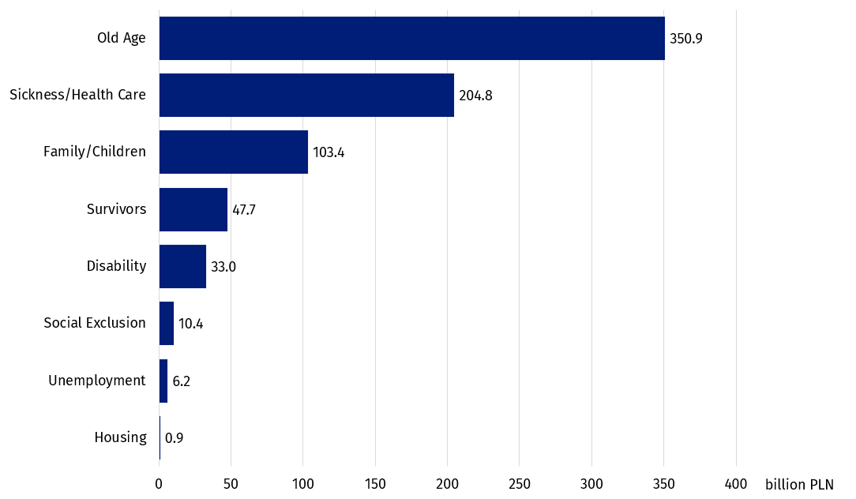
Chart 1. Expenditure on social protection benefits by function in 2023
Cash benefits accounted for 71.4% of the total amount for social protection benefits
In 2023 the largest share of expenditure was allocated to non-means-tested benefits (98.5%). The remaining share was allocated to means-tested benefits. Expenditure on cash benefits accounted for 71.4% of total expenditure on social protection benefits, while the remaining share was spent on benefits in kind.
Table 1. Expenditure on social protection benefits by function and type in 2023
Specification | In cash | In kind
Specification | in bn PLN
Total | 540.6 | 216.6
Old Age | 349.1 | 1.8
Sickness/Health Care | 32.8 | 172.0
Family/Children | 74.4 | 29.0
Survivors | 47.7 | –
Disability | 29.5 | 3.5
Social Exclusion | 2.5 | 7.8
Unemployment | 4.5 | 1.7
Housing | – | 0.9
Dash (–) means that the phenomenon did not occur.

Expenditure on social protection benefits in Europe in 2023
Expenditure on social protection benefits in Poland accounted for 22.5% of GDP
In 2023, the largest share of expenditure on social protection benefits as a percentage of GDP was recorded in France (33.8%), while the lowest was recorded in Türkiye (10.0%). In Poland, expenditure on social protection benefits accounted for 22.5% of GDP (in 2022 – 20.6%). A similar share was recorded in Luxembourg (22.5%) and Slovenia (23.1%).
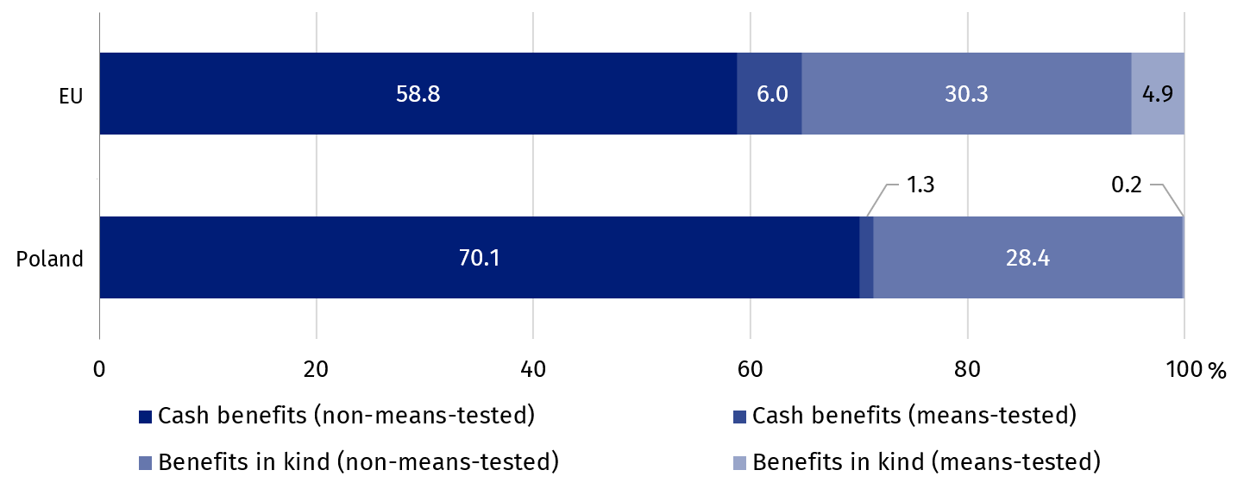
Chart 2. Expenditure on social protection benefits in cash and in kind in 2023
Source: Eurostat.
In 2023 expenditure on cash benefits accounted for 71.4% of total expenditure on social protection benefits in Poland, which was higher than the European Union average (64.8%).
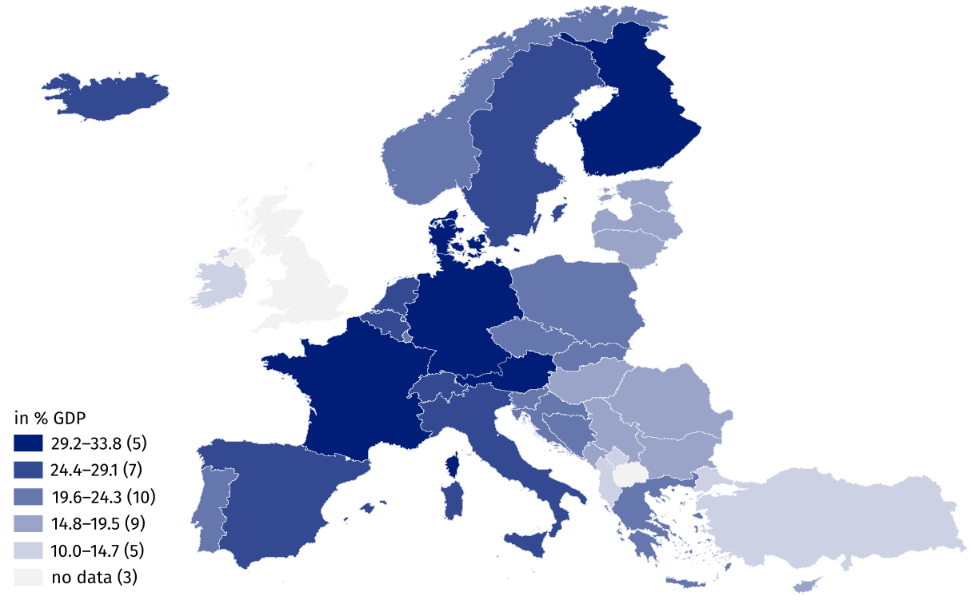
Map 1. The share of expenditure on social protection benefits in European countries in 2023
In 2023 the largest share of expenditure on social protection benefits as a percentage of GDP was recorded in France (33.8%), while the lowest was recorded in Türkiye (10.0%)
Source: Eurostat.
The share of means-tested benefits in total expenditure on social protection benefits in Poland was lower than the European Union average. Expenditure on means-tested cash benefits accounted for 1.3% of total expenditure, while expenditure on means-tested benefits in kind accounted for 0.2%; in the EU it was 6.0% and 4.9%, respectively.

Supplementary notes
The European system of integrated social protection statistics (ESSPROS) has been developed in response to the need for creating the special instrument of statistical observance of social protection. The underlying goal of the ESSPROS methodology is to provide the complex and consistent description of social protection in the European Union member states by calculating the value of the full scope of benefits and their financing in order to enable their international comparability and harmonisation with other statistics, in particular with national accounts. The social protection benefits in the ESSPROS system are grouped in 8 functions: Sickness/Health protection, Disability, Old Age, Survivors, Family/Children, Unemployment, Housing, Social Exclusion.
The scope of benefits granted in social protection in Poland has been defined within the survey “Satellite Social Protection Account. The European system of integrated social protection statistics (ESSPROS)” implemented in the framework of the Statistical Survey Program of Official Statistics.
According to the ESSPROS methodology there are four categories of expenditures: social protection benefits, administrative costs related to the benefits delivery, transfers to other schemes and other expenditures.
Social protection benefits are divided into cash transfers and transfers in kind, which are granted to the households and individual persons in order to relieve them from the burden of the certain type of risk or to meet specific need. Cash benefits need not document the actual expenses. Benefits in kind refer to the provision of goods and services. They can be provided directly or reimbursed and require to be documented. Considering the income criterion the social protection benefits can be means-tested and non-means-tested.
Due to rounding of values, in some cases the totals of sub-components may differ from general total.
When quoting this publication, please provide its title and indicate Statistics Poland as the author. When publishing your own calculations based on data from this publication, please include the following statement: Author’s work based on data from Statistics Poland’s publication entitled ‘Social protection benefits in 2023’.
Prepared by:  Statistical Office in Kraków  Director Agnieszka Szlubowska  Phone: (+48 22) 420 40 50 | Issued by:  Press Office  Mobile: (+48) 695 255 032  Phone: (+48 22) 608 38 04, (+48 22) 449 41 45,  (+48 22) 608 30 09  e-mail: obslugaprasowa@stat.gov.pl

stat.gov.pl/en/

@StatPoland

@GlownyUrzadStatystyczny

@gus_stat

@GłównyUrządStatystycznyGUS

@Glówny Urząd Statystyczny
Related information
Social Protection Satellite Account
News release “Social protection benefits in 2022”
Infographic “European System of Integrated Social Protection Statistics in 2022”
Dashboard „Social protection benefits” (only in polish)
Data available in databases
Eurostat database
Terms used in official statistics
Social assistance
Social protection
Social protection benefits

