Consumer price indices in August 2026
Consumer prices in August 2026 increased by 3.4% compared with the corresponding month of the previous year (with an increase of prices of services by 5.6% and goods by 2.5%).
As related to the previous month consumer prices increased by 0.3% (of which services by 0.7% and goods by 0.2%).
3.4%
price increase compared with August 2025
The consumer price index in August in annual terms (103.4) was the same as published in the flash estimate

NOTE: Starting with data for 2026, the CPI is calculated according to the international COICOP 2018 classification.
More information on the changes in the consumer price survey was published on the Statistics Poland website: Current information on inflation.
Table 1. Consumer price indices in August 2026
SPECIFICATION | 08 2026 |  |  | 01-08 2026 | CONTRIBUTION OF CHANGES  07 2026=  =100
SPECIFICATION | 08 2025=  =100 | 12 2025=  =100 | 07 2026=  =100 | 01-08 2025=  =100 | CONTRIBUTION OF CHANGES  07 2026=  =100
TOTAL | 103.4 | 103.0 | 100.3 | 102.8 | x
Food and non-alcoholic beverages | 99.1 | 99.1 | 99.3 | 101.0 | -0.18
Alcoholic beverages and tobacco | 106.6 | 105.2 | 100.0 | 106.7 | 0.00
Clothing and footwear | 97.1 | 93.2 | 99.3 | 96.9 | -0.02
Housing, water, electricity, gas and other fuels | 104.6 | 103.5 | 100.3 | 104.5 | 0.06
Furnishings, household equipment and routine household maintenance | 99.8 | 100.0 | 99.7 | 99.0 | -0.02
Health | 104.7 | 103.8 | 100.1 | 104.9 | 0.01
Transport | 111.2 | 111.3 | 103.5 | 102.4 | 0.37
Information and communication | 103.7 | 104.3 | 99.7 | 104.1 | -0.02
Recreation, sport and culture | 106.5 | 109.0 | 101.5 | 104.9 | 0.10
Education services | 105.4 | 100.8 | 100.1 | 105.9 | 0.00
Restaurants and accommodation services | 104.2 | 103.5 | 100.3 | 104.5 | 0.02
Insurance and financial services | 102.3 | 100.7 | 100.7 | 100.9 | 0.01
Personal care, social protection and miscellaneous goods and services | 102.4 | 103.0 | 100.6 | 101.8 | 0.02
A table with indices in more detail is available in the data file attached to this news release and in the Knowledge Databases.

Contributions of price changes to the total consumer price index
In August of the current year, compared with the previous month, the highest contribution to the total consumer price index came from higher prices related to: Transport (by 3.5%), Recreation, sport and culture (by 1.5%) as well as Housing, water, electricity, gas and other fuels (by 0.3%), which increased the index by: 0.37 pp, 0.10 pp and 0.06 pp, respectively.
Lower prices related to Food and non-alcoholic beverages, Clothing and footwear (by 0.7% each), Furnishings, household equipment and routine household maintenance as well as Information and communication (by 0.3% each) decreased the index by 0.18 pp and 0.02 pp each, respectively.
Compared with the corresponding month of the previous year, higher prices related, among others, to: Transport (by 11.2%), Housing, water, electricity, gas and other fuels (by 4.6%), Recreation, sport and culture (by 6.5%), Alcoholic beverages and tobacco (by 6.6%) and Health (by 4.7%) increased the index by: 1.13 pp, 0.94 pp, 0.42 pp, 0.32 pp and 0.29 pp,
respectively. Lower prices related, among others, to Food and non-alcoholic beverages (by 0.9%) and Clothing and footwear (by 2.9%) decreased the index by 0.23 pp and 0.10 pp, respectively.
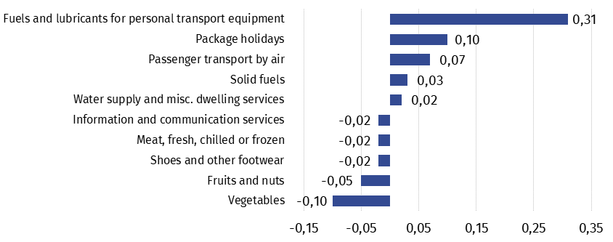
Chart 1. Contribution of price changes of selected groups of consumer goods and services in August 2026 (change in pp compared with the previous period)

Chart 2. Weighting system used in the compilations of consumer price indices in 2026
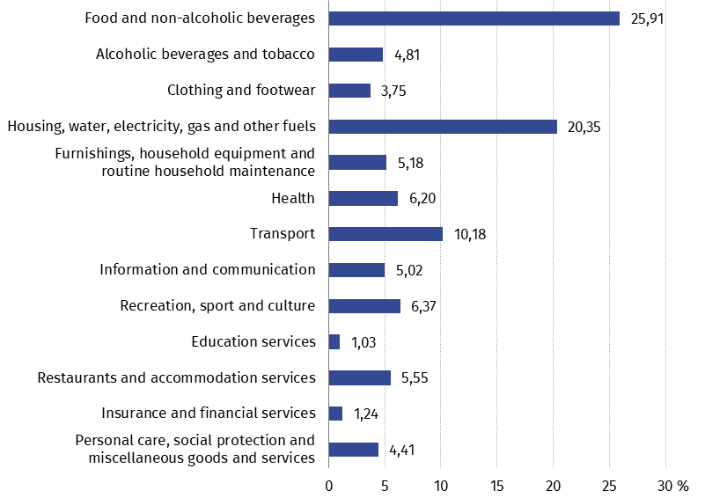
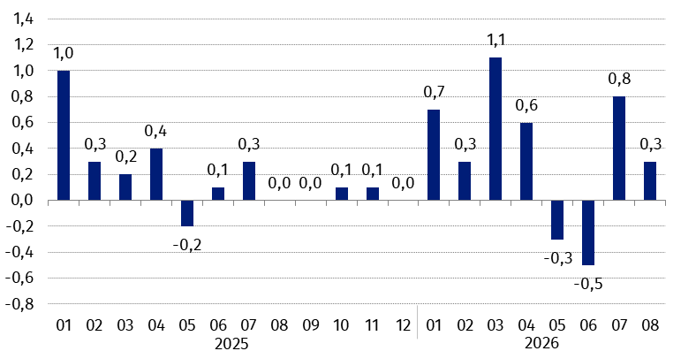
Chart 3. Changes in consumer prices as related to the previous month (in %)

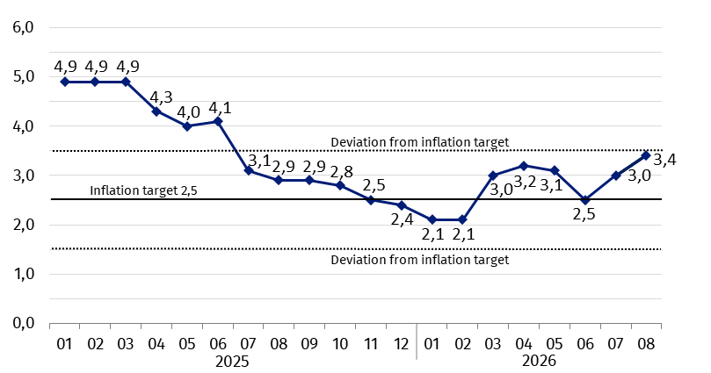
Chart 4. Changes in consumer prices as related to the corresponding period of the previous year (in %)
In August 2026 the consumer price index was within the deviations from inflation target determined by the Monetary Policy Council (2.5% +/- 1 pp)
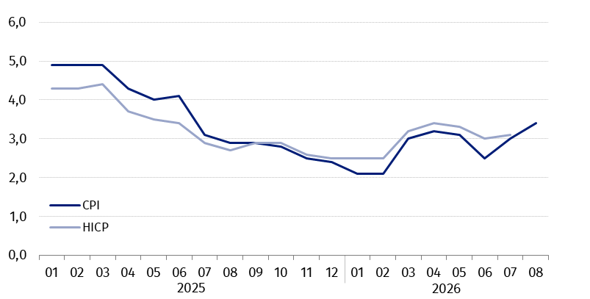
Chart 5. Changes in prices according to consumer price index (CPI) and harmonised index of consumer prices (HICP) as related to the corresponding period of the previous year (in %)
When quoting this publication, please provide its title and indicate Statistics Poland as the author. When publishing your own calculations based on data from this publication, please include the following statement: Author’s work based on data from Statistics Poland’s publication entitled ‘Consumer price indices in August 2026’.
Prepared by:  Prices and Services Department  Director Ewa Adach-Stankiewicz  Phone: (+48 22) 608 31 24 | Issued by:  Press Office  Mobile (+48) 695 255 032  Phone (+48 22) 608 38 04  (+48 22) 608 30 09  (+48 22) 449 41 45  e-mail: obslugaprasowa@stat.gov.pl

stat.gov.pl/en/

@StatPoland

@GlownyUrzadStatystyczny

@gus_stat

@GłównyUrządStatystycznyGUS

@Glówny Urząd Statystyczny
Related information
Communications and Announcements
News releases
Information on the implementation of the COICOP 2018 classification with 2026 data
Information on the changes in the consumer price survey in 2026
Data available in databases
Knowledge Database Prices
Macroeconomic Data Bank
Local Data Bank
Price indices (Topics: Prices. Trade)
Prices (Topics: Prices. Trade)
Terms used in official statistics
Price index of consumer goods and services
Retail price

