Pig population as of June 2026
According to preliminary data, the population of pigs in June 2026 was 9 206.2 thousand heads showing a increase of 0.9% compared to the analogical period last year. The increase in numbers occurred in the pigs, from 20 kg to less than 50 kg, fattening pigs and covered sows.
0.9%
Increase in pig population in June 2026 y/y
The population of pigs in June 2026 was 9 206.2 thousand heads. In the structure of the herd, the biggest change concerned the share of piglets and pigs, from 20 kg to less than 50 kg

At the beginning of June 2026, the pig population amounted to 9 206.2 thousand heads and was higher by 82.7 thousand heads (by 0.9%) than the state recorded in the analogical period of 2025, and compared with the number of pigs in December 2025 – lower by 19.0 thousands heads, i.e. by 0.2%.

Table 1. Pig population in thousands heads in June 2026
Specification | 06 2026 | 06 2025=100 | 12 2025=100
Pigs | 9 206.2 | 100.9 | 99.8
Piglets, less than 20 kg | 1 843.3 | 96.2 | 100.1
Pigs, from 20 kg to less than 50 kg | 2 668.0 | 104.5 | 98.4
Fattening pigs, 50 kg and over | 4 071.0 | 101.0 | 100.7
Breeding pigs 50 kg and over | 623.9 | 99.9 | 99.4
of which: breeding sows | 614.4 | 100.0 | 99.4
of which covered sows | 433.0 | 102.4 | 101.2

The herd of sows for breeding remained at the same level as in June 2025 by 614.4 thousand heads, including the number of covered sows increased by 10.3 (by 2.4%) to 433.0 thousand heads. Compared to December 2025, the number of sows for breeding decreased by 3.8 thousand heads (by 0.6%), but covered sows increased by 5.1 thousand heads, i.e. by 1.2%.

In the structure of the total pig herd, the share of individual production-use groups
The largest share in the herd structure was the population of fattening pigs - 44.2%
in June 2026 was:
- piglets, less than 20 kg – 20.0%,
- pigs, from 20 kg to less than 50 kg – 29.0%,
- fattening pigs, 50 kg and over – 44.2%,
- breeding pigs, 50 kg and over – 6.8%,
of which:
- breeding sows together – 6.7%,
- of which covered sows – 4.7%.

Chart 1. Pigs and sows population in June 2020-2026

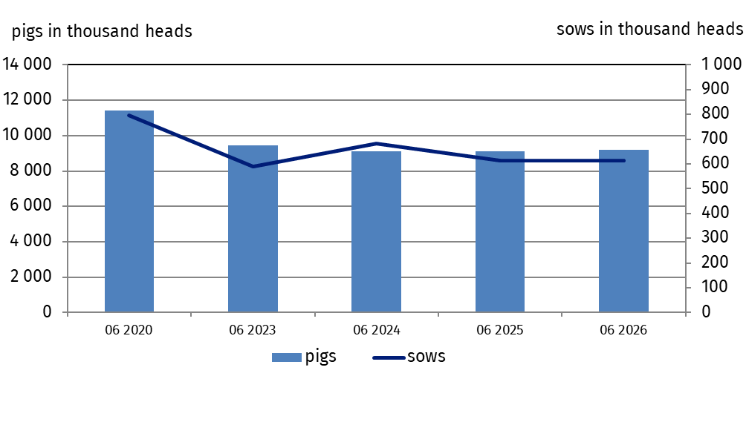
Compared to the structure of the pig population recorded at the beginning of June 2025, the proportion of pigs, from 20 kg to less than 50 kg (by 1 pp.) and covered sows (by 0.1 pp.) was increased in 2026, however piglets (by 1 pp.) was decreased in 2026. The share of pig groups: fattening pigs, 50 kg and over, breeding pigs, 50 kg and over and breeding sows remained at the level of the previous year.
Chart 2. Pig population structure in June 2025 and 2026

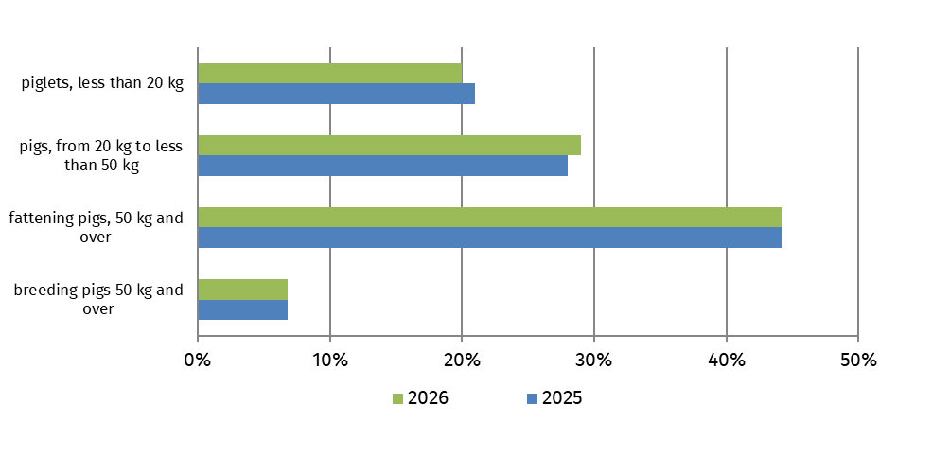

In the period from January to June 2026 (according to preliminary data) the import of live pigs amounted to 4 511.8 thousand heads and was by 4.9% higher than in the analogical period of the previous year, including the import of piglets and pigs weighing from 20 kg to 50 kg increased by 3.8%. The average weight of one imported pig during this period was 34.1 kg compared to 32.4 kg in 2025.
From January 1 to June 30 2026, pig import increased by 4.9% compared to the analogical period of the previous year
The largest shares in the national pig population were in the following voivodeships: Wielkopolskie (23.9%), Mazowieckie (17.9%), Łódzkie (12.2%), Kujawsko-pomorskie (9.4%) and Pomorskie (9.1%). The lowest shares pig population were in voivodeships: Lubuskie (1.4%), Małopolskie (1%) and Podkarpackie (0.8%).
In June 2026, the purchase price of pork (PLN 5.08 per kg) was by 7.5% lower than the previous month, and year-on-year it decreased by 27.6%.
African swine fever (ASF) continues to be at risk. In the first half of 2026, the General Veterinary Inspectorate registered 1 outbreaks of ASF in pigs, the disease affected 23 217 animals.
Additional table on pig population by voivodeships is available in Excel file.

When quoting this publication, please provide its title and indicate Statistics Poland as the author. When publishing your own calculations based on data from this publication, please include the following statement: Author’s work based on data from Statistics Poland’s publication entitled ‘Pig population as of June 2026’.
Prepared by:  Agriculture and Environment Department  Director Marta Wojciechowska  Phone: (+48 22) 608 31 28 | Issued by:  Press Office  Mobile: (+48) 695 255 032  Phone: (+48 22) 608 38 04, (+48 22) 449 41 45,  (+48 22) 608 30 09  e-mail: obslugaprasowa@stat.gov.pl

stat.gov.pl/en/

@StatPoland

@GlownyUrzadStatystyczny

@gus_stat

@GłównyUrządStatystycznyGUS

@Glówny Urząd Statystyczny
Related information
Farm animals in 2025
Data available in databases
Local Data Bank
Terms used in official statistics
Pigs

Preliminary generalised results of a representative survey of pig population and pig production comprising: - all holdings of legal persons and unincorporated entities, - selected individual holdings (12 thousand holdings - sample of approximately 0.9%).

