Cattle population as of June 2026
1.3%
Increase in cattle population in June 2026 y/y

Cattle population in June 2026 reached 6 229.1 thousand heads and was higher by 1.3% compared to June of last year. The increase in the total cattle herd size resulted from an increase in the number of calves less than 1 years old.

In June 2026, the cattle population was 6 229.1 thousand heads and was by 81.8 thousand heads (1.3%) higher than a year earlier, while in comparison to the number of the head size in December 2025, the population was increased by 85.8 thousand heads (1.4%).
The population of cattle in June 2026 was 6 229.1 thousand heads. In the herd structure, the biggest change concerned the share of the calves population. Their share increased by 6.1 pp. compared to June 2025

Table 1. Cattle population in June 2026
Specification | 06 2026  in thousand heads | 06 2025=100 | 12 2025=100
Cattle | 6 229.1 | 101.3 | 101.4
Calves less than 1 years old | 2 244.7 | 122.1 | 118.1
Young cattle 1–2 years old (uncomplete) | 1 422.0 | 89.1 | 89.7
Cattle 2 years old and over | 2 562.4 | 94.4 | 96.4
of which cows | 2 145.8 | 99.4 | 102.6

The number of calves of age less than 1 year increased in comparison to the number in June 2025 by 22.1% and compared to December 2025 by 18.1% reaching the level of 2 244.7 thousand heads.
The stock of young cattle aged 1–2 years old (uncomplete) decreased by 10.9% compared to the previous year, while compared to December 2025, it decreased by 10.3% and reached the level of 1 422.0 thousand heads.
The number of cattle aged 2 years and over decreased by 5.6% compared to June 2025 population, while compared to December 2025 decreased by 3.6%, reaching the level of 2 562.4 thousand heads.
In comparison to June 2025, the number of cows decreased by 12.9 thousand heads (by 0.6%) reaching the level of 2 145.8 thousand heads while compared to December 2025, the number of cows increased by 54.7 thousand heads (by 2.6%).

Chart 1. Cattle and cows population in June 2020-2026

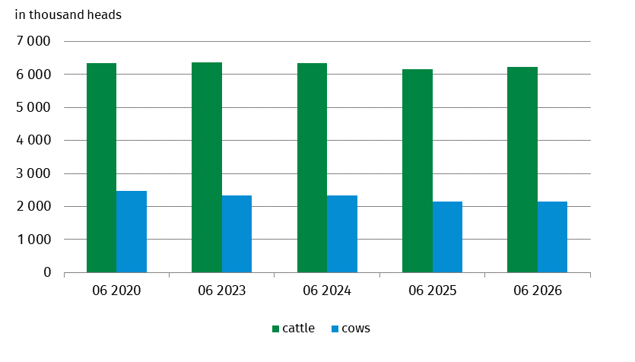
In the structure of the cattle herd, the largest share is represented by calves - 36.0%

In the structure of the total cattle herd, the share of individual age-utility groups in June 2026 was the following:
- calves less than 1 year old – 36.0%,
- young cattle 1-2 years old for breeding and for slaughter – 22.8%,
- cows – 34.4%,
- other adult cattle 2 years old and over for breeding and for slaughter – 6.7%.
Compared to the structure of the cattle population in June 2025 the share of calves less than 1 year old increased by 6.1 pp. However, it was noted the population of young cattle 1–2 years old (uncomplete) for breeding and for slaughter decreased by 3.1 pp., the share of other adult cattle 2 years old and over for breeding and for slaughter decreased by 2.3 pp. and the share of cows decreased by 0.7 pp. in the considered period.
From January to June 2026 cattle imports decreased by 3.8% compared to the analogical period of the previous year

In the period from January to June 2026 (according to preliminary data) imports of cattle amounted to about 170.9 thousand heads and decreased by 3.8% compared to the analogical period of the previous year. Cattle exports amounted to 18.0 thousand heads.
In June 2026, the average price of cattle for slaughter was PLN 14.15/kg and was by 5.2% higher than the price recorded in the corresponding period of 2025.
The average milk procurement price in June this year (PLN 174.09 per 100 l) was by 22.7% lower than the price recorded in the same month of 2025.
The largest share in the national cattle population was recorded in the following voivodeships: Wielkopolskie (20.1%), Mazowieckie (17.9%) and Podlaskie (16.3%). In Dolnośląskie, Lubuskie, Podkarpackie and Zachodniopomorskie voivodeships the share in the national cattle population did not reach 2.0%.
Additional table on cattle population by voivodeships is available in Excel file.

When quoting this publication, please provide its title and indicate Statistics Poland as the author. When publishing your own calculations based on data from this publication, please include the following statement: Author’s work based on data from Statistics Poland’s publication entitled ‘Cattle population as of June 2026’.
Prepared by:  Agriculture and Environment Department  Director Marta Wojciechowska  Phone: (+48 22) 608 31 28 | Issued by:  Press Office  Mobile: (+48) 695 255 032  Phone: (+48 22) 608 38 04, (+48 22) 449 41 45,  (+48 22) 608 30 09  e-mail: obslugaprasowa@stat.gov.pl

stat.gov.pl/en/

@StatPoland

@GlownyUrzadStatystyczny

@gus_stat

@GłównyUrządStatystycznyGUS

@Glówny Urząd Statystyczny
Related information
Livestock in 2025
Data available in databases
Local Data Bank
Terms used in official statistics
Cattle

Data from the Agriculture Restructurisation and Modernisation Agency (ARMA); cattle population by herd location.

