Education in Mazowieckie Voivodship in the 2025/26 school year
In the 2025/26 school year, 1,065.2 thousand children, youth and adults were educated in pre-primary education establishments, primary schools, secondary schools and post-secondary schools in Mazowieckie Voivodship, which constituted 19.3% of the voivodship’s population (8.3 thousand less than a year ago).
0.8%
decrease in the numer of students in educational institutions y/y

As of the end of September 2025, a total of 1,065.2 thousand students were educated in all educational institutions for children, youth and adults in Mazowieckie Voivodship. people, i.e. 0.8% less than in the previous school year. They constituted 19.3% of the voivodship's population and 15.9% of all persons educated in these institutions in the country.
Pre-primary education
59.3% of pre-primary education establishments in the Voivodship were public entities
Pre-primary education is the first stage of education. In the 2025/26 school year, there were 3,550 pre-primary education establishments in Mazowieckie Voivodship (73 fewer than in the 2024/25 school year), attended by 223.4 thousand children (5.8% less).
Table 1. Pre-primary education
As of 30 September
SPECIFICATION  a – 2024/25  b – 2025/26 |  | Establishments | Sections | Children
Total | a | 3623 | 12627 | 237220
Total | b | 3550 | 12206 | 223354
Nursery schools | a | 2273 | 10151 | 193283
Nursery schools | b | 2257 | 9890 | 183371
Pre-primary sections in primary schools | a | 1092 | 2218 | 39870
Pre-primary sections in primary schools | b | 1030 | 2053 | 36039
Pre-primary education units | a | 1 | 1 | 7
Pre-primary education units | b | 1 | 1 | 5
Pre-primary centres | a | 257 | 257 | 4060
Pre-primary centres | b | 262 | 262 | 3939

Most establishments were located in urban areas (62.1% of the total number), where pre-primary education was provided in 1,707 nursery schools, 311 pre-primary sections in primary schools, 187 pre-primary centers, and 1 pre-primary education unit. Among the establishments providing pre-primary education in rural areas, pre-primary sections in primary schools predominated (719). On average, 71 children attended each establishment in urban areas, compared to 49 in rural areas.
139.1% more children attended pre-primary education establishments in urban than in rural areas
Chart 1. Children in pre-primary education establishments in urban and rural areas in the 2025/2026 school year
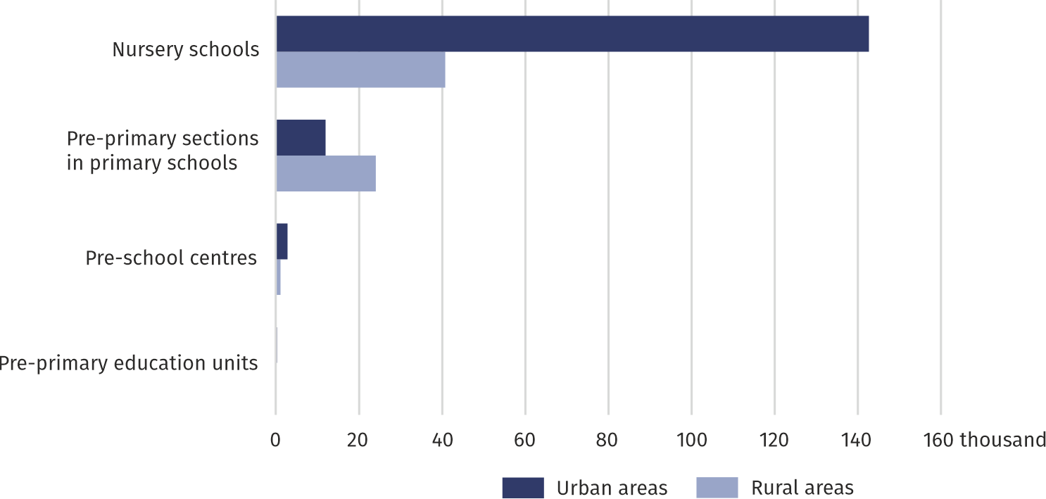
As of 30 September

The majority of children in pre-primary education were between the ages of 3 and 6. In Mazowieckie Voivodship, 98.7% of children of this age (nationally 97.1%) participated in some form of pre-primary education, which is 1.0 pp less than the year before. In urban areas, this share was higher (110.8%) than in rural areas (78.5%).
At the beginning of the 2025/26 school year, 62.3 thousand six-year-olds were completing mandatory one-year pre-primary preparation. In urban areas, a large proportion of this group of children (78.6%) attended nursery schools, while in rural areas, the majority (58.5%) attended pre-primary sections in primary schools.
Primary schools for children and youth
Table 2. Primary schools for children and youth
As of 30 September
SPECIFICATION  a – 2024/25  b – 2025/26 |  | Schools | Sections | Pupils | Graduates ª
Total | a | 1908 | 28874 | 509847 | 39544
Total | b | 1921 | 29586 | 519048 | 57699
Urban areas | a | 908 | 18379 | 351949 | 27523
Urban areas | b | 933 | 18994 | 357534 | 39426
Rural areas | a | 1000 | 10495 | 157898 | 12021
Rural areas | b | 988 | 10592 | 161514 | 18273
a From the previous school year.
In the 2025/26 school year, there were 1,921 primary schools for children and youth in the Voivodship, over half of which (51.4%) were located in rural areas. Compared to the previous year, the number of schools increased by 13, with the increase occurring in urban areas (2.8%) and a decrease in rural areas (1.2%). Most primary schools in the Voivodship (78.4%) are run by local governments.
Every third primary school pupil in Mazowieckie Voivodship was educated in rural areas
Mazovia's primary schools enrolled 519.0 thousand children and youth (1.8% more than in the previous year), including 9.2 thousand in special schools. 65.7 thousand children, or 12.7% of all primary school pupils, began their education in the first grade. Girls constituted 48.6% of all pupils enrolled in this level of education.
In the 2025/26 school year, the average section size in a mainstream primary school was 19 pupils (nationally 18). Primary schools for children and youth (excluding special schools) located in rural areas had significantly lower section sizes (16 pupils) than in urban areas (21).
In June 2025, 57.7 thousand pupils completed primary education (including 1.1 thousand graduates of special education schools), which is 45.9% more than in the previous year. This increase was the result of earlier educational reforms and demographic changes.
Post-primary schools for youth
Table 3. Post-primary schools for youth
As of 30 September
General secondary schools comprised 58.2% of secondary school students in Mazowieckie Voivodship
SPECIFICATION  a – 2024/25  b – 2025/26 |  | Schools | Students |  | Graduates ª
 |  | Schools | total | Of which in first grade | Graduates ª
Grand total | a | 974 | 265211 | 47014 | 49299
Grand total | b | 987 | 264205 | 63796 | 56092
Special job-training schools | a | 77 | 1836 | 514 | 345
Special job-training schools | b | 77 | 1842 | 539 | 378
Stage I sectoral vocational schools | a | 192 | 19875 | 6062 | 4202
Stage I sectoral vocational schools | b | 194 | 18848 | 6985 | 6205
Stage II sectoral vocational schools | a | 18 | 1076 | 706 | 431
Stage II sectoral vocational schools | b | 22 | 1782 | 1368 | 320
General secondary schools | a | 455 | 155003 | 25482 | 29962
General secondary schools | b | 464 | 153753 | 35190 | 35438
Technical secondary schools | a | 220 | 85732 | 13969 | 14120
Technical secondary schools | b | 218 | 86221 | 19324 | 13508
Art schools ^{b} | a | 12 | 1689 | 281 | 239
Art schools ^{b} | b | 12 | 1759 | 390 | 243
a From the previous school year. b Leading to professional certification.
In the 2025/26 school year, 987 schools for youth (13 more than the year before) provided post-primary education, including 167 special schools. This number included 194 stage I sectoral vocational schools and 22 stage II sectoral vocational schools, 464 general secondary schools, 218 technical secondary schools, 77 special job-training schools, and 12 art schools leading to professional certification. They enrolled a total of 264.2 thousand students, which is 0.4% less than in the previous school year.
The most popular schools were those that offered the opportunity to obtain a secondary school leaving certificate and thus continue education at higher education institutions; 92.2% of the total number of students at this level of education attended them (88.1% nationally).
In the 2025/26 school year, over half (58.2%) of all students in post-primary schools (including special schools), i.e., 153.8 thousand, were enrolled in general secondary schools. This was 0.8% less students than in the previous year. The share of women was 57.6%. General vocational secondary schools, which include technical schools, art schools leading to professional certification, and stage II sectoral vocational schools, were attended by 89.8 thousand students (34.0% of all students in this type of school in the Voivodship), which is 1.4% more than in the 2024/25 school year. Women accounted for 36.0% of these students. The remaining students were 18.8 thousand students in stage I sectoral vocational schools and 1.8 thousand students in special job training schools (5.2% less and 0.3% more, respectively, than the previous year). Every third student in these schools is a woman.
Women dominated in art schools and general secondary schools, while men predominated in sectoral schools and technical schools, as well as in special job training schools
In the 2024/25 school year in Mazowieckie Voivodship, 56.1 thousand persons received a certificate of completion of a post-primary school for youth (13.8% more than a year earlier), including 1.1 thousand persons who graduated from special schools.
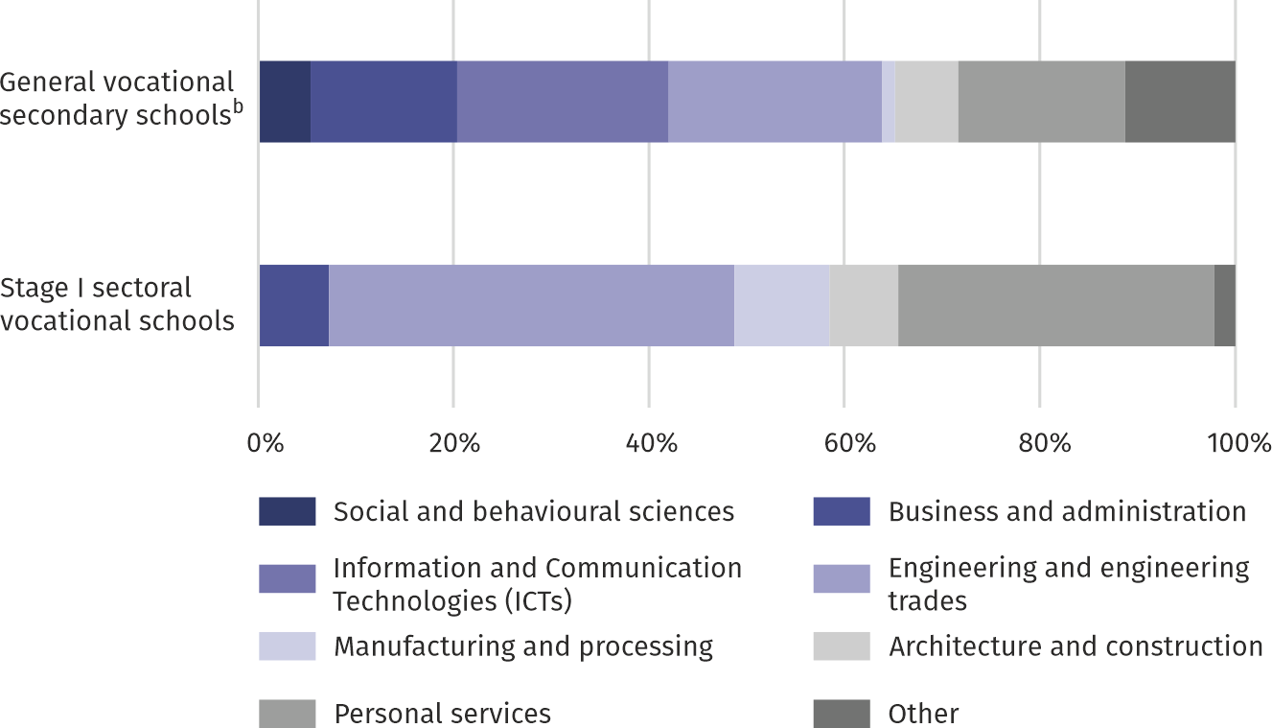
Chart 2. Graduates of vocational schools for youth by narrow fields of education ª in the 2024/2025 school year
Among youth graduating from vocational schools, women were most often graduates of fields of study from the personal services (3.1 thousand persons), while men were graduates of engineering and engineering trades (5.3 thousand persons)

a According to the International Classification of Fields of Education and Training (ISCED-F 2013). b Stage II sectoral vocational schools, technical secondary schools, and art schools leading to professional certification.
Post-secondary schools
In the 2025/26 school year, there were 142 post-secondary schools in Mazowieckie Voivodship (147 in the previous school year), in which 40.7 thousand students were learning a profession (7.6% less than a year ago), of which 66.4% were women.
The number of post-secondary school graduates in the 2024/25 school year amounted to 14.1 thousand persons and decreased by 5.3% compared to the previous year.

Table 4. Post-secondary schools
As of 30 September
The majority of post-secondary school graduates completed their education in medical and artistic fields
SPECIFICATION | Schools | Students |  | Graduates ª
SPECIFICATION | Schools | total | of which  women | Graduates ª
2024/25 | 147 | 44050 | 28757 | 14864
2025/26 | 142 | 40703 | 27022 | 14070
a From the previous year.
Schools for adults
Schools for adults are primarily focused on continuing interrupted education. In the 2025/2026 school year, 99 adult schools operated in Mazowieckie Voivodship: four primary schools and 95 general secondary schools. They had a total of 17.9 thousand students (3.9% more than in the previous school year), of whom 43.1% were women.
In the 2024/25 school year, a total of 4.4 thousand students graduated from adult education, i.e. 31.8% more than in 2023/24.
Table 5. Schools for adults
As of 30 September
The number of students in schools for adults was 3.9% higher than last year
SPECIFICATION  a – 2024/25  b – 2025/26 |  | Schools | Students |  | Graduates ª
 |  | Schools | total | of which  women | Graduates ª
Total | a | 99 | 17235 | 7532 | 3332
Total | b | 99 | 17905 | 7714 | 4392
Primary schools | a | 3 | 63 | 39 | 19
Primary schools | b | 4 | 61 | 24 | 22
General secondary schools | a | 96 | 17172 | 7493 | 3313
General secondary schools | b | 95 | 17844 | 7690 | 4370
a From the previous years.
Teachers
15.7% of teachers employed in Poland worked in educational institutions in Mazowieckie Voivodship
In the 2025/26 school year, 78.4 thousand teachers were employed (full-time equivalents) in educational institutions in Mazowieckie Voivodship, which is 0.3% more than in the previous year. More than half (52.7%) are teachers employed in primary schools.
Women constituted 84.0% of all employed teachers, with the largest number working in pre-primary education establishments and primary schools (99.0% and 84.4%, respectively). Men were most numerous in stage I sectoral schools (40.1%) and art schools (35.4%). More than half of the teachers (51.4%) were certified teachers.

Table 6. Teachers (full-time equivalents)ª by type of school
As of 30 September
Every sixth teacher in Masovian educational institutions is a man
SPECIFICATION | 2024/25 | 2025/26
SPECIFICATION | in absolute numbers |  | 2024/25=100
Total | 78150 | 78411 | 100,3
Pre-primary education establishments | 17497 | 17231 | 98,5
Primary schools | 40842 | 41324 | 101,2
Stage I sectoral vocational schools | 1461 | 1469 | 100,5
Stage II sectoral vocational schools | 27 | 42 | 153,7
General secondary schools | 10329 | 10493 | 101,6
Technical secondary schools | 6608 | 6416 | 97,1
General secondary schools ^{b} | 258 | 272 | 105,6
Special job-training schools | 729 | 743 | 102,0
Post-secondary schools ^{c} | 399 | 422 | 105,7
a Data may not sum up due to rounding. b Providing professional qualifications. c Including colleges of social service workers.
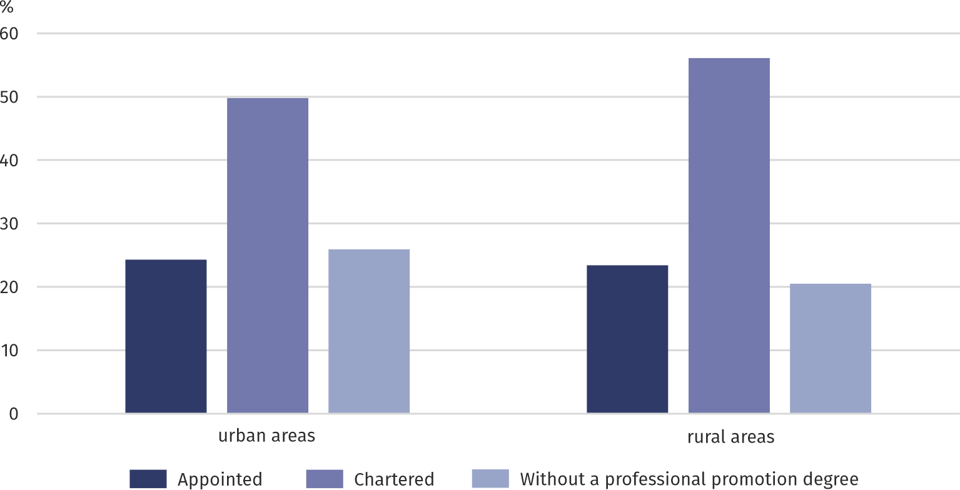
Chart 3. Full-time and part-time teachers (full-time equivalents) ª in urban and rural areas by career advancement degree in the 2025/2026 school year

In the 2025/26 school year, there was an average of 14 pupils and students (children, youth and adults) per full-time teacher in educational institutions in Mazowieckie Voivodship.

Methodologial notes
The information presented was prepared on the basis of the educational information system managed by the minister responsible for education.
Data on students is as of 30 September, and data on graduates is as of the end of the school year.
This publication divides schools into schools for children and youth and schools for adults, which employ separate educational systems. Adult schools admit individuals aged 18 and over (as well as those who turn 18 in the calendar year in which they are admitted).
Data on teachers refer to teachers employed in the implementation of mandatory educational activities, i.e. excluding after-school care workers and librarians conducting only extracurricular activities, etc. Data on teachers refer to full-time and part-time employees, converted into full-time employees.
A detailed discussion of the methodology in the field of education can be found in the annual publication entitled: „Education”, available on the Information Portal of the Statistics Poland.

In the case of quoting Statistics Poland data, please provide information: ‘Source of data: Statistics Poland’, and in the case of publishing calculations made on data published by Statistics Poland, please provide information: ‘Own work based on Statistics Poland data’.

Prepared by:  Statistical Office in Warszawa  Director Agnieszka Ajdyn  Phone: (+48 22) 464 23 15 | Issued by:  Statistical Information Centre  Marcin Kałuski  Mobile: (+48) 783 940 141
Press office in the Statistical Office in Warszawa  Mobile: (+48) 783 940 141  e-mail: m.kaluski@stat.gov.pl |   warszawa.stat.gov.pl/en/

@Warszawa_STAT

@UrzadStatystycznywWarszawie

gus_stat

glownyurzadstatystycznygus

glownyurzadstatystyczny

Related information
Education in the 2024/2025 school year
Data available in databases
Local Data Bank – Pre-primary education
Local Data Bank – Education
Knowledge Databases - Education
STRATEG - Development Monitoring System – Education
Public Services Monitoring System - Education
OECD database – Education
Eurostat database – Education
Terms used in official statistics
Pre-primary education
Primary school
Post-primary school
Post-secondary school
School for adults
Pupil/student
Graduate
Teacher

The study does not include teachers in art schools other than general education schools.

