Housing economy in 2025

In Poland as of the end of 2025 there were recorded almost 16.2 million dwellings (an increase of 1.2 % compared to the end of 2024). Their total useful floor area increase by 1.4%, the number of rooms by 1.2%.
1.2%
The increase in the number of dwellings compared to the previous year
okiem ubiegłym

Dwelling stocks
As of 31 December 2025. dwelling stocks located on the territory of Poland amounted to almost 16.2 million (an increase of 1.2 %) of dwellings with the total useful floor area of 1,223.5 million m² (an increase of 1.4 %) with 61.9 million rooms (an increase of 1.2 %).
Compared to the 2024 year, dwellings stocks increased by 196.5 thousand of dwellings with the total useful floor area of 16. 650.0 thousand m² and 707.8 thousand rooms.
Almost 11.0 million dwellings with the useful floor area of 713.4 million m² and 38.4 million rooms were located in urban areas. More than 5.2 million dwellings with the useful floor area of 510.1 million m² and 23.5 million rooms were in rural areas. In urban areas the number of dwellings increased by 130.0 thousand (by 1.2 %) while in rural areas the increase was 66.8 thousand (by 1.3 %).
Table 1. Dwelling stocks (as of 31 December)
Specification | 2024 |  |  | 2025
Specification | Total | Urban areas | Rural areas | Total | 2024 =  = 100 | Urban areas | Rural areas
Dwellings in thousands | 15 965.7 | 10 844.1 | 5 121.6 | 16 162.2 | 101.2 | 10 979.3 | 5 182.9
Rooms in dwellings in thousands | 61 164.9 | 37 929.4 | 23 235.4 | 61 872.6 | 101.2 | 38 340.0 | 23 532.6
Useful floor area of dwellings in thousand m² | 1 206 828.7 | 704 244.7 | 502 584.0 | 1 223 478.7 | 101.4 | 713 413.9 | 510 064.9
Dwellings per 1 000 population | 425.9 | 486.8 | 336.7 | 432.9 | 101.7 | 495.6 | 3 41.4
Dwelling stocks. the average:
number of rooms in a dwelling | 3.83 | 3.50 | 4.54 | 3.83 | 100.0 | 3.49 | 4.54
useful floor area in m²:
per dwelling | 75.6 | 64.9 | 98.1 | 75.7 | 100.1 | 65.0 | 98.4
per person | 32.2 | 31.6 | 33.0 | 32.8 | 101.9 | 32.2 | 33.6
number of persons:
per dwelling | 2.35 | 2.05 | 2.97 | 2.31 | 98.3 | 2.02 | 2.93
per room | 0.61 | 0.59 | 0.65 | 0.60 | 98.4 | 0.58 | 0.65

In 2025 housing conditions in Poland slightly improved. The average dwelling size amounted to 75.7 m² and increased by 0.1 m² in comparison with the previous year. The average useful floor area per 1 person increased by 0.6 m² and amounted to 32.8 m² (in urban areas increased from 31.6 m² to 32.2 m². and in rural areas from 33.0 m² to 33.6 m²).
In 2025, a further, slight improvement in housing conditions was observed in Poland
In rural areas dwellings were on average 33.4 m² larger than in urban areas (relevant indicators were 98.4 m² for rural areas and 65.0 m² for urban areas). In 2025 the average number of rooms per 1 dwelling reached 3.83. In rural areas, it was significantly higher than in urban areas ( 4.54 compared with 3.49).
There were 496 dwellings per 1000 residents in urban areas while in rural areas 341. Disproportions between urban and rural areas also concerned the density of population in dwellings. There were 202 persons per 100 dwellings in urban areas whereas in rural areas 293 and the average for Poland was 231. The average number of persons per 1 room amounted to 0.60. In rural areas amounted to 0.65, and in urban areas 0.58.
In 2025, there were disproportions between urban and rural areas in dwellings fitted with basic installations
In 2025 the share of dwellings fitted with sanitary and technical installations was at a high level. Water supply system was fitted in 97.8 % of dwellings, lavatory in 95.4 %, bathroom in 94.0 % and 59.4 % dwelling were fitted with gas installation. Disproportions in dwellings fitted with basic installations have been present between urban and rural areas. In urban areas share of dwellings fitted with installations was higher than in rural areas (gas installations – a deviation of 38.5 p.p., bathroom 7.9 p.p., lavatory 6.1 p.p. and water supply system 2.4 p.p.).
Chart 1. Dwellings fitted with installations in % of total number of dwellings in 2025 (as of 31 December)

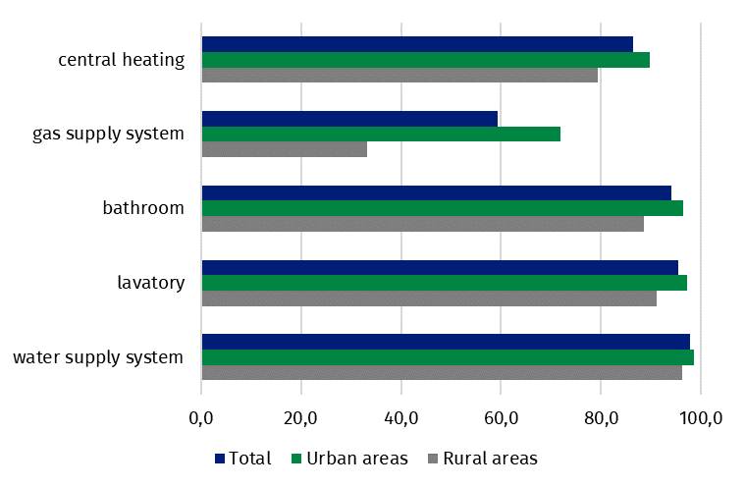

Gminas’ dwelling stocks
As of the end of 2025 the number of premises rented from gminas’ dwelling stocks was 590,839
Gminas’ dwelling stocks should be understood as premises used for satisfying housing needs. owned by gmina. As of the end of 2025. the number of residential premises with rental contracts (excluding replacement premises and temporary premises) amounted to 590.839 and their useful floor area to 26.320.8 thousand m². Compared to 2024. the number of rental contracts for such dwellings decreased by 4.957 (0.8 %). and useful floor area of such premises decreased by 222.6 thousand m² (0.8%). The average useful floor area of rented premises in gminas’ dwelling stocks decreased by 0.1 m² in comparison with the 2024. and it was 44.5 m².
As of 31 December 2025 the number of residential premises with social rental agreements amounted to 64.746 and was higher by 1.4 % (compared to 2024). and their useful floor area to 2.271.6 thousand m² (a increase of 1.7 %). Gminas had rental contracts for 1.592 temporary premises with useful floor area of 38.0 thousand m².
Compared to 2024, number of households waiting for residential premises rental from gminas decreased by 1.4 %
In 2025 as many as 117.741 households waited for gminas’ stocks rental (excluding replacement premises and temporary premises). Compared to 2024. number of households waited for rental of premises being part of gminas’ dwelling stocks decreased by 1.4 %. 63.499 households waited for social renting (a decrease of 2.7 % compared to 2024). of which 34.010 of households under execution of eviction sentences (a decrease of 4.9 %).
Table 2. Households waiting for residential premises and temporary premises rental from gminas’ dwelling stocks – as of 31 December 2025
Specification | Total | Social renting premises |  | Temporary premises renting
Specification | Total | Total | Of which execution of eviction sentences
In absolute numbers
Poland | 117 741 | 63 499 | 34 010 | 13 227
Urban areas | 101 092 | 57 978 | 33 497 | 13 095
Rural areas | 16 649 | 5 521 | 513 | 132
Poland = 100
Urban areas | 85.9 | 91.3 | 98.5 | 99.0
Rural areas | 14.1 | 8.7 | 1.5 | 1.0

Housing allowances
In 2025 the number of paid housing allowances decreased by 3,4 %, and their amount by 0.1 %
In 2025 over 2.6 million housing allowances were paid. 92.200 less than in 2024. Their total amount reached PLN 897.9 million and it was PLN 486.9 thousand lower than in the previous year. There was the domination of housing allowances (in their total number) that was paid to the users of gminas’ premises (37.7 % share) and housing cooperatives dwellings (28.1 % share). The share of allowances paid to the users of dwellings of public building societies and other entities occurred to be very low (2.4 % and 4.6 %).
Average amount of housing allowance was PLN 340.5. The average amount of the allowance that was paid to the users of dwellings of public building societies reached PLN 405.1 and was the highest. while the lowest (PLN 296.7) to the users of premises being part of housing condominiums.
Table 3. Housing allowances

Specification | 2024 | 2023 = 100 | 2025 | 2024 = 100
Number of housing allowances paid in thousands | 2 729.3 | 97.2 | 2 637.1 | 96.6
Amount of housing allowances paid in thousand PLN | 898 399.0 | 102.2 | 897 912.1 | 99.9
Average amount of housing allowance in PLN | 329.2 | 105.1 | 340.5 | 103.4

Management of land for housing construction
Out of total gminas’ land destined for housing construction, 78.8 % were meant for single-family housing
In Poland. land (not built up) being part of gminas’ stocks meant for housing construction. comprised 24.591.1 ha. As of the end of 2025. 63.3 % such a kind of land was located in urban areas of which 78.8 % of urban land meant for single-family housing.
Out of the total area of land meant for housing construction. 46.3 % accounted for land with infrastructure facilities (of which 62.3 % was in urban areas).
In 2025. gminas handed over to investors 571.3 ha of land for housing construction. of which 78.8 % were meant for single-family housing. Of the total area of land meant for housing construction. 58.6 % accounted for land in urban areas.

When quoting this publication, please provide its title and indicate Statistics Poland as the author. When publishing your own calculations based on data from this publication, please include the following statement: Author’s work based on data from Statistics Po-land’s publication entitled ‘Housing economy in 2025’.
Prepared by:  Statistical Office in Lublin  Director dr Krzysztof Markowski  Phone: (+48 81) 465 20 18 | Issued by:  Press Office  Mobile: (+48) 695 255 032  Phone: (+48 22) 608 38 04, (+48 22) 449 41 45,  (+48 22) 608 30 09  e-mail: obslugaprasowa@stat.gov.pl

stat.gov.pl/en/

@StatPoland

@GlownyUrzadStatystyczny

@gus_stat

@GłównyUrządStatystycznyGUS

@Glówny Urząd Statystyczny
Related information
Housing Economy in 2024
Housing Economy and Municipal Infrastructure in 2024
Data available in databases
Local Data Bank
Knowledge Database Municipal and Dwelling Infrastructure
Terms used inn official statistics
Dwelling
Dwellings owned by a gmina
Dwelling stocks
Housing allowance
Households awaiting the rental of premises from a gmina
Improved lands
Social renting

