Construction and assembly production in August 2026
According to preliminary data construction and assembly production (in constant prices) carried out domestically was in August 2026 higher by 6.7% an annual. Compared to July 2026 a decrease was noted by 0.6%.
6.7%
Increase of construction and assembly production compared to August 2025

After seasonally adjusted, the increase was noted in construction and assembly production of 4.3% an annual

In August 2026, after eliminating the seasonal factors, construction and assembly production reached the level by 4.3% higher than in the corresponding month of the previous year and higher by 1.9% in comparison to July 2026.
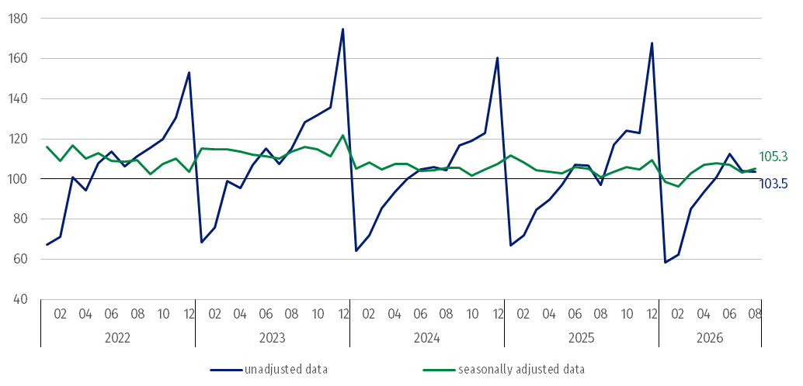
Chart 1. Construction and assembly production (constant prices; average monthly base 2021=100) ª
ª Preliminary data for August 2026.
Compared to the average monthly value of 2021 construction and assembly production in August 2026 (in constant prices), was higher by 3.5%, whereas after eliminating the seasonal factors was higher by 5.3%.
The construction and assembly production increased in in entities whose basic type of activity was civil engineering works of 29.0%
Construction and assembly production in August 2026 increased in entities whose basic type of activity was civil engineering works of 29.0% and performing specialised construction activities of 4.1%. A decrease was noted in entities dealing mainly with construction of buildings of 19.6%.
In August 2026 compared to July 2026, decreases in the sales of construction and assembly production were noted in entities whose basic type of activity was construction of buildings of 16.5% and performing specialised construction activities of 4.6%. An increase was noted in entities dealing mainly with civil engineering works of 12.3%.
Table 1. Construction and assembly production (constant prices) ª
Specification | 2026
Specification | 07 | 08 | 07 | 08 | 01-07 | 01-08
Specification | previous month = 100 |  | corresponding period of the previous year = 100
CONSTRUCTION | 92.5* | 99.4 | 97.7* | 106.7 | 97.5 | 97.9
Construction of buildings ^{Δ} | 96.0* | 83.5 | 98.2 | 80.4 | 95.5 | 93.8
Civil engineering works ^{Δ} | 87.7* | 112.3 | 99.9* | 129.0 | 99.1* | 101.6
Specialised construction activities | 97.2* | 95.4 | 93.8* | 104.1 | 97.5 | 97.3
ª Data including final information on production and prices in July and preliminary data in August 2026.
* The data has been changed compared to what was previously published.
^{Δ} Abbreviated form according to PKD 2007.
In the period January-August 2026 construction and assembly production decreased of 2.1%

In the period January-August 2026, in relation to the same period of the previous year, decreases in the sales of construction and assembly production were noted of 6.2% in entities whose basic type of activity was construction of buildings and in entities performing specialised construction activities of 2.7%. An increase was noted in entities dealing mainly with civil engineering works of 1.6%.
Analyzing the value of construction and assembly production in August 2026 in terms of construction works (investment and restoration works) were observed:
In August 2026, investment works increased by 19.3% an annual

- an annual an increase for investment works by 19.3% and a decrease for restoration works by 20.8% (in August 2025, decreases for investment works of 4.8% and for restoration works of 11.5%),
- compared to July 2026, a decrease for investment works by 1.0% and an increase for restoration works by 0.7%.
In the period January-August 2026, in relation to the same period of the previous year, a decrease in the sales of construction and assembly production was noted for restoration works by 28.1% and an increase for investment works by 9.7% (in 2025, decreases for restoration works of 3.2% and for investment works of 0.4%).

When quoting this publication, please provide its title and indicate Statistics Poland as the author. When publishing your own calculations based on data from this publication, please include the following statement: Author’s work based on data from Statistics Poland’s publication entitled ‘Construction and assembly production in August 2026’.
Prepared by:  Statistical Office in Lublin  Director Krzysztof Markowski, Ph.D.  Phone: (+48) 695 255 301 | Issued by:  Press Office  Mobile: (+48) 695 255 032  Phone: (+48 22) 608 38 04, (+48 22) 449 41 45,  (+48 22) 608 30 09  e-mail: obslugaprasowa@stat.gov.pl

stat.gov.pl

@GUS_STAT

@GlownyUrzadStatystyczny

@gus_stat

@GłównyUrządStatystycznyGUS

@Główny Urząd Statystyczny
Related information
Statistical Bulletin
Socio-economic situation of the country
Data available in databases
Knowledge Database - Construction
Macroeconomic Data Bank
Macroeconomic indicators
Local Data Bank

Terms used in official statistics
Sale of construction and assembly production
Seasonally unadjusted index of sale of construction and assembly production in constant prices
Seasonally adjusted index of sale of construction and assembly production
Sale of construction works with an investment character
Sale of construction works with a restoration character and other works

Preliminary data; comprise enterprises employing over 9 persons, whose the main type of activity is included in the section F “Construction” in accordance with the Polish Classification of Activities (PKD 2007).

