Retail sales in August 2026
In August 2026 retail sales at constant prices were by 3.8% higher than the year before (against an increase of 3.1% in August 2025). Compared with July 2026, there was a decrease by 0.3% in retail sales. In the period of January-August 2026 sales increased y/y by 3.4% (against an increase by 3.6% in the corresponding period of 2025).
3.8%
An increase compared with
the corresponding month of the previous year

Retail sales seasonally adjusted
In August 2026, an increase of 4.6% in retail sales seasonally adjusted was recorded in comparison with August 2025
After eliminating the seasonal factors, in August 2026 retail sales at constant prices were by 4.6% higher than in the corresponding month of 2025 and increased by 1.0% compared with July 2026.

Chart 1. Retail sales (constant prices, monthly average 2021=100)
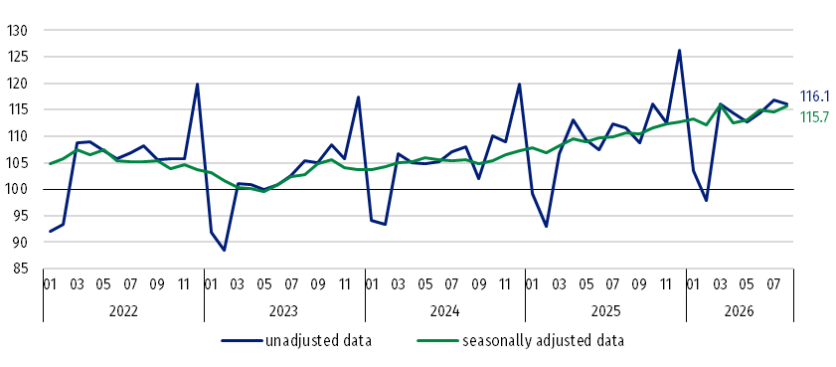

Chart 2. Retail sales (constant prices, corresponding period of previous year=100)
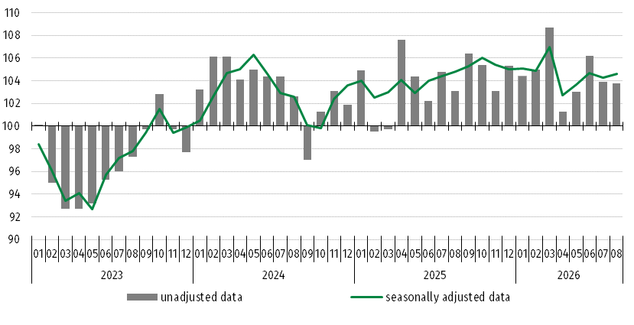

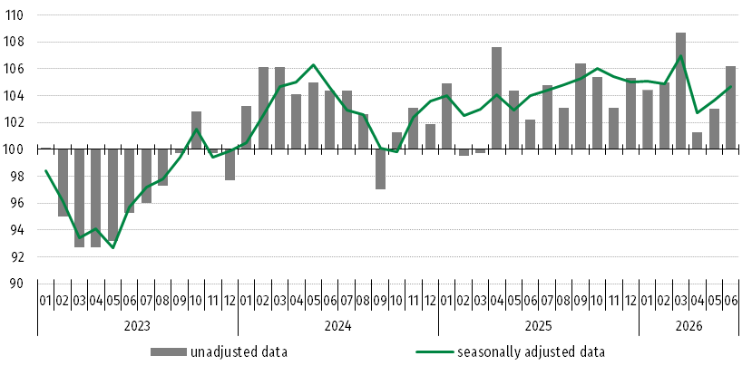

Retail sales of goods by predominant type of enterprise activity
In August 2026, an increase in retail sales y/y was recorded in most groups
In August 2026, retail sales (at constant prices) compared with the corresponding period of 2025 increased significantly in the following groups: “motor vehicles, motorcycles, parts” (by 11.7%), “others” (by 11.1%), “furniture, radio, TV and household appliances” (by 10.6%), “pharmaceuticals, cosmetics, orthopaedic equipment” (by 6.2%). In the group with the highest share in “total” retail sales - “food, beverages and tobacco products” there was an increase in sales of 1.0%. A decrease in sales was recorded in units classified into group “textiles, clothing, footwear” (by 2.7%).
In August 2026, the value of retail sales via Internet at current prices was by 17.5% higher than a year ago and the share of sales via Internet in “total” sales compared with the corresponding period of 2025 increased from 8.1% to 9.0%. Among the presented groups with a significant share of sales via Internet an increase in share was reported by enterprises from the groups: “newspapers, books, other sale in specialized stores” (from 18.3% a year ago to 23.2%), “furniture, radio, TV and household appliances” (respectively from 16.6% to 20.0%) and “textiles, clothing, footwear” (from 22.7% to 23.5%).

Chart 3. Retail sales of goods in August 2026 by groups (constant prices, corresponding period of previous year=100)

Table 1. Index numbers of retail sales (constant prices)
Specification | 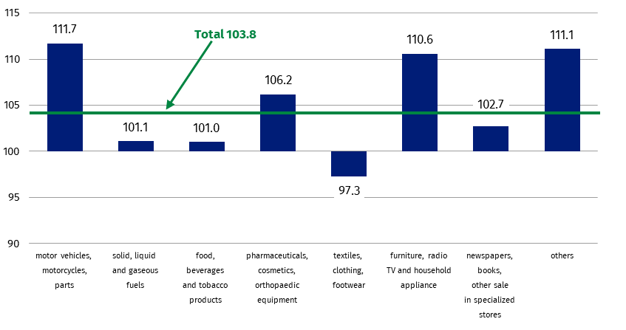  08 2026 |  | 01-08 2026
Specification | 07 2026=100 | 08 2025=100 | 01-08 2025=100
TOTAL | 99.7 | 103.8 | 103.4
of which:
Motor vehicles, motorcycles, parts | 90.4 | 111.7 | 104.5
Solid, liquid and gaseous fuels | 106.5 | 101.1 | 105.9
Food, beverages and tobacco products | 100.5 | 101.0 | 99.7
Other retail sale in non-specialized stores | . | . | .
Pharmaceuticals, cosmetics, orthopaedic equipment | 94.3 | 106.2 | 108.1
Textiles, clothing, footwear | 102.7 | 97.3 | 99.7
Furniture, radio, TV and household appliances | 101.1 | 110.6 | 107.6
Newspapers, books, other sale in specialized stores | 100.7 | 102.7 | 98.0
Others | 100.5 | 111.1 | 108.0
(.) Data not available, classified data (statistical confidentiality) or providing data impossible or purposeless

Table 2. Index numbers and structure of retail sales (current prices)
Specification | 08 2026 |  | 01-08 2026
Specification | 07 2026=100 | 08 2025=100 | 01-08 2025=100 | Structure in %
TOTAL | 100.1 | 106.4 | 104.3 | 100.0
of which:
Motor vehicles, motorcycles, parts | 90.0 | 104.4 | 98.0 | 7.6
Solid, liquid and gaseous fuels | 111.0 | 121.9 | 113.3 | 14.4
Food, beverages and tobacco products | 99.9 | 101.3 | 101.5 | 25.2
Other retail sale in non-specialized stores | . | . | . | .
Pharmaceuticals, cosmetics, orthopaedic equipment | 94.6 | 108.5 | 110.2 | 8.1
Textiles, clothing, footwear | 102.1 | 94.6 | 96.6 | 5.4
Furniture, radio, TV and household appliances | 101.1 | 110.6 | 106.7 | 7.9
Newspapers, books, other sale in specialized stores | 100.6 | 104.7 | 99.3 | 3.6
Others | 100.3 | 111.2 | 108.5 | 9.7
(.) Data not available, classified data (statistical confidentiality) or providing data impossible or purposeless

Methodological notes
The data presented in this news release concerns trade and non-trade enterprises employing more than 9 persons. Groups of enterprises were created on the basis of the Polish Classification of Activities (PKD 2007) and a given enterprise is included to a specific category by predominating kind of activity and according to its present organizational status in mentioned period. The recorded changes of rise or fall of the dynamics of retail sales in particular groups of enterprises activity may result from a change in the predominating kind of activity and organisational changes (e.g. a merger of enterprises). This does not have impact on the dynamics of the total retail sales.
The published monthly information on trade activity, in addition to retail sales, also includes data on the volume of sales by kind-of-activity unit (KAU), which is compiled for the needs of European statistics. The volume of sales (constant prices 2021=100) includes divisions and groups of Section G according to PKD 2007 - "Wholesale and retail trade; repair of motor vehicles and motorcycles”. The data is disseminated on the website of the Statistics Poland: Knowledge Databases - Short-Term Statistics data by KAU

When quoting Statistics Poland data, please provide the information: “Source of data: Statistics Poland”, and when publishing calculations made on data published by Statistics Poland, please include the following disclaimer: “Own study based on figures from Statistics Poland”.

Prepared by:  Prices and Services Statistics Department  Director Ewa Adach-Stankiewicz  Phone: (+48 22) 608 31 24, (+48) 695 255 067 | Issued by:  Press Office  Mobile: (+48) 695 255 032  Phone: (+48 22) 608 38 04, (+48 22) 449 41 45,  (+48 22) 608 30 09  e-mail: obslugaprasowa@stat.gov.pl

stat.gov.pl/en/

@StatPoland

@GlownyUrzadStatystyczny

@gus_stat

@GłównyUrządStatystycznyGUS

@Glówny Urząd Statystyczny
Related information
Internal market in 2024
Socio-economic situation of the country
Statistical Bulletin
Data available in databases
Knowledge Database - Internal market
Local Data Bank
Macroeconomic Data Bank
Terms used in official statistics
Retail sales of goods
Kind-of-activity unit

Corrections made by reporting entities were included in cumulative data.
The volume of sales is defined as turnover in trade deflated by price index i.e. turnover at constant prices (2021=100).

