Functioning of stationary social welfare facilities in Mazowieckie Voivodship in 2025
As of 31 December 2025, there were 338 stationary social welfare facilities operating in Mazowieckie Voivodship, with 20.4 thousand places and 18.5 thousand residents. Compared to 2024, the number of stationary social welfare facilities increased by 8.7%, the number of places in these facilities increased by 8.9%, and the number of residents by 7.9%
7.9%
Increase in the number of res-idents of stationary social wel-fare facilities compared to 2024

Facilities
The number of stationary so-cial welfare facilities increased by 8.7% compared to 2024
At the end of 2024, Mazowieckie Voivodship had 338 stationary social welfare facilities (27 more than at the end of 2024) and 3 branches. These constituted 14.3% of all such facilities in Poland.

Table 1. Stationary social welfare facilities by type of facility

As of 31 December
Specification |  | Facilities ª | Places ^{b} | Residents ^{b}
Total | 2024 | 311 | 18745 | 17157
 | 2025 | 338 | 20419 | 18513
Social assistance houses |  | 108 | 9962 | 9760
Family-based assistance houses |  | 1 | 10 | 8
Centres run within the scope of economic or statutory activity ^{c} |  | 158 | 7588 | 6526
Community self-help centres ^{d} |  | 1 | 3 | 1
Houses for mothers with children under age and pregnant women |  | 8 | 270 | 201
Night shelters |  | 10 | 492 | 387
Hostels for homeless persons |  | 43 | 1924 | 1537
Others |  | 9 | 170 | 93
a Excluding branches. b Including branches. c Establishments ensuring 24-hour care for disabled persons, chronic patients or elderly persons within the scope of economic activity or their statutory activity. d Including round-the-clock places.
Of the total number of facilities, 46.7% were facilities providing 24-hour care to persons with disabilities, chronically ill persons or elderly persons, operating on the basis of the provisions on economic activity or statutory regulations, 32.0% – social assistance houses, 15.7% – night shelters and hostels for the homeless, 2.4% – houses for mothers, 0.3% each – family-based assistance houses and community self-help centres (with 24-hour stay places) and 2.7% – other not classified in the above categories.
Facilities providing 24-hour care to persons with disabilities, chronically ill persons or the elderly accounted for 47% of all stationary social welfare facilities
For 151 stationary social welfare facilities, the governing bodies were natural or legal persons, accounting for 44.7% of all such establishments. The remaining facilities were operated by entities such as local government units, associations, foundations, churches, and religious organisations.

Chart 1. Stationary social welfare facilities by governing body in 2025

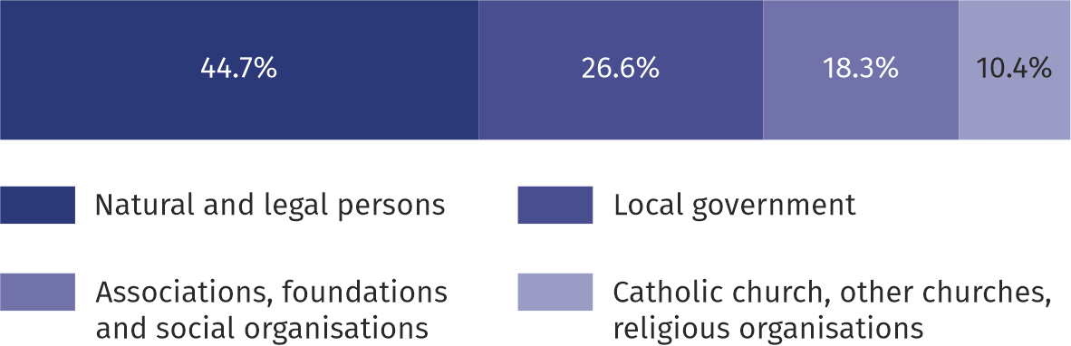
As of 31 December
93% of buildings were adapted to the needs of persons with disabilities. Most facilities (more than 72%) were equipped with ramps and platforms to facilitate entry. Elevators were available in more than 64% of facilities. Bathrooms adapted for persons with disabilities were available in 72% of facilities, and nearly 46% of buildings had non-slip floors. The remaining facilities (7%), primarily shelters and hostels for homeless persons, had no facilities for persons with disabilities.
Places
Nearly 49% of all places in stationary social welfare facilities are places in social assistance houses
Stationary social welfare facilities (including branches) had 20,419 places available (an increase of 1674, or 8.9%, compared to 2024). As in previous years, social assistance houses had the largest number of places (9,962, or 48.8% of the total).
Facilities run by local government units offered the highest number of places – 8.7 thousand. Establishments operated by natural and legal persons provided 7.0 thousand places; those run by associations, foundations, and social organisations offered 2.8 thousand; and those managed by the Catholic Church, other churches, and religious organisations provided 1.9 thousand places.
Residents
As of the end of the year, there were 18,513 residents in all facilities (an increase of 7.9% compared to the previous year), 55.6% of whom were women. Among the residents of stationary social welfare facilities, the largest number were in facilities for the elderly (8,020 persons), followed by facilities for the chronically mentally ill (3,228 persons), while the smallest number were in facilities for other groups (93 persons).
In terms of structure by age, the largest group were persons at least 60 years old - 73.5%, and the least numerous was the group of young persons (up to 18 years of age), constituting 1.4% of the total population.

Chart 2. Structure of residents of stationary social welfare facilities by age group in 2025

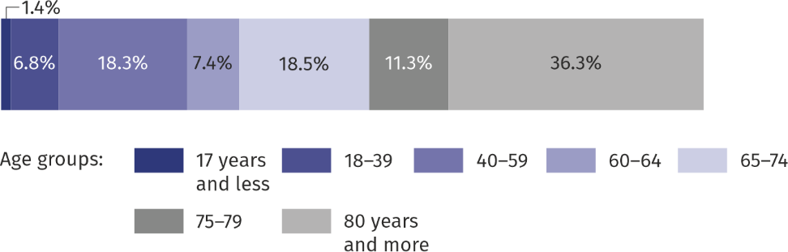
As of 31 December
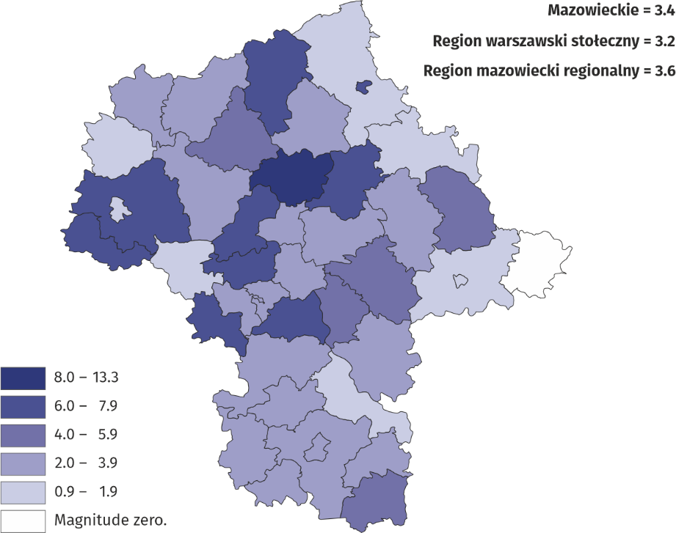
Map 1. Residents of stationary social welfare facilities per 1,000 population in 2025 As of 31 December
Among the powiats of Mazowieckie Voivodship, the highest number of residents in stationary social welfare facilities was recorded in m. st. Warszawa and piaseczyński powiat, while the lowest numbers were found in ostrowski and białobrzeski powiats. Regarding the number of residents in stationary social welfare facilities per 1,000 inhabitants, the rate was highest in pułtuski powiat (13.3) and lowest in ostrowski and ostrołęcki powiats (0.9 each). It is worth noting that no stationary social welfare facilities were recorded in łosicki powiat.
A total of 1,545 persons were waiting for placement in stationary social welfare facilities. The largest group – 76.4% of all those waiting – was awaiting a place in social assistance houses. The majority of residents (71.0%) contributed at least partially to the cost of their stay, covering expenses from their own income. However, only 14.8% of them covered the full cost. For 20.6% of residents, the stay was paid for entirely by family, while for 7.1%, it was covered by the gmina or the state budget. There were also residents exempt from payment; at the end of 2025, there were 238 such individuals, compared to 291 the previous year.
In 2025, 29.2 thousand residents were staying in stationary social welfare facilities
In 2025, 29,207 persons stayed in stationary social welfare facilities.
In the case of quoting data from the Statistics Poland, please provide information: “Statistics Poland data source”, and in the case of publishing calculations made on data published by the Statistics Poland, please provide information: “Own study based on Statistics Poland data”.

Prepared by:  Statistical Office in Warszawa  Director Agnieszka Ajdyn  Phone: (+48 22) 464 23 15 | Issued by:  Statistical Information Centre  Marcin Kałuski  Mobile: (+48) 783 940 141
Press office in the Statistical Office in Warszawa  Mobile: (+48) 783 940 141  e-mail: m.kaluski@stat.gov.pl |   www.warszawa.new.stat.gov.pl/en/

@WARSZAWA_STAT

@UrzadStatystycznywWarszawie

gus_stat

glownyurzadstatystycznygus

glownyurzadstatystyczny

Related information
Social assistance, child and family services in 2024
Data available in databases
Local Data Bank -> Health care, social welfare and benefits to the family
Terms used in official statistics
Social assistance house
House for mothers with children under age and pregnant women
Family-based assistance house

