Border traffic and expenses made by foreigners in Poland and by Poles abroad in the 2nd quarter of 2026
In the 2nd quarter of 2026, there was an increase in the border traffic of foreigners by 1.3% and of Poles by 3.1%, compared to the corresponding period of the previous year. The values of goods and services purchased by foreigners in Poland and goods and services purchased by Poles abroad during this period were higher than in the 2nd quarter of 2025 by 8.7% and 9.0% respectively.
2.1%
The increase in the number of crossings of the Polish border in the 2nd quarter of 2026 in relation to the 2nd quarter of 2025

Border traffic
In the 2nd quarter of 2026, the total number of crossings of the Polish border was higher compared to the same period in 2025, as well as in the 1st quarter of 2026
In the 2nd quarter of 2026, the number of crossings of the Polish border amounted to 78.4 million. In the total number of crossings of the border, foreigners (non-residents) constituted 55.6% and Poles (residents) – 44.4%. The border traffic (from and to Poland) was higher by 1.6 million of crossings in relation to the 2nd quarter of 2025. Compared to the previous quarter, the total number of crossings increased by 23.6% (foreigners by 22.9% and Poles by 24.5%).
In the 2nd quarter of 2026, 68.8% of all crossings concerned the land border of Poland with the European Union (EU) countries; 23.5% the border at airports, 7.1% external land border of the European Union and 0.6% sea border.
Chart 1. Border traffic of people (from and to Poland) by sections of the border in the
2nd quarter of 2025
Foreigners predominated in the structure of crossings of the Polish border
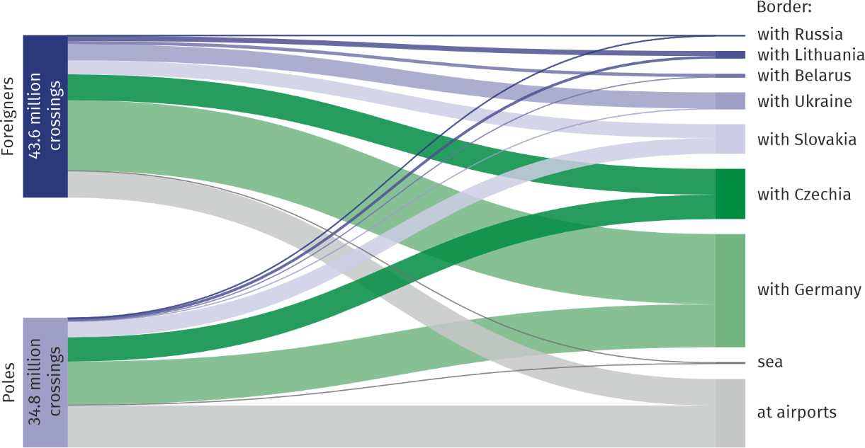
In the structure of border traffic at the land border, the largest share was accounted for by crossings of the section of the border with Germany (51.0%), followed by Czechia (22.6%), Slovakia (13.4 %), Ukraine (7.6%), Lithuania (3.5%), Belarus (1.6%) and Russia (0.3%).
Expenses made by foreigners in Poland and by Poles abroad
The values of goods and services purchased both by foreigners in Poland and by Poles abroad were higher than in the 2nd quarter of 2025
The value of goods and services purchased in Poland by foreigners in the 2nd quarter of 2026 amounted to PLN 14.2 billion (an increase of 8.7% compared to the same period of the previous year), while the expenses incurred abroad by Polish residents in this period amounted to PLN 9.4 billion (9.0% higher). In comparison with the 1st quarter of 2026, the expenses of both foreigners and Poles increased by 30.7% and 21.1% respectively.
Chart 2. Total expenses made by foreigners in Poland and by Poles abroad by border
sections in the 2nd quarter of 2026
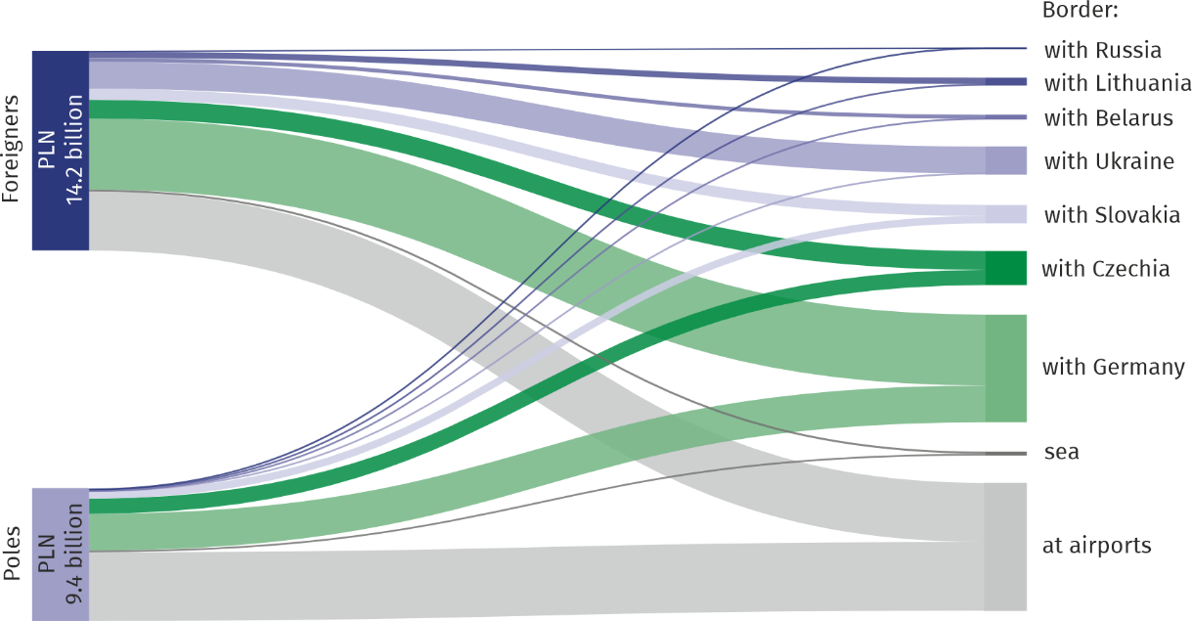
In the structure of expenses incurred in Poland by foreigners crossing the land border in the 2nd quarter of 2026 the largest share was constituted by expenses of persons crossing the border with Germany (51.3%), followed by Ukraine (19.5%), Czechia (13.6%), Slovakia (8.0%), Lithuania (4.5%), Belarus (2.8%) and Russia (0.3%).
In the case of the residents of Poland crossing the land border of the country the highest expenses abroad were incurred by persons crossing the border with Germany (60.0%), followed by Czechia (24.8%), Slovakia (12.2%), Lithuania (2.4%), Ukraine (0.4%), Belarus and Russia (0.1% each).
Chart 3. Structure of expenses made by foreigners in Poland and by Poles abroad by assortment groups in the 2nd quarter of 2026 ª
Foreigners | Poles
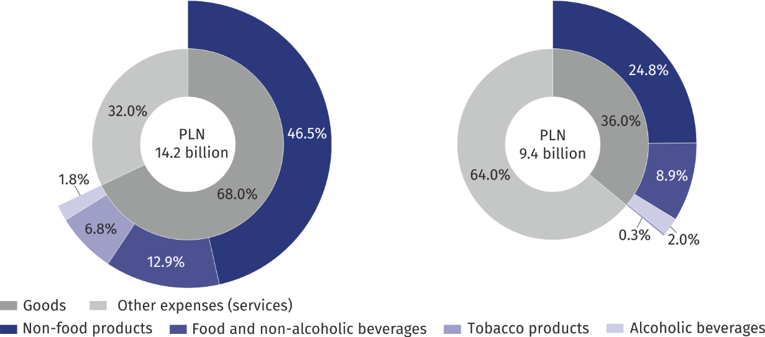
a Total expenditure of foreigners and Poles crossing the land border (the external and internal EU border), the sea border and at the airports.
Foreigners crossing the external land border of the EU in Poland incurred 76.3% of their
expenses for the purchase of non-food products, on food and non-alcoholic beverages – 15.0% and 8.7% on other expenses (services).
Polish residents who crossed the external land border of the EU in Poland spent majority of their expenses abroad on the purchase of non-food products (57.3%). Poles spent 22.2% of their expenses on other expenses (services) and on food and non-alcoholic beverages – 10.1%.
In the structure of total expenditures incurred in Poland by foreigners crossing the internal EU border in the 2nd quarter of 2026, non-food products accounted for the largest share (52.5%). Other expenses (services) had a significant share in the structure of non-residents expenses – 19.3% and expenses on food and non-alcoholic beverages – 14.1%. On the other hand, in the structure of expenditure incurred abroad by Polish citizens returning to the country through the internal EU border, other expenses (services) – 42.1% and non-food products – 40.0% predominated, while 14.3% of Poles’ expenses were spent on food and non-alcoholic beverages.
Table 1. Border traffic and expenses of foreigners in Poland and Poles abroad in the 2nd quarter of 2026
Border | Border trafficª |  |  |  | Expenses
Border | foreigners |  | Poles |  | foreigners |  | Poles
Border | million persons | Q2 2025 =100 | million persons | Q2 2025 =100 | million PLN | Q2 2025 =100 | million PLN | Q2 2025 =100
Total | 43.64 | 101.3 | 34.79 | 103.1 | 14 231.2 | 108.7 | 9 398.8 | 109.0
land | 36.32 | 98.7 | 23.27 | 98.6 | 9 867.0 | 104.0 | 4 366.8 | 104.6
EU’s external | 5.38 | 103.1 | 0.23 | 117.9 | 2 227.9 | 108.4 | 25.1 | 115.7
with Russia | 0.14 | 84.2 | 0.01 | 69.0 | 27.9 | 93.5 | 2.2 | 88.8
with Belarus | 0.88 | 134.7 | 0.07 | 193.2 | 278.8 | 160.1 | 6.3 | 159.9
with Ukraine | 4.36 | 99.1 | 0.15 | 105.7 | 1 921.1 | 103.7 | 16.6 | 108.9
EU’s internal | 30.94 | 98.0 | 23.04 | 98.5 | 7 639.1 | 102.8 | 4 341.6 | 104.6
with Lithuania | 1.36 | 93.9 | 0.71 | 96.1 | 441.3 | 98.4 | 104.1 | 103.3
with Slovakia | 3.76 | 103.6 | 4.22 | 103.8 | 785.3 | 107.8 | 531.5 | 113.1
with Czechia | 6.96 | 95.4 | 6.53 | 94.7 | 1 344.2 | 97.5 | 1 082.1 | 105.7
with Germany | 18.87 | 98.3 | 11.58 | 99.0 | 5 068.2 | 103.9 | 2 623.9 | 102.6
sea | 0.20 | 94.4 | 0.23 | 94.8 | 144.1 | 101.9 | 122.4 | 104.5
at airports | 7.12 | 117.4 | 11.29 | 113.9 | 4 220.1 | 122.1 | 4 909.6 | 113.3
a From and to Poland.
Differences in expenses, also in terms of the assortment structure of products, were observed on individual sections of the border both among foreigners as well as Poles. It is associated with the way of travelling, destination, length of stay and profitability of shopping abroad, among other things.
Local border traffic
In the 2nd quarter of 2026, local border traffic accounted for 3.9% of crossings of Poland's land border with Ukraine by foreigners
In the 2nd quarter of 2026, 171.7 thousand crossings of the Polish border with Ukraine made by foreigners as part of the local border traffic (LBT) were recorded. Compared to the same period in 2025, there was a decrease of 6.0% in crossings under the LBT regime, and a decrease of 0.3% compared to the 1st quarter of 2026. The value of expenses incurred by foreigners crossing the border under the LBT regime in the 2nd quarter of 2026 amounted to PLN 73.9 million (a decrease of 10.2% compared to the same period of the previous year).
Chart 4. Local border traffic of foreigners on the Polish-Ukrainian border

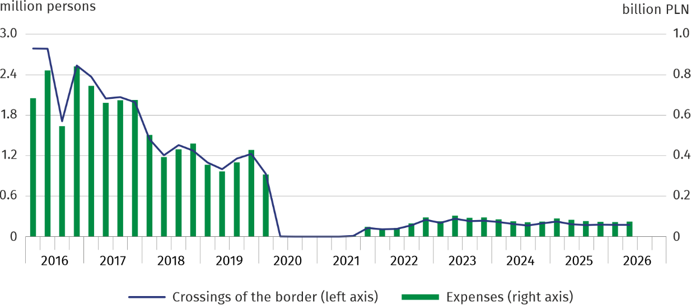
Range of border impact
The results of the surveys show that in the 2nd quarter of 2026 both foreigners and Poles crossing the Polish land border were mostly residents of the villages located at a distance of up to 50 km from the border – 74.5% foreigners and 72.2% Poles, with 56.0% of foreigners and 59.4% Poles living in the area up to 30 km from the border.
Map 1. Range of impact of the border on the basis of crossing the sections of the border
by foreigners in the 2nd quarter of 2025
Both foreigners and Poles crossing the Polish land border were mostly residents of places located up to 50 km from the border
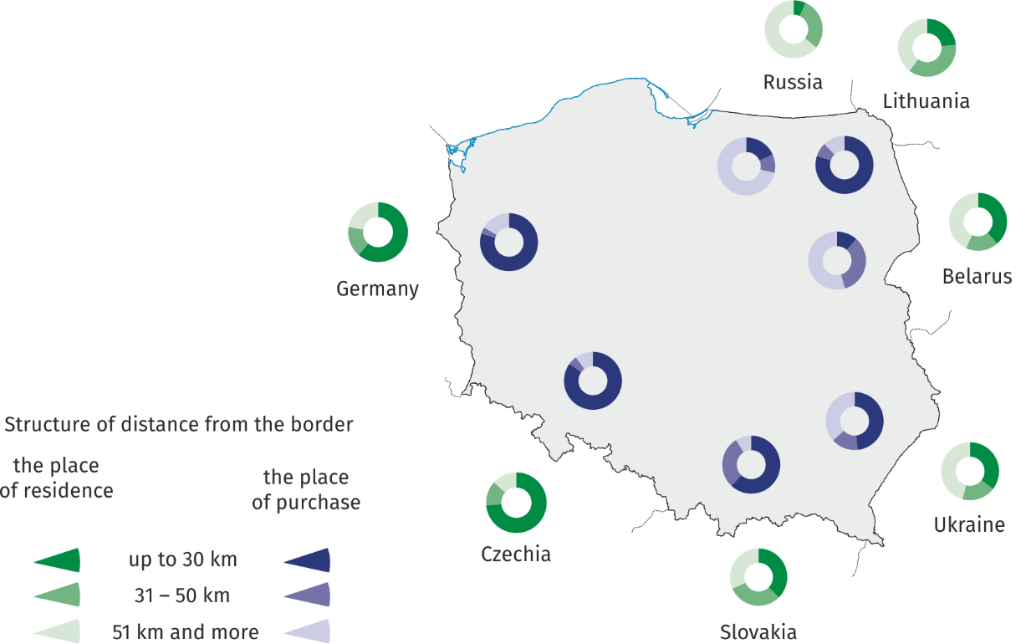
As to the external border of the European Union in Poland, 54.2% of foreigners and 73.1% of Poles crossing the Polish land border lived at the distance of up to 50 km from the border, and in the case of the internal border of the European Union 77.9% and 72.2%, respectively.
Map 2. Range of impact of the border on the basis of crossing the sections of the border
by Poles in the 2nd quarter of 2026
The majority of both foreigners and Poles crossing the Polish land border made purchases within 50 km from the border
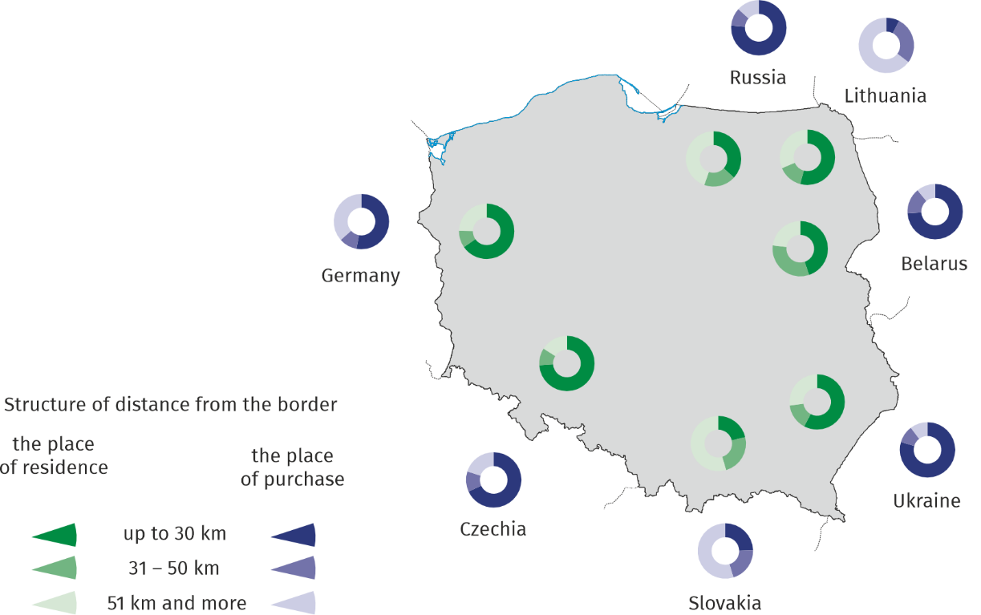
Most of the surveyed foreigners made purchases at the distance of up to 50 km from the border. In the case of the external border of the European Union in Poland it was 59.5% of those crossing the border, and in the case of the internal EU border – 86.1%. On the other hand, of those crossing the border, Poles making purchases at the distance of up to 50 km from the border constituted 89.3% in the case of the external border and 63.9% in the case of the internal border.
Methodological notes
- Presented information was developed on the basis of the survey results of "Trips made by non-residents to Poland. The movement of vehicles and persons at the Polish border with the countries of the European Union" and "Participation of residents of Poland in trips" included in the program of statistical surveys of official statistics. The survey methodology has been prepared by Statistics Poland, Statistical Office in Rzeszów in cooperation with the National Bank of Poland and the Ministry of Sport and Tourism. Since 2014 the surveys conducted jointly by these institutions are the result of the integration of four surveys (including "The survey of goods and services turnover at the external land border of European Union on the territory of Poland").
- The survey on trips made by foreigners (non-residents) to Poland and the movement of vehicles and persons at the Polish border with the countries of the European Union in the second quarter of 2026 was carried out in the field by statistical interviewers. The results of the survey were also prepared using other data sources. The survey of trips made by foreigners (non-residents) includes those leaving Poland by internal and external border of EU in Poland. Persons who have been living in Poland for over one year are not covered by the survey with the exception of those travelling for educational and health purposes. Data on expenses incurred by foreigners (non-residents) in Poland include goods purchased in Poland for resale in the country of foreigner. The survey of border traffic (in both directions – from Poland and to Poland) covers persons and vehicles crossing the Polish border with the European Union at selected border crossings.
- Survey on the participation of Poles (residents) in trips is conducted in households on a quarterly basis (in the month following the quarter) using mainly the telephone method. The survey does not cover persons staying abroad for more than one year with the exception of those travelling for educational and health purposes. The presented data on expenses incurred abroad by residents include expenses financed only from own funds (expenses financed by workplace and other individuals and institutions are not included) and also goods purchased abroad for resale in Poland.
- Data on border traffic at the external border of the EU in Poland come from the Border Guard Main Headquarters and concern the number of crossings of the border. A person crossing the border several times is counted as many times as he/she crosses this border. Data cover all border crossings (road, rail and river).
- The agreement between the Government of the Republic of Poland and the Cabinet of Ministers of Ukraine on the principles of local border traffic entered into force on 1 July 2009.
- The agreement between the Government of the Republic of Poland and the Russian Federation on the principles of local border traffic entered into force on 27 July 2012, however, from 4 July 2016 it remains suspended.
- The rules for crossing the border at specific border crossing are defined in the Regulation of the Minister of Internal Affairs and Administration of 13 March 2020 on temporary suspension or restriction of border traffic at specific border crossing (Journal of Laws of 2020, item 435, with later amendments).
- Due to rounding the sums of the figures may differ from the figure "total" in some cases. Relative numbers (indicators, percentages) were calculated on the basis of absolute data expressed with more accuracy than it was given in the report. These numbers are correct in terms of content.
- The presented data are preliminary.

When quoting this publication, please provide its title and indicate Statistics Poland as the author. When publishing your own calculations based on data from this publication, please include the following statement: Author’s work based on data from Statistics Poland’s publication entitled ‘Border traffic and expenses made by foreigners in Poland and by Poles abroad in the 2nd quarter of 2026’.

Prepared by:  Statistical Office in Rzeszów  Acting Director Andżelika Malinowska  Phones: (+48 17) 853 52 10, (+48 17) 853 52 19 | Issued by:  Press Office  Mobile: (+48) 695 255 032  Phones: (+48 22) 608 38 04, (+48 22) 449 41 45,  (+48 22) 608 30 09  e-mail: obslugaprasowa@stat.gov.pl

stat.gov.pl/en/

@StatPoland

@GlownyUrzadStatystyczny

@gus_stat

@GłównyUrządStatystycznyGUS

@Główny Urząd Statystyczny
Related information
Border traffic and expenses made by foreigners in Poland and Poles abroad in 2024
Tourism in 2025
Data available in databases
Knowledge Databases
Terms used in official statistics
Foreigners
Non-residents
Residents
Local border traffic

