Employed persons in the national economy in Poland in April 2026
On the last day of April 2026, the population of employed persons in the national economy was 15 036.5 thousand and compared with 30 April 2025 it decreased by 0.3%. Compared with the last day of March 2026, their number decreased by 0.2%.
15.0 million
number of employed persons in the national economy as at 30 April 2026
Employed persons in the national economy
Among all employed persons in the national economy, men accounted for a slightly larger proportion. At the end of April 2026, their share was 52.5%. This was 0.1 percentage points (pp) lower than a year earlier and 0.1 pp lower than at the end of March this year.
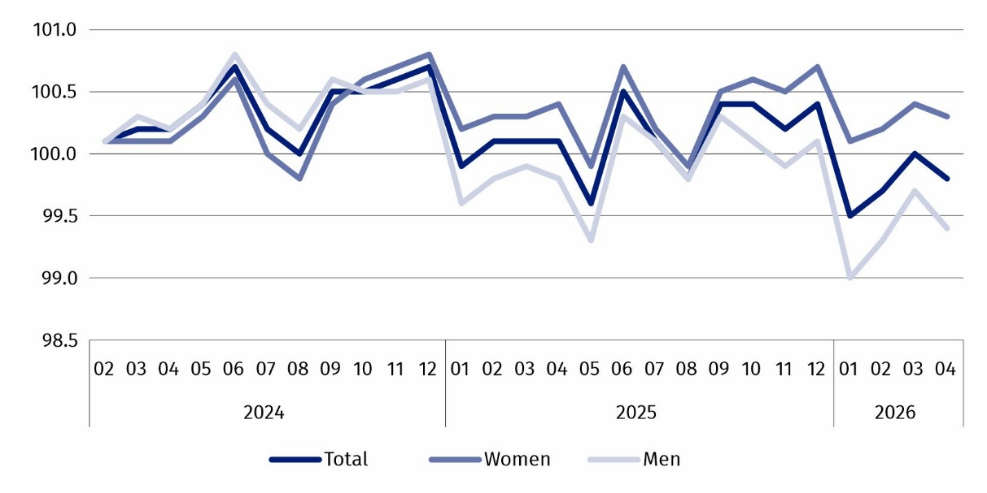
Chart 1. Indices of the number of employed persons in the national economy
(01.2024 = 100)
Employed persons by PKD 2007/NACE Rev. 2 section
The structure of employed persons in the national economy by PKD 2007/NACE Rev. 2 section did not change significantly from month to month. As at the end of April 2026, the most persons were employed in the Manufacturing section – 2 716.2 thousand, which accounted for 18.1% of the total number of employed persons in the national economy. This share was 0.2 pp lower than it was on the last day of April 2025. However, it remained unchanged compared with 31 March 2026. The second-largest section in terms of the number of employed persons was Trade; repair of motor vehicles∆, which employed 2 123.3 thousand persons, i.e., 14.1% of the total. This share was 0.3 pp lower than a year earlier and the same as at the end of March 2026.
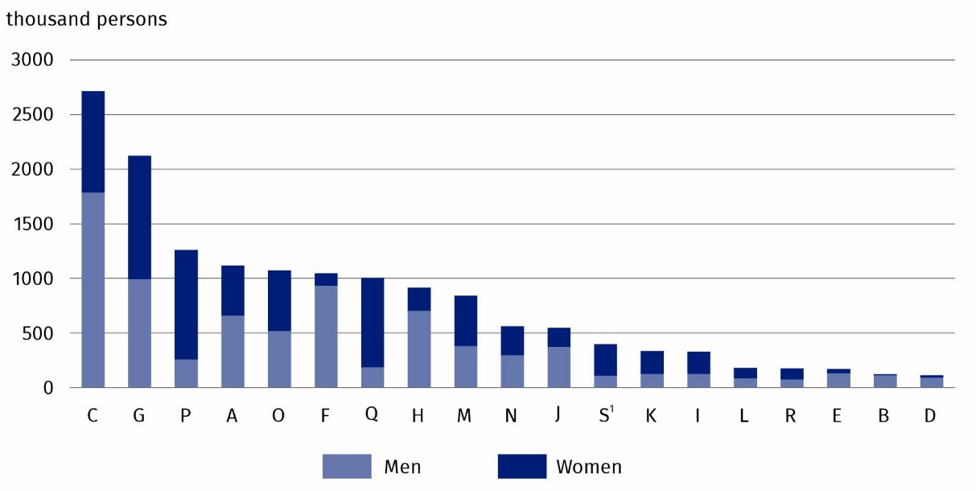
Chart 2. Employed persons in the national economy by sex and PKD 2007/NACE Rev. 2 section in April 2026
As at the end of the month
At the end of April 2026, similarly to previous months, the Human health and social work activities section (Q) was the most feminised, while the greatest share of men was in the Mining and quarrying section (B)
Among the PKD 2007/NACE Rev. 2 sections analysed, the largest decrease in the number of employed persons compared with 30 April 2025 was in the Agriculture, forestry and fishing section – by 4.4%. Decreases in the number of employed persons were also recorded in the Trade; repair of motor vehicles∆ and Manufacturing sections – by 2.2% and 1.6%, respectively. Among the PKD 2007/NACE Rev. 2 sections², the largest increase in the number of employed persons compared with 30 April 2025 occurred in the Public administration and defence; compulsory social security section – by 2.2%. The number of employed persons also increased in the Human health and social work activities section – by 1.9%, in the Education section – by 1.5%, and in the Construction section – by 0.1%.

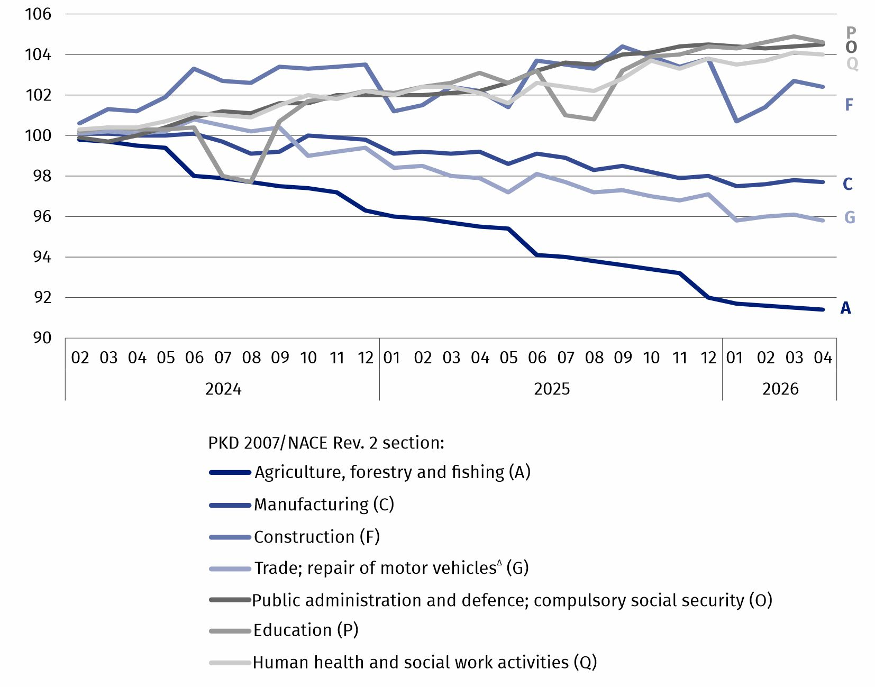
Chart 3. Indices of the number of employed persons in the national economy by selected PKD 2007/NACE Rev. 2 sections
(01.2024 = 100)
***
Starting with the data for January 2026, the scope of tables attached to the news release has been reduced. Data on employed persons in the national economy, broken down by territory, i.e., by administrative and statistical units are available in the Local Data Bank. Detailed data on demographic characteristics of employed persons will be published once a year – as at 31 December.
The tables attached to this news release present selected survey results by PKD 2025/NACE Rev. 2.1 section. During the transitional period, which runs until 31 December 2026, relating to the reclassification of national economy entities from PKD 2007/NACE Rev. 2 to PKD 2025/NACE Rev. 2.1, the data from the Survey on Employment in the National Economy are presented using, amongst other things, correspondence tables between NACE Rev. 2 and NACE Rev. 2.1, available on the Eurostat website:
https://ec.europa.eu/eurostat/web/nace/correspondence-tables
***
The data refer to employed persons in the national economy, living in Poland or abroad. Each employed person is identified once – in the main job.
Data on employed persons in the national economy refer to persons performing work which brings them earnings (in the form of wages and salaries) or income.
Employed persons include:
- employees, i.e., persons employed on the basis of an employment relationship (employment contract, appointment, nomination, election) or a service relationship;
- self-employed persons, including contributing family workers;
- outworkers;
- members of farming cooperatives;
- clergypersons fulfilling pastoral duties.

In this publication symbols and abbreviated names of PKD 2007/NACE Rev. 2 sections were used marking abbreviations with a ‘Δ’ symbol. The full names can be found in the list of PKD 2007/NACE Rev. 2 sections below.
Full names of PKD 2007/NACE Rev. 2 sections:
A – Agriculture, forestry and fishing;
B – Mining and quarrying;
C – Manufacturing;
D – Electricity, gas, steam and air conditioning supply;
E – Water supply; sewerage, waste management and remediation activities;
F – Construction;
G – Wholesale and retail trade; repair of motor vehicles and motorcycles;
H – Transportation and storage;
I – Accommodation and food service activities;
J – Information and communication;
K – Financial and insurance activities;
L – Real estate activities;
M – Professional, scientific and technical activities;
N – Administrative and support service activities;
O – Public administration and defence; compulsory social security;
P – Education;
Q – Human health and social work activities;
R – Arts, entertainment and recreation;
S – Other service activities.
The data for the Other service activities (S) section also cover employed persons in the Activities of households as employers; undifferentiated goods- and services-producing activities of households for own use (T) and Activities of extraterritorial organisations and bodies (U) sections.
When quoting this publication, please provide its title and indicate Statistics Poland as the author. When publishing your own calculations based on data from this publication, please include the following statement: Author’s work based on data from Statistics Poland’s publi-cation entitled ‘Employed persons in the national economy in Poland in April 2026’.
Prepared by:  Statistical Office in Bydgoszcz  Acting Director Katarzyna Klamrowska  Phone: (+48 52) 366 93 90 | Issued by:  Press Office  Mobile phone: (+48) 695 255 032  Landline phones: (+48 22) 608 38 04, (+48 22) 449 41 45,  (+48 22) 608 30 09  e-mail: obslugaprasowa@stat.gov.pl

stat.gov.pl/en/

@StatPoland

@GlownyUrzadStatystyczny

@gus_stat

@GłównyUrządStatystycznyGUS

@Glówny Urząd Statystyczny
Related information
Methodological report Employment in the national economy
Data available in databases
Knowledge Databases → Database → Society → Labour Market
Local Data Bank → Labour Market
Strateg → Statistics by theme → Labour Market
Platform SDG – national indicators
Geostatistics Portal
Terms used in official statistics
Employed persons in the national economy

The data for the Other service activities (S) section also cover employed persons in the Activities of households as employers; undifferentiated goods- and services-producing activities of households for own use (T) and Activities of extraterritorial organisations and bodies (U) sections.
This refers to PKD 2007/NACE Rev. 2 sections in which the number of employed persons, as at 30 April 2026, exceeded one million: Agriculture, forestry and fishing (A), Manufacturing (C), Construction (F), Trade; repair of motor vehicles∆ (G), Public administration and defence; compulsory social security (O), Education (P), Human health and social work activities (Q).

