Family benefits in 2025
In 2025, PLN 15.0 billion was allocated to support families in the form of family benefits, and PLN 1.4 billion under the "Good Start" programme. PLN 8.5 billion was allocated for the support benefit. The total amount of benefits paid from the alimony fund amounted to nearly PLN 1 billion. Under the government programme "Family 800+" PLN 64.9 billion was allocated for child-raising benefits.
2.1%
Increase in the amount of family benefits paid y/y

Total family benefits
On average, 1.2 million beneficiaries benefited from family benefits each month
In 2025, PLN 15.0 billion was allocated for family benefits (see chart 1), i.e. PLN 0.3 billion (2.1%) more than the year before. These benefits were used by an average of 1.2 million beneficiaries monthly (8.5% less than a year earlier), and on average 2.3 million benefits were paid out per month (12.2% less than a year earlier).
The largest amount of funds, as in 2024, was spent on assistance directed to disabled people, i.e. on attendance benefits, which accounted for 87.8% of the total amount of expenditures. Expenses on aid directed to families with children, i.e. family allowances with supplements, subsidies due to giving birth to a child, parental benefits and other family benefits paid from gminas’ own resources accounted for 12.2% of the total amount of expenditures.

Chart 1. Expenditures on family benefits in 2025

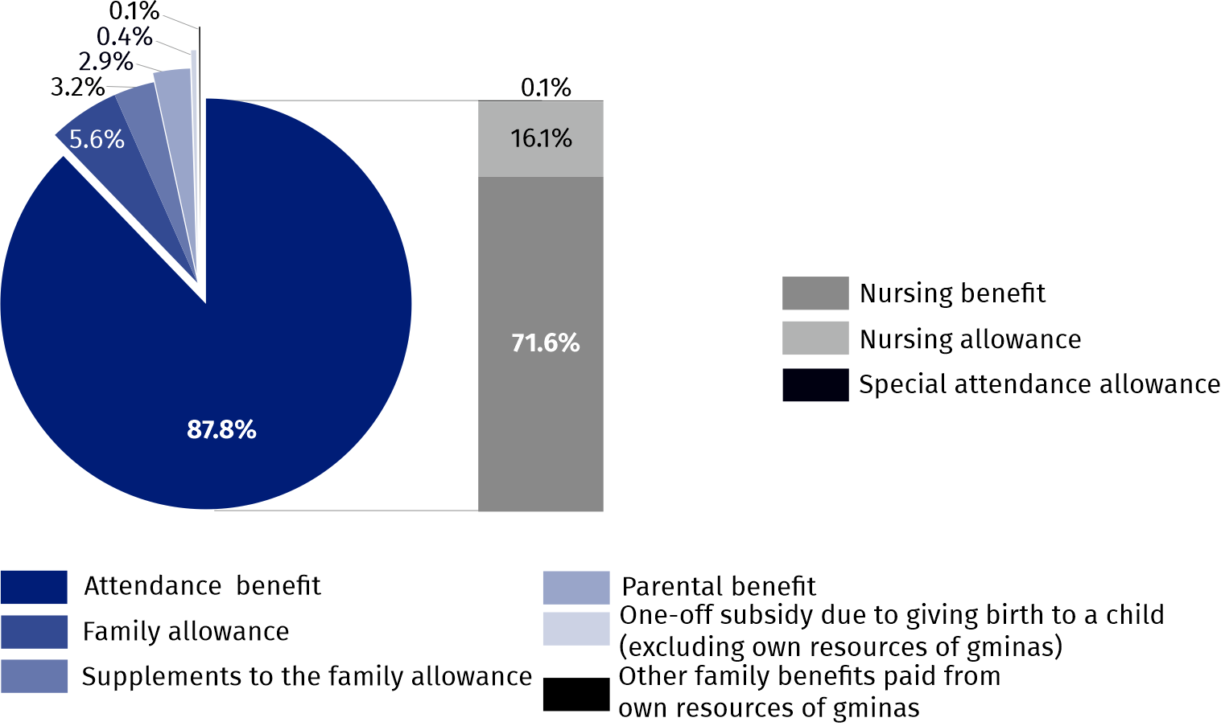
Source: National Family Benefits Monitoring System of the Ministry of Family, Labour and Social Policy.
In 2025, PLN 234.2 million was allocated for family benefits for citizens of Ukraine, who came to Poland in connection with the warfare taking place on the territory of their country and whose stay was recognized as legal. This was PLN 11.0 million (4.9%) more than the year before. On average, 41.4 thousand benefits were paid monthly.
Among family benefits paid to Ukrainian citizens, attendance benefits dominated, i.e. those addressed to disabled people and their caregivers. They amounted to PLN 164.9 million, representing 70.4% of the total value of benefits paid to citizens of Ukraine. Compared to 2024, the amount of these benefits increased by PLN 27.8 million, i.e. by 20.2%.
Family allowances with supplements amounted to PLN 36.0 million, representing 15.3% of total family benefits for citizens of Ukraine. These benefits decreased year-on-year by PLN 12.3 million, i.e. 25.5%. Moreover, parental benefits amounting to PLN 31.8 million (13.6% of the total) and subsidies due to giving birth to a child – PLN 1.6 million (0.7%) were paid.

Total attendance benefits
PLN 13.2 billion was allocated to attendance benefits
Attendance benefits addressed for disable people and their caregivers in 2025 amounted to PLN 13.2 billion, accounting for the largest share, at 87.8%, of the total value of family benefits. Attendance benefits include: nursing benefits, nursing allowances and special attendance allowances. Compared to 2024, the amount of attendance benefits increased by PLN 0.8 million, i.e. by 6.1%.
Since 1 January 2024, the nursing benefit has been granted under changed rules, meaning it is available to those caring for disabled children up to the age of 18 (previously, the benefit was also available to adults). The amount of the attendance benefit has also been increased (from PLN 2 988 in 2024 to PLN 3 287 in 2025).
The amendment to the regulations in 2024 made it possible to combine care with employment, as well as to use the benefit by people receiving a retirement or other pension. If caring for more than one disabled person, the benefit is increased by 100% for the second and each subsequent person. Those who received the nursing benefit before 1 January 2024 under old rules, may continue to receive it under the previous conditions.
In 2025, PLN 10.8 billion in total was allocated for nursing benefits, representing 81.5% of all attendance benefits paid. Nursing benefits paid under old rules amounted to PLN 7.5 billion, i.e. 70.1% of total payments, while benefits granted under changed rules reached the value of PLN 3.2 billion, i.e. 29.9%. On average, 192.7 thousand nursing benefits were paid monthly under old rules and 77.4 thousand under changed rules, the vast majority (93.6%) of which were benefits for one disabled child.
The amount of nursing allowances paid in 2025 amounted to PLN 2.4 billion. This monthly benefit was paid to an average of 935.0 thousand people, towards 965.6 thousand people in 2024. The largest number of nursing allowances were granted to people aged 16–74 (71.4% of the total). Benefits for disabled children under the age of 16 accounted for 27.0% of the total. In the year under review, nursing allowance was paid monthly on average for 252.6 thousand children under the age of 16, which constituted 4.3% of the total number of children of this age. Benefits granted to people over 75 had the smallest share – 1.6%.
Nursing allowance was paid monthly on average for 252.6 thousand children under the age of 16

In 2025, 2.1 thousand people received the special attendance allowance monthly, and PLN 15.9 million was allocated for its payment.

Family allowances and supplements to family allowances
On average, 263.0 thousand families received the family allowance monthly

In 2025, family allowances amounted to PLN 833.4 million, which was by PLN 234.1 million (21.9%) less than the year before. An average of 263.0 thousand families received family allowances monthly, which was by 78.4 thousand (23.0%) less than in 2024. The reduction in the number of beneficiaries is due to the freezing of income thresholds and the simultaneous increase in wages and salaries (especially the minimum wage and salary), which meant that the income of more families exceeded the applicable income criteria.
169.5 thousand families received the allowance for one or two children, representing 64.4% of all families receiving this type of benefit. Among families receiving family allowances, two-parent families accounted for 69.5% (182.9 thousand families). In 2025, 55.0 thousand families with a disabled child received family allowances, representing 20.9% of all families receiving the family allowance.
Taking into account per capita family income, the largest group of family allowances beneficiaries were families with income not exceeding PLN 400 – 153.4 thousand families, i.e. 58.3% of the total. Income between above PLN 400 and the income criterion was achieved by 85.7 thousand families (32.6%), and income above the income criterion – 23.9 thousand families (9.1%).

Chart 2. Families receiving the family allowance in 2025

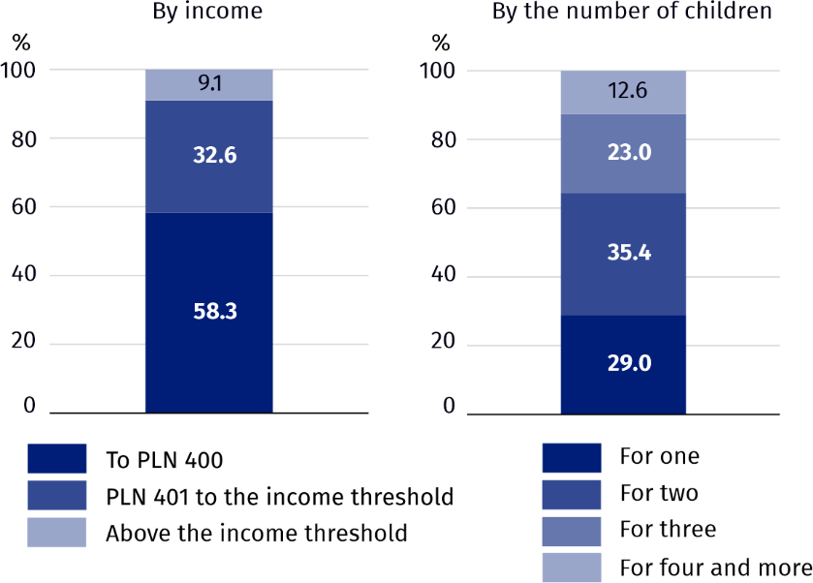
Source: National Family Benefits Monitoring System of the Ministry of Family, Labour and Social Policy.
Monthly family allowances were paid in 2025 on average to 611.2 thousand children, with the largest group being children aged 6–12 (250.3 thousand – 41.0%). Next came children aged 13–17 – 27.8%, then children under the age of 6 – 25.6% and those aged 18 and more who were dependent mainly for the purpose of education – 5.6%.
In 2025, PLN 458.2 million was allocated for supplements to family allowances, representing 3.2% of the total amount of family benefits. On average, 403.8 thousand families received this support monthly, which is 98.2 thousand (19.6%) less than a year before. Supplements to family allowances were financed from the state budget, and gminas spent PLN 5.9 million from their own funds to increase these amounts, additionally.
Supplements for raising a child in a multi-children family accounted for 33.2% of the total expenses on family allowance supplements
In the total amount of supplements to family allowances in 2025, supplements for raising a child in a multi-children family predominated – PLN 160.8 million, i.e. 33.2% of the total. Least was allocated for supplements due to the birth of a child – PLN 19.0 million (3.9%).
The share of children under the age of 18 for whom parents received family allowances in the total number of children of this age amounted to 8.7% and was lower by 2.2 pp compared to 2024. This indicator reached the highest value in the Warmińsko-Mazurskie Voivodship (12.3%) and the lowest in Dolnośląskie and Śląskie Voivodship (6.2% each).
Parents received family allowances for 8.7% of children under the age of 18

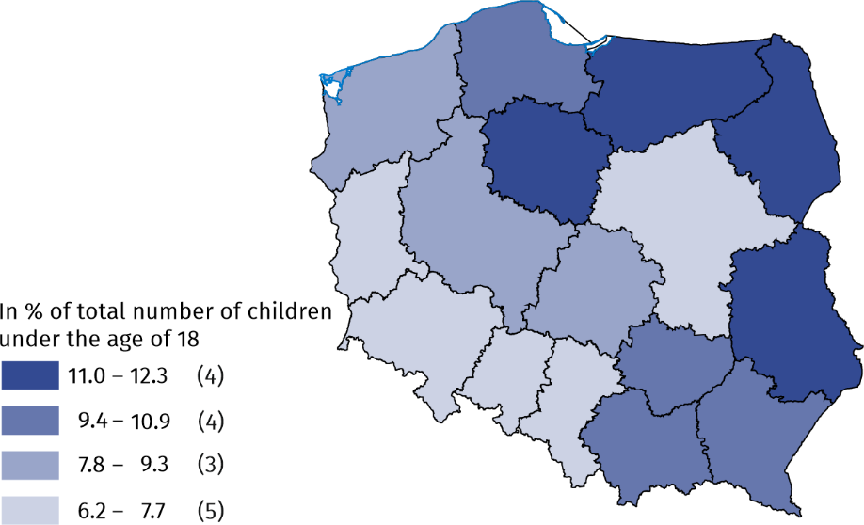
Map 1. Children under the age of 18 for whom the family allowance has been collected in 2025
Source: National Family Benefits Monitoring System of the Ministry of Family, Labour and Social Policy.

Parental benefits
In 2025, expenditures on parental benefits amounted to PLN 431.5 million and accounted for 2.9% of all expenses on family benefits. An average of 39.0 thousand eligible persons received parental benefits each month. Compared to the previous year, both the value and the average monthly number of parental benefits paid decreased by 10.2% and 10.8%, respectively.
On average 39.0 thousand people collected parental benefits monthly

One-off subsidy due to giving birth to a child
Parents of 61.4 thousand children received subsidies due to giving birth to a child ("baby bonus")
In 2025, 61.4 thousand one-off subsidies due to giving birth to a child, known as "baby bonus", were paid, which was 21.5 thousand (25.9%) less than in the previous year. Of the total number of families receiving one-off subsidies due to giving birth to a child, 31.0% were families with one child, while families with two children and large families (with three or more children) accounted for 36.8% and 32.2% of the population in question, respectively. Expenditures on "baby bonus" financed from the state budget amounted to PLN 61.4 million, representing 0.4% of total expenditure on family benefits. In 2025, an additional 5.8 thousand subsidies due to giving birth to a child were paid from own resources of gminas for a total amount of PLN 4.3 million.

Social security and health insurance contributions
In 2025, PLN 1.5 billion was spent on social security and health insurance contributions for persons receiving nursing benefits or special attendance allowances. Monthly contributions were paid on average for 149.3 thousand beneficiaries. Health insurance contributions were also paid for persons receiving these benefits – an average of 97.5 thousand eligible persons per month, for a total amount of PLN 341.1 million.

Support benefit
Introduced on 1 January 2024, this support benefit is available to disable adults. The benefit amount depends on the number of points awarded by the Voivodship Disability Assessment Board (WZON) and can amount from 40% to 220% of the social pension. Until 28 February 2025, the social pension was PLN 1 780.96 gross (PLN 1 620.67 net), whereas since 1 March 2025, following indexation, it has increased to PLN 1 878.91 gross (PLN 1 709.81 net).
In 2025, PLN 8.5 billion was allocated for support benefits, i.e. more by PLN 5.8 billion than in the previous year. A total of 3.2 million benefits were paid out (3.8 times more than in 2024), with an average monthly number of payouts amounting to 267.7 thousand.
The largest share of support benefits – 26.8% – was paid out at the level of 220% of the social pension
The largest share of support benefits was paid out at the level of 220% of the social pension (26.8%), while the smallest share consisted of benefits paid at the level of 40% of the social pension (0.1%).

Chart 3. Support benefits paid in 2025

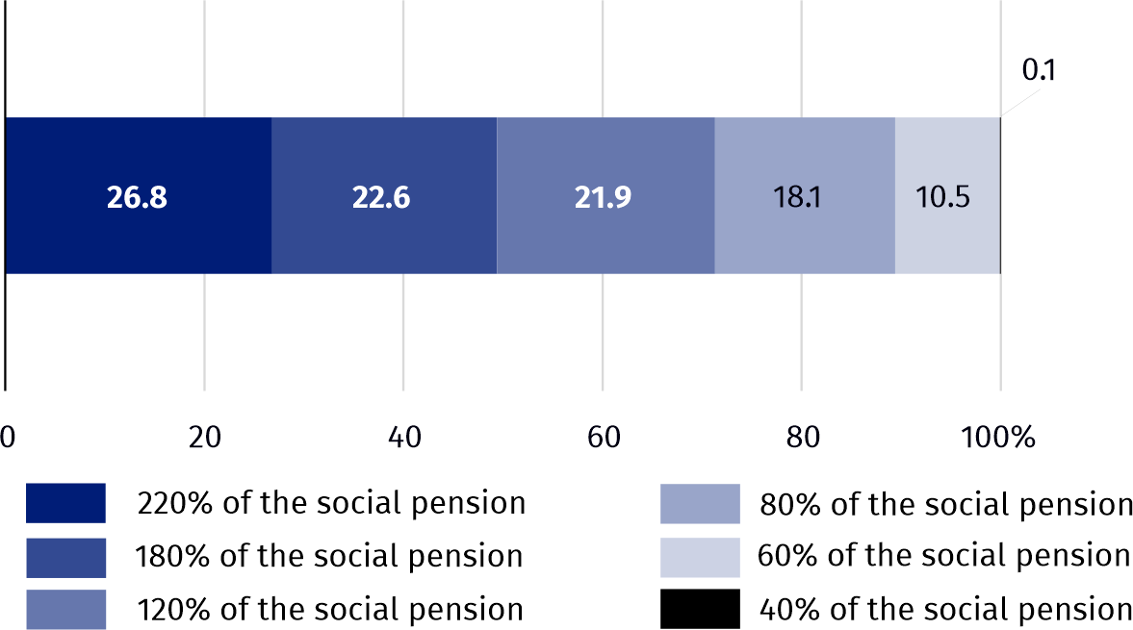
Source: ZUS Comprehensive Information System.

Family Care Capital and the "Active Parent" programme
The "Active Parent" programme has been in force since 1 October 2024, and provides support to parents of children up to the age of 3. Under this programme, parents can receive benefits such as "Active parents at work", "Actively in the nursery" and "Actively at home", which have replaced the previous family care capital (RKO) scheme.
A total of PLN 6.3 billion has been allocated for the implementation of the "Active Parent" programme
In 2025, a total of PLN 6.3 billion was allocated for the implementation of the "Active Parent" programme . The largest share of this amount consisted of "Actively in the nursery" benefits, accounting for PLN 3.4 billion (54.7% of the total). A total of 307.6 thousand children received this benefit at least once. Expenditure on "Active parents at work" benefits amounted to PLN 2.2 billion (35.3%), covering 214.9 thousand children. "Actively at home" benefits accounted for the smallest share – 10.0%. In the year under review, this benefit was paid at least once to 198.7 thousand children, and the total amount of payments was PLN 0.6 billion.

Chart 4. Expenditures on benefits from the "Active Parent" programme in 2025

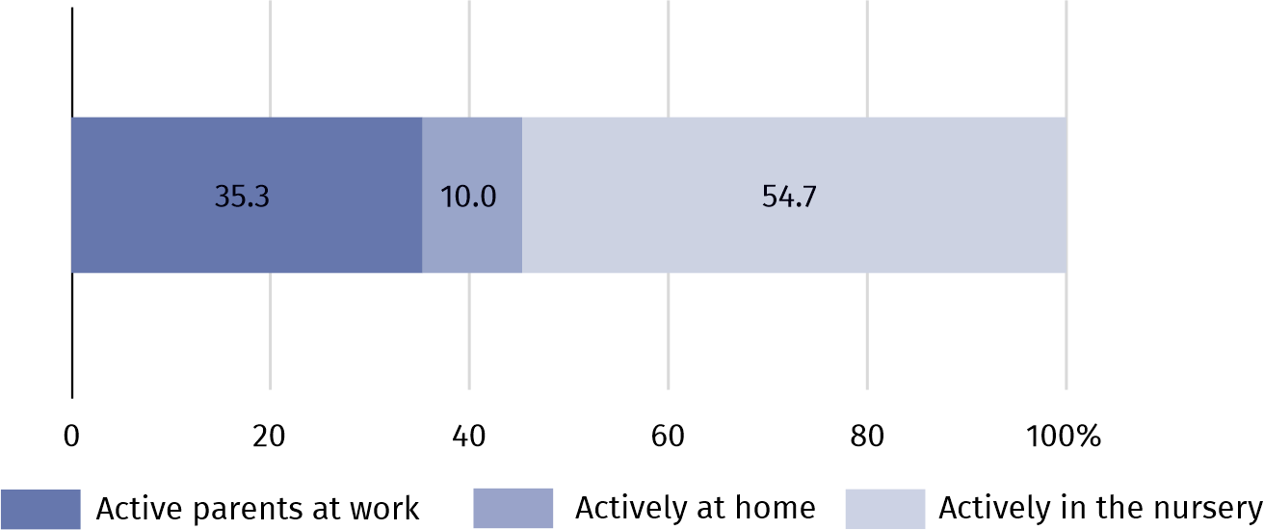
Source: ZUS Comprehensive Information System.
In 2025, the Family Care Capital (RKO) benefit was paid to individuals who had acquired the right to it before 1 October 2024, subject to the rule that RKO and benefits from the "Active Parent" programme could not be received simultaneously. In 2025, 450.5 thousand such payments were made, for a total amount of PLN 0.4 billion. The majority of these were payments of PLN 1 000 (70.9%).

Benefits from the "Good Start" programme
The support system for families with children includes a one-off payment of PLN 300 for school supplies under the "Good Start" programme. This benefit is independent of family income. It is available for every child attending school up to the age of 20, or up to the age of 24 for children with disabilities. In 2025, as in 2024, 4.7 million students received support under the programme, and its value amounted to PLN 1.4 billion.

Alimony fund benefits
The average monthly amount of benefits from the alimony fund was PLN 557.62
In 2025, 1.7 million benefits for a total value of PLN 973.9 million were paid out from the alimony fund. Compared to the previous year, 7.0% less benefits were granted, however, total expenditure on these benefits increased by 15.7%. An average of 145.5 thousand benefits were paid out monthly, and the average benefit amount increased to PLN 557.62, compared to a monthly average of 156.5 thousand benefits at an average amount of PLN 448.26 paid out in 2024.

Child-raising benefits
The child-raising benefit paid under the "Family 800+" programme is available for every child up to the age of 18, regardless of the family's per capita income. In 2025, expenditure on the child-raising benefit amounted to PLN 64.9 billion, with an average of 6.7 million benefits paid out monthly. Compared to the previous year, a decrease was recorded in both expenditure and the number of benefits paid – by 1.8% and 1.5%, respectively.

The Large Family Card
In 2025, 3.9% more families held the Large Family Card than in 2024
Eligibility for the Large Family Card extends to all parents and spouses of parents who have or have had a total of at least three children in their care. It is a system offering discounts and additional benefits at both public institutions and private companies. In 2025, over 1.9 million families held the Large Family Card (an increase of 3.9% compared to the previous year).
Table 1. Amounts of selected benefits for the family paid in 2025
The highest amount of family benefits was paid in Mazowieckie Voivodship (PLN 1 715.8 million), and the lowest in the Opolskie (PLN 301.4 million)
Specification | Amount of benefits paid
Specification | family | from the alimony fund | child-  -raising from the “Family 800 plus” program-me | support | from the "Good Start" program-me | from the "Active Parent" program-me
Specification | in milion PLN
Poland | 15 031.8 | 973.9ª | 64 851.2^{b} | 8 524.7 | 1 410.8 | 6 255.3^{c}
Dolnośląskie | 906.6 | 82.6 | 4 763.2 | 692.0 | 103.2 | 475.9
Kujawsko-Pomorskie | 1 031.0 | 71.3 | 3 307.5 | 626.1 | 74.3 | 288.8
Lubelskie | 858.1 | 58.0 | 3 231.5 | 551.0 | 71.3 | 294.3
Lubuskie | 495.8 | 31.9 | 1 653.5 | 195.4 | 37.2 | 144.2
Łódzkie | 879.3 | 57.4 | 3 843.7 | 369.9 | 84.6 | 376.7
Małopolskie | 1 007.1 | 58.5 | 6 255.8 | 1 138.7 | 132.4 | 638.7
Mazowieckie | 1 715.8 | 111.9 | 10 300.5 | 583.3 | 215.3 | 1 097.4
Opolskie | 301.4 | 22.3 | 1 442.7 | 311.6 | 32.0 | 141.1
Podkarpackie | 1 168.4 | 42.0 | 3 482.2 | 805.2 | 76.6 | 335.7
Podlaskie | 480.6 | 27.5 | 1 891.9 | 374.4 | 41.0 | 198.0
Pomorskie | 1 275.1 | 74.8 | 4 411.1 | 504.1 | 95.3 | 418.8
Śląskie | 1 502.0 | 104.1 | 7 041.5 | 540.4 | 159.7 | 644.1
Świętokrzyskie | 661.8 | 31.8 | 1 759.3 | 493.4 | 39.7 | 155.9
Warmińsko-Mazurskie | 639.8 | 53.9 | 2 203.5 | 381.3 | 49.6 | 179.5
Wielkopolskie | 1 542.1 | 87.8 | 6 478.2 | 565.2 | 141.0 | 625.8
Zachodniopomorskie | 566.9 | 58.3 | 2 591.5 | 392.7 | 57.6 | 238.6
a Due to rounding, the data do not sum to the total amount of benefits paid from the alimony fund. b Also includes data that could not be assigned to specific voivodships due to incorrect or missing voivodship information; this amount excludes benefits paid abroad (PLN 747.4 thousand). c Also includes data that could not be assigned to specific voivodships due to incorrect or missing voivodship information.
Source: National Family Benefits Monitoring System of the Ministry of Family, Labour and Social Policy and Central Statistical Application – the area of Child-raising Benefit of the Ministry of Family, Labour and Social Policy, data of the Social Insurance Institution.
When quoting this publication, please provide its title and indicate Statistics Poland as the author. When publishing your own calculations based on data from this publication, please include the following statement: Author’s work based on data from Statistics Poland’s publication entitled ‘Family benefits in 2025’.
Prepared by:  Statistical Office in Kraków  Director Agnieszka Szlubowska  Phone: (+48 12) 420 40 50 | Issued by:  Press Office  Mobile: (+48) 695 255 032  Phone: (+48 22) 608 38 04, (+48 22) 449 41 45,  (+48 22) 608 30 09  e-mail: obslugaprasowa@stat.gov.pl

stat.gov.pl/en/

@StatPoland

@GlownyUrzadStatystyczny

@gus_stat

@GłównyUrządStatystycznyGUS

@Glówny Urząd Statystyczny
Related information
Methodological report ‘Benefits for the family and their beneficiaries’
Statistics Poland publication ‘Social assistance, child and family services in 2024’
Data available in databases
Local Data Bank – Health care, social welfare and benefits to the family
Terms used in official statistics
Beneficiaries from family benefits
The Large Family Card
Family care capital
Good Start programme
Nursing benefit
Family benefits
Child-raising benefits
Alimony fund benefits
Nursing allowance

Beneficiaries of family benefits are families receiving family benefits for dependent children and adults entitled to benefits for themselves.
Pursuant to the Act of 12 March 2022 on Assistance to Citizens of Ukraine in Connection with the Armed Conflict on the Territory of that Country (Journal of Laws of 2025, item 337, as amended).
Since 1 January 2024, new provisions of the Act on Family Benefits have come into force, regulating the conditions for granting nursing benefits, introduced by the Act of 7 July 2023 on Support Benefits.
The special attendance allowance was abolished on 1 January 2024. Based on transitional provisions, this allowance could also be granted after 1 January 2024 on the basis of maintaining acquired rights, under the conditions applicable until 31 December 2023.
The income criterion determining the payment of family benefits is PLN 674 per capita or PLN 764 for families with a disabled child.
Act of 7 July 2023 (Journal of Laws of 2026, item 873).
Due to rounding, the data on individual benefit payments do not sum up to the total.

