Reconciliation of work and family life in 2025. Results of the LFS module survey
Module survey ‘Reconciliation of work and family life’ was carried out within the Labour Force Survey (LFS) in 2025. The module covered persons aged 18-74, and the main aim of the survey was obtaining information on the scale and ways of reconciling professional work with taking care of family members. The survey was related both the care of children younger than 15 years and close relatives aged 15 years and more requiring care due to their health condition or old age. Childcare providers were asked about their use of formal/institutionalised childcare services, and respondents who have raised/are raising at least one child, were also asked about use of leaves related to raising children. Employed persons were asked about actions taken to facilitate the reconciliation of caregiving responsibilities with professional work, as well as about work-related obstacles that make it difficult to combine tasks from both areas.
The module survey was carried out on part of the sample of the LFS throughout all quarters of 2025. Data presented below are the average results for the whole 2025 year. The basis for presented results are the respondents' answers obtained during interviews conducted by statistical interviewers of the Statistics Poland in the dwellings selected for the survey.
35.9%
Percentage of persons aged 18-74 with care responsibilities
in the total number of persons of this age
In 2025 slightly over 1/3 persons aged 18-74 had care responsibilities (35.9%).
Among this group of persons (9 469 thousand) – 80.0% took care exclusively of children/grandchildren younger than 15 years, 14.8% took care exclusively of relatives (including family members) aged 15 years and more, and 5.2% combined taking care of children/grandchildren with taking care of relatives.

In the case of persons aged 18-74 who were employed, the percentage of taking care of other persons amounted to 42.4%.
42.4%
Percentage of employed persons with care responsibilities
(in the total population of employed persons aged
18-74)
Among all persons in this age group combining employment and care responsibilities (7 269 thousand) – 85.4% took care only of children/grandchildren younger than 15 years, 10.4% cared exclusively of relatives (including family members) aged 15 years and more, and 4.2% combined taking care of children/grandchildren with taking care of relatives.

General characteristics of the population covered by the survey, taking into account the responsibilities related to taking care
In 2025 the survey covered 26 399 thousand persons aged 18-74. This group was dominated by women (51.1%), and taking into account the place of residence – urban residents (59.7% of total).
Among persons surveyed, 9 469 thousand (i.e. 35.9%) declared that they take care of children or grandchildren younger than 15 years or relatives aged 15 and more requiring care due to their health condition or old age. However, the vast majority of persons (16 930 thousand, i.e. 64.1%) did not take care of either children/grandchildren younger than 15 years or of other persons.
The survey showed that:
- Most persons (7 576 thousand, i.e. 80.0% of all persons providing care) took care exclusively of children or grandchildren younger than 15 years. Apart from that, some persons (1 404 thousand, i.e. 14.8%) took care only of relatives/family members aged 15 years and more. There were also persons (489 thousand, i.e. 5.2%) who cared of both children/grandchildren younger than 15 years and relatives requiring care.
The care of other persons was more often provided by women.
In 2025, among all women aged 18-74 years, the percentage of those taking care of family members was 38.5%. Among men, the corresponding percentage was 33.1%.
- Care was more often provided by women. Among all women aged 18-74, 38.5% (i.e. 5 200 thousand) declared providing care to various groups of persons. Among men, the corresponding percentage was 33.1%. Higher percentages of women providing care were recorded both for taking care only of children or grandchildren (29.9% vs. 27.5% for men) and for taking care only of relatives aged 15 years and more (respectively 6.4% and 4.2%), as well as for taking care simultaneously of persons from both groups, i.e. children younger than 15 years and persons aged 15 and more (2.2% and 1.4%).
- Rural residents took care of other persons slightly more often than urban residents. Such care was provided by 37.4% of rural residents and by 34.8% of urban residents.
Chart 1. Persons aged 18-74 by the fact of providing care for other persons and groups of persons receiving care

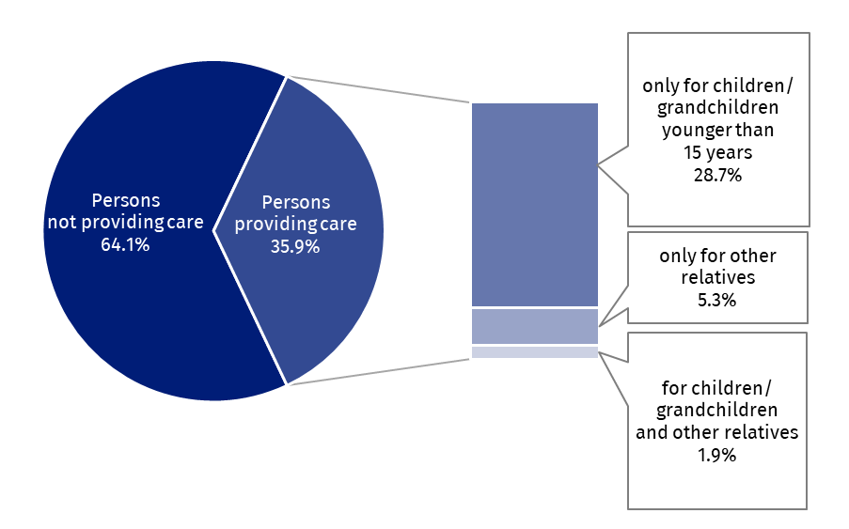

Table 1. Persons aged 18-74 by the fact of taking care of other persons, sex and status on the labour market
Specification | Total | Persons taking care of: |  |  |  |  |  | Persons not providing care
Specification | Total | total | children or grandchildren younger than  15 years |  | relatives aged  15 years and more |  | children or grandchildren younger than 15 years  and relatives aged 15 years and more | Persons not providing care
Specification | Total | total | total¹ | of which exclusi-vely | total² | of which exclusi-vely |  | Persons not providing care
Specification | in thousands
TOTAL | 26399 | 9469 | 8065 | 7576 | 1893 | 1404 | 489 | 16930
Men | 12905 | 4269 | 3727 | 3543 | 727 | 542 | 184 | 8636
Women | 13494 | 5200 | 4338 | 4033 | 1167 | 862 | 305 | 8294
Employed  persons | 17163 | 7269 | 6516 | 6207 | 1062 | 753 | 309 | 9894
Men | 9232 | 3726 | 3394 | 3245 | 481 | 332 | 149 | 5506
Women | 7931 | 3543 | 3122 | 2962 | 581 | 421 | 160 | 4388
Unemployed  persons | 555 | 180 | 148 | 137 | 43 | 32 | 11 | 374
Men | 275 | 60 | 44 | 42 | 17 | 16 | . | 215
Women | 280 | 121 | 104 | 95 | 26 | 17 | . | 159
Economically inactive persons | 8681 | 2020 | 1401 | 1232 | 788 | 619 | 169 | 6661
Men | 3399 | 484 | 289 | 255 | 229 | 194 | 34 | 2915
Women | 5283 | 1536 | 1112 | 977 | 559 | 424 | 135 | 3746
¹ Including persons who, in addition to taking care of children or grandchildren, also take care of relatives
(489 persons). ² Including persons who, in addition to taking care of relatives, also take care of children or grandchildren (489 persons).
The population covered by the survey consisted of 65.0% of employed, 2.1% of unemployed and 32.9% of economically inactive persons.
Among all persons with care responsibilities, there were 76.8% of employed persons, 1.9% of unemployed and 21.3% of economically inactive persons.
Employment rate for total of persons taking care of other family members amounted to 76.8%.
The employment rate for persons covered by the survey was 65.0%, but for persons with care responsibilities it was higher and amounted to 76.8%. The difference is mainly due to the fact that the persons taking care of children younger than 15 years (and they constituted the majority of persons providing care) were mainly persons at the working age, and therefore more active on the labour market.
Reconciling professional work with care responsibilities by persons aged 18-74
Number of employed persons aged 18-74 in 2025 was 17 163 thousand, of which 7 269 thousand (42.4%) in addition to performing professional work, regularly took care of other family members, i.e. children/grandchildren younger than 15 years or relatives aged 15 and more requiring care because of their health condition or old age.
Among all employed persons, the largest group of those who took care of others – 6 207 thousand (36.2%) were persons who took care exclusively of children or grandchildren younger than 15 years; the remaining groups were much less numerous: 753 thousand (4.4%) took care exclusively of relatives/family members aged 15 years and more, while 309 thousand (1.8%) – took care of persons from both mentioned groups.
Employed women accounted for 68.1% of all women aged 18-74 with care responsibilities.
The corresponding percentage for men was 87.3%
The survey results indicate that in 2025:
- Among women with care responsibilities, employed women constituted 68.1%, the corresponding percentage for men was 87.3%. It means, that women taking care of other persons (even though there were more of them than men – 5 200 thousand vs. 4 269 thousand) were less likely than men to combine taking care with work. Part of women performing care responsibilities remained outside the labour market.
- In order to more easily reconcile both aspects of their activity, i.e. professional work and care responsibilities, part of employed persons with care responsibilities (21.2%, i.e. 1 538 thousand) have made certain adjustments/changes in connection with their work. Women made such adjustments more than 2.5 times as often as men – they were introduced by 31.2% of employed women and 11.6% of men.
- Overall, the most frequently mentioned change was a change of job or employer – it was reported by 20.2% of those who made adjustments. However, the main changes made by men and women were different.
- Women, when specifying the type of change, most often chose the answer ‘I am currently absent from work (including paid or unpaid leave etc.)’ – it was indicated by 24.1% of women who made any adjustment (97.8% of all, who pointed such change). Change of job or employer was declared by 20.0% of women (who made any adjustment), and reduced working time – by 13.8%.
- Among men, the most frequently mentioned specific work-related change (apart from ‘other adjustment’) was transition to remote or hybrid work (22.9% of indications) and then changing the working time schedule, without changing the working time (21.3% of indications). A change of the job or employer was reported by 20.8% of men (who made any adjustment).
Chart 2. Adjustments made at work to better combine work and care responsibilities
(in % of total persons who made an adjustment)
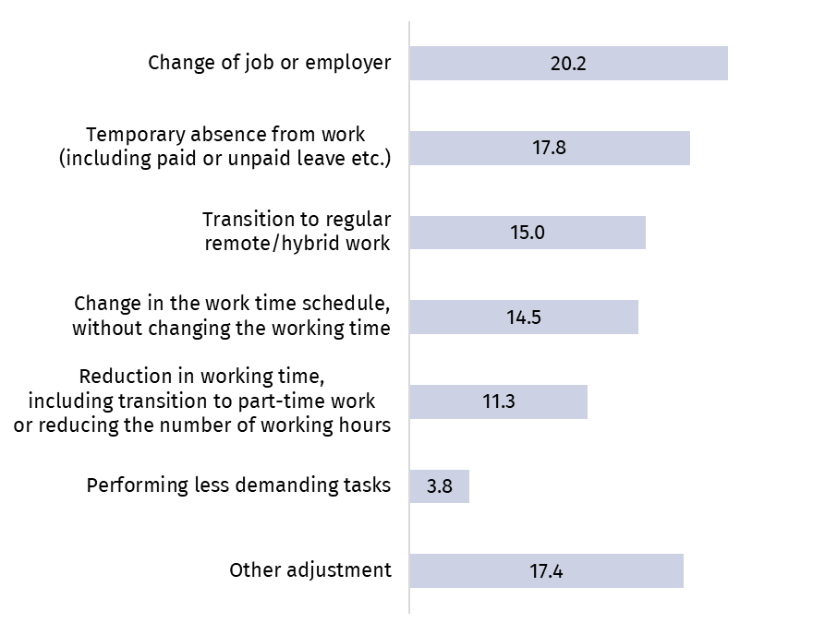
- A significant proportion of persons (63.0% of employed persons with care responsibilities) did not perceive any work-related obstacles/difficulties in reconciling work under the existing conditions with their care responsibilities. However, 33.6% of persons identified such difficulties.
- The biggest difficulty turned out to be long working hours. It was indicated by 11.2% of all persons working and regularly taking care of other persons. Part of persons (7.5%) complained about demanding or exhausting work, and 6.0% about unpredictable or difficult work schedules (for example: shift work, working during the evening or the weekend).
- Long working hours were indicated as the main difficulty by persons taking care of all groups, although this was reported more often by those taking care of children/grandchildren than by persons taking care of relatives. Of all persons taking care who identified difficulties, this reason was indicated by 34.1% of persons taking care of children/grandchildren and 27.8% of persons taking care of relatives.
Chart 3. Difficulties faced by employed persons in combining their job with care responsibilities (in % of all persons who indicated such a difficulty)
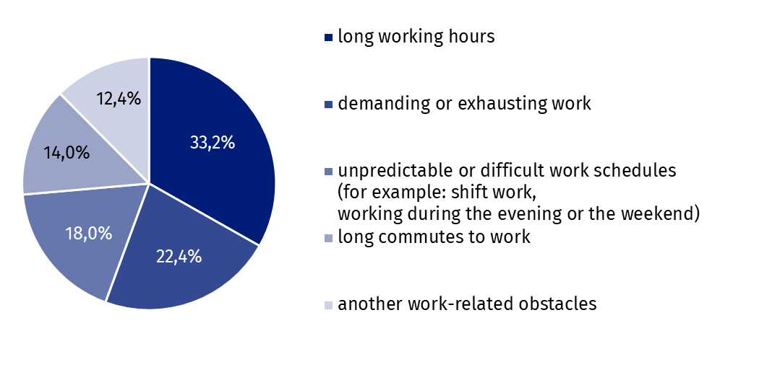
Use of formal/institutionalised childcare services
Formal/institutionalised childcare services were used by 50.6% of persons taking care of children younger than 15 years
Out of 7 189 thousand persons taking care of children, 3 636 thousand, i.e. 50.6% in 2025 were using formal/institutionalised childcare services, such as: nurseries, kindergartens, pre-school and after-school clubs or persons professionally (formally) performing the work of a caregiver/babysitter.
The vast majority of persons using such services (2 956 thousand) used them for all children, while others (680 thousand) only for some children.
Chart 4. Persons aged 18-74 taking care of children younger than 15 years by the fact of using formal/institutionalised childcare services
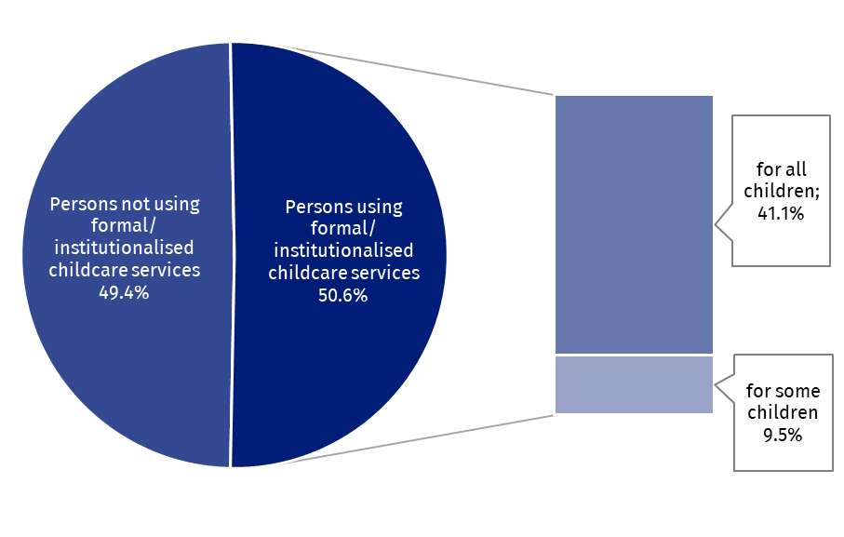
Among persons taking care of children, the vast majority (87.0%) were employed. Percentage of employed persons was higher among those using formal/institutionalised childcare services (90.2%) than among those not using such services (83.7%).
This means that employed persons were more likely to use this type of service. 52.5% of employed persons used such services, while among the economically inactive persons this percentage was 35.2%.
The fact that employed persons used such forms of care only of some children or did not use them at all was most often due to the lack of such need. This reason was indicated by 92.1% of persons using such type of services for some children and by 95.0% not using them at all. For employed persons working part-time the percentages were respectively: 94.7% and 94.0%.
Employed persons who did not see the need to use such services at all or not for all children most often explained this by the fact that they prefer to organise care themselves or together with spouse/partner (40.1% of answers). This was also a common reason, namely that the child/children could take care of themselves – it concerned older children who were able to do so (34.2% of answers). Part of persons (15.8%) preferred organising care with the support of grandparents or other persons.
Taking leave related to raising children by persons aged 18-54 employed at the time of survey or in the past
Out of 17 575 thousand persons aged 18-74, 10 467 thousand, i.e. 59.6% have raised/are raising at least one child – it should be noted that both the father and the mother of the child could declare the upbringing of the same child. The largest group consisted of the persons who have raised/are raising two children (48.7% of total number of persons raising children) while 35.3% of persons raised/are raising one child, and 12.3% – three children.
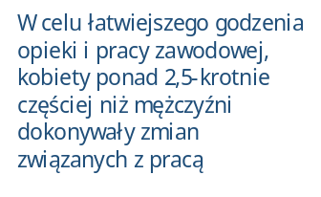 Leaves related to raising children was used by 52.7% of persons aged 18-54 who are currently or have been employed in the past and who have raised/are raising at least one child
The issue of leave for raising children in the survey concerned persons aged 18-54 who were currently employed and those who had ever been employed. There were 10 280 thousand of such persons in total, but not all of them had taken leave to raise children. This type of leave was taken by 52.7% of this group of persons (i.e. 5 418 thousand), while 45.3% did not take it.
Chart 5. Persons aged 18-54 who were employed at the time of the survey or in the past and have raised/are raising at least one child by the fact of taking leaves related to raising children and type of the leave
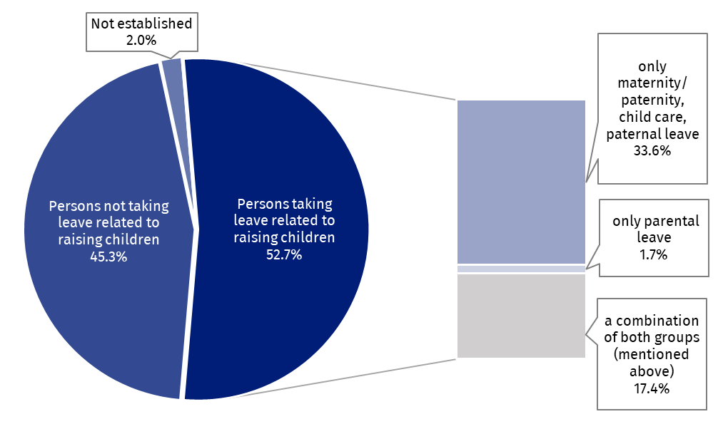
The survey results indicate that in 2025:
- The percentage of persons taking leaves differed significantly depending on the sex of the persons taking care – among women it was 82.0%, while among men it was significantly lower and amounted to 18.3%. It should be noted that in the past due to legal regulations, fathers could not receive paternal, paternity leaves etc., this results in a limited extent of men taking leaves.
Women were considerably more likely to take leave for raising children – 82.0% of women and 18.3% of men who are raising/have raised at least one child took such leave.
- The number of women who took leave to raise children in their lifetime was 4 554 thousand. They used only maternity or child care leave (58.2%), only parental leave (3.3%) or combination of leaves mentioned above, i.e. leaves related to the birth of a child and parental leave (38.5%).
- Men using leaves (864 thousand) took most often only paternity, parental leave (93.5%), only parental leave (1.9%) or different type of leaves related to the birth of a child and parental leave (4.6%).
- The length of leaves related to raising children used by men differed significantly from the length of leave taken by women (they were definitely shorter).
- Women most often took leaves lasting in total more than 1 year up to 3 years (42.0% of them had such a break at work), slightly fewer women took leaves lasting more than 6 months up to 1 year (25.5%).
- Men most often used leaves lasting up to 1 month, less frequently up to 2 or 6 months.

Methodological notes
Labour Force Survey – LFS (Badanie Aktywności Ekonomicznej Ludności/BAEL – in Polish) has been carried out in Poland quarterly since May 1992, and it has been improved in accordance with the International Labour Organization and Eurostat recommendations.
The module survey ‘Reconciliation of work and family life’ is one of six regular European module surveys (EU LFS), each of which, starting from 2021, is to be implemented exactly every 8 years.
It was carried out on part of the LFS sample in all quarters of 2025, and it concerned persons aged 18-74. The survey covered the following issues:
  - care for children younger than 15 years (living together with the surveyed person or outside her/his household)
  - use of formal/institutionalised childcare services
  - care of grandchildren
  - care for relatives aged 15 and more, who require care due to their health condition or old age (living together with the surveyed person or outside her/his household)
  - reconciling work with care responsibilities
  - use of leave related to raising children
In the survey, the term ‘children’ was understood to include not only one's own children in the general sense (biological), but also adopted children and stepchildren as well as children for whom the respondent was a foster parent or legal guardian. It means that (unless otherwise stated) this term covered also children of a spouse/partner from other relationship who were not the respondent’s own children.
If grandparents were foster parents or legal guardians of their grandchildren, these grandchildren should also be considered as ‘own children’. The same applies to siblings, aunts/uncles and godfathers/godmothers who were foster parents or legal guardians of children.
The survey determined whether the surveyed person regularly took care of children younger than 15 years.
Regular childcare was understood as care provided on average for at least several hours a week, however, care did not have to be provided every week, but at least twice a month for at least a few hours.
Based on the above definition, care provided exclusively during school holidays/breaks or care/financial assistance only was not sufficient to be considered regular care.
Childcare included, among other things, ensuring their safety, providing support during bathing, dressing and eating, as well as playing, helping with homework, reading books, spending time together (walks, going to the cinema, etc.), giving a ride (e.g. to school, extracurricular activities), etc.
Formal/institutionalised childcare services included all forms of care organised by private or public institutions – e.g. nurseries, kindergartens, pre-school or after-school clubs. Care could also be provided by persons professionally performing legal work as caregivers/ babysitter.
Caregivers employed directly by parents – in order to be considered as providing formal services – had to work on the basis of a written contract and receive an agreed remuneration in accordance with the provisions of that contract. This also involved paying all legally required insurance contributions and taxes (these could be covered by the state budget or directly by parents). This also included caregivers undertaking this work as part of their own business or through a company/agency.
Relatives/kin, other household members, friends or neighbours who took care of children on a non-professional basis were considered informal carers, and were not included in this survey as persons providing formal care services.
Sports club activities, extra-curricular sports activities, language courses or similar extra-curricular activities attended by children were not considered childcare and the institutions providing them were not considered to be providing childcare services.
Care for grandchildren
If a person had no children in their household and no children outside the household that they cared for, the survey asked whether they had grandchildren younger than 15 years and whether they regularly cared for them. It may have been the same child who was also cared for by his parents.
Care for relatives
In the survey it was also determined whether the examined person regularly took care of one or more relatives aged 15 years and more, of which his spouse/partner and other members of family, who required care due to health condition or advanced age. Taking care of neighbours and friends was not taken into account.
By regular care for relatives aged 15 years and more was understood as care or help provided on average for at least several hours a week, however, care did not have to be provided every week, but at least twice a month for at least a few hours. This included care provided regardless of the day of the week. Therefore, care provided on Saturdays and Sundays also had to be included, as well as the special case of care provided on one full weekend (Saturday and Sunday) each month.

Caregiving responsibilities for these individuals may have included preparing meals, shopping for groceries or personal items, performing light or heavy housework, transporting to medical appointments, as well as assistance with bathing, dressing, eating, getting in and out of bed or a chair, or assisting with administrative matters. They also included keeping company, e.g. reading a book, playing games or walking with the person who was receiving care or assistance.
In the survey information about the number of children that the surveyed person raised throughout his or her life was obtained. All children should have been included (including those who are now adults and those still being cared for). However, only one's own children, defined as biological and adopted children, and children of whom the respondent was a legal guardian or foster parent (excluding children of the spouse/partner) who are not her/his children) should be taken into account.
Help provided by grandparents to parents in raising children was not taken into account. However, if grandparents were foster parents or legal guardians of their grandchildren, these grandchildren should also be considered as ‘own children’. The same concerned siblings, aunts/uncles and godfathers/godmothers who were foster parents or legal guardians of children.
Leaves related to raising children covered: maternity, paternity, child care, parental and paternal leaves, i.e. those available following the birth of a child as well as for the purpose of raising a child.

In the case of quoting Statistics Poland data, please provide information: ‘Source of data: Statistics Poland’, and in the case of publishing calculations made on data published by Statistics Poland, please provide information: ‘Own work based on Statistics Poland data.’

Prepared by:  Labour Market and Human Capital Department  Director Agnieszka Zgierska, PhD  Phone: (+48 22) 608 34 99 | Issued by:  Press Office  Mobile: (+48) 695 255 032  Phone: (+48 22) 608 38 04, (+48 22) 449 41 45,  (+48 22) 608 30 09  e-mail: obslugaprasowa@stat.gov.pl

stat.gov.pl/en/

@StatPoland

@GlownyUrzadStatystyczny

@gus_stat

@GłównyUrządStatystycznyGUS

@Glówny Urząd Statystyczny
Related information
Methodological report. Labour Force Survey
Labour Force Survey in Poland
Reconciliation between work and family life in 2018
Other publications containing the results of LFS and its module surveys stat.gov.pl → Topics → Labour Market
Data available in databases
Strateg → Topics → Labour Market
Local Data Bank → labour Market
Knowledge Databases → Society → Labour Market
Terms used in official statistics
Economic activity by LFS
Economically active population by LFS
Employed persons by LFS
Unemployed persons by LFS
Economically inactive population according to the LFS

Activity rate by LFS
Employment rate by LFS
Unemployment rate by LFS


EUROPEAN UNION
News release contains the results of the survey on ‘Reconciliation of work and family life’
co-financed by the European Union

The core scope of the LFS enables a quarterly broad characterization of persons on the labour market. In this study, due to its synthetic nature of ‘News release’ series, the focus was primarily on presenting the results of the module LFS survey, dedicated to persons aged 18-74, which expands the scope of information available for this group of persons in the core LFS by including the aspect of fulfilling care obligations towards children and other persons requiring care.
An earlier edition of this survey was conducted in 2018, but its subjective and objective scope as well as the reference period were different from the 2025 survey. The results of the 2018 survey are available in the publication ’Reconciliation work and family life in 2018’ posted on the Statistics Poland website.
By ‘children’ was to be understood not only one's own children in the general sense (biological), but also children of the spouse/partner. Adopted children and stepchildren as well as children for whom the respondent was a foster parent or legal guardian should also have been taken into account. More information in Methodological notes placed at the end of the study.
If there was a child younger than 15 years in the household, then by the assumption each of the parents (father and mother) who were members of that household took care of the child.
No changes aimed at making it easier to reconcile professional and care responsibilities were made by 76.4% of employed persons with care responsibilities. For 2.4% of respondents no information was obtained on whether they had made any changes in connection with work.
For 3.4% of respondents no answer was received on this topic.
Persons who were employed by parents on the basis of a written contract and received the remuneration specified in that contract, which involved the payment of all legally required social security contributions and taxes. More detailed information are located in Methodological notes.
Data refer to own children (excluding children of a spouse/partner) regardless of their age. More information about one’s own children is included in Methodological notes placed at the end of this study.
For 2.0% no response was received regarding the use of this type of leave.
In line with the timetable set out in Delegated Regulation (EU) 2020/256 on multiannual rolling planning.

