Gross domestic product and gross value added in regional breakdown in 2024
In 2024, more than half of the gross domestic product value was generated in the 5 regions: Warszawski stołeczny, Śląskie, Wielkopolskie, Dolnośląskie and Małopolskie.
56.4%
Percentage of GDP value in the 5 regions with the greatest share in GDP generation in 2024

Gross domestic product
In 2024, the value of the generated gross domestic product amounted to 3 669 531 million PLN. In comparison to 2023, it grew by 7.4% at current prices.
In 2024, all regions recorded an increase in GDP at current prices compared to the previous year
An increase in gross domestic product at current prices, compared to 2023, was recorded in all regions, the largest in Lubelskie region – by 9.6% and the smallest in Śląskie region – by 3.8%.
In 2024, the shares of individual regions in the generation of GDP ranged from 1.9% in Opolskie region to 18.6% in Warszawski stołeczny region. Value of GDP generated in Warszawski stołeczny region in 2024 was over 9 times higher than in Opolskie region (similar to 2023).
In 2024, the group of regions with high shares in GDP generation included, apart from Warszawski stołeczny region, the following regions: Śląskie, Wielkopolskie, Dolnośląskie and Małopolskie. Entities operating in the 5 above-mentioned regions, which accounted for 51.7% of the total employed persons in the national economy, jointly generated 56.4% of the GDP value.

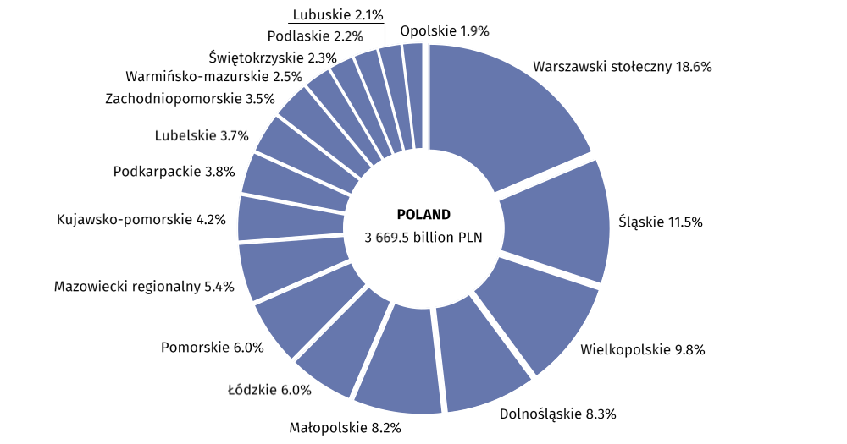
Graph 1. Share of regions in the generation of gross domestic product in 2024 (current prices)

In 2024, the following regions were in the group of regions with the lowest shares in GDP generation (less than 3%): Opolskie, Lubuskie, Podlaskie, Świętokrzyskie and Warmińsko-mazurskie. Their total share in GDP generation amounted to 11.0% and employment in these regions constituted 12.8% of the total employed persons in the national economy.
In 2024, the average gross domestic product per capita amounted to 97 786 PLN. Compared to 2023, it was higher by 7.7% at current prices. An increase in GDP per capita at current prices, compared to 2023, was recorded in all regions – from 4.4% in Śląskie region to 10.4% in Lubelskie region.
Indicator of dispersion of GDP per capita, calculated at regions’ level for Poland, in 2024 amounted to 20.7%. Despite a decrease in this indicator, compared to the previous year (by 0.4 pp.), the level of GDP per capita in individual regions was still differentiated.
GDP per capita exceeding the national average was recorded in 3 regions: Warszawski stołeczny, Dolnośląskie and Wielkopolskie
The highest level of GDP per capita in 2024 was recorded in Warszawski stołeczny region – 197 889 PLN. It exceeded the national average by two times and it was almost three times higher than the value of GDP per capita in Lubelskie region, where the lowest level was recorded. In 2024, GDP per capita above the national average was also observed in Dolnośląskie region – by 6.2% and in Wielkopolskie region – by 4.8%.
In 2024, a low level of GDP per capita (less than 75% of the national average), apart from Lubelskie and Warmińsko-mazurskie regions (respectively 70.6% and 70.7% of the national average), was also recorded in Podkarpackie region (72.5% of the national average).

Map 1. Gross domestic product per capita by regions in 2024 (current prices)
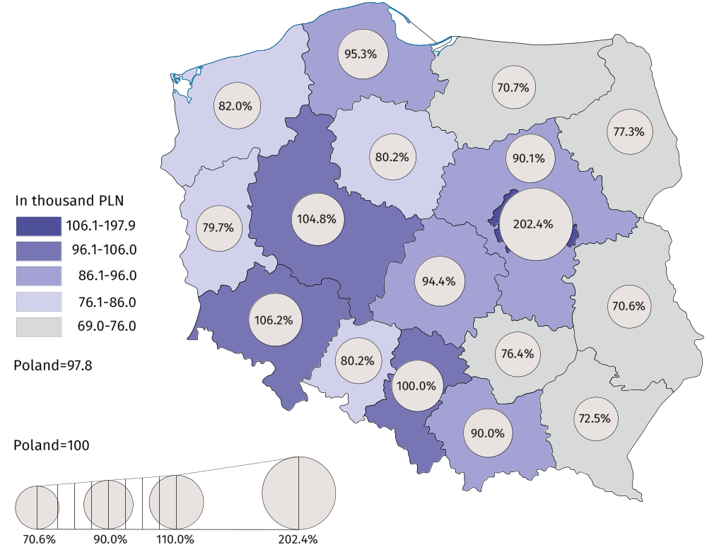

Table 1. Gross domestic product by regions in 2024 (current prices)
REGIONS | Total |  |  | Per capita
REGIONS | in million PLN | in percent | previous year=100 | in PLN | Poland=100 | previous year=100
POLAND | 3 669 531 | 100.0 | 107.4 | 97 786 | 100.0 | 107.7
Dolnośląskie | 302 857 | 8.3 | 107.0 | 103 845 | 106.2 | 107.1
Kujawsko-pomorskie | 153 545 | 4.2 | 107.0 | 78 410 | 80.2 | 107.6
Lubelskie | 135 536 | 3.7 | 109.6 | 69 026 | 70.6 | 110.4
Lubuskie | 76 239 | 2.1 | 107.2 | 77 936 | 79.7 | 107.6
Łódzkie | 219 773 | 6.0 | 106.5 | 92 344 | 94.4 | 107.2
Małopolskie | 299 660 | 8.2 | 108.7 | 88 003 | 90.0 | 108.7
Mazowiecki regionalny | 197 312 | 5.4 | 106.3 | 88 094 | 90.1 | 106.9
Opolskie | 71 281 | 1.9 | 106.9 | 78 452 | 80.2 | 107.5
Podkarpackie | 140 487 | 3.8 | 108.7 | 70 899 | 72.5 | 109.1
Podlaskie | 82 333 | 2.2 | 107.3 | 75 564 | 77.3 | 107.8
Pomorskie | 220 562 | 6.0 | 107.7 | 93 228 | 95.3 | 107.6
Śląskie | 420 391 | 11.5 | 103.8 | 97 752 | 100.0 | 104.4
Świętokrzyskie | 84 581 | 2.3 | 109.1 | 74 701 | 76.4 | 110.1
Warmińsko-mazurskie | 90 370 | 2.5 | 107.1 | 69 118 | 70.7 | 107.9
Warszawski stołeczny | 683 617 | 18.6 | 109.3 | 197 889 | 202.4 | 108.5
Wielkopolskie | 360 987 | 9.8 | 107.6 | 102 459 | 104.8 | 107.7
Zachodniopomorskie | 130 001 | 3.5 | 107.2 | 80 211 | 82.0 | 107.8

Gross value added by kind of activity
In 2024, 27.7% of the total gross value added was generated by entities operating in services, i.e. trade; repair of motor vehicles; transportation and storage; accommodation and catering; information and communication. In the individual regions, the share of these entities in the generation of gross value added in 2024 ranged from 21.9% in Opolskie region to 33.9% in Warszawski stołeczny region.
Entities engaged in other services (including public administration and defence; compulsory social security) in 2024 generated 27.0% of the total gross value added. In 2024, Małopolskie region was characterised by the highest share of other services – 31.0% while Mazowiecki regionalny region was marked by the smallest share – 20.4%.
In 2024, the largest share of industry in creating GVA was recorded in 7 regions
In 2024, entities engaged in industry generated 24.0% of the total gross value added. In the regional breakdown, a significant variation in the shares of industry was observed in 2024, ranging from 13.5% in Warszawski stołeczny region to 33.0% in Mazowiecki regionalny region.

In 2024, entities engaged in financial and insurance activities; real estate activities generated 11.0% of the total gross value added. In the individual regions, the shares of entities engaged in financial and insurance activities; real estate activities in gross value added generation, in 2024, ranged from 7.0% in Mazowiecki regionalny region to 16.6% in Warszawski stołeczny region.
Entities engaged in construction, in 2024, generated 7.4% of the total gross value added. In the regional breakdown, in 2024, the shares of these entities in the generation of gross value added ranged from 6.0% in Łódzkie region to 8.7% in Małopolskie and Zachodniopomorskie regions.
In 2024, the share of agriculture, forestry and fishing in the generation of total gross value added amounted to 2.8%. In the individual regions, the shares of entities engaged in agriculture, forestry and fishing were differentiated in 2024 – from 0.6% in Warszawski stołeczny region to 9.7% in Mazowiecki regionalny region.

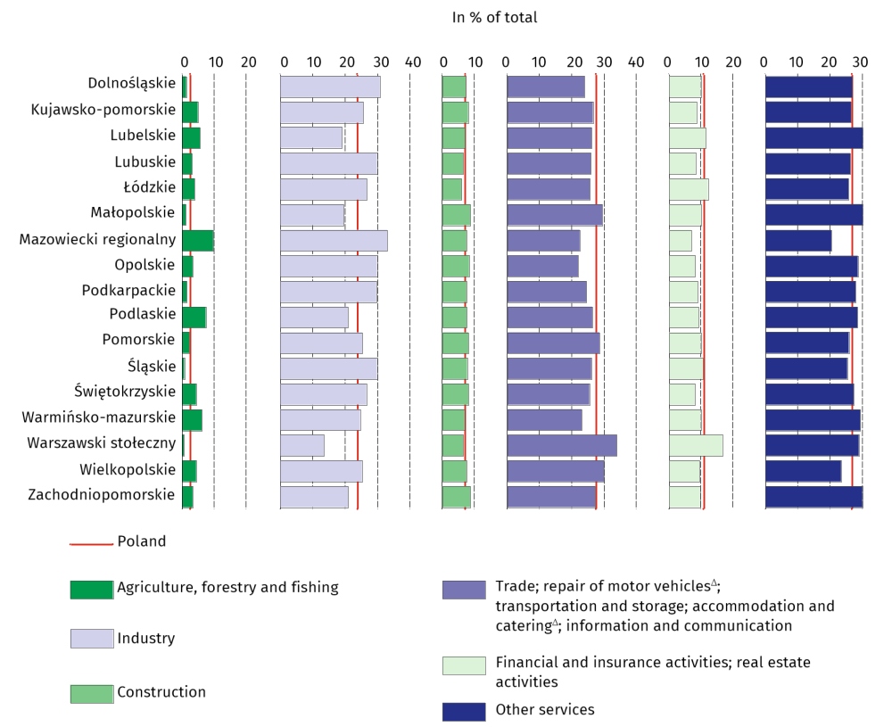
Graph 2. Gross value added by kind of activity and regions in 2024 (current prices)

Table 2. Gross value added by kind of activity and regions in 2024 (current prices)
REGIONS  a – in million PLN  b – in % of total  c – previous year=100 |  | Total | Agriculture, forestry  and fishing | Industry | Construction | Trade; repair of motor vehicles^{Δ};  transportation and storage;  accommodation and catering^{Δ};  information and communication | Financial and insurance activities;  real estate activities | Other services
POLAND | a | 3 265 313 | 93 014 | 783 404 | 241 720 | 905 762 | 360 097 | 881 316
 | b | 100.0 | 2.8 | 24.0 | 7.4 | 27.7 | 11.0 | 27.0
 | c | 105.8 | 99.0 | 94.9 | 108.5 | 107.1 | 109.7 | 114.5
Dolnośląskie | a | 269 495 | 3 465 | 82 809 | 19 658 | 64 439 | 26 744 | 72 381
 | b | 100.0 | 1.3 | 30.7 | 7.3 | 23.9 | 9.9 | 26.9
 | c | 105.4 | 103.4 | 95.9 | 110.0 | 107.5 | 108.6 | 113.9
Kujawsko-pomorskie | a | 136 631 | 6 635 | 35 013 | 10 876 | 36 193 | 11 739 | 36 175
 | b | 100.0 | 4.9 | 25.6 | 8.0 | 26.5 | 8.6 | 26.5
 | c | 105.4 | 104.5 | 95.3 | 108.1 | 105.4 | 109.3 | 115.3
Lubelskie | a | 120 606 | 6 803 | 23 016 | 8 587 | 31 424 | 13 840 | 36 936
 | b | 100.0 | 5.6 | 19.1 | 7.1 | 26.1 | 11.5 | 30.6
 | c | 108.0 | 94.9 | 101.0 | 109.4 | 106.5 | 109.4 | 116.3
Lubuskie | a | 67 841 | 2 105 | 20 240 | 4 438 | 17 574 | 5 653 | 17 830
 | b | 100.0 | 3.1 | 29.8 | 6.5 | 25.9 | 8.3 | 26.3
 | c | 105.6 | 98.3 | 94.3 | 111.2 | 109.4 | 107.5 | 116.3
Łódzkie | a | 195 564 | 7 714 | 52 206 | 11 673 | 49 980 | 23 660 | 50 331
 | b | 100.0 | 3.9 | 26.7 | 6.0 | 25.6 | 12.1 | 25.7
 | c | 104.9 | 98.0 | 94.7 | 105.8 | 105.6 | 110.6 | 115.3
Małopolskie | a | 266 651 | 3 221 | 52 188 | 23 251 | 78 317 | 26 889 | 82 785
 | b | 100.0 | 1.2 | 19.6 | 8.7 | 29.4 | 10.1 | 31.0
 | c | 107.1 | 112.9 | 94.5 | 109.9 | 108.7 | 107.1 | 114.0
Mazowiecki regionalny | a | 175 577 | 17 047 | 58 021 | 13 151 | 39 340 | 12 248 | 35 769
 | b | 100.0 | 9.7 | 33.0 | 7.5 | 22.4 | 7.0 | 20.4
 | c | 104.7 | 97.1 | 97.2 | 107.9 | 108.4 | 109.8 | 116.2
Opolskie | a | 63 429 | 2 088 | 18 892 | 5 252 | 13 882 | 5 170 | 18 144
 | b | 100.0 | 3.3 | 29.8 | 8.3 | 21.9 | 8.2 | 28.6
 | c | 105.2 | 96.0 | 98.0 | 108.3 | 104.3 | 104.8 | 115.5
Podkarpackie | a | 125 012 | 1 874 | 36 952 | 9 391 | 30 601 | 11 281 | 34 912
 | b | 100.0 | 1.5 | 29.6 | 7.5 | 24.5 | 9.0 | 27.9
 | c | 107.1 | 105.8 | 98.5 | 111.3 | 106.8 | 108.2 | 116.5
Podlaskie | a | 73 263 | 5 396 | 15 346 | 5 584 | 19 292 | 6 799 | 20 846
 | b | 100.0 | 7.4 | 20.9 | 7.6 | 26.3 | 9.3 | 28.5
 | c | 105.7 | 91.8 | 97.4 | 111.4 | 104.2 | 108.0 | 116.6
Pomorskie | a | 196 266 | 4 450 | 49 797 | 15 949 | 55 915 | 19 461 | 50 694
 | b | 100.0 | 2.3 | 25.4 | 8.1 | 28.5 | 9.9 | 25.8
 | c | 106.1 | 100.2 | 97.1 | 108.1 | 106.7 | 109.2 | 114.4

Table 2. Gross value added by kind of activity and regions in 2024 (cont.)
REGIONS  a – in million PLN  b – in % of total  c – previous year=100 |  | Total | Agriculture, forestry  and fishing | Industry | Construction | Trade; repair of motor vehicles^{Δ};  transportation and storage;  accommodation and catering^{Δ};  information and communication | Financial and insurance activities;  real estate activities | Other services
Śląskie | a | 374 083 | 2 651 | 111 563 | 28 668 | 97 198 | 39 517 | 94 486
 | b | 100.0 | 0.7 | 29.8 | 7.7 | 26.0 | 10.6 | 25.3
 | c | 102.3 | 96.3 | 89.1 | 107.2 | 105.7 | 110.8 | 113.1
Świętokrzyskie | a | 75 264 | 3 325 | 20 051 | 6 068 | 19 142 | 6 122 | 20 556
 | b | 100.0 | 4.4 | 26.6 | 8.1 | 25.4 | 8.1 | 27.3
 | c | 107.4 | 101.6 | 100.4 | 108.3 | 107.7 | 108.0 | 115.7
Warmińsko-mazurskie | a | 80 415 | 4 958 | 19 798 | 5 558 | 18 488 | 7 978 | 23 635
 | b | 100.0 | 6.2 | 24.6 | 6.9 | 23.0 | 9.9 | 29.4
 | c | 105.5 | 91.3 | 97.0 | 110.7 | 106.2 | 105.0 | 115.9
Warszawski stołeczny | a | 608 313 | 3 421 | 82 173 | 39 345 | 206 352 | 101 159 | 175 862
 | b | 100.0 | 0.6 | 13.5 | 6.5 | 33.9 | 16.6 | 28.9
 | c | 107.6 | 96.9 | 93.6 | 108.1 | 107.6 | 111.2 | 113.6
Wielkopolskie | a | 321 223 | 14 060 | 81 046 | 24 175 | 96 161 | 30 565 | 75 216
 | b | 100.0 | 4.4 | 25.2 | 7.5 | 29.9 | 9.5 | 23.4
 | c | 105.9 | 106.1 | 95.2 | 108.1 | 107.9 | 111.2 | 114.2
Zachodniopomorskie | a | 115 680 | 3 800 | 24 293 | 10 095 | 31 466 | 11 270 | 34 757
 | b | 100.0 | 3.3 | 21.0 | 8.7 | 27.2 | 9.7 | 30.0
 | c | 105.6 | 91.2 | 95.2 | 108.0 | 106.0 | 108.8 | 114.0

Symbol ∆ — categories of applied PKD 2007 classification (link) are presented in abbreviated form.
Data from regional accounts included in this note have been revised in relation to those published on 30 December 2025 and balanced with annual national accounts data included in the publication entitled ‘National accounts by institutional sectors and sub-sectors 2021-2024’. The full set of information for 2024, including data by subregions as well as data on income in the households sector, will be available in November this year.
When quoting this publication, please provide its title and indicate Statistics Poland as the author. When publishing your own calculations based on data from this publication, please include the following statement: Author’s work based on data from Statistics Poland’s publication entitled ‘Gross domestic product and gross value added in regional breakdown in 2024’.
Prepared by:  Statistical Office in Katowice  Director Grażyna Witkowska  Phone: (+48 32) 779 12 48 | Issued by:  Press Office  Mobile: (+48) 695 255 032  Phone: (+48 22) 608 38 04, (+48 22) 449 41 45,  (+48 22) 608 30 09  e-mail: obslugaprasowa@stat.gov.pl


stat.gov.pl/en/
 | @StatPoland

@GlownyUrzadStatystyczny

@gus_stat

@GłównyUrządStatystycznyGUS

@Glówny Urząd Statystyczny
Related information
Gross domestic product — regional accounts in the years 2021-2023
Methodological report Gross domestic product and its elements in the regional breakdown
National accounts by institutional sectors and sub-sectors 2021-2024
Provisional estimates of gross domestic product in regional breakdown in 2024
Real GDP increased in most EU regions in 2024
Data available in databases
Knowledge Databases -> National and regional accounts -> Regional accounts
Local Data Bank -> Regional accounts
Terms used in official statistics
Gross domestic product
Regional accounts
Value added, gross

