Price indices of residential premises in the second quarter of 2026

In the second quarter of 2026, prices of residential premises in Poland increased by 1.5% compared to the previous quarter. On the primary market, this increase amounted to 1.3%, while on the secondary market it was 1.6%. Compared to the corresponding period in 2025, prices of residential premises were 6.3% higher, with increase of 6.5% recorded on the primary market and 6.1% on the secondary market.
6.3%
Increase in prices of residential premises compared to the 2nd quarter of 2025

Table 1. Price indices of residential premises in the second quarter of 2026
Specification | Q2 2026
Specification | Q1 2026=100 | Q2 2025=100 | 2025=100
Total | 101.5 | 106.3 | 105.7
Primary market | 101.3 | 106.5 | 105.8
Secondary market | 101.6 | 106.1 | 105.6
Chart 1. Weighting system used in the compilations of price indices of residential premises
in 2026
For compiling price indices
of residential premises
in 2026, weight of 45.6% and 54.4% are assigned to the
primary and secondary market respectively
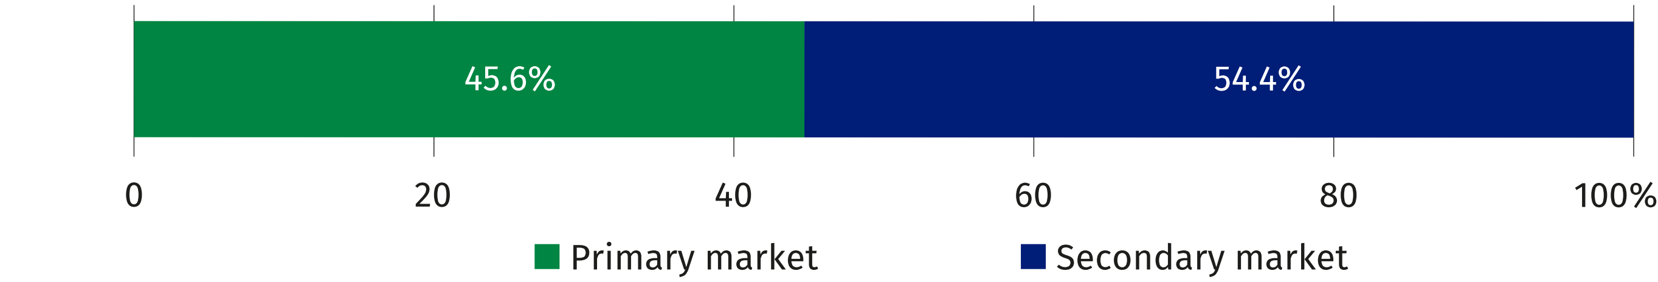

Chart 2. Changes in prices of residential premises compared to the previous quarter
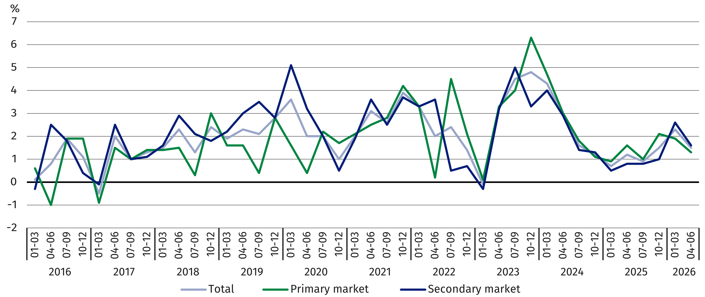
Chart 3. Changes in prices of residential premises compared to the corresponding
quarter of the previous year
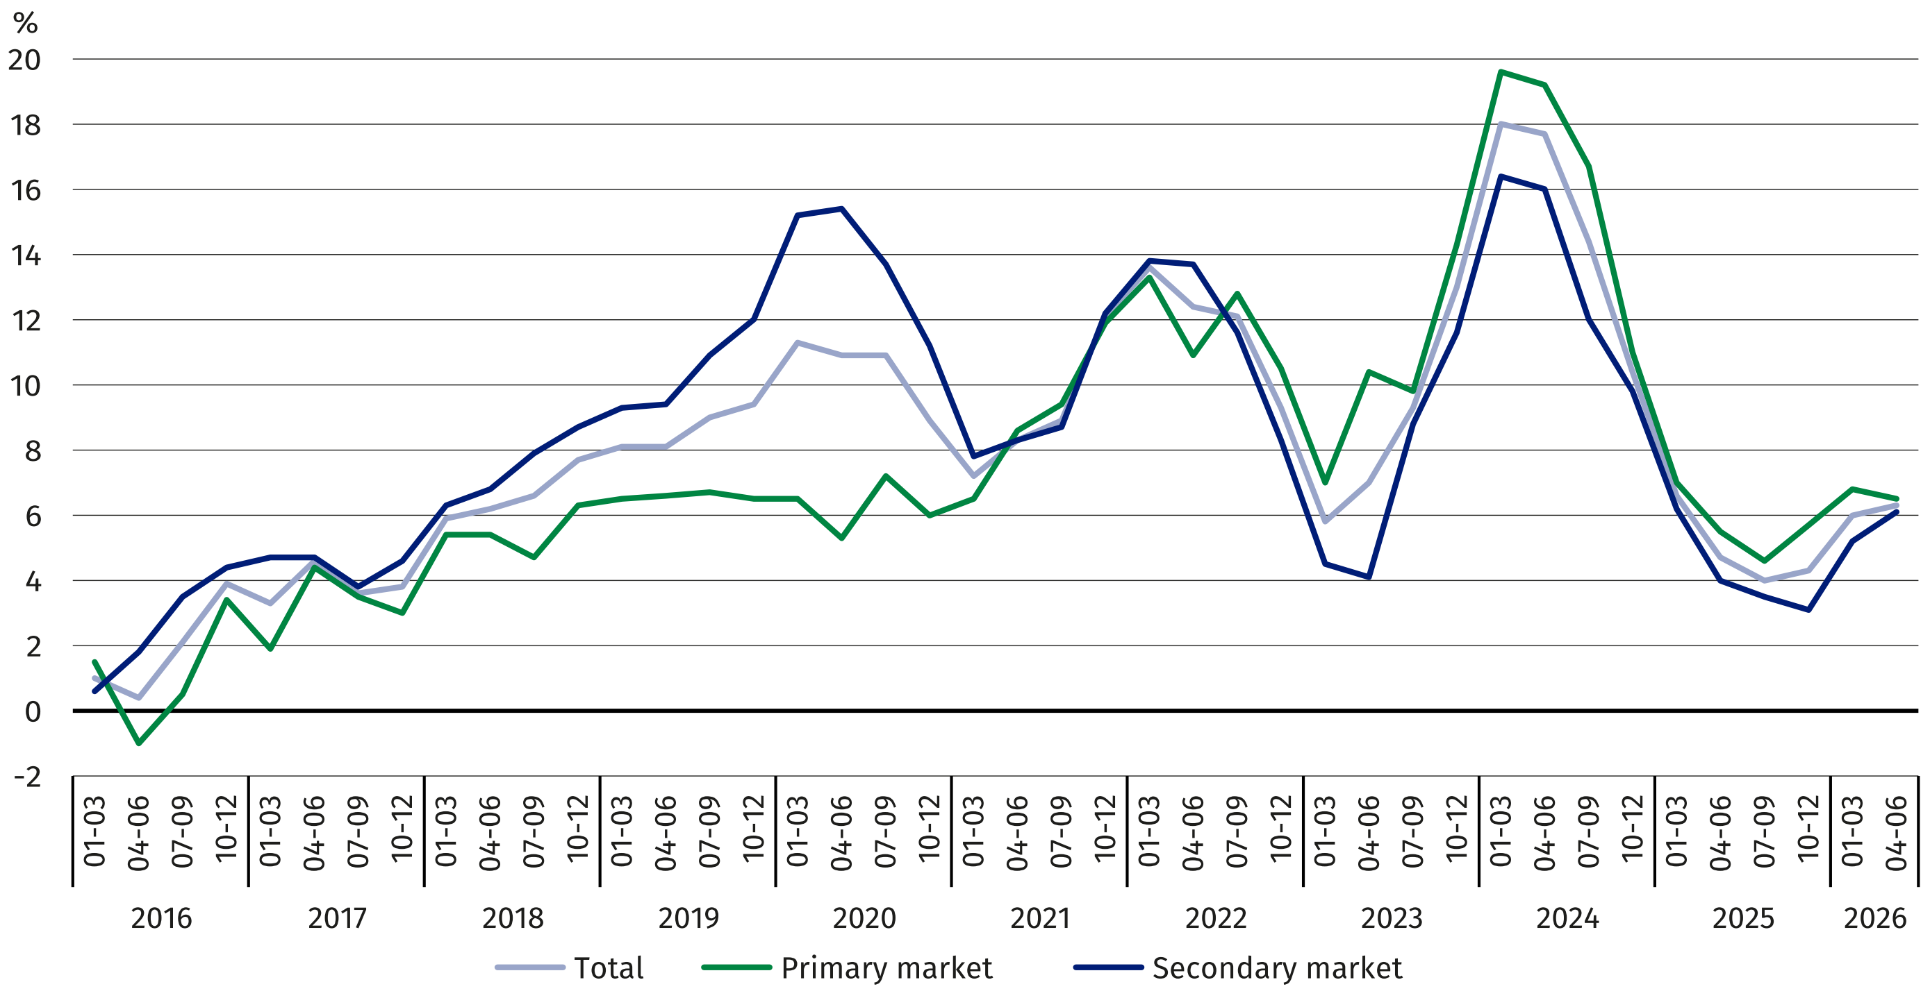

Chart 4. Changes in prices of residential premises compared to 2025
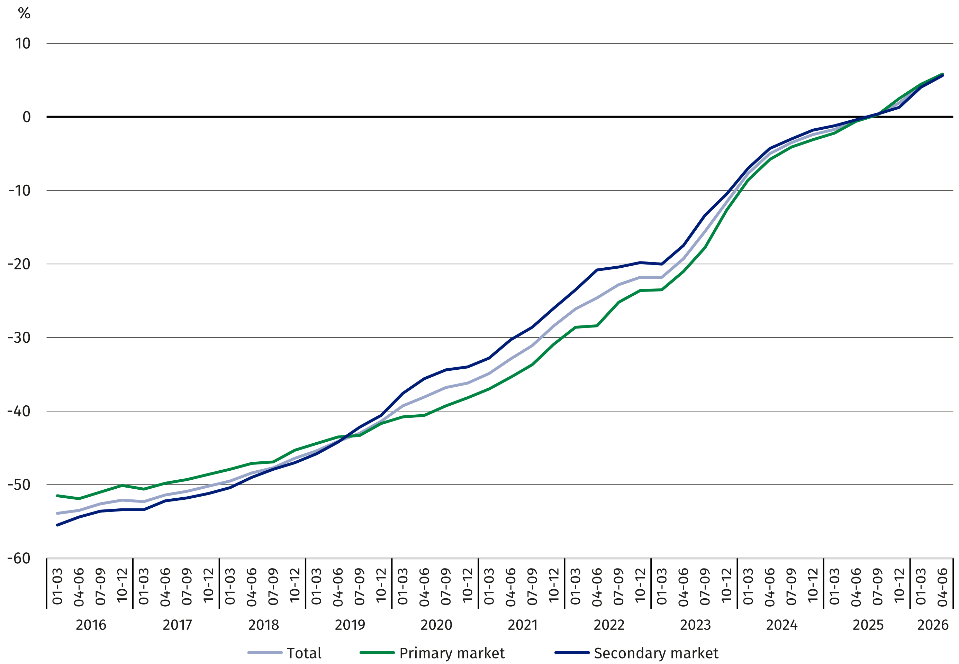
In the second quarter of 2026 prices of residential premises were 5.7% higher compared
to the average price for 2025
(with increase of 5.8% on the
primary market and 5.6% on the secondary market)

Table 2. Price indices of residential premises by voivodships
In the second quarter of 2026, the highest increase in price
of residential premises,
compared to the corresponding period in 2025, was recorded
in the Kujawsko-pomorskie
Voivodship (of 8.6%)
Specification | Q2 2026
Specification | Q1 2026=100 | Q2 2025=100
Poland | 101.5 | 106.3
Dolnośląskie | 102.0 | 104.0
Kujawsko-pomorskie | 102.1 | 108.6
Lubelskie | 102.1 | 105.0
Lubuskie | 101.2 | 108.1
Łódzkie | 101.8 | 101.5
Małopolskie | 102.0 | 106.8
Mazowieckie | 101.0 | 107.5
Opolskie | 102.9 | 107.2
Podkarpackie | 100.7 | 104.6
Podlaskie | 101.5 | 108.2
Pomorskie | 102.3 | 107.8
Śląskie | 100.8 | 104.4
Świętokrzyskie | 102.4 | 108.4
Warmińsko-mazurskie | 101.7 | 106.2
Wielkopolskie | 100.5 | 107.1
Zachodniopomorskie | 101.0 | 104.8
When quoting Statistics Poland data, please provide the information: “Source of data: Statistics Poland”, and when publishing calculations made on data published by Statistics Poland, please include the following disclaimer: “Own study based on figures from Statistics Poland”.

Prepared by:  Statistical Office in Szczecin  Director Magdalena Wegner  Phone: (+48 91) 459 77 00 | Issued by:  Press Office  Mobile: (+48) 695 255 032  Phone: (+48 22) 608 38 04, (+48 22) 449 41 45,  (+48 22) 608 30 09  e-mail: obslugaprasowa@stat.gov.pl

stat.gov.pl/en/

@StatPoland

@GlownyUrzadStatystyczny

@gus_stat

@GłównyUrządStatystycznyGUS

@Glówny Urząd Statystyczny
Related information
Price indices of residential premises by voivodships
Price of one square meter of usable floor space of a residential building in the second quarter of 2026
Real estate sales in 2024
Data available in databases
Knowledge Databases (DBW) – Economy – Prices – Real estate prices
Local Data Bank – Real estate market
Terms used in official statistics
Real estate turnover
Real Estate Price Register
Premises
Price indices of residential premises

