Socio-economic situation of Mazowieckie Voivodship in June 2026
- In June this year, the average employment in the enterprise sector decreased on a yearly basis by 0.5%, and on a monthly basis by 0.1%. The registered unemployment rate amounted to 4.4% and increased on an annual basis by 0.4 pp, and decreased by 0.1 pp on a monthly basis.
- Average monthly gross wages and salaries in the enterprise sector in June this year were higher by 6.5% compared to the previous year and lower by 2.3% than in the previous month.
- On the agricultural market in June 2026, the average procurement prices of wheat, rye, pigs for slaughter, as well as milk were lower than in the previous year, while the prices of potatoes, cattle and poultry for slaughter were higher. On a monthly basis, more was paid for wheat, cattle and poultry for slaughter, and less for rye, potatoes, pigs for slaughter as well as milk.
- In June this year, sold production of industry (at constant prices) increased on a yearly basis (by 7.3%), and decreased on a monthly basis (by 4.6%). Construction and assembly production (at current prices) was larger by 17.5% than in the previous year and by 12.5% than a month earlier.
- The number of dwellings completed in June this year, was larger by 13.9% than a year before and by 40.6% compared to the previous month. Most dwellings were built for sale or rent.
- In June this year, there was an increase in retail sales in annual terms (by 12.9%). Wholesale was also higher than in the previous year (by 28.8%).
- In June this year, the number of entities of the national economy registered in the REGON register was higher by 3.3% than in the previous year and by 0.3% than in the previous month.
- In July of this year, the general business climate indicator across all surveyed economic sectors points to a stabilisation or improvement in business conditions compared to the previous month. The largest increase in the indicator (11.1 points) was recorded in the accommodation and catering section, while significant improvement was also observed in retail trade (an increase of 2.1 points). In the remaining sections, business sentiment remained at levels similar to those of the previous month. Across all surveyed areas of the economy, the outlook regarding business tendencies is positive. Entities in the accommodation and catering section express the most optimism, with the indicator value exceeding the long-term average.

Contents
Labour market 4
Wages and salaries 7
Agriculture 9
Industry and construction 12
Residential construction 14
Internal market 16
Entities of the national economy 17
Business tendency 19
Selected data on Mazowieckie Voivodship 25

General notes
Data presented in the news release:
- on employment, wages and salaries and sold production of industry and construction, construction and assembly production, as well as retail sales and wholesale concern economic entities employing more than 9 persons,
- on enterprise sector refer to entities conducting economic activity in the field of: forestry and logging; maritime fishing; mining and quarrying; manufacturing; electricity, gas, steam and air conditioning supply; water supply; sewerage, waste management and remediation activities; construction; wholesale and retail trade; repair of motor vehicles and motorcycles; transportation and storage; accommodation and food service activities; information and communication; real estate activities; legal and accounting activities; activities of head offices; management consultancy activities; architectural and engineering activities; technical testing and analysis; advertising and market research; other professional, scientific and technical activities; arts, entertainment and recreation; repair of computers and personal and household goods; other personal service activities,
- on retail prices of foodstuffs and non-foodstuffs as well as services that originate from quotations of prices conducted by interviewers at selected points of sale in selected regions of price surveys; prices of food are collected once a month, with the exception of fruit and vegetables, for which prices are collected twice a month,
- on procurement of agricultural products include procurement from producers from the voivodship; prices are given excluding VAT tax,
- on financial results of enterprises and investment outlays refer to economic entities keeping accounting ledgers (excluding entities whose activity is classified according to the NACE Rev. 2 in the sections “Agriculture, forestry and fishing” and “Financial and insurance activities” as well as higher education institutions) in which the number of employed persons exceeds 49.
Data in value terms are provided at current prices and form the basis for calculating the structure indicators. Dynamic indices are provided on the basis of value at current prices, except for industry, for which the dynamic indices are provided on the basis of value at constant prices (average current prices of 2015).
Relative numbers (indices, percentages) were calculated on the basis of absolute data expressed with higher precision than that presented in the text and tables.
Data have been presented in accordance with the Polish Classification of Activities – PKD 2007 (NACE Rev. 2).

Polish Classification of Activities 2007 (PKD 2007)
Abbreviation | Full name
sections
trade; repair of motor vehicles | wholesale and retail trade; repair of motor vehicles and motorcycles
accommodation and catering | accommodation and food service activities
divisions
trade; repair of motor vehicles | wholesale and retail trade; repair of motor vehicles and motorcycles

Symbols
Symbol | Description
(–) | – magnitude zero
(.) | – data not available, classified data (statistical confidentiality) or providing data impossible or purposeless
(*) | – data revised
∆ | – categories of applied classification are presented in abbreviated form
„Of which” | – indicates that not all elements of the sum are given
Data describing Mazowieckie Voivodship can also be found in statistical publications issued by the Statistical Office in Warszawa and in the publications of Statistics Poland.
The report „Economic situation in Mazowieckie Voivodship in July 2026” was published on the home page of the Statistical Office in Warszawa:: https://warszawa.stat.gov.pl/ on 28 July 2026.
When publishing Statistical Office data, please indicate the source.

Labour market
In June this year, the average employment in the enterprise decreased year-on-year but increased month-on-month. The registered unemployment rate increased compared to the previous year and decreased compared to the previous month.
Average employment in the enterprise sector in June this year amounted to 1,565.0 thousand persons (full-time equivalent) and was by 0.5% lower in annual terms (in the previous month by 0.4%). The most significant decrease was recorded in professional, scientific and technical activities (by 7.3%), and also in real estate activities (by 2.8%), transportation and storage (by 1.4%), and trade; repair of motor vehicles (by 0.8%). The highest increase was recorded in accommodation and catering (by 2.4%), followed by manufacturing (by 1.6%), construction (by 0.4%), and information and communication (by 0.2%).
In comparison with May this year, average employment increased by 0.1%. Declines were recoreded in administrative and support service activities (by 0.7%), trade; repair of motor vehicles and real estate activities (by 0.4%), and also in electricity, gas, steam and air conditioning supply (by 0.3%). In manufacturing, employment did not change, and in the remaining sections surveyed it was lower than a month ago; the deepest decline was recorded in construction (by 0.6%).
Table 1. Average employment in the enterprise sector in june 2026
SPECIFICATION | 06 2026 |  | 01–06 2026
SPECIFICATION | In thousands | 06 2025=100 | In thousands | 01–06 2025=100
TOTAL | 1565,0 | 99,5 | 1565,4 | 99,3
of which:
Industry | 397,8 | 101,8 | 398,3 | 101,7
of which:
manufacturing | 355,5 | 101,6 | 356,3 | 101,6
electricity, gas, steam and air conditioning supply | 20,2 | 99,7 | 20,2 | 99,8
Construction | 93,9 | 100,4 | 93,5 | 99,9
Trade; repair of motor vehicles Δ | 323,2 | 99,2 | 323,5 | 99,2
Transportation and storage | 258,1 | 98,6 | 257,8 | 97,8
Accommodation and catering Δ | 35,3 | 102,4 | 35,1 | 102,4
Information and communication | 137,8 | 100,2 | 138,0 | 100,2
Real estate activities | 28,1 | 97,2 | 28,1 | 97,1
Professional, scientific and technical activities a | 116,1 | 92,7 | 116,2 | 93,0
Administrative and support service activities | 136,6 | 99,9 | 136,9 | 99,6
a Excluding divisions: Research and experimental development work and Veterinary activities.
In January-June of this year, average employment in the enterprise sector amounted to 1566,4 thousand persons and decreased by 0.7% compared to the same period of 2025 (a year ago the decrease was 1.1%).
Chart 1. Average employment in the enterprise sector (monthly average 2021=100)
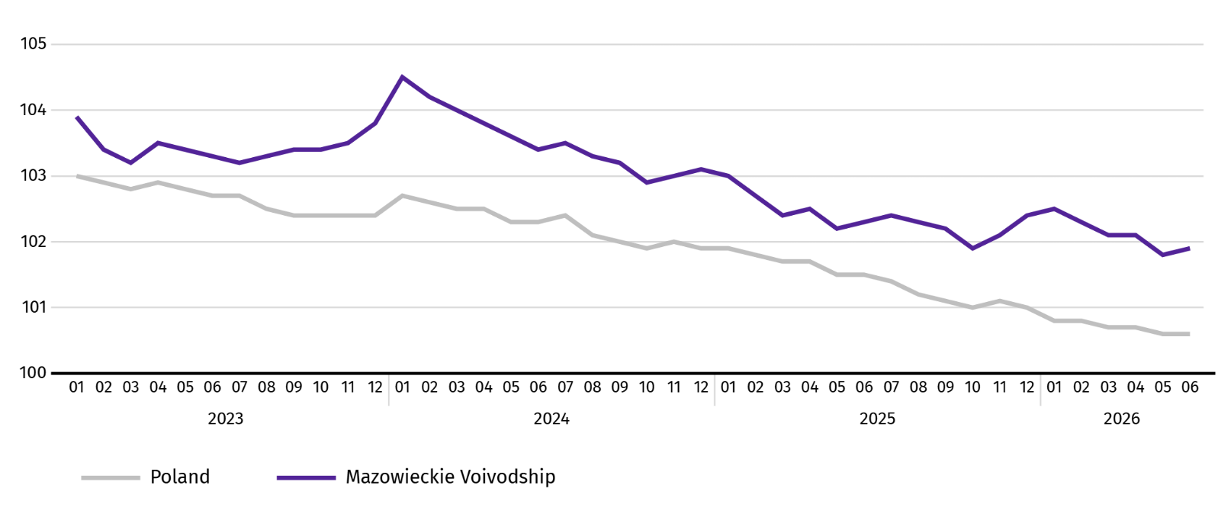
At the end of June this year, the number of unemployed persons registered in labour offices amounted to 121.5 thousand persons and increased on a yearly basis by 10.4 thousand persons (i.e. by 9.4%), and on a monthly basis decreased by 1.4 thousand persons (i.e. by 1.1%). Women accounted for 46.9% of total registered unemployed persons (a year before 47.7%)
Table 2. Number of unemployed persons and unemployment rate
SPECIFICATION | 2025 | 2026
SPECIFICATION | 06 | 05 | 06
Registered unemployed persons (as of end of month) in thousands | 111,0 | 122,8 | 121,5
Newly registered unemployed persons (during a month) in thousands | 10,1 | 10,4 | 10,7
Unemployed persons removed from unemployment rolls (during a month) in thousands | 7,8 | 11,6 | 12,1
Registered unemployment rate (as of end of month) in % | 4,0 | 4,5 | 4,4
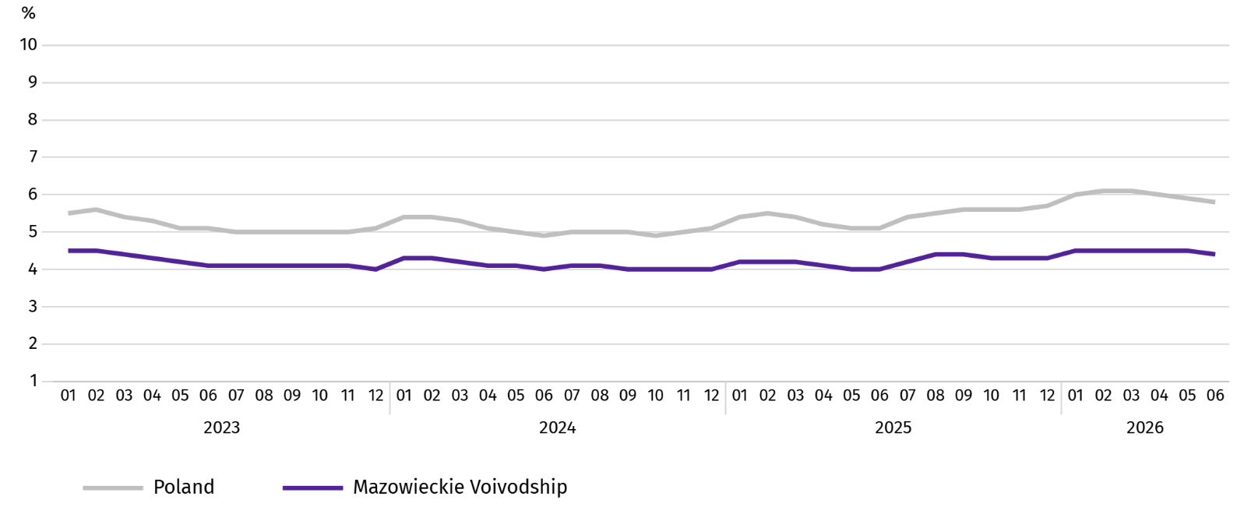
Chart 2. Registered unemployment rate (as of end of month)

Registered unemployment rate at the end of June this year amounted to 4.4% and was lower than the national average (5.8%). It increased on a yearly basis (0.4 pp), and decreased by 0.1 pp on a monthly basis.
The territorial differentiation of the unemployment rate continued in the Voivodship. Powiats with the highest unemployment rate were still szydłowiecki (22.4% against 21.9% in June last year), przysuski (18.0% compared to 17.9%), and makowski (17.3% against 15.5%), and with the lowest – Warszawa (1.6% against 1.5%), warszawski zachodni (2.0% against 1.6%) and pruszkowski (2.7% against 2.3%).
Compared to June last year, the unemployment rate increased in 41 out of 42 powiats. The highest increase was recorded in the powiats: makowski (by 1.8 pp), gostyniński and zwoleński (by 1.7 pp each), as well as wołomiński and wyszkowski (by 1.3 pp each).
Compared to May this year, the decrease in unemployment rate of 0.1-0.2 pp took place in 13 powiats. The increase of 0.1-0.3 pp took place in 10 powiats.
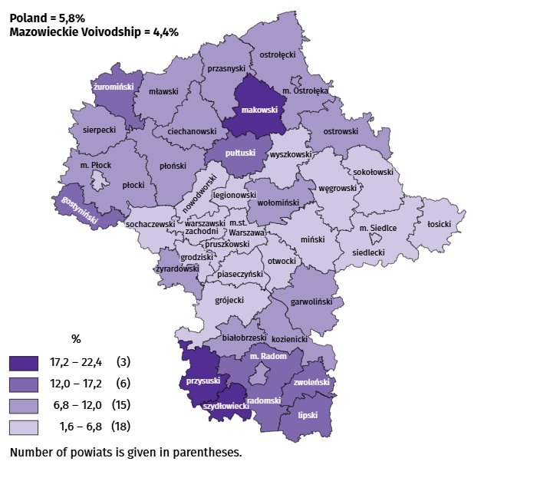
Map 1. Registered unemployment rate by powiats in 2026 (as of end of June)

In June this year, 10.7 thousand unemployed persons were registered in labour offices, i.e. more by 5.8% than a year before and by 2.5% than in the previous month. Among the newly registered, 70.5% were persons registering for the second time (72.1% in the previous year). Share of persons previously not employed amounted to 16.1% (a decrease of 0.2 pp year-on-year), persons terminated for company reasons 4.9% (an increase of 0.2 pp). Among newly registered unemployed persons, 37.9% lived in rural areas (a decrease of 1.5 pp). Graduates accounted for 7.4% of newly registered unemployed persons (an increase of 0.3 pp). Unemployed persons supporting at least one child under the age of 18 or a disabled child under the age of 24 constituted 23.4% of all newly registered unemployed.
In June this year, 12.1 thousand persons were removed from unemployment rolls, i.e. more by 55.1% than a year before and by 4.4% than a month before. 7.0 thousand persons (29.7% more than a year before) were removed from unemployment rolls due to undertaking employment. The share of this category of persons in the total number of persons removed from unemployment rolls decreased by 11.4 pp on a yearly basis and amounted to 58.0%. There was also a decrease in the percentage of persons who voluntarily gave up their status of the unemployed (by 3.4 pp to 4.8%), and persons who started training and employer sponsored traineeships decreased (by 0.2 pp to 2.8%). The share of persons who obtained retirement or pension rights increased (by 0.2 pp to 0.9%).
At the end of June this year, 107.2 thousand unemployed persons were not entitled to the unemployment benefit, and their share in the total number of the registered unemployed was 88.3% (a 4.1 pp increase in annual terms).
At the end of the surveyed month, 63.4 thousand, i.e. 52.2% out of registered unemployed persons were the long-term unemployed. The number of unemployed persons under the age of 30 amounted to 27.1 thousand, which accounted for 22.3% of the total unemployed (of which persons under the age of 25 constituted 11.8%). Persons aged over 50 amounted to 33.3 thousand (27.4%). The number of unemployed single parents with at least one child was 8.9 thousand (7.3%), and persons with a Large Family Card were 5.6 thousand (4.6%) of all registered unemployed persons (these are groups which, pursuant to the Act on the Labour Market and Employment Services, were included in the category of unemployed with additional entitlements to assistance). The number of unemployed persons with disabilities was 5.7 thousand (i.e. 4.7%).
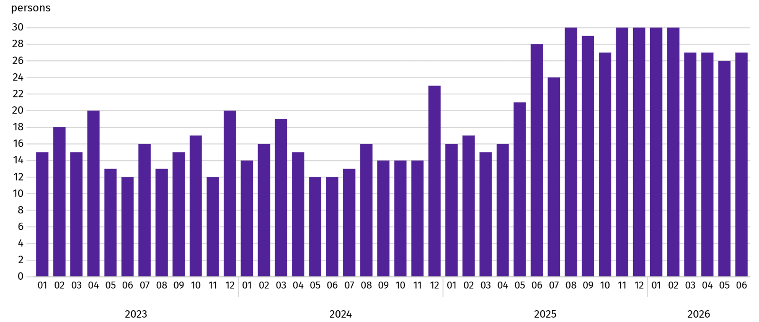
Chart 3. Registered unemployed persons per job offerª (as of end of month)

a From 1 June 2025, data on job offers are not fully comparable with earlier periods due to methodological changes resulting from the entry into force of the Act on the Labour Market and Employment Services (Journal of Laws of 2025, item 620).
In June this year, 3.8 thousand job offers were submitted to labour offices, i.e. more by 0.3% than in the previous month. At the end of month, there were 27 unemployed persons per job offer (26 a month before).
According to the labour offices, as of the end of June this year, 35 companies announced termination of 2.6 thousand employees in the near future (a year before, respectively 42 companies – 62.3 thousand employees).

Wages and salaries
In June this year, the average monthly gross wages and salaries in the enterprise sector increased both on a yearly basis and on a month basis.
Average monthly gross wages and salaries in the enterprise sector in June this year amounted to PLN 10833.56 and were higher than in the country (PLN 9401.58). It increased by 6.5% on a yearly basis (by 5.9% in the previous month). The increase was recorded in all surveyed sections; the highest in professional, scientific and technical activities (by 11.1%), followed by, among others, in manufacturing (by 8.9%), real estate activities and electricity, gas, steam and air conditioning supply (by 8.5% each), as well as information and communication (by 7.6%).
W porównaniu z majem br. przeciętne wynagrodzenie było wyższe o 2,3%. Największy wzrost wystąpił w przetwórstwie przemysłowym (o 14,2%), a ponadto m.in. w transporcie i gospodarce magazynowej (o 1,1%), obsłudze rynku nieruchomości (o 0,9%) oraz handlu; naprawie pojazdów samochodowych (o 0,6%). Spadek odnotowano w informacji i komunikacji (o 5,4%), wytwarzaniu i zaopatrywaniu w energię elektryczną, gaz, parę wodną i gorącą wodę (o 2,4%) oraz administrowaniu i działalności wspierającej (o 0,8%).

Chart 4. Relative deviations of average monthly gross wages and salaries in selected sections from average wages and salaries in the enterprise sector in June 2026
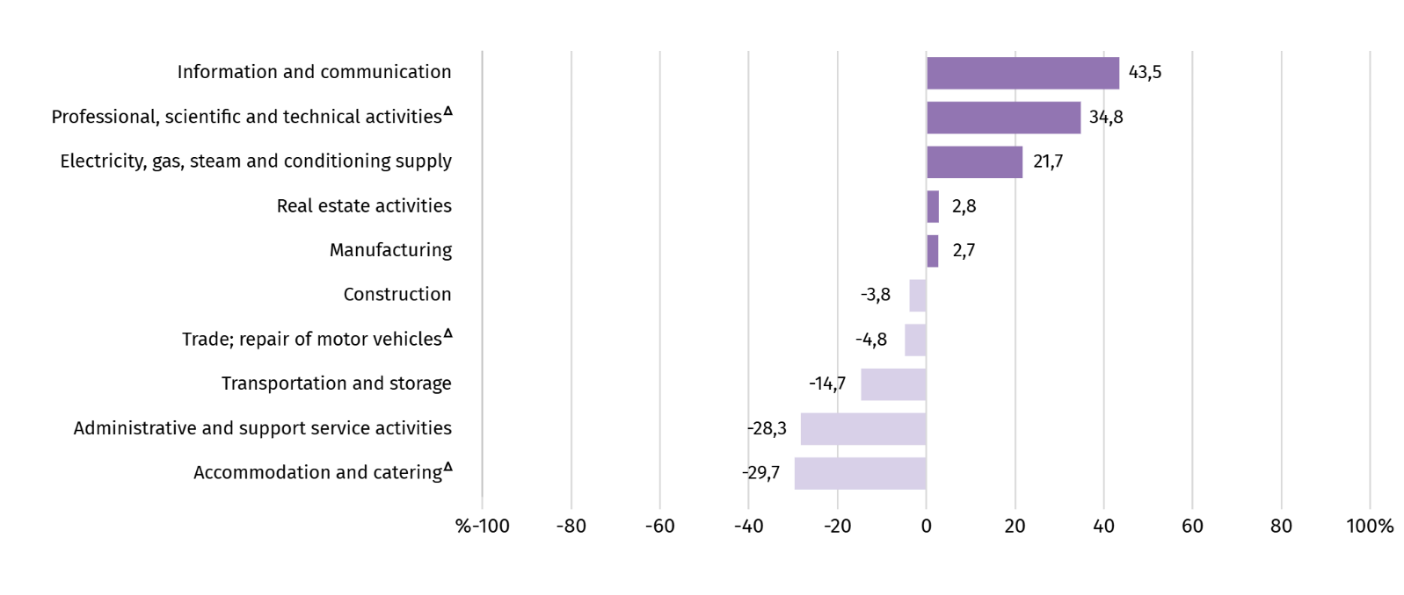
a Excluding divisions: Research and experimental development work and Veterinary activities.
Table 3. Average monthly gross wages and salaries in the enterprise sector in June 2026
SPECIFICATION | 06 2026 |  | 01–06 2026
SPECIFICATION | In PLN | 06 2025=100 | In PLN | 01–06 2025=100
TOTAL | 10833,56 | 106,5 | 10870,25 | 106,0
of which:
Industry | 11122,32 | 108,7 | 10491,38 | 106,0
of which:
manufacturing | 11125,84 | 108,9 | 10267,60 | 106,0
electricity, gas, steam and air conditioning supply | 13189,04 | 108,5 | 15666,25 | 104,6
Construction | 10421,62 | 105,2 | 10517,64 | 103,9
Trade; repair of motor vehicles Δ | 10311,72 | 105,7 | 10662,24 | 106,1
Transportation and storage | 9245,85 | 103,4 | 9151,31 | 105,2
Accommodation and catering Δ | 7619,18 | 105,3 | 7734,54 | 105,8
Information and communication | 15544,09 | 107,6 | 16435,74 | 107,2
Real estate activities | 11134,67 | 108,5 | 11330,04 | 107,7
Professional, scientific and technical activities a | 14604,35 | 111,1 | 14959,71 | 111,0
Administrative and support service activities | 7769,13 | 102,8 | 7921,97 | 102,5
a Excluding divisions: Research and experimental development work and Veterinary activities.
In the period January-June this year, the average monthly gross wages and salaries in the enterprise sector amounted to PLN 10870.25 and was 6.0% higher than in the same period of 2025 (9.4% higher a year ago).
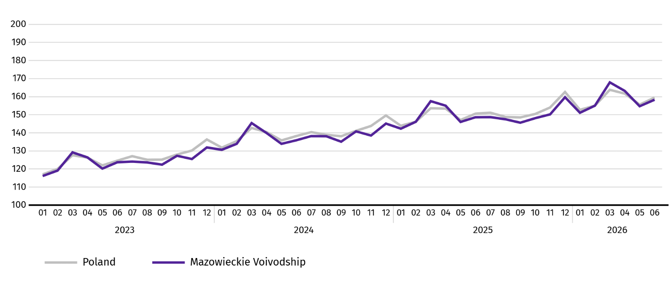
Chart 5. Average monthly gross wages and salaries in the enterprise sector (monthly average 2021=100)

Agriculture
On the agricultural market in June 2026, average procurement prices for wheat, rye, pigs for slaughter as well as milk were lower than a year ago, whereas the prices of potatoes, cattle and poultry for slaughter were higher. On a monthly basis, more was paid for wheat, cattle and poultry for slaugher, and less for rye, potatoes, pigs for slaughter and milk.
The average air temperature in Mazowieckie Voivodship in June 2026 amounted to 19.2°C and was by 2.1°C higher from the average from the years 1991–2020, while the maximum temperature reached 38.5°C in Kozienice, and the minimum amounted to 5.8°C in Mława. The average atmospheric precipitation (65.2 mm) accounted for 100% of the standard for the multi-year periods (ranging from 61% in Kozienice to 170% in Mława). The number of days with precipitation, depending on the region, ranged from 11 to 14.
Table 4. Procurement of cereal ª
SPECIFICATION | 07 2025–06 2026 |  | 06 2026
SPECIFICATION | In thousand tonnes | corresponding  period  of previous year=100 | In thousand tonnes | 06 2025=100 | 05 2026=100
Grain of basic cereal ^{b} | 599,4 | 107,9 | 35,3 | 134,4 | 92,2
of which:
wheat | 468,0 | 109,7 | 27,0 | 130,6 | 89,9
rye | 50,0 | 101,0 | 4,5 | 191,5 | 161,8
a In January-June 2026, excluding procurement by natural persons. b Includes: wheat, rye, barley, oat, triticale; including cereal mixed, excluding sowing seed.
Deliveries of basic cereals (including cereal mixed, excluding sowing seed) for procurement from last year's harvest in the July 2025-June 2026 period were 7.9% higher than during the same period last year, with wheat deliveries increasing by 9.7% and rye by 1.0%. In June 2026, procurement of cereal was 34.4% higher than a year ago and 7.8% lower than in the previous month.
Table 5. Procurement of basic animal products ª
SPECIFICATION | 01–06 2026 |  | 06 2026
SPECIFICATION | in thousand tonnes | 01–06 2025=100 | in thousand tonnes | 06 2025=100 | 05 2026=100
Animals for slaughter ^{b} | 534,2 | 104,1 | 43,2 | 45,7 | 50,8
of which:
cattle (including calves) | 13,6 | 55,2 | 1,8 | 44,1 | 83,1
pigs | 110,8 | 89,5 | 14,3 | 66,2 | 74,5
poultry | 409,4 | 112,4 | 27,0 | 39,3 | 42,5
Milk ^{c} | 1472,2 | 102,1 | 246,1 | 101,4 | 94,8
a Excluding procurement by natural persons. b Including cattle, calves, pigs, sheep, horses and poultry; in terms of meat including fats in post-slaughter warm weight. c In million litres.

Since the beginning of this year, producers in Mazowieckie Voivodship have supplied 534.2 thousand tonnes of animals for slaughter (in post-slaughter warm weight), which is 4.1% more than a year ago. The increase in procurement concerned poultry for slaughter (by 12.4%), while the decrease for cattle for slaughter (by 44.8%) and pigs for slaughter (by 10.5%). In June 2026, the supply of animals for slaughter was 54.3% lower than a year ago and 49.2% lower than a month ago.
Deliveries of milk in June this year (246.1 million litres) were by 1.4% larger than in the previous year and by 5.2% than in the previous month.
Table 6. Average procurement prices of basic agricultural products
SPECIFICATION | 06 2026 |  |  | 01–06 2026
SPECIFICATION | PLN | 06 2025=100 | 05 2026=100 | PLN | 01–06 2025=100
Wheat ª per dt | 82,38 | 92,6 | 101,3 | 79,17 | 85,8
Rye ª per dt | 65,54 | 88,0 | 99,4 | 63,89 | 88,4
Potatoes per dt | 89,43 | 100,8 | 69,2 | 119,37 | 83,9
Animals for slaughter per kg of live weight:
cattle (excluding calves) | 17,21 | 109,1 | 129,4 | 17,64 | 106,3
pigs | 5,46 | 73,9 | 98,0 | 5,63 | 81,7
poultry | 6,11 | 104,6 | 110,7 | 5,46 | 94,7
Milk per 1 hl | 175,52 | 78,3 | 97,4 | 183,34 | 81,0
a Excluding sowing seed.
In June 2026, PLN 82.38 was paid for 1 dt of wheat at procurement, i.e. 1.3% more than last month and less by 7.4% than last year. The average price of wheat at marketplaces was PLN 106.84 and was larger by 0.2% than in May 2026, and smaller by 8.5% than in June 2025. The procurement price of rye decreased by 0.6% (to PLN 65.54) compared to the previous month, and the marketplace price increased by 1.8% (to PLN 70.27). Compared to June 2025, procurement prices for rye were 12.0% lower, and marketplace prices by 12.9%.

Table 7. Average marketplace prices of wheat and potatoes
SPECIFICATION | 06 2026 |  |  | 01–06 2026
SPECIFICATION | PLN | 06 2025=100 | 05 2026=100 | PLN | 01–06 2025=100
Wheat per dt | 106,84 | 91,5 | 100,2 | 106,07 | 92,6
Rye per dt | 70,27 | 87,1 | 101,8 | 70,66 | 89,6
Potatoes b per dt | 152,11 | 76,7 | 93,7 | 170,00 | 78,5
a Edible late.
Chart 6. Average marketplace prices of cereals and potatoesª
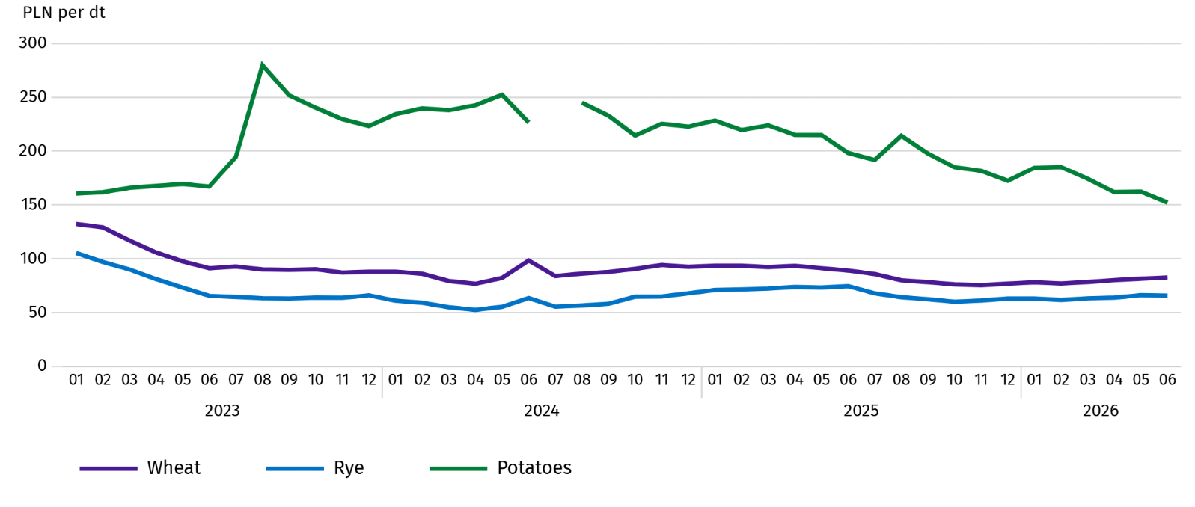
a In July 2024, the price of late edible potatoes was not recorded due to their absence at the time of observations.
In June 2026, the average procurement price of potatoes was PLN 89.43/dt, i.e. less by 30.8% than in the previous month and more by 0.8% than last year. At marketplaces, the average price of 1 dt of potatoes was PLN 152.11 and was 6.3% lower than in the previous month, and lower by 23.3% than in the previous year.
Chart 7. Average procurement prices of animals for slaughter and milk
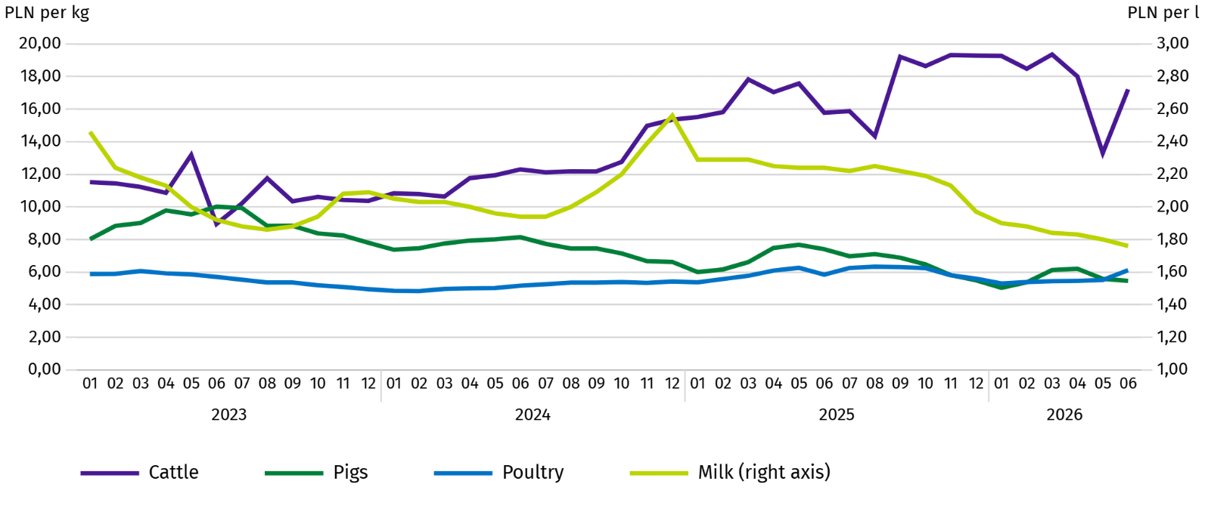
In June 2026, the average procurement price of pigs for slaughter was lower by 2.0% than in the previous month, and by 26.1% than In the previous year.
Chart 8. Ratio of the average procurement prices of pigs for slaughter to the average marketplace prices of rye
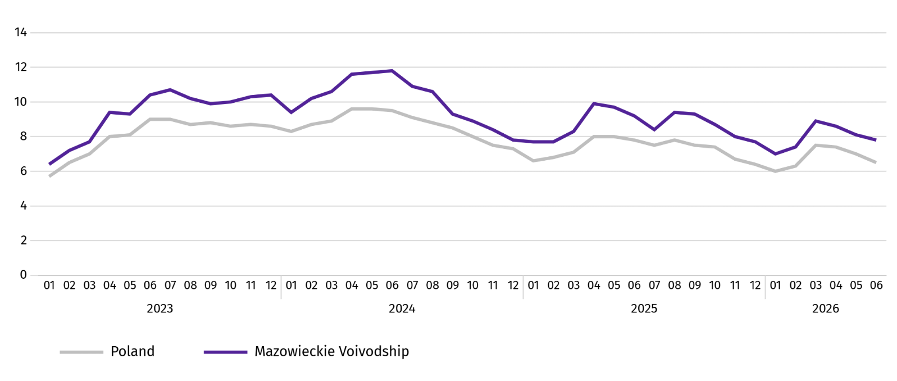
In June this year, the average procurement price of cattle for slaughter was by 29.4% higher than in the previous month and by 9.1% than in the previous year.
In June 2026, suppliers paid an average of PLN 6.11 per 1 kg of poultry for slaughter, i.e. 10.7% more than in May 2026 and 4.6% less than in June 2025.
Procurement prices of milk in June this year were by 2.6% lower than in the previous month and by 21.7% than in the previous year.

Industry and construction
Sold production of industry in June this year, reached the value (at current prices) of 44362.2 million and was (at constant prices) by 7.3% higher than a year before (compared to a 9.9% increase in May this year); as compared to the previous month it decreased by 4.6%.
Sold production in manufacturing (constituting 88.1% of sold production of industry) compared to June last year increased (at constant prices) by 7.0%. There was also an increase (by 11.2%) in sold production in the section of electricity, gas, steam and air conditioning supply (the share of this section represents 9.2% of industrial production).
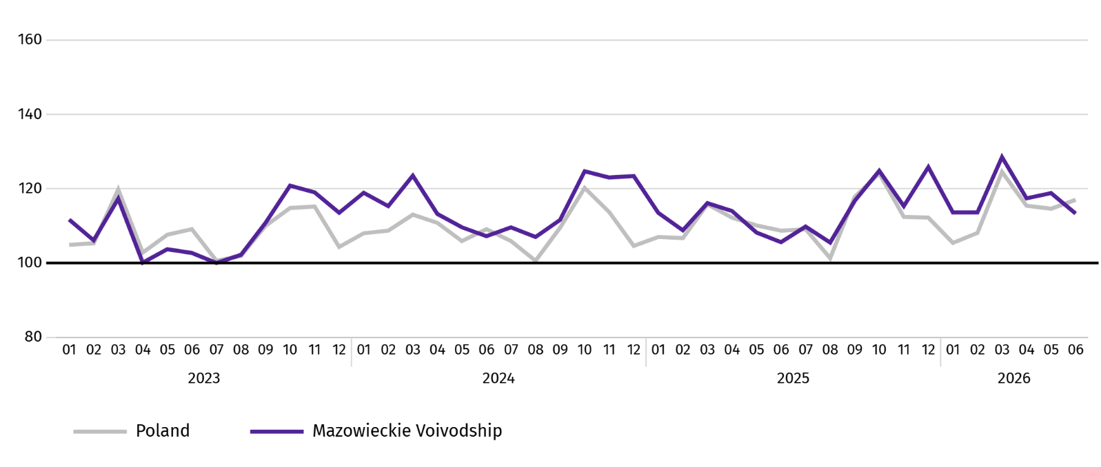
Chart 9. Sold production of industry (monthly average 2021=100; constant prices)

In June of this year, the increase in sold production in annual terms was recorded in 25 (out of 32 in the Voivodship) divisions of industry, among others, in: manufacture of beverages (by 44.2%), food products (by 17.2%), rubber and plastic products (by 14.9%), computer, electronic and optical equipment (by 5.9%), paper and paper products. (by 4.9%), basic metals and chemicals and chemical products (by 3.5% each), other non-metalic mineral products (by 1.0%). However, there was a decrease in sold production of, among others, machinery and equipment n.e.c. (by 9.7%), electrical equipment (by 8.6%).
Table 8. Indices (constant prices) and structure (current prices) of sold production of industry in June 2026
SPECIFICATION | 06 2026 | 01–06 2026
SPECIFICATION | corresponding period of previous year=100 |  | In percent
TOTAL | 107,3 | 106,0 | 100,0
of which:
Manufacturing | 107,0 | 105,8 | 86,4
of which manufacture of:
food products | 117,2 | 118,8 | 20,9
beverages | 144,2 | 137,3 | 2,4
paper and paper products | 104,9 | 95,6 | 1,8
chemicals and chemical products | 103,5 | 102,9 | 3,9
manufacture of rubber and plastic products | 114,9 | 110,1 | 3,1
other non-metallic mineral products | 101,0 | 95,7 | 2,2
metal products ^{Δ} | 103,5 | 98,7 | 3,5
computer, electronic and optical equipment | 105,9 | 101,4 | 4,7
electrical equipment | 91,4 | 89,4 | 3,6
machinery and equipment n.e.c. | 90,3 | 108,3 | 2,0
Electricity, gas, steam and air conditioning supply ^{Δ} | 111,2 | 107,2 | 11,0
Labour productivity in industry measured by sold production per employed person, in June this year amounted (at current prices) to PLN 111.5 thousand and was (at constant prices) by 5.5% higher than a year before, with a increase in average paid employment by 1.8% and an increase in average monthly gross wages and salaries by 8.7%.
In the January-June period of this year, sold production of industry amounted to PLN 275458.9 million (at current prices) and was (at constant prices) 6.0% higher than in the same period of the previous year.
Sold production of construction (at current prices) in June this year, reached the value of PLN 10993.9 million and was by 2.4% higher than in the previous year (compared to a 9.4% decrease in May this year). In January-June this year, sold production of construction amounted to PLN 53242.7 million and was 9.3% lower compared to the corresponding period of previous year.
Labour productivity in construction, measured by revenue from the sale of goods and services per employed person in June this year amounted to PLN 117.0 thousand (at current prices) and was by 2.0% higher compared to the corresponding month of the previous year, with an increase in average employment in construction by 0.4% and in average monthly gross wages and salaries by 5.2%.
Construction and assembly production (at current prices) in June this year, amounted to PLN 3175.7 million and was by 17.5% higher than a year before (as compared to 11.6% increase in May this year). The increase in production was recorded in units specialising in civil engineering (by 39.4%), in enterprises mainly performing specialised construction activities (by 9.1%). The decrease was recorded in entities whose basic activity is the construction of buildings (by 3.3%). In January-June of this year, construction and assembly production amounted to PLN 14189.1 million and was by 1.0% lower compared to the corresponding period of previous year.
Table 9. Indices and structure (current prices) of construction and assembly production in June 2026
SPECIFICATION | 06 2026 | 01–06 2026
SPECIFICATION | corresponding period of previous year=100 |  | in percent
TOTAL | 117,5 | 99,0 | 100,0
Construction of buildings ^{Δ} | 96,7 | 101,2 | 31,1
Civil engineering | 139,4 | 99,4 | 43,7
Specialised construction activities | 109,1 | 95,9 | 25,2

Residential construction
In June this year, the number of dwellings completed increased by 13.9% compared to the corresponding month of 2025. The number of dwellings for which permits have been granted or which have been registered with a construction project increased by 86.1%, and dwellings in which construction has begun by 40.9%.
According to preliminary data in June this year, there were 3922 dwellings completed, i.e. by 480 more (by 13.9%) than in the previous year and by 1133 (by 40.6%) than in the previous month. There were 2779 dwellings built for sale or rent (70.9% of their total number), followed by private dwellings 808 (20.6%). Compared to June last year, there were more dwellings for sale or rent by 2.5%, and private dwellings by 10.7%.
The effects of housing construction obtained in Mazowieckie Voivodship in the surveyed month constituted 21.0% of national effects.
Table 10. Number of dwellings completed in January-June 2026
SPECIFICATION | Dwellings completed |  |  | Average useful floor area of a dwelling in m²
SPECIFICATION | In absolute numbers | In percent | 01–06 2025=100 | Average useful floor area of a dwelling in m²
TOTAL | 18883 | 100,0 | 96,4 | 88,3
Private | 5148 | 27,3 | 106,5 | 145,9
Cooperative | 5 | 0,0 | 3,6 | 58,8
For sale or rent | 13253 | 70,2 | 91,9 | 67,6
Public building society | 90 | 0,5 | 100,0 | 49,1
Company | 287 | 1,5 | 270,8 | 46,7
Private | 100 | 0,5 | . | 35,8

Chart 10. Dwellings completed (corresponding period 2021=100)
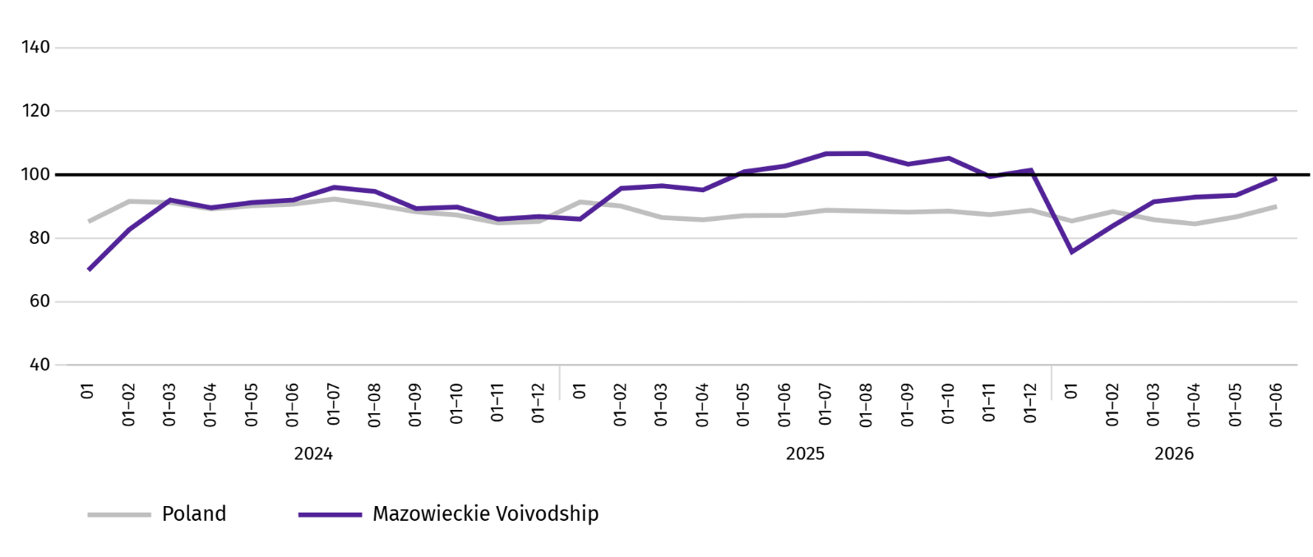
In January-June this year, most dwellings were completed in Warszawa (6867), and then in piaseczyński (1122), and wołomiński (1071), and the least in Ostrołęka (19), łosicki and żuromiński (22) and lipski (26) powiats.
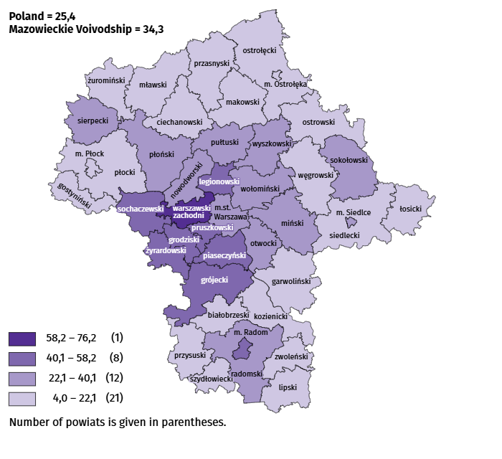
Map 2. Dwellings completed per 10 thousand populationª by powiats in January–June 2026

a Population as of 31 December 2025.
The average useful floor area of dwellings completed in June this year amounted to 83.0 m² and was larger than a year earlier by 4.2 m². The largest dwellings were completed in Siedlce (273.4 m²), and in garwoliński (211.0 m²) and szydłowiecki (164.4 m²) powiats.
In June this year, the number of dwellings for which permits have been granted or which have been registered with a construction project amounted to 5687, i.e. larger by 2631 (by 86.1%) than a year earlier and by 2170 (by 61.7%) than in the previous month. Of the total number of dwellings, 75.3% were dwellings for sale or rent, and 23.9% private.
In the surveyed month, the construction began in 4262 dwellings, which means an increase by 1238 (by 40.9%) in annual terms and by 384 (by 8.3%) in monthly terms. Dwellings for sale or rent accounted for 71.5% of their total number, and private 26.5%.
Table 11. Number of dwellings for which permits have been granted or which have been registered with a construction project as well as dwelling in which construction has begun in January–June 2026
SPECIFICATION | Dwellings for which permits have been granted or which have been registered with |  |  | Dwellings in which construction has begun
SPECIFICATION | in absolute numbers | in percent | 01–06 2025=100 | in absolute numbers | in percent | 01–06 2025=100
TOTAL | 25683 | 100,0 | 117,4 | 21804 | 100,0 | 99,1
Private | 7334 | 28,6 | 111,4 | 6117 | 28,1 | 101,3
Cooperative | – | – | . | 30 | 0,1 | .
For sale or rent | 18105 | 70,5 | 120,0 | 15603 | 71,6 | 98,3
Municipal | 123 | 0,5 | 279,5 | – | – | .
Public building society | 121 | 0,5 | 89,6 | 54 | 0,2 | 70,1

Internal market
In June this year, both retail and wholesale sales were higher than in the previous year.
Retail sales (at current prices) in trade and non-trade enterprises in June this year, increased by 12.9% compared to the year before. The increase in sales was recorded in units from the group: “pharmaceuticals, cosmetics, orthopedic equipment” (by 17.4%), „others” (by 11.0%), „newspapers, books, other sales in specialised stores” (by 7.2%), “furniture, electronics and household appliances” (by 6.5%), “motor vehicles, motorcycles, parts” (by 6.2%), “other retail sales in non-specialised stores” (by 5.9%). The decrease in sales was recorded in units from the group: „food, beverages and tobacco” (by 2.4%).
Compared to May this year, retail sales decreased by 0.6%. The decrease in sales was recorded, among others, in the group: „pharmaceuticals, cosmetics, orthopedic equipment” (by 7.2%). The largest increase in sales was recorded in, among others, units from the group: „others” (by 5.7%), “textiles, clothing and footwear” (by 5.1%), “other retail sales in non-specialised stores” (by 4.0%).
Table 12. Indices and structure (at current prices) of retail sales in June 2026
SPECIFICATION | 06 2026 | 01–06 2026
SPECIFICATION | corresponding period of previous year=100 |  | in percent
TOTAL ª | 112,9 | 110,4 | 100,0
of which:
Motor vehicles, motorcycles, parts | 106,2 | 106,6 | 6,9
Food, beverages and tobacco | 97,6 | 95,6 | 12,6
Other retail sales in non-specialised stores | 105,9 | 111,3 | 3,6
a The grouping of enterprises was made on the basis of the Polish Classification of Activities - PKD 2007, including the enterprise to a specific category according to the type of predominant activity, in accordance with the organizational status in the period under consideration. The recorded changes (increase/decrease) in retail sales in particular groups of activity of enterprises may also result from changes in the type of predominant economic activity and organisational changes (e.g. mergers of enterprises). This does not affect the dynamics of retail sales in general.
Table 12. Indices and structure (at current prices) of retail sales in June 2026 (cont.)
SPECIFICATION | 06 2026 | 01–06 2026
SPECIFICATION | corresponding period of previous year=100 |  | in percent
Pharmaceuticals, cosmetics and orthopedic equipment | 117,4 | 120,0 | 5,3
Textiles, clothing and footwear | 102,5 | 102,9 | 5,3
Furniture, electronics and household appliances | 106,5 | 99,2 | 15,9
Newspapers, books, other sales in specialised stores | 107,2 | 99,2 | 6,6
Others | 111,0 | 106,2 | 8,8
In January-June 2026, retail sales increased by 10.4% year-on-year. The increase in sales was recorded by, among others, enterprises from the group: „pharmaceuticals, cosmetics and orthopedic equipment” (by 20.0%), "other retail sales in non-specialised stores" group (by 11.3%), „motor vehicles, motorcycles, parts” (by 6.6%), while the largest sales decline was recorded by enterprises from the group: „food, beverages and tobacco” (by 4.4%).
Wholesale (at current prices) in trade enterprises in June this year was by 9.0% higher as compared to the previous month and by 28.8% higher compared to June 2025. In wholesale enterprises it was higher by 7.1% and by 19.1%, respectively.
In January-June 2026, trade enterprises achieved wholesale that was 19.3% higher than a year ago, and wholesale enterprises achieved wholesale that was 14.6% higher.

Entities of the national economy
In June this year, the number of national economy entities entered into the REGON register increased by 0.3% compared to the previous month. There were more entities with suspended activity as well as newly registered entities (by 4.5% and 1.0%, respectively) than a month ago. Whereas there were fewer entities removed from the register (a decrease of 3.9%).
As of the end of June this year, 1106580 entities of the national economy were registered in the REGON register, i.e. by 3.3% more than last year and by 0.3% than in the previous month.
In the total number of registered entities, the greatest number is natural persons conducting economic activity. At the end of June this year, there were 711615 of them, i.e. more by 3.0% than in the previous year. The number of companies which were registered in the REGON register amounted to 312564, including 252683 commercial companies (an annual increase by 3.8% and 4.7%, respectively). There were 59418 civil partnerships i.e. more by 0.1% compared to the previous year.
According to the expected number of employed persons, entities that declared employment of up to 9 persons pre-vailed upon entry in the REGON register; they constituted 97.4% of all registered units. The share of entities with an estimated number of 10-49 employed persons was 2.1%, and of entities employing more than 49 persons – 0.5%. Over the year, the increase in the number of entities occurred among the smallest entities (up to 9 persons) – by 3.4%.
Compared to June 2025, the largest increase in the number of entities was recorded in the sections: professional, scientific and technical activities – more by 6807 units (in percentage terms, an increase of 4.1%), administrative and support service activities – by 5548 units (an increase of 10.3%), information and communication – by 5174 (an increase of 5.1%).
Compared to May this year, the largest increase in the number of entities was recorded in the sections: administrative and support service activities (by 1.0%), construction, information and communication, financial and insurance activities real estate activities, professional, scientific and technical activities, human health and social work activities (by 0.4% each).
Chart 11. Entities of the national economy newly registered and removed from the register in May 2026
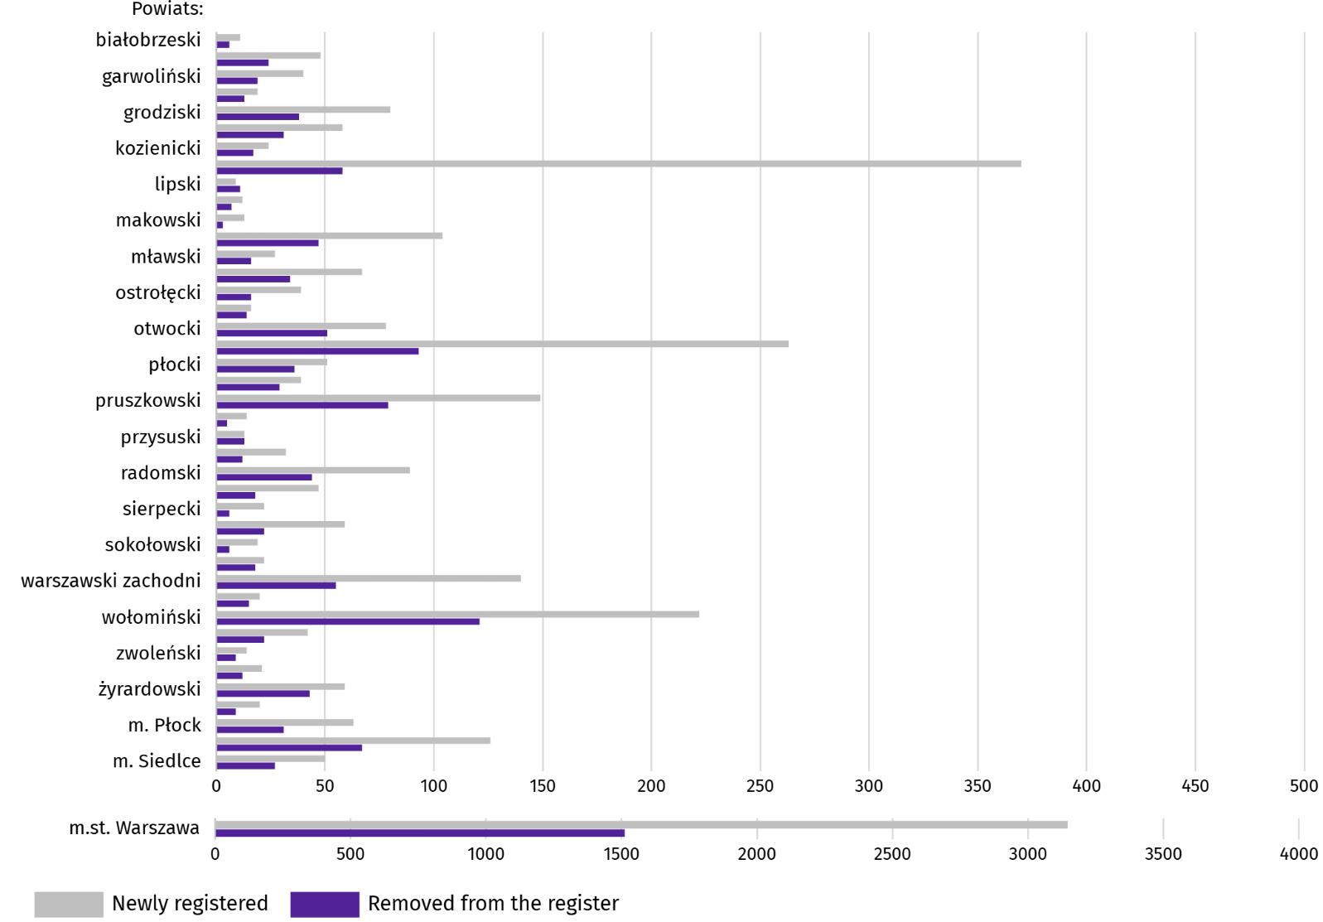
In June this year, 5757 new entities were entered in the REGON register, i.e. by 4.5% more than in the previous month. The newly registered units were dominated by natural persons conducting economic activity, 3662 of whom were registered (by 2.2% less than in the previous month). The number of newly registered commercial companies was larger by 15.8%, including companies with limited liability by 16.3%.
In the surveyed month, 2709 entities were removed from the REGON register (by 3.9% less than a month ago), including 2026 natural persons conducting economic activity (by 5.1% less).
As of the end of June this year, there were 154566 entities in the REGON with suspended activity (by 1.0% more than a month ago). The vast majority were natural persons conducting economic activity (93.7%; the same as in the previous month).
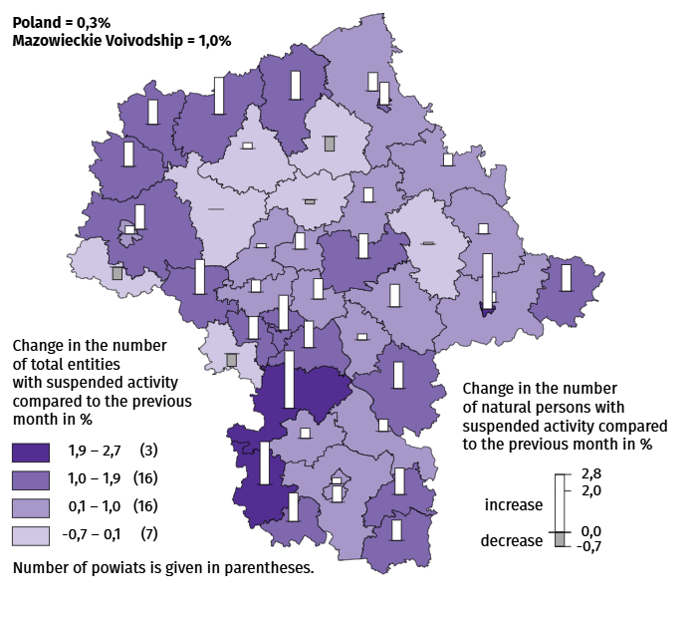
Map 3. Entities of the national economy with suspended activity in June 2026

Business tendency
In July of this year, the general business climate indicator across all surveyed economic sectors points to a stabilisation or improvement in business conditions compared to the previous month. The largest increase in the indicator (11.1 points) was recorded in the accommodation and catering section, while significant improvement was also observed in retail trade (an increase of 2.1 points). In the remaining sectors, business sentiment remained at levels similar to those of the previous month. Across all surveyed economic sectors, the outlook regarding business conditions is positive. The most optimistic assessments come from entities in the accommodation and catering section (+31.3), with the indicator value exceeding the long-term average (+1.4).

Chart 12. Indices of the general business climate by type of activity (sections and divisions of NACE Rev. 2)
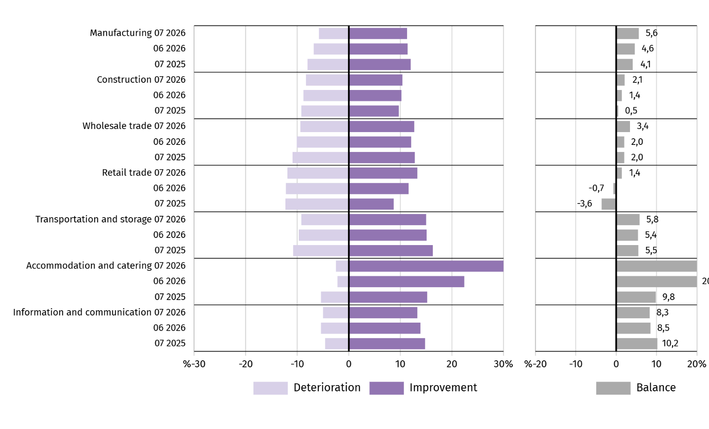
Questions about the impact of the war in Ukraine
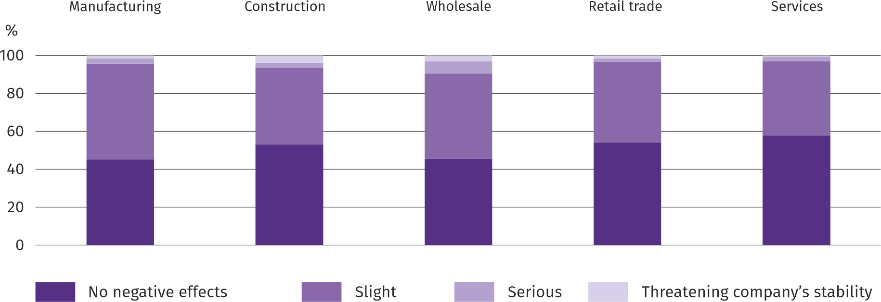
Question 1. The negative effects of the war in Ukraine and its consequences for the economic activities of your company will be this month:

Across all the economic sectors surveyed, the prevailing view among entrepreneurs was that the ongoing war had caused no negative effects in July of this year, or posed only a minor threat to their business operations. Entrepreneurs in the wholesale trade section were the most likely to experience serious consequences threatening their company's stability, while those in the services section were the least likely to do so.

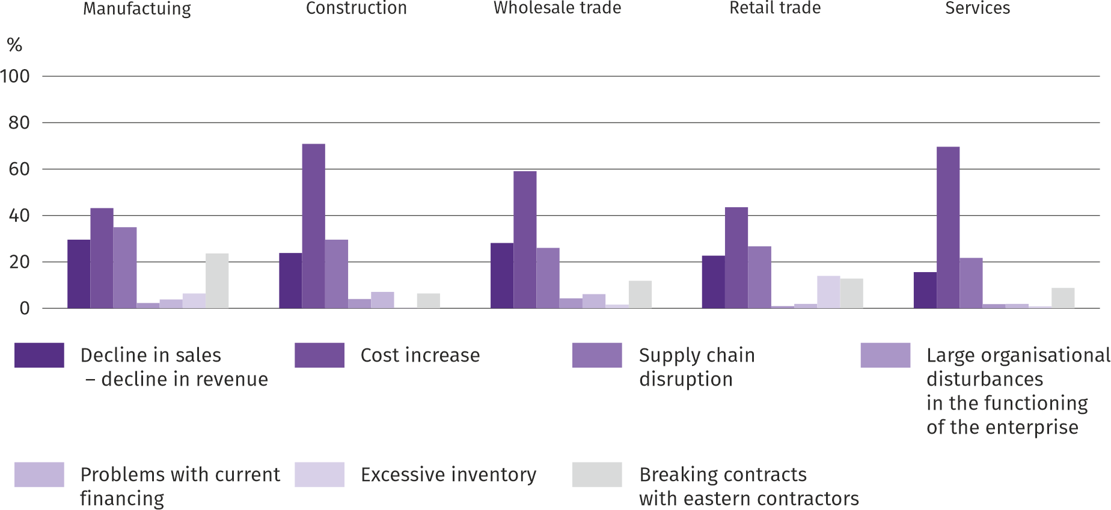
Question 2. Of the negative effects of the war in Ukraine observed last month, the ones that most concern your company are:

Entrepreneurs, regardless of the type of business, considered the most significant negative effect of the war in Ukraine to be an increase in costs, followed by a drop in sales/revenue in wholesale trade, and disruptions in the supply chain in the remaining surveyed sections.
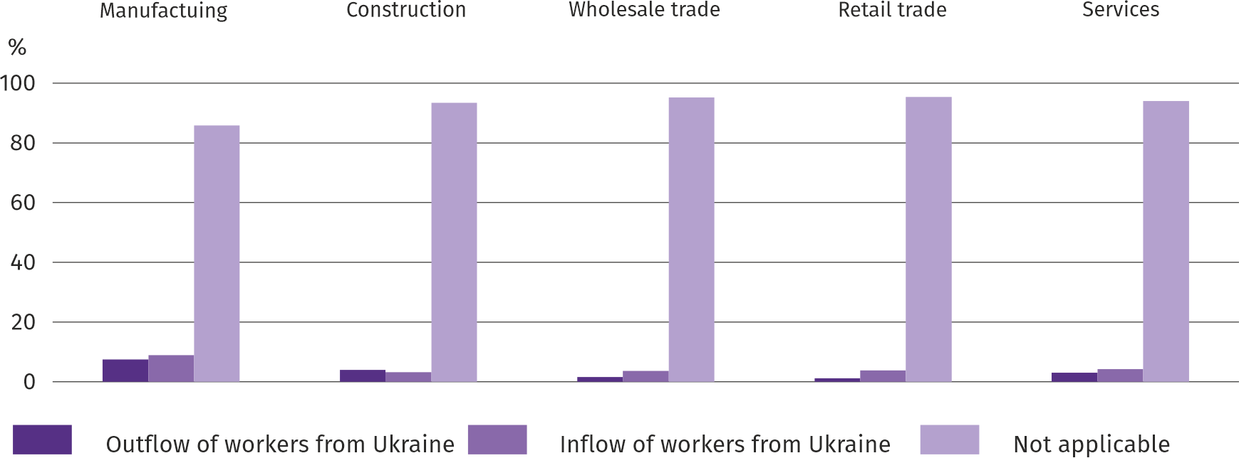
Question 3. If your company employs workers from Ukraine, have you observed the following over the past month in connection with the war in Ukraine :

In July of this year, an outflow and inflow of workers from Ukraine due to the ongoing war were observed across all surveyed sectors; however, the vast majority of companies are unaffected by this phenomenon. Both the outflow and inflow of workers were most frequently reported in manufacturing, while the outflow was least common in retail trade and the inflow in construction.

Questions about pricing processes
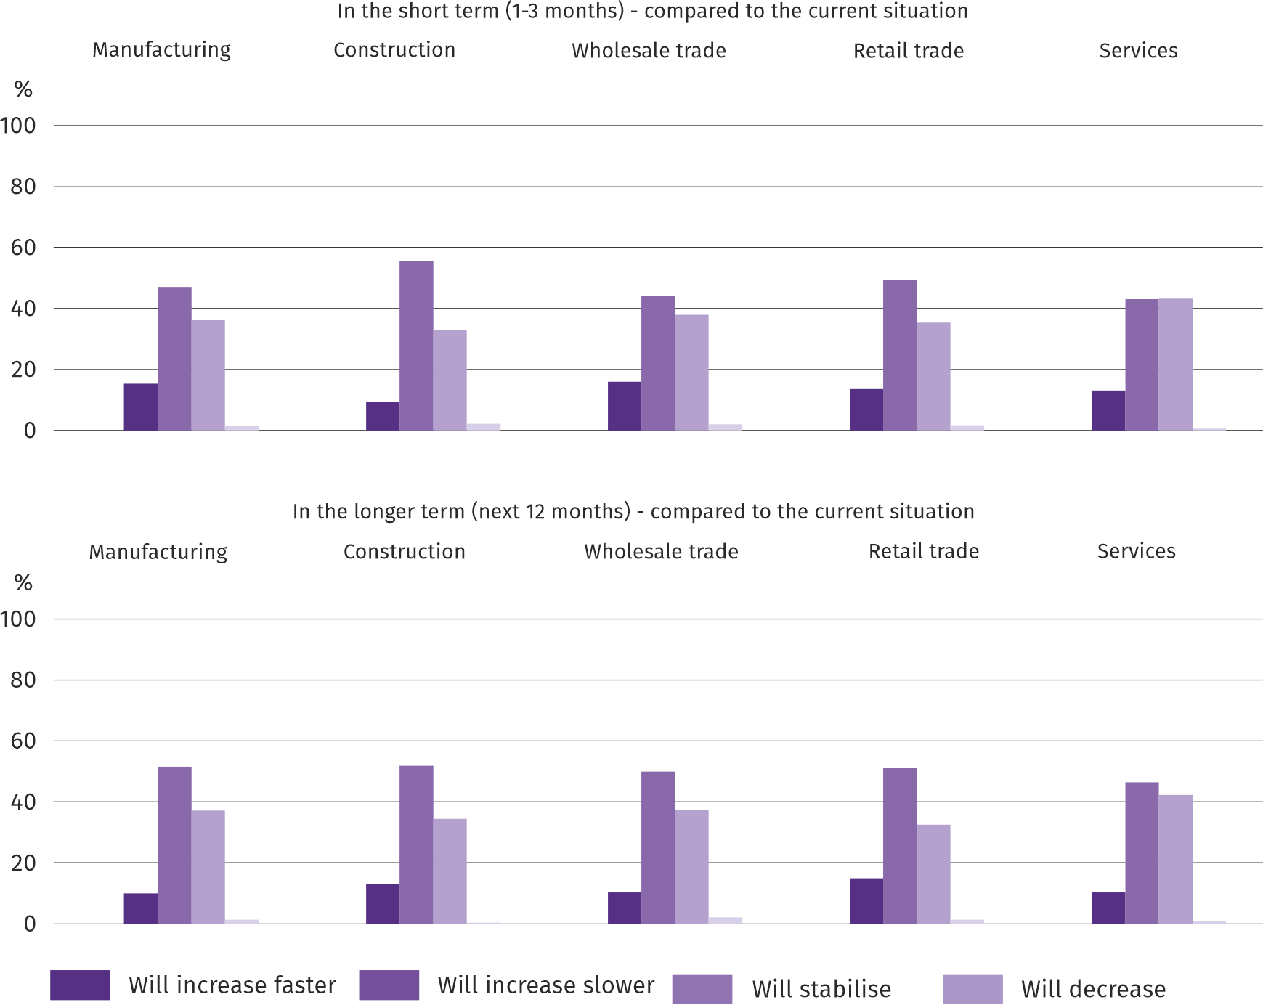
Question 4. How do you expect the prices of services, materials, and raw materials used by your company in its business operations to evolve?

In most of the surveyed types of economic activity, entrepreneurs believed that in the short term (1-3 months) the price increase would be slower than currently, only in services there were the most opinions that prices would stabilise. Anticipating the situation in the longer term (the next 12 months), regardless of the type of business, most entrepreneurs expressed the opinion that prices will grow slower than currently

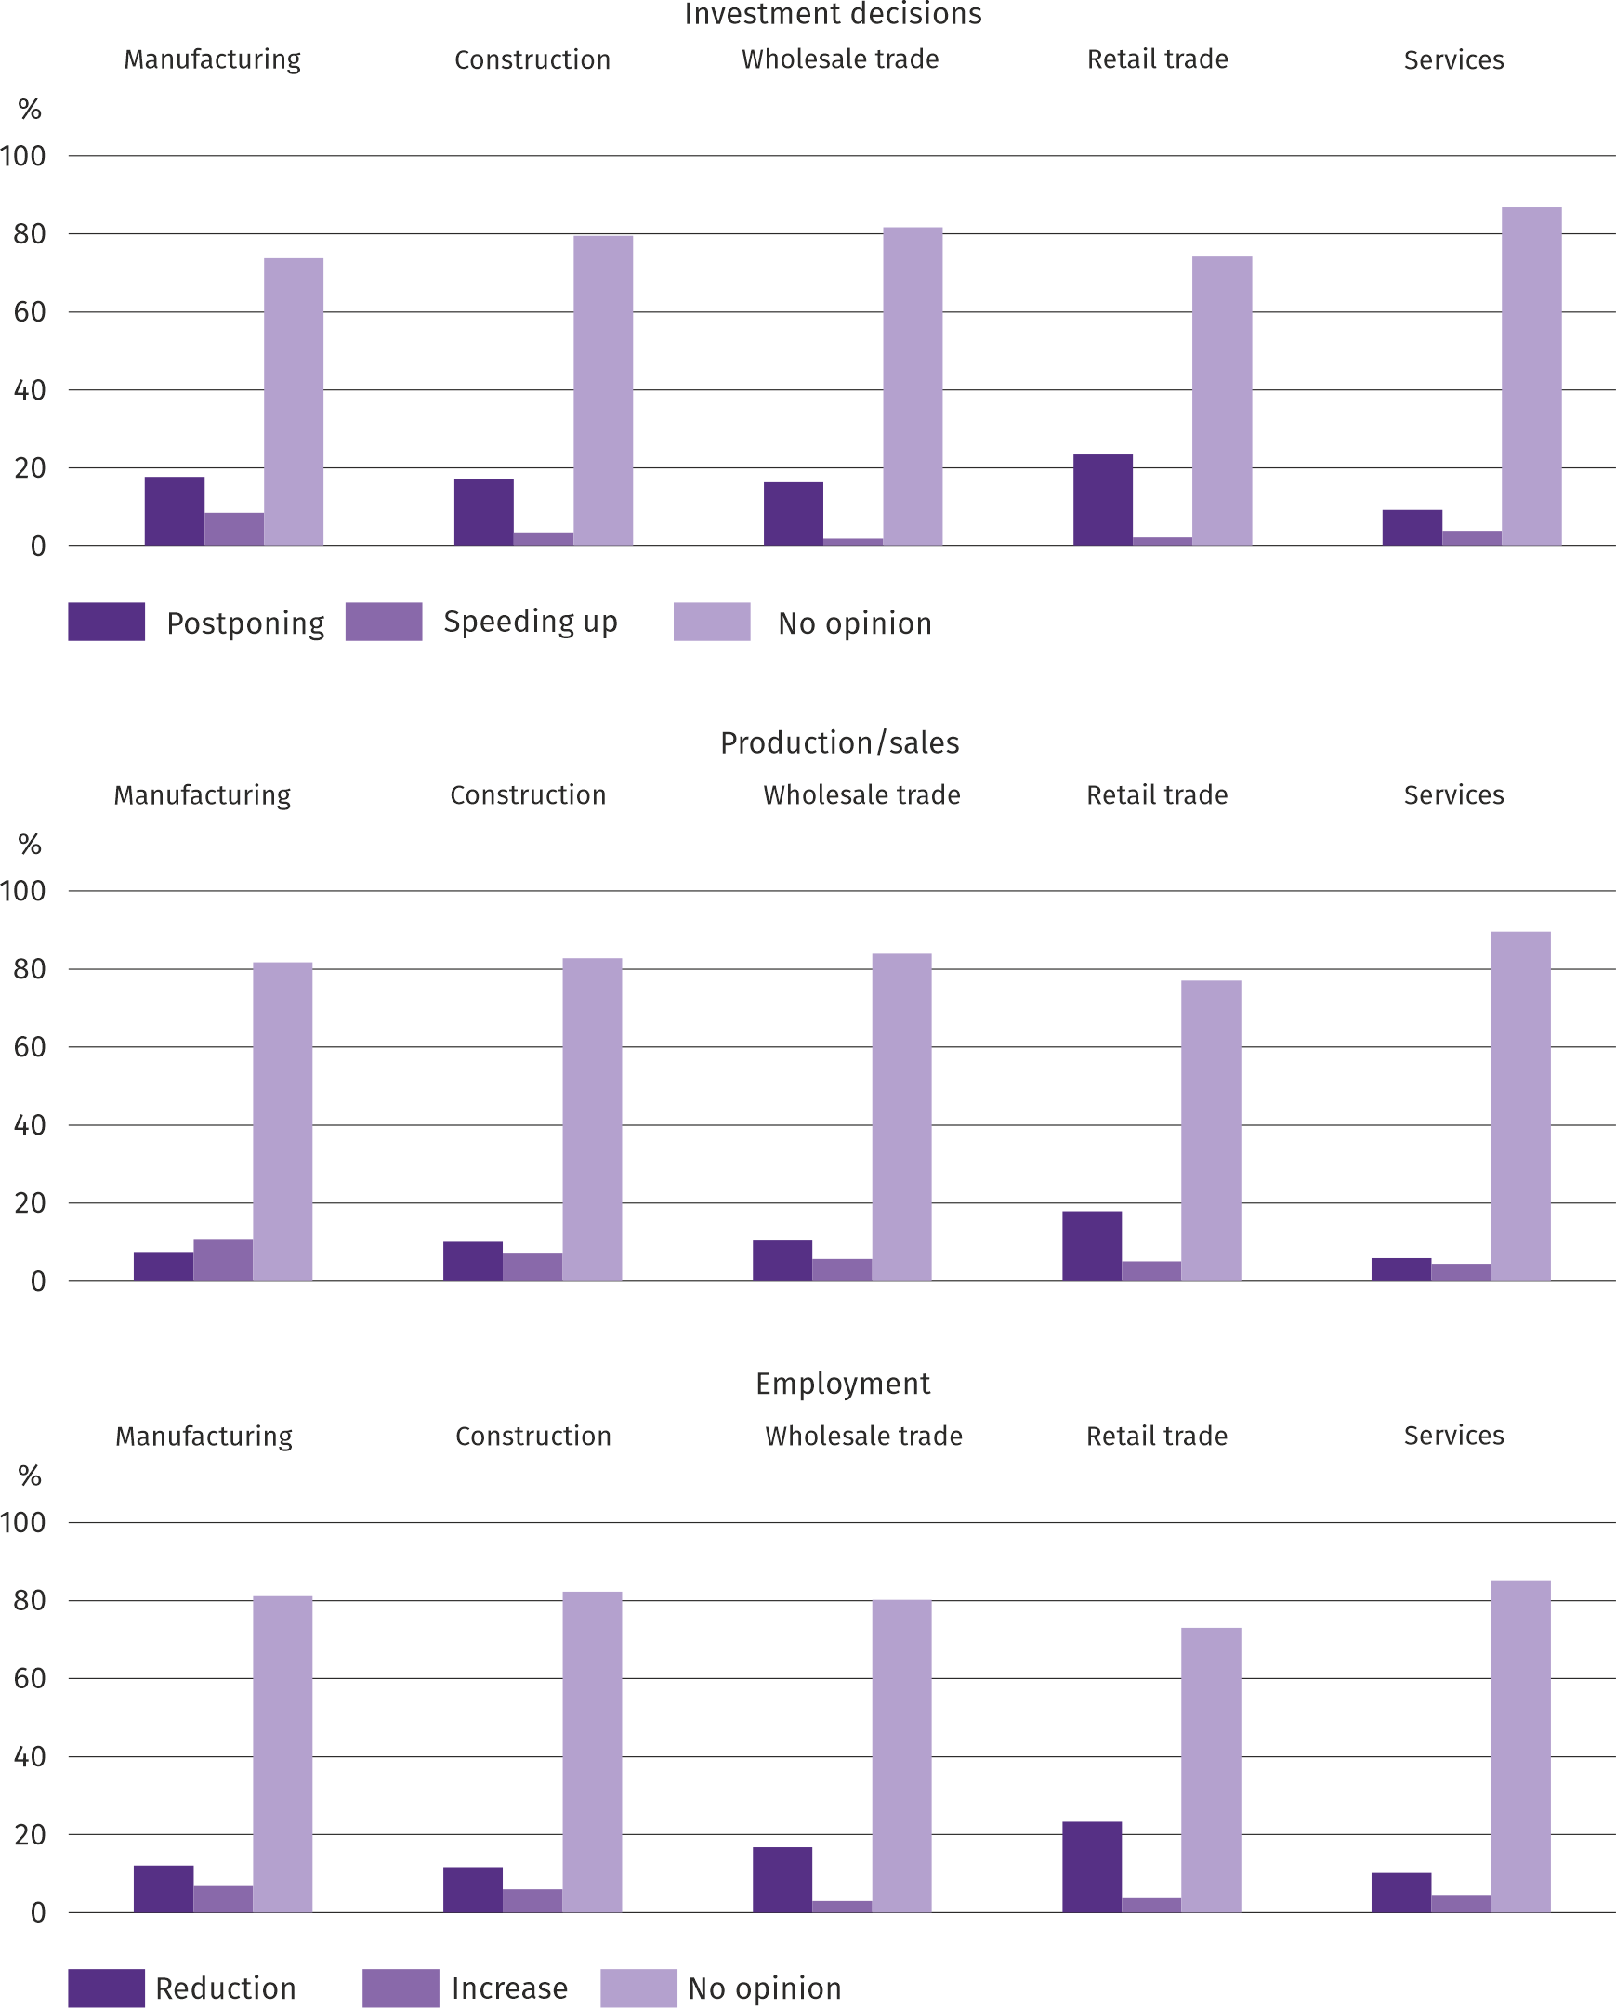
Question 5. Which of the following factors will have the greatest impact on the operating costs of your company in the next quarter?

Entrepreneurs in all surveyed types of activity considered the prices of energy and fuels and employment costs to be the factors having the greatest impact on the increase in the company's operating costs, and in manufacturing, in addition to the prices of energy and fuels, the prices of components and services were mentioned. The factors that have the greatest impact on the decline in costs in all industries include financing costs (credits, loans, etc.), and most of them - prices of direct imports, and in manufacturing - prices of rent, premises, etc.

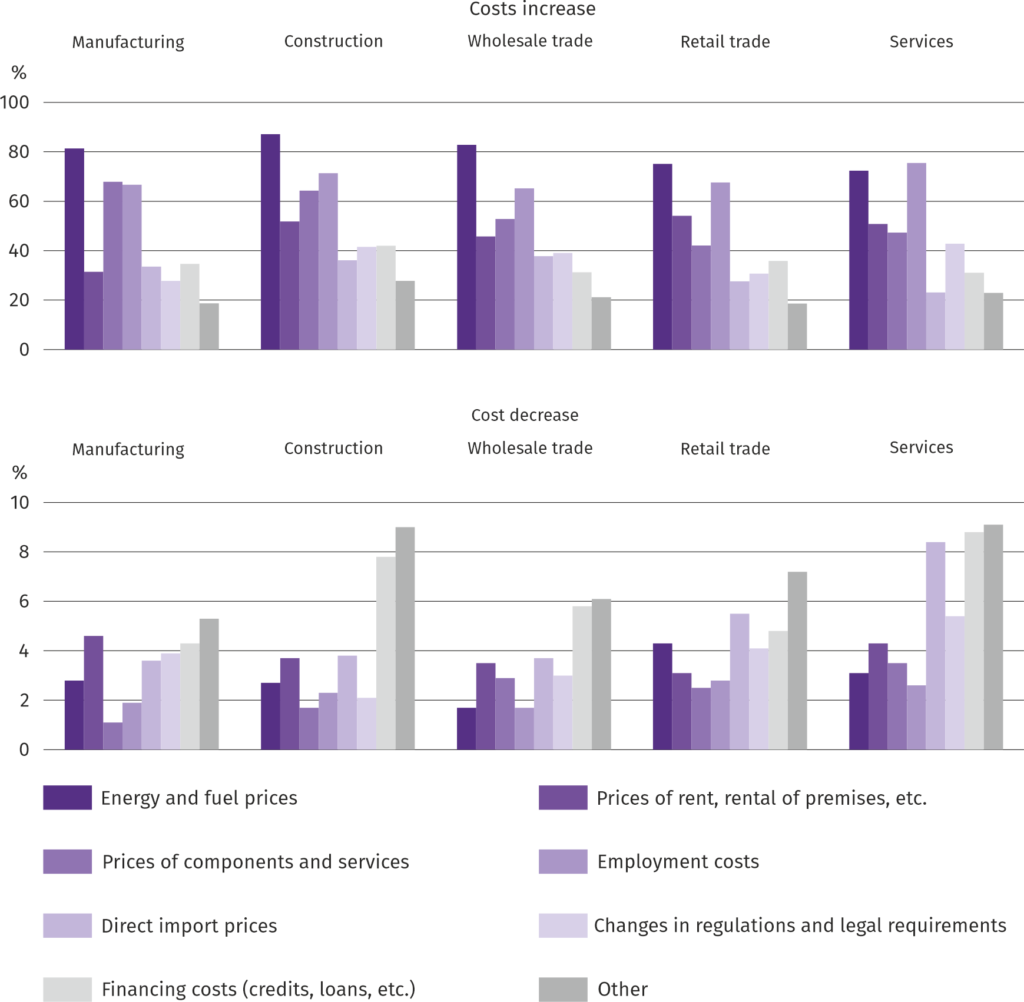
Question 6. Will the observed and expected changes in the company's financing conditions (costs of bank loans and their availability, trade credit, deferred payments, etc.) result, in the next 12 months, in the event of:

The answers to the questions about how the observed and expected changes in the company's financing conditions over the next 12 months will affect investment decisions, production/sales and employment indicate that it was difficult for entrepreneurs to assess this impact – the vast majority of respondents always had no opinion on this subject. Those who expressed their opinion mostly expected postponement of investments, reduction of production/sales and employment rather than growth in the mentioned areas of activity.
More information on the results of the business climate survey can be found on the website of the Statistical Office in Zielona Góra https://zielonagora.stat.gov.pl/osrodki/osrodek-badan-koniunktury/obk-dane/.

Table 13. Selected data on Mazowieckie Voivodship
SPECIFICATION  A – 2025  B – 2026 |  | 01 | 02 | 03 | 04 | 05 | 06 | 07 | 08 | 09 | 10 | 11 | 12
Average employment in the enterprise sector ª  (in thousand persons) | A | 1582,5 | 1577,9 | 1572,7 | 1574,8 | 1570,6 | 1572,8 | 1574,1 | 1572,8 | 1571,5 | 1567,2 | 1570,8 | 1575,1
 | B | 1576,5 | 1573,2 | 1569,5 | 1569,5 | 1564,0 | 1565,0
previous month=100 | A | 99,9 | 99,7 | 99,7 | 100,1 | 99,7 | 100,1 | 100,1 | 99,9 | 99,9 | 99,7 | 100,2 | 100,3
previous month=100 | B | 100,1 | 99,8 | 99,8 | 100,0 | 99,7 | 100,1
corresponding month of previous year=100 | A | 98,5 | 98,5 | 98,4 | 98,8 | 98,7 | 99,0 | 99,0 | 99,2 | 99,2 | 99,2 | 99,3 | 99,4
corresponding month of previous year=100 | B | 99,6 | 99,7 | 99,8 | 99,7 | 99,6 | 99,5
Registered unemployed persons (in thousand persons; as of end of period) | A | 114,7 | 115,9 | 113,9 | 111,3 | 108,7 | 111,0 | 116,0 | 120,2 | 119,6 | 118,7 | 118,1 | 118,2
 | B | 122,6 | 124,9 | 124,7 | 124,0 | 122,8 | 121,5
Unemployment rate b (in %; as of end of period) | A | 4,2 | 4,2 | 4,2 | 4,1 | 4,0 | 4,0 | 4,2 | 4,4 | 4,4 | 4,3 | 4,3 | 4,3
Unemployment rate b (in %; as of end of period) | B | 4,5 | 4,5 | 4,5 | 4,5 | 4,5 | 4,4
Job offers (submitted during a month) | A | 15760 | 13938 | 14768 | 13164 | 11459 | 4235 | 5656 | 4432 | 5028 | 4975 | 3612 | 2876
Job offers (submitted during a month) | B | 3327 | 4023 | 5549 | 4346 | 3824 | 3836
Unemployed persons per 1 job offer (as of end of period) | A | 16 | 17 | 15 | 16 | 21 | 28 | 24 | 30 | 29 | 27 | 30 | 42
Unemployed persons per 1 job offer (as of end of period) | B | 39 | 36 | 27 | 27 | 26 | 27
Average monthly gross wages and salaries in the en-terprise sector ª (in PLN) | A | 9739,87 | 10004,89 | 10785,77 | 10612,28 | 9995,20 | 10173,45 | 10185,77 | 10100,98 | 9974,07 | 10141,45 | 10285,58 | 10933,28
 | B | 10345,31 | 10618,33 | 11502,04 | 11174,84 | 10588,61 | 10833,56
previous month=100 | A | 98,1 | 102,7 | 107,8 | 98,4 | 94,2 | 101,8 | 100,1 | 99,2 | 98,7 | 101,7 | 101,4 | 106,3
previous month=100 | B | 94,6 | 102,6 | 108,3 | 97,2 | 94,8 | 102,3
corresponding month of previous year=100 | A | 108,9 | 109,2 | 108,4 | 110,9 | 109,2 | 109,4 | 107,7 | 106,9 | 108,0 | 105,3 | 108,5 | 110,1
corresponding month of previous year=100 | B | 106,2 | 106,1 | 106,6 | 105,3 | 105,9 | 106,5
Price indices:
consumer goods and services ^{c}:
corresponding month of previous year=100 | A | . | . | 104,7 | . | . | 103,7 | . | . | 102,6 | . | . | 102,3
corresponding month of previous year=100 | B | . | . | . | . | . | .
a In enterprises employing more than 9 persons. b Share of registered unemployed persons in civilian economically active population, estimated at the end of each month. c From 1 June 2025, data on job offers are not fully comparable with earlier periods due to methodological changes resulting from the entry into force of the Act on the LaboUr Market and Employment Services (Journal of Laws of 2025, item 620). D In the quarter.
Table 13. Selected data on Mazowieckie Voivodship (cont.)
SPECIFICATION  A – 2025  B – 2026 |  | 01 | 02 | 03 | 04 | 05 | 06 | 07 | 08 | 09 | 10 | 11 | 12
Price indices (cont.):
Procurement of cereal grain:
previous month=100 | A | 102,5 | 100,3 | 98,5 | 102,4 | 98,1 | 97,1 | 94,2 | 93,1 | 99,4 | 97,5 | 100,0 | 101,6
previous month=100 | B | 100,9 | 99,2 | 101,9 | 101,8 | 100,6 | 100,7
corresponding month of previous year=100 | A | 106,6 | 109,4 | 116,0 | 125,8 | 115,7 | 94,0 | 108,0 | 93,8 | 92,9 | 85,7 | 81,9 | 85,4
corresponding month of previous year=100 | B | 84,1 | 83,2 | 86,0 | 85,5 | 87,6 | 90,9
procurement of cattle for slaughter (excluding calves):
previous month=100 | A | 101,0 | 102,0 | 112,7 | 95,6 | 103,1 | 89,8 | 100,6 | 90,3 | 134,0 | 97,0 | 103,7 | 99,8
previous month=100 | B | 99,9 | 95,9 | 104,7 | 93,0 | 73,9 | 129,4
corresponding month of previous year=100 | A | 143,3 | 146,7 | 167,6 | 144,9 | 147,2 | 128,3 | 130,9 | 117,7 | 157,8 | 146,1 | 129,1 | 125,6
corresponding month of previous year=100 | B | 124,2 | 116,8 | 108,6 | 105,6 | 75,7 | 109,1
procurement of pigs for slaughter:
previous month=100 | A | 90,7 | 102,7 | 107,4 | 113,0 | 102,6 | 96,4 | 94,3 | 101,8 | 96,9 | 94,0 | 89,8 | 94,5
previous month=100 | B | 91,5 | 106,9 | 114,0 | 101,3 | 90,0 | 98,0
corresponding month of previous year=100 | A | 81,4 | 82,6 | 85,4 | 94,3 | 95,8 | 90,9 | 90,2 | 95,5 | 92,4 | 90,6 | 87,1 | 83,0
corresponding month of previous year=100 | B | 83,8 | 87,2 | 92,6 | 82,9 | 72,7 | 73,9
Ratio of procurement prices ª of pigs for slaughter to marketplace prices of rye | A | 7,7 | 7,7 | 8,3 | 9,9 | 9,7 | 9,2 | 8,4 | 9,4 | 9,3 | 8,7 | 8,0 | 7,7
 | B | 7,0 | 7,4 | 8,9 | 8,6 | 8,1 | 7,8
Sold production of industry ^{b} (at constant prices):
previous month=100 | A | 92,0 | 95,9 | 106,7 | 98,2 | 94,9 | 97,6 | 104,0 | 96,1 | 110,6 | 106,9 | 92,4 | 109,1
previous month=100 | B | 90,3 | 100,0 | 113,1 | 91,4 | 101,2* | 95,4
corresponding month of previous year=100 | A | 95,4 | 94,3 | 93,9 | 100,6 | 98,6 | 98,4 | 100,2 | 98,6 | 104,6 | 100,2 | 93,9 | 102,1
corresponding month of previous year=100 | B | 100,2 | 104,5 | 110,7 | 103,1 | 109,9* | 107,3
Construction and assembly production b (at current prices):
previous month=100 | A | 47,2 | 107,8 | 118,8 | 106,2 | 100,8 | 106,8 | 104,8 | 89,5 | 116,9 | 104,2 | 93,7 | 149,9
previous month=100 | B | 39,4 | 99,1 | 131,3 | 110,6 | 114,7 | 112,5
corresponding month of previous year=100 | A | 141,1 | 123,2 | 130,9 | 110,6 | 109,7 | 109,3 | 116,1 | 109,4 | 112,4 | 113,0 | 103,7 | 111,0
corresponding month of previous year=100 | B | 92,6 | 85,2 | 94,1 | 98,0 | 111,6 | 117,5
a Current prices excluding VAT. b In enterprises employing more than 9 persons.

Table 13. Selected data on Mazowieckie Voivodship (cont.)
SPECIFICATION  A – 2025  B – 2026 |  | 01 | 02 | 03 | 04 | 05 | 06 | 07 | 08 | 09 | 10 | 11 | 12
Dwellings completed (from the beginning of the year) | A | 3349 | 6879 | 9681 | 12469 | 16151 | 19593 | 23700 | 27265 | 30842 | 35358 | 38969 | 45020
Dwellings completed (from the beginning of the year) | B | 2947 | 6029 | 9181 | 12172 | 14961 | 18883
corresponding month of previous year=100 | A | 123,0 | 115,8 | 104,9 | 106,2 | 110,7 | 111,6 | 111,1 | 112,7 | 115,7 | 117,2 | 115,5 | 116,9
corresponding month of previous year=100 | B | 88,0 | 87,6 | 94,8 | 97,6 | 92,6 | 96,4
Retail sales of goods ª (at current prices):
previous month=100 | A | 78,0 | 94,8 | 113,7 | 104,7 | 97,6 | 98,8 | 104,6 | 98,9 | 95,6 | 105,7 | 99,6 | 117,2
previous month=100 | B | 80,8 | 94,1 | 125,3 | 103,5 | 94,3 | 99,4
corresponding month of previous year=100 | A | 101,6 | 96,3 | 97,2 | 100,1 | 98,7 | 98,2 | 97,3 | 97,3 | 101,3 | 100,6 | 99,0 | 103,7
corresponding month of previous year=100 | B | 107,4 | 106,6 | 117,4 | 116,0 | 112,2 | 112,9
Turnover profitability indicator in enterprises ^{b}:
gross ^{c} (in %) | A | . | . | 4,6 | . | . | 4,9 | . | . | 4,9 | . | . | 5,1
gross ^{c} (in %) | B | . | . | 5,4 | . | . | .
net ^{d} (in %) | A | . | . | 3,6 | . | . | 3,9 | . | . | 4,0 | . | . | 4,2
net ^{d} (in %) | B | . | . | 4,0 | . | . | .
Investment outlays of enterprises ^{b} – from the begin-ning of the year (in million PLN; current prices) | A | . | . | 13471,2 | . | . | 31921,6 | . | . | 51529,6 | . | . | 80764,9
 | B | . | . | 14872,8 | . | . | .
corresponding month of previous year=100 (current prices) | A | . | . | 99,7 | . | . | 106,8 | . | . | 106,4 | . | . | 106,6
corresponding month of previous year=100 (current prices) | B | . | . | 110,4 | . | . | .
Entities of the national economy ^{e} in the REGON regis-ter (as of end of period) | A | 1055182 | 1057965 | 1061558 | 1064898 | 1068064 | 1071074 | 1074082 | 1077325 | 1080871 | 1084899 | 1088107 | 1089830
 | B | 1090957 | 1093881 | 1097984 | 1100753 | 1103449 | 1106580
of which commercial companies | A | 237041 | 237949 | 239071 | 240155 | 240700 | 241451 | 242422 | 243409 | 696939 | 245130 | 246088 | 247076
of which commercial companies | B | 247914 | 248761 | 249824 | 250982 | 251735 | 252683
Dwellings completed (from the beginning of the year) | A | 42461 | 42567 | 42726 | 42857 | 42903 | 43009 | 43119 | 43266 | 43348 | 43446 | 43570 | 43665
Dwellings completed (from the beginning of the year) | B | 43657 | 43697 | 43742 | 43895 | 43977 | 44136
a In enterprises employing more than 9 persons. b In enterprises employing more than 49 persons. c Relation of gross financial result to revenues from total activity. d Relation of net financial result to revenues from total activity. e Excluding persons tending private farms in agriculture.
Prepared by:  Statistical Office in Warszawa  Director Agnieszka Ajdyn  Phone: (+48 22) 464 23 15 | Issued by:  Statistical Information Centre  Marcin Kałuski  Mobile: (+48) 783 940 141
Press office in the Statistical Office in Warszawa  Mobile: (+48) 783 940 141  e-mail: m.kaluski@stat.gov.pl |   warszawa.new.stat.gov.pl/en/

@Warszawa_STAT

@UrzadStatystycznywWarszawie

gus_stat

glownyurzadstatystycznygus

glownyurzadstatystyczny

In the case of quoting data from the Statistics Poland, please provide information “Statistics Poland data source”, and in the case of publishing calculations made on data published by the Statistics Poland, provide information: “Own study based on Statistics Poland data”.
Related information
Statistical Bulletin of Mazowieckie Voivodship
Report on the socio-economic situation of Mazowieckie Voivodship 2025
Socio-economic situation of voivodships No. 1/2026
Data available in databases
Local Data Bank (BDL)
Knowledge Databases (DBW)
Terms used in official statistics
Average paid employment
Registered unemployed persons
Registered unemployment rate
Monthly gross wages and salaries
Retail prices
Price index of consumer goods and services
Procurement of agricultural products
Procurement prices
Marketplace prices
Pigs
Cattle
Sold production of industry
Construction and assembly production
Dwellings completed
Retail sales of goods (including VAT)
Wholesale (including VAT)
Financial results of enterprises
Investment outlays
Entities of the national economy
Business tendency

The long-term unemployed include persons who have been in the register of the powiat labor office for a total period of more than 12 months in the last 2 years, excluding periods of internship and vocational preparation.
Refers to vacancies and places of occupational activation.
The average values of temperature and precipitation were calculated as arithmetic means of the average monthly values from five hydrological and meteorological stations of the Institute of Meteorology and Water Management located in Kozienice, Mława, Płock, Siedlce and Warszawa.
Registration data – may change after the quarterly reports are prepared.
It applies to legal persons, organisational units without legal personality and natural persons conducting economic activity (excluding natural persons tending private farms in agriculture).
The survey was conducted from 1 to 10 of a current month, on a sample of industrial, construction, commercial and service units. The questions were divided into two sections - questions about the impact of the war in Ukraine on the economic situation and questions about price processes. Answers to the entire additional block of questions are provided on a voluntary basis. In all questions, the percentage of respondents' answers to a given variant is presented. The data has been aggregated in accordance with the aggregation (weighting) methodology used as standard in the study of the economic situation.
It was allowed to select one answer for each variant ("outflow" and "inflow") at the same time, therefore the sum of the variants may exceed 100%. The answer "not applicable" was marked if the company did not employ employees from Ukraine or did not observe their "outflow" or "inflow" last month.

