Statistics of Warszawa No. 8/2026
In August 2026, there was a decrease in the average employment and the number of unemployed persons compared to the corresponding period of previous year. Sold production of industry as well as construction and assembly production were higher than a year ago. Both retail and wholesale sales increased compared to the previous year. August 2026 was characterised by a higher number of dwellings completed than a year earlier.

Average paid employment
Average paid employment in the enterprise sector in August 2026 amounted to 1108.5 thousand persons (converted into full-time equivalents) and was by 0.9 thousand persons, i.e. by 0.1% larger than in July 2026, and by 5.7 thousand persons, i.e. by 0.5% smaller than in August 2025.
Compared to July 2026, the increase in the average employment was recorded in the following sections: administrative and support service activities (by 1.5%), accommodation and catering (by 0.8%), trade; repair of motor vehicles (by 0.2%).
Whereas a decrease in the average employment was recorded in the sections: industry (by 0.4%), transportation and storage (by 0.3%), construction (by 0.1%), real estate activities (by 0.1%).

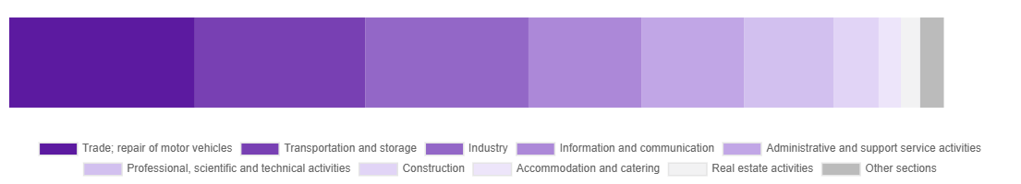
Chart 1. Structure of average paid employment by sections of PKD in August 2026

Compared to August 2025, a decrease in average employment was recorded in the sections: accommodation and catering (by 3.3%), real estate activities (by 2.9%), trade; repair of motor vehicles (by 1.9%), transportation and storage (by 1.3%), industry (by 0.4%).
An increase in average employment occurred in the sections: professional, scientific and technical activities (by 1.6%), administrative and support service activities (by 1.0%), information and communication (by 0.5%).

Registered unemployment*
At the end of August 2026, the number of registered unemployed persons amounted to 21990 and was by 189 persons, i.e. by 0.9% smaller than at the end of July 2026 and by 424 persons, i.e. by 1.9% smaller than in the corresponding period of 2025.
The number of registered unemployed women amounted to 10765, which accounted for 49.0% of the total unemployed (48.8% a month before, and 47.3% a year before) and 18.4% of unemployed women in Mazowieckie Voivodship. As compared to July 2026, the number of unemployed women decreased by 62 persons, i.e. by 0.6%, and compared to August 2025 it increased by 155 persons, i.e. by 1.5%.
The registered unemployment rate amounted to 1.6% (as in the previous month and in the previous year), in Mazowieckie Voivodship it was 4.5% (as a month before and 4.4% a year before), while in the country at a level of 5.8% (as a month before and 5.5% a year before).
In August 2026, there were 2870 unemployed persons registered in labour offices (3428 in July 2026, and 2686 in August 2025). Registered unemployed persons accounted for 25.8% of the total registered unemployed in the Voivodship.
The number of persons registering for the first time amounted to 1128 (1295 a month before), which accounted for 39.3% of the total unemployed who registered in August 2026 and 30.7% of persons registering for the first time in the Voivodship. The share of persons terminated due to company reasons among unemployed persons registered in August 2026 amounted to 3.7% (4.7% in Mazowieckie Voivodship), 3.9% a month before and 4.0% a year before.
In August 2026, 3059 persons were removed from unemployment rolls (3518 in July 2026, and 1433 in August 2025), which accounted for 27.8% of unemployed persons removed from unemployment rolls in Mazowieckie Voivodship. Out of the unemployed removed from unemployment rolls, 1275 persons took up work. Moreover, 1471 persons lost their status of the unemployed as a result of not maintaining contact with the labour office at least once every 90 days. The reason for removing from the register was also starting training or traineeship, acquisition of retirement or pension rights, and others.

There were 19217 persons who were not entitled to the unemployment benefit, i.e. 87.4% of the total unemployed (19418 persons a year before, i.e. 86.6%), whereas 2773 unemployed persons were entitled to the unemployment benefit.
In August 2026, there were 1844 job offers* submitted to labour offices, which accounted for 40.6% of job offers in Mazowieckie Voivodship and at the end this month the labour offices had job offers for 1447 persons. At the end of August 2026, there were 15 persons per one job offer (16 in the previous month, 18 a year ago), while in Mazowieckie Voivodship, there were 26 persons (25 a month before, and 30 a year before) registered as unemployed.

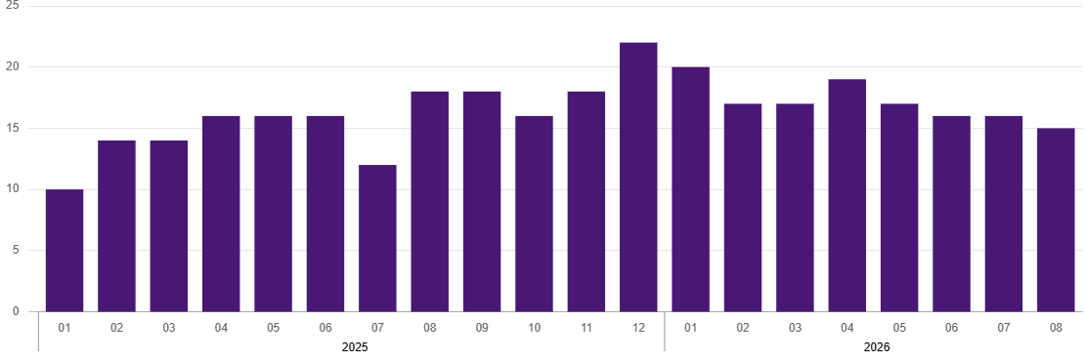
Chart 2. Number of unemployed persons per job offer (as of end of month)
* On 1 June 2025, the new Act on the Labour Market and Employment Services (Journal of Laws of 2025, item 620) entered into force, introducing changes to the rules for registering and recording unemployed persons. As a result, some published data has been adjusted to reflect the current legal status and statutory terminology, which may affect the comparability of current data with previous periods.
Wages and salaries
The average monthly gross wages and salaries in the enterprise sector in August 2026 amounted to PLN 11239.26 and were by 1.3% lower as compared to the previous month and by 7.0% higher than in the corresponding period of 2025.
Compared to July 2026, a decrease in the average gross wages and salaries was recorded in the following sections: accommodation and catering (by 7.1%), industry (by 4.2%), trade; repair of motor vehicles (by 2.9%), transportation and storage (by 2.5%), administrative and support service activities (by 1.9%), construction (by 1.1%), real estate activities (by 0.5%).
Whereas an increase in the average gross wages and salaries was recorded in the section of information and communication (by 2.9%).
Compared to August 2025, an increase in the average gross wages and salaries was recorded in the sections: information and communication (by 9.0%), professional, scientific and technical activities (by 8.0%), industry (by 7.5%), real estate activities (by 7.0%), trade; repair of motor vehicles (by 6.8%), transportation and storage (by 6.0%), administrative and support service activities (by 3.7%), accommodation and catering (by 3.6%), construction (by 3.4%).

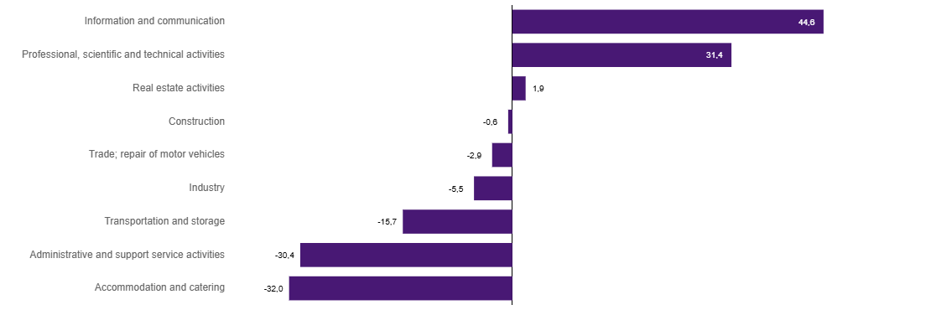
Chart 3. Relative deviations (in %) of monthly gross wages and salaries in selected sections from average wages and salaries in enterprise sector in Warszawa in August 2026

Construction
Sold production of construction in August 2026 amounted (at current prices) to PLN 5963.1 million and compared to July 2026 was smaller by 4.7% and compared to the corresponding period of previous year it dcreased by 3.7%.
In January-August 2026, sold production of construction reached the value of PLN 46550.3 million, i.e. by 5.8% smaller than in the corresponding period of 2025.
Construction and assembly production in August 2026 amounted to PLN 1710.6 million (at current prices) and accounted for 28.7% of sold production of construction. Compared to the previous month, construction and assembly production increased by 2.7%, and compared to August 2025 it was larger by 14.6%.
In January-August 2026, construction and assembly production amounted to PLN 11442.2 million and accounted for 24.6% of sold production of construction (22.0% a year before). Compared to the corresponding period of previous year, construction and assembly production was larger by 5.2%.
The increase in production in relation to the corresponding period of 2025 occurred in units dealing with civil engineering (by 10.2%), construction of buildings (by 1.8%) and specialised construction activities (by 0.6%).
Labour productivity measured by production per employed person in construction in August 2026 amounted to PLN 111.7 thousand and was by 4.6% lower than a month before and by 3.7% than in August 2025.

Trade
Retail sales in trade and non-trade enterprises in August 2026 (at current prices) were by 0.01% larger than in July 2026 and by 8.7% higher compared to August 2025.
Compared to July 2026, the largest increase was recorded in sales of solid, liquid and gas fuels (by 10.0%), and other retail sales in non-specialised stores (by 8.0%). Whereas a decrease was recorded in sales of pharmaceuticals, cosmetics, orthopaedic equipment (by 10.5%), sales motor vehicles, motorcycles, parts (by 7.1%), sales of furniture, electronic goods and household equipment (by 4.2%), and sales in the “others” group (by 1.8%).
Compared to August 2025, the largest increase was recorded in sales of solid, liquid and gas fuels (by 26.4%), other retail sales in non-specialised stores (by 24.5%), sales in the “others” group (by 18.5%), sales of newspapers, books, other retail sales in specialised stores (by 7.2%). Whereas a decrease was recorded in sales of motor vehicles, motorcycles, parts (by 4.2%) and sales of food, beverages and tobacco (by 3.4%).
In January-August 2026, retail sales increased by 5.3% compared to the corresponding period of 2025.
Wholesale in trade enterprises in August 2026 (at current prices) was by 7.9% smaller as compared to the previous month and by 11.6% higher than in August 2025, and in wholesale enterprises it was lower by 5.1% and higher by 10.4%, respectively.
In January-August 2026, retail units achieved wholesale that was 11.8% higher than a year ago, while wholesale enterprises achieved wholesale that was 12.5% higher.

Industry
The sold production of industry in August 2026 amounted to (in current prices) PLN 14894.0 million and was (at constant prices) larger than in the corresponding month of 2025 by 8.7%. As compared to August 2025, an increase in sold production of industry was recorded in manufacturing by 8.5%.
In the period January-August 2026, sold production of industry amounted to PLN 126792.7 million (at current prices) and was (at constant prices) higher by 5.6% than that achieved in the same period of 2025. In manufacturing, an increase in production by 5.8% was recorded.
Among the divisions classified as manufacturing, the increase in sales was recorded, among others, in: manufacture of textiles (by 106.2%), manufacture of beverages (by 42.5%), manufacture of furniture (by 34.1%), repair and installation of machinery and equipment (by 26.1%), manufacture of computer, electronic and optical products (by 25.4%), manufacture of basic metals (by 18.1%), other manufacturing (by 12.2%), manufacture of machinery and equipment n.e.c. (by 6.1%), manufacture of pharmaceutical products (by 5.1%), manufacture of food products (by 4.7%), manufacture of motor vehicles, trailers and semi-trailers (by 1.2%), manufacture of paper and paper products (by 0.8%), manufacture of chemicals and chemical products (by 0.3%).
The decrease in sales was recorded, among others, in: manufacture of wearing apparel (by 23.4%), manufacture of products of wood, cork, straw and wicker (by 21.4%), manufacture of metal products (by 14.7%), manufacture of electrical equipment (by 9.9%), printing and reproduction of recorded media (by 3.9%), manufacture of coke and refined petroleum products (by 1.8%), manufacture of rubber and plastics (by 1.2%), manufacture of other non-metallic mineral products (by 0.6%).
Labour productivity in industry measured by production per employed person, in January-August 2026 amounted to PLN 656.7 thousand (at current prices) and was – at constant prices – by 6.6% higher than in the previous year.

Residential construction
According to preliminary data, 1817 dwellings were completed in Warszawa in August 2026, i.e. by 8.6% more than in the previous year.
In the period January-August 2026, 10457 dwellings were completed (by 7.0% less than in the corresponding period of 2025), and 26396 dwellings in Mazowieckie Voivodship, i.e. 3.2% less than in January-August 2025. The number of completed dwellings decreased in cooperative construction from 64 to 48, i.e., 25.0% less, in private construction from 425 to 365, i.e., 14.1% less, in construction intended for sale or rent from 10688 to 9699, i.e., 9.3% less. Meanwhile, there was an increase in public building societies from 66 to 245, i.e., 271.2% more. Furthermore, 100 dwellings were completed in company construction between January and August 2026.
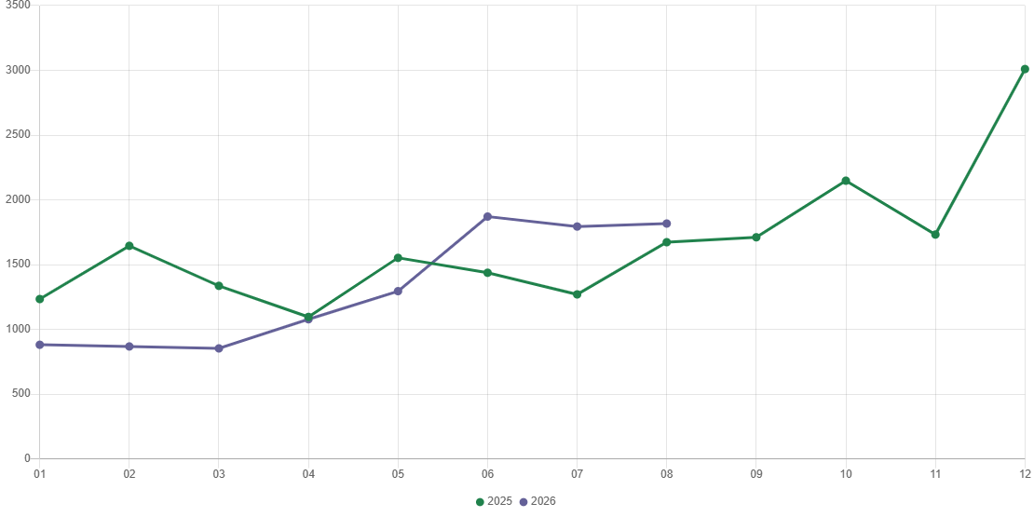
Chart 4. Dwellings completed

In January-August 2026, construction begun in 9385 dwellings (by 8.7% more than in the corresponding period of 2025) of which: 9022 in construction for sale or rent, 363 in private construction.
In January-August 2026, the number of dwellings for which permits have been granted or which have been registered with a construction project amounted to 9925 (by 5.8% more than in the corresponding period of 2025), of which 321 dwellings in buildings built by private investors.
The average useful floor area of a dwelling completed in January-August 2026, amounted to 59.7 m² and decreased by 1.5 m² compared to the corresponding period of 2025. In private construction, the average useful floor area of dwellings amounted to 158.2 m² (by 24.4 m² less than in the corresponding period of 2025), in cooperative construction – 62.2 m² (by 12.8 m² more), in construction for sale or rent – 56.5 m², in public building societies – 46.1 m² (by 3.8 m² less), in company construction – 35.8 m².

Entities of the national economy
At the end of August 2026, there were 611985 entities of the national economy registered in the REGON register in Warszawa, which accounted for 55.0% of the total in Mazowieckie Voivodship. Compared with July 2026, the number of entities of the national economy increased by 1545 (i.e. by 0.3%), and compared to August 2025 increased by 20344 (i.e. by 3.4%).
As of the end of August this year, there were 276912 legal persons and organisational units without legal personality registered in the REGON register, of which 201423 commercial companies. The number of these entities increased by 0.3% and 0.4%, respectively, compared to the previous month, by 3.8% and 4.4%, respectively, on an annual basis.
The number of registered natural persons conducting economic activity as of the end of August 2026 amounted to 335073 and compared to July 2026 it was higher by 0.2%, and compared to the corresponding period of the previous year increased by 3.2%.
In Warszawa, in August 2026, the most numerous were entities dealing with: professional, scientific and technical activities (19.4% of total registered units), trade; repair of motor vehicles (15.4%), as well as information and communication (13.1%).
Compared to July 2026, the number of entities increased, among others, in the sections: education (by 0.6%), agriculture, forestry and fishing (by 0.4%), electricity, gas, steam and air conditioning supply, arts, entertainment and recreation, financial and insurance activities, human health and social work activities, real estate activities, construction, information and communication as well as professional, scientific and technical activities (by 0.3% each). However there was a decrease in the number of entities in the section of water supply; sewerage, waste management and remediation activities (by 0.3%).
Compared to August 2025, the largest increase in the number of entities was recorded, among others, in the sections: administrative and support service activities (by 8.2%), human health and social work activities (by 6.1%), electricity, gas, steam and air conditioning supply and education (by 5.7% each), construction (by 5.0%), information and communication (by 4.2%), financial and insurance activities (by 4.1%). Whereas a decrease in the number of entities was noted in the sections: mining and quarrying (by 2.4%), water supply; sewerage, waste management and remediation activities (by 0.9%), agriculture, forestry and fishing (by 0.3%) as well as trade; repair of motor vehicles (by 0.2%).
In August 2026, 3047 new entities were entered into the REGON register, i.e. by 7.4% less than in the previous month. The newly registered entities were dominated by natural persons conducting economic activity – 1593 (by 9.4% less than in July 2026). The number of newly registered commercial companies was smaller compared to the previous month by 2.8%, including limited liability companies – smaller by 2.3%.

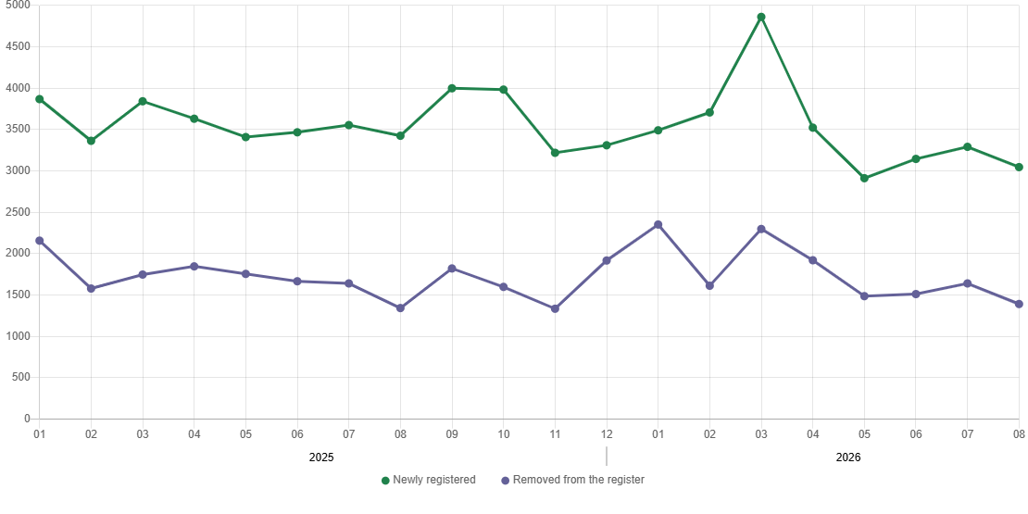
Chart 5. Entities newly registered and removed from the register

In August 2026, 1392 entities were removed from the REGON register (compared to 1641 in the previous month), including 867 natural persons conducting economic activity (by 13.0% less).
As of the end of August 2026, 79945 entities had suspended activity in the REGON register (by 1.5% more than a month before). The vast majority were natural persons conducting economic activity (90.8%).

When quoting this publication, please provide its title and indicate the Statistical Office in Warszawa as the author. When publishing your own calculations based on data from this publication, please include the following statement: Author’s work based on data from the publication entitled ‘Statistics of Warszawa No. 8/2026’ by the Statistical Office in Warszawa .

Prepared by:  Statistical Office in Warszawa  Director Agnieszka Ajdyn  Phone: (+48 22) 464 23 15 | Issued by:  Mazovian Centre for Regional Surveys  Information Centre  Mobile: (+48) 783 940 141
Press office in the Statistical Office in Warszawa  Mobile: (+48) 783 940 141  e-mail: m.kaluski@stat.gov.pl |   warszawa.stat.gov.pl/en/

@Warszawa_STAT

@UrzadStatystycznywWarszawie

gus_stat

glownyurzadstatystycznygus

glownyurzadstatystyczny

Related information
Communications and Announcements
Data available in databases
Local Data Bank → Labour market
Terms used in official statistics
Registered unemployed persons
Registered unemployment rate
Average paid employment
Average monthly gross wages and salaries
Dwellings completed

