Disabled persons in 2024
3.9 million
Persons with a certificate of disability or a level of disability or an equal one
As of 31 December 2024 in Poland, there were 3.9 million persons who held a valid certificate of disability or a level of disability issued by the medical examination committee or an equivalent. Such persons accounted for 10.5% off total population.

Disabled persons with legal confirmation
Disabled persons with legal confirmation hold at least one of the following certificates:
- of disability or a level of disability issued by the medical examination committee;
- of a level of incapacity to work issued by the Social Insurance Institution (ZUS);
- of a level of incapacity to work on a farm issued prior to 1 January 1998 by the Agricultural Social Insurance Institution (KRUS);
- of level of disability issued prior to 1 January 1998 by the medical committee subordinate to the Ministry of National Defence (MON);
- of a level of disability issued prior to 1 January 1998 by the medical examination committee subordinate to the acting minister of internal affairs.

Table 1. Disabled persons with legal confirmation by type of held certificate in 2024

As of 31 December
The persons with the certificate issued by medical examination committee accounted for 76.2%
Specification | Persons
Total | 3 949 489
Persons holding the certificate of disability issued by the medical examination committee | 3 010 000
Persons holding the certificate issued by ZUS | 1 680 091
Persons holding two certificates – issued by the medical examination committee and issued by ZUS | 768 241
Persons holding certificate issued prior to 1 January 1998 by KRUS | 31 621
Persons holding two certificates – issued by the medical examination committee and issued by KRUS | 8 661
Persons holding certificate issued prior to 1 January 1998 by the medical committee subordinate to MON | 6 160

Table 1. Disabled persons with legal confirmation by type of held certificate in 2024 (cont.)

As of 31 December
Specification | Persons
Persons holding two certificates – issued by the medical examination committee and issued by MON | 1 565
Persons holding certificate issued prior to 1 January 1998 by the medical committee subordinate to the acting minister of internal affairs | 125
Persons holding two certificates – issued by the medical examination committee and issued by the medical committee subordinate to the acting minister of internal affairs | 36
Persons holding two certificates – issued by ZUS and by MON | 5
Source: own development based on the data in the Electronic System on Certification on Disability (EKSMOoN), the ZUS pension systems (EMIR and RENTIER), the KRUS complex system of servicing pension benefits, the MON information system, the MSWiA Pension Institution information system Emeryt.
Out of all disabled persons with legal confirmation, 53.3% were women
In 41.1% cases the certificate of moderate disability was issued, the certificate of severe disability in 29.9% cases and of mild disability in 24.0% cases. Other certificates with non-defined level of disability were issued for the children up to the age of 16 (5.8%). Women accounted for over a half (53.3%) in population of disabled persons. Most persons (555.7 thousand) was aged from 70 to 74.

Chart 1. Disabled persons with legal confirmation by sex and groups of age in 2024

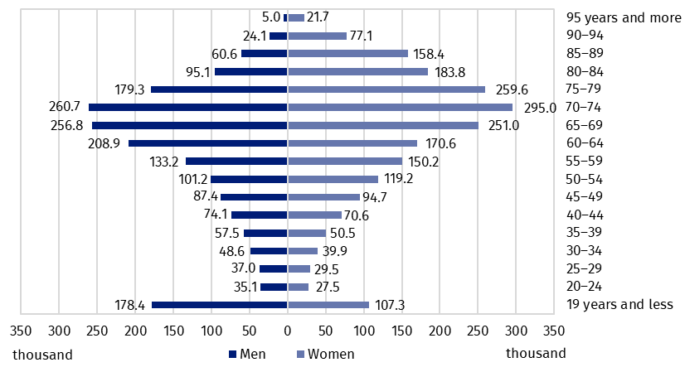
As of 31 December
Source: own development based on the data from EKSMOoN, ZUS EMIR and RENTIER, KRUS, MON, MSWiA.
The biggest number of disabled persons with legal confirmation (448.4 thousand) lived in Śląskie voivodship and the smallest one in Opolskie voivodship (85.6 thousand). The index of the number of disabled persons with legal confirmation per 1 thousand population was the highest in Lubuskie voivodship (160.7) and the lowest one in Mazowieckie voivodship (74.0).

Map 1. Disabled persons with legal confirmation by voivodships in 2024
The biggest number of disabled persons with legal confirmation per 1,000 population was recorded in Lubuskie voivodship (160.7)

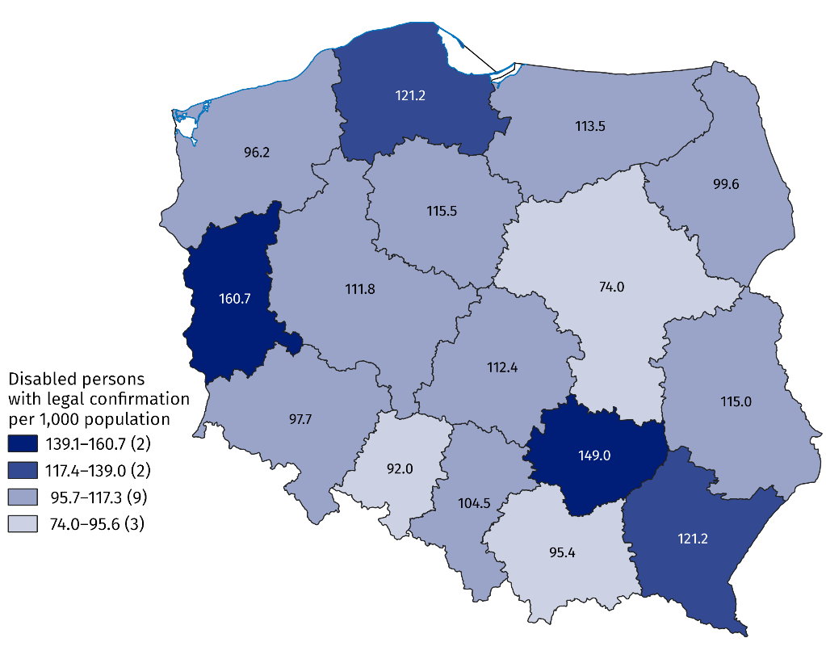
As of 31 December
Note: in case of 2.7 thousand persons the home address was not determined. The number of voivodships was given in the brackets.
Source: own development based on the data from EKSMOoN, ZUS EMIR and RENTIER, KRUS, MON, MSWiA.
The largest number of disabled persons with legal confirmation lived in Warsaw (98.8 thousand). They accounted for 2.5% of disabled persons with legal confirmation in Poland. Per 1,000 population, the highest index noted in in the gmina of Ostrowiec Świętokrzyski (246.6), and the smallest one in the gmina of Długołęka (30.0).

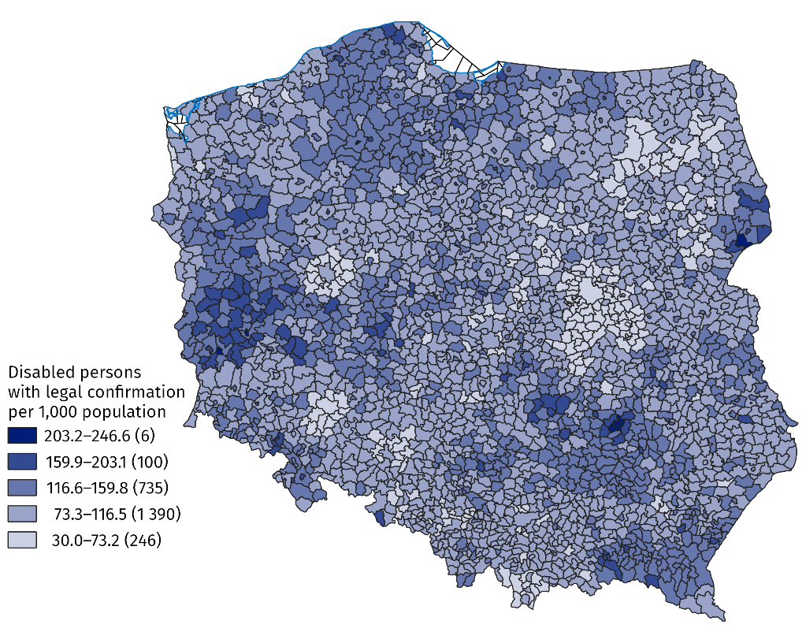
Map 2. Disabled persons with legal confirmation by gminas in 2024

As of 31 December
The highest value of index of disabled persons with legal conformation per 1 thousand population was recorded in Ostrowiec Świętkorzyski (246.6)
Note: in case of 2.7 thousand persons the home address was not determined. The number of gminas was given in the brackets.
Source: own development based on the data from EKSMOoN, ZUS EMIR and RENTIER, KRUS, MON, MSWiA.

Persons with a certificate of disability or a level of disability issued by the medical examination committee
As of 31 December 2024, 3,010.8 thousand persons held a certificate of disability or a level of disability issued by the medical examination committee. The certificate may contain no more than three symbols of causes of disability. The certificates recording:
- one cause – noted for 58.6% persons;
- two causes – 31.4% persons;
- three causes – 10.0% persons.
The biggest number of persons held a certificate issued because of motor impairment (1,382.4 thousand), and the smallest one because of epilepsy (68.2 thousand).

Chart 2. Persons with certificate of disability or a level of disability by its causes in 2024
The biggest number of certificates of disability or a level of disability was issued because of motor impairment (1 382.4 thousand)

As of 31 December

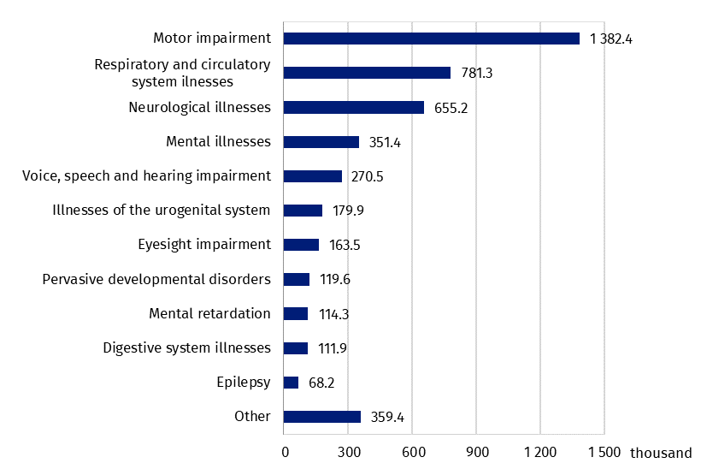
Source: own development based on the data from EKSMOoN.
In 2024, the medical examination committees processed 863.7 thousand applications referred to certificate of disability, a level of disability or reliefs and entitlements. The biggest numbers of applications was processed in Śląskie voivodship (105.3 thousand) and the smallest one in Opolskie voivodship (19.6 thousand). The index per 1 thousand population was the highest in Świętokrzyskie voivodship (38.5) and the lowest one in Mazowieckie voivodship (14.6). Over 77% applications were processed for more than 30 days. The biggest share of cases processed for more than 30 days was recorded in Pomorskie voivodship (91.1%) and the smallest one was recorded in Warmińsko-mazurskie voivodship (57.7%).

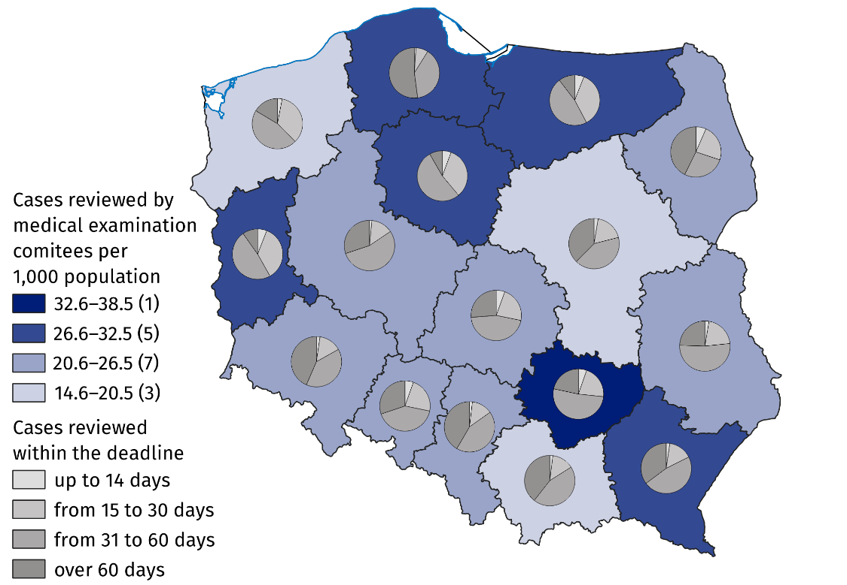
Map 3. Applications processed by medical examination committees in 2024
Note: The number of voivodships was given in the brackets.
Source: own development based on the data from EKSMOoN.
793.3 thousand persons with certificate of disability or a level of disability held valid parking card
As of 31 December 2024 there were 793.3 thousand persons with certificate of disability or a level of disability who held valid parking card. The biggest number of such persons per 1 thousand population was recorded in Lubuskie voivodship (33.4) and the smallest one in Mazowieckie voivodship (13.2).

Chart 3. Persons with a certificate of disability or level of disability with a valid parking card per 1,000 population by voivodships in 2024

As of 31 December
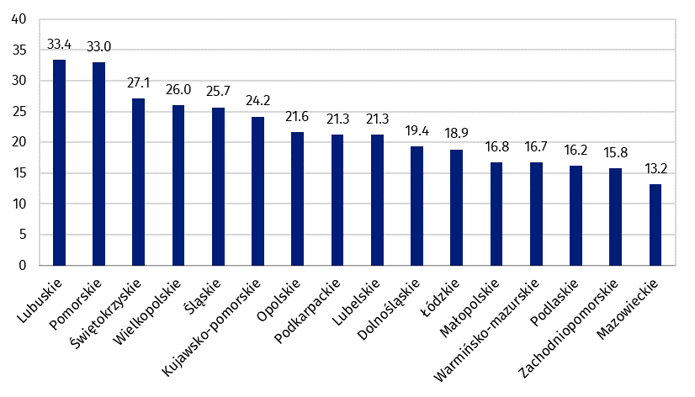
Source: own development based on the data from EKSMOoN.

Persons with a certificate of a level of incapacity to work issued by Social Insurance Institution
As of 31 December 2024, 1,680.1 thousand persons held a valid certificate of incapacity to work. Out of them, 43.8% held a certificate of total incapacity to work and live independent life, 22.1% – total incapacity to work and 34.1% – partial incapacity to work. Women accounted for 50.6% of total number of persons with a certificate of a level of incapacity to work. Permanent certificate was held by 58.2% persons and temporary one by 23.9%, while in other cases the information on validity of the certificate could not be determined.
As of the end of December 58.2% persons held a certificate of incapacity to work for indefinite period
The largest number of persons with certificate lived in Śląskie voivodship (203.8 thousand), and the smallest one in Opolskie voivodship (31.5 thousand). About 68.8% persons with a certificate of incapacity to work were over 60 years old. Out of both women and men, the largest number of persons at age of 70-74 (286.6 thousand). The share of 0.5% persons (8.2 thousand) was less than 20 years old.

Persons with certificate of a level of incapacity to work on a farm issued by the Agricultural Social Insurance Institution prior to 1 January 1998
As of 31 December 2024, 31.6 thousand people held a valid certificate of incapacity to work on a farm issued by the Agricultural Social Insurance Fund before 1 January 1998. Out of them 73.8% held a certificate of complete incapacity to work on the farm without certified inability to live independent life, while the rest held a certificate of complete incapacity to work in the farm and certificate of inability to live independent life. In the surveyed population, 96.3% persons held permanent certificate (issued for indefinite period), while the others held certificate of temporary incapacity to work on the farm.
The largest number of persons with certificate lived in Lubelskie voivodship (4.6 thousand) and the smallest in Opolskie voivodship (0.3 thousand persons). The highest index per 1,000 population was recorded in the Lubelskie voivodship (2.3) and the lowest one in Śląskie voivodship (0.2). About 99.2% persons were 50 or over years of age. Most men were aged 65–69 years (25.1%) and women were in the group of 70–74 years old (30.8%).

Persons with certificate of level of disability issued by the medical committee subordinate to the Ministry of National Defence prior to 1 January 1998
As of 31 December 2024, 6.2 thousand persons held a valid certificate of a level of disability, issued before 1 January 1998 by a medical commission subordinate to the Minister of National Defence. In this group, 13.7% held a certificate of the first degree disability group, 26.7% held certificate of the second degree disability group and 59.6% held the third degree disability group. All certificates were issued for indefinite period.
The largest number of persons lived in Łódzkie voivodship (1.2 thousand) and the smallest one in Lubelskie voivodship (0.1 thousand). All women lived in Mazowieckie voivodship. In the case of 16 persons, the address could not be determined. Over 96% persons was 65 years old or more while the other belonged to the age group of 49-64.

Persons with certificate of level of disability issued by the medical committee subordinate to the acting minister of internal affairs prior to 1 January 1998
As of 31 December 2024, 125 persons held a valid certificate of a level of disability, issued before 1 January 1998 by a medical commission subordinate to the minister responsible for internal affairs. Out of that population, 13 persons held a certificate certificate of disability of group I, 45 persons held a certificate of disability of group II and 67 persons held certificate of disability of group III. Men were predominant (70 persons). All certificates were issued for indefinite period.
The largest number of persons lived in Mazowieckie voivodship (65). In Dolnośląskie and Podlaskie voivodships, there was no person with certificate of a level of disability. Over 92% persons were aged 70 and over, while the rest belonged to the age group of 57–69. The youngest man was 57 years old, and the youngest woman was 67 years old.

Persons reported to Social Insurance Institution by contributors who informed the payer of contributions that they had a certificate of disability or level of disability or certificate of incapacity to work
In December 2024, over 738 thousand persons reported by contributors with ZUS informed the contribution payers that they had a certificate of disability or a level of disability (issued by the medical examination committee) or a certificate of a level of incapacity to work (issued by ZUS). The shares of individual levels of disability accounted for:
- mild – 28.0%;
- moderate – 60.4%;
- severe – 11.3%.
The others held a certificate of non-defined level due to age (up to 16 years old). The largest number of men with the certificate lived in Mazowieckie voivodship (42.0 thousand), and women in Śląskie voivodship (35.9 thousand). The smallest group lived in Opolskie voivodship (15.7 thousand). Per 1,000 inhabitants, the largest number of persons lived in Lubuskie voivodship (33.8), and the smallest one in Mazowieckie voivodship (13.4).

Map 4. Persons reported to Social Insurance Institution by contributors who informed the payer of contributions that they held a certificate of disability or a level of disability or certificate of incapacity to work by voivodships in 2024
The index of the number of persons who presented the payer of contributions a certificate of disability, level of disability or level of incapacity to work per 1,000 thousand population was the highest in Lubuskie Voivodship (33.8)

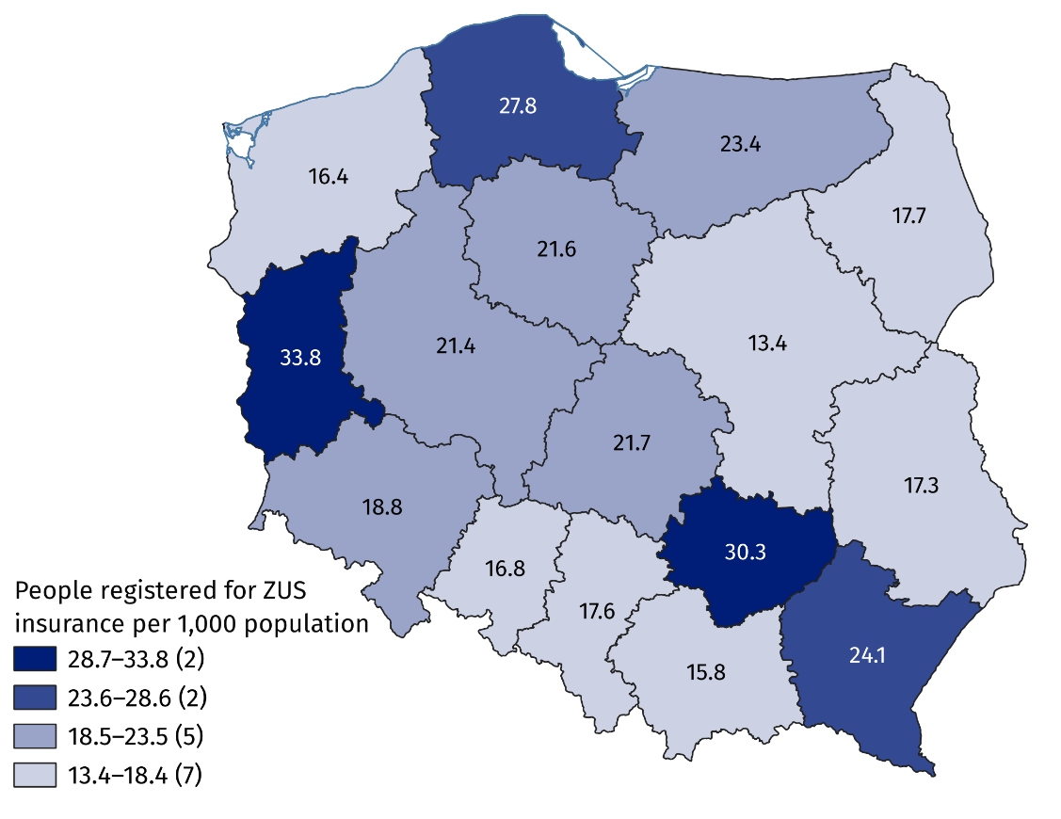
As of 31 December
Note: The number of voivodships was given in the brackets.
Source: Information System of the Social Insurance Institution.
In the surveyed population persons at age of 50 and more (60.1%) dominated. The majority of men was in the 60–64 age group (19.0%), while most women were in the 55–59 age group (20.0%).
In the surveyed population 60.0% persons was 50 years and more

Chart 4. Persons reported to Social Insurance Institution by contributors who informed the payer of contributions that they had a certificate of disability or level of disability or certificate of incapacity to work by sex and by age group in 2024

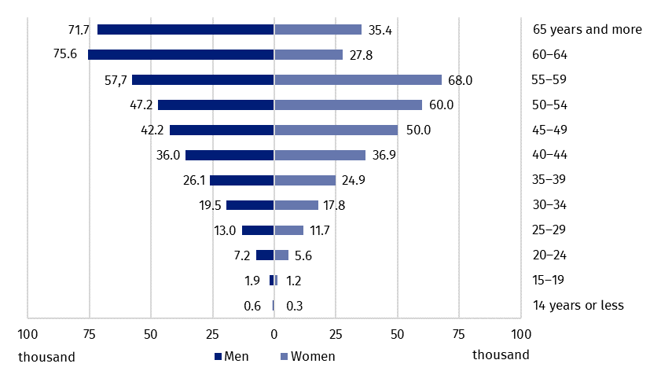
As of 31 December
Source: Information System of the Social Insurance Institution.
55.4% persons who presented to the contribution payer the certificate of disability or level of disability or certificate of incapacity to work , was reported to be insured in ZUS due to the contract for employment
Out of persons reported to the insurance in ZUS with a certificate, 18.1% was entitled to disability pension and 12.4% was entitled to old age pension. Over a half of persons (55.4%) was employed under an contract for employment. In the case of 14.8% persons, social contributions were paid by a social assistance organisational unit or by the village mayor, the mayor or the city president. Besides, 7.0% of insured persons executed agency contract, contract of mandate or service contract. Moreover, 5.5% was unemployed who received neither allowance nor stipend.

Educating persons with disabilities and persons with special educational needs
In the 2024/25 school year, there were 380 special nursery schools, attended by 8.9 thousand children with disabilities. The largest number of children was over 7 years old (27.1%). Boys predominated in the group of children in special nursery schools (70.7%). Other nursery schools and other pre-primary education establishments were attended by 62.8 thousand children with disabilities, who accounted for 4.3% of total number of children. The majority of children with disabilities attended regular nursery schools (79.4%), including the integrated nursery schools (11.4%) and the ones with integrated sections (9.6%).

Table 2. Pre-primary education units in the 2024/25 school year

As of 30 September
Specification | Units | Sections | Children
Specification | Units | Sections | total | of which with disabilitiesª
Total | 22 279 | 75 098 | 1 452 357 | 62 802
Nursery schools | 13 962 | 60 224 | 1 188 544 | 49 882
special | 380 | 1 859 | 8 897 | .
integrated | 508 | 1 927 | . | 7 154
with integrated sections | 535 | 3 522 | . | 6 009
with special sections | 101 | 628 | . | 1 811
with integrated and special sections | 141 | 1 058 | . | 4 220
other pre-primary schools | 12 297 | 51 230 | . | 30 688
Pre-primary education units | 34 | 34 | 457 | 19
Pre-primary sections | 1 286 | 1 286 | 20 847 | 5 730
Pre-primary sections at primary schools | 6 997 | 13 554 | 242 509 | 7 171
a Excluding children in special units.
Dot (.) means that populating the cells is not possible or is purposeless
Source: own development based on the data from Education Information System of MEN.
In the 2024/2025 school year 279.9 thousand children and youth with special educational needs attended schools (schools for adults excluded), i.e. 5.3% of total number of students
There were 56.9 thousand children in special primary schools. Moreover, 148.9 thousand children with certified special educational needs attended sections at regular primary schools. The total number of children with disabilities who received special education at primary level was 205.8 thousand (6.4% of the total number of children), out of which 68.8% were boys. Out of 3.4 thousand children who were taught individually, there were 45.8% children with disabilities.
In the 2024/25 school year, there were 351 special care and education centres and special education units. They were assigned for children with special education certificate issued due to their disability, but could not attend kindergarten or school in their place of residence because of their disability. Out of 22.7 thousand available places, 43.5% were used. Persons intellectually retarded accounted for 53.2% students. Moreover, the units provided care for children and youth with combined disabilities (29.4%), deaf or hearing impaired (4.7%) and blind or visually impaired (3.1%).
As of 30 September 2024, 191 rehabilitation and educational centres provided 8.3 thousand places, of which 74.7% were used. The facilities provided participation in classes for children with combined disabilities (3.5 thousand) and those with profound intellectual disabilities (2.5 thousand).
Education of young people with special educational needs at the secondary level was provided in special schools and in regular schools. The largest share of special schools were those that offered preparation for a specific profession: special schools for vocational training and special vocational schools of the first level. All special schools educated 31.5 thousand persons. Moreover, 42.4 thousand students with special educational needs were educated in sections at regular schools, including:
- 45.6% students in sections at general secondary schools,
- 32.3% students in sections at technical secondary schools
- 21.0% students in sections at stage I sectoral vocational schools.
The total number of children and youth covered by special education at the secondary level was 73.8 thousand, accounting for 4.1% of their total number.
Post-secondary schools were attended by 256 students with special educational needs. There were predominantly special schools (224 students).
As of 31 December 2024, 23.5 thousand persons with disabilities were studying at higher education institutions (1.9% of total number of students), and 5.3 thousand persons completed them (1.8% of total number of graduates). Out of doctoral students, 2.3% were the persons with disabilities (0.5 thousand).

Adaptation of infrastructure in the area of culture to the needs of disabled persons
Of all organisations operating in the field of culture, 55.5% had at least one adaptation for the disabled persons
Out of nearly 10 thousand organisations operating in the field of culture 5.5 thousand had at least one adaptations for the disabled. Most adaptations to the needs for disabled persons were in the cinemas (90.7%) and the least of them in public libraries (51.3%). In 2024 the share of buildings adapted to the needs of the disabled, where the centres of culture, clubs and community centres operate, accounted for 60.6%.

Table 3. Adaptations to the needs of disabled persons in institutions of culture in 2024

As of 31 December
Specification | Total | Of total the facilities adapted to the needs of disabled persons
Specification | Total | total adapted facilities | entrance to the building | adaptations inside the building
Theatres and musical institutions | 206 | 174 | 171 | 171
Art galleries and art exhibitions | 310 | 190 | 182 | 159
Para-museum institutions | 359 | 237 | 229 | 200
Cinemas | 535 | 485 | 484 | 457
Museums and museum branches | 982 | 551 | 529 | 479
Public libraries | 7 541 | 3 871 | 3 802 | 2 583
Note. The table does not refer to the centres of culture, cultural centres and establishments, clubs and community centres, because the data on amenities in those units are related only to the buildings.

Adaptation of infrastructure in the area of health care to the needs of disabled persons
24.8 thousand outpatient departments and medical practises had the adaptations to the needs of disabled persons
Out of 27.3 thousand outpatient departments and individual medical practises 91.1% had at least one adaptation to the needs of disabled persons. Among them, toilets were the most common adaptation to the needs of the disabled (78.7%), while the least common adaptations referred to the amenities for hearing impaired and deaf (4.1%). In 8.9 objects there were no adaptations.

Chart 5. Adaptations to the needs of the disabled persons in outpatient departments and individual medical practises in 2024

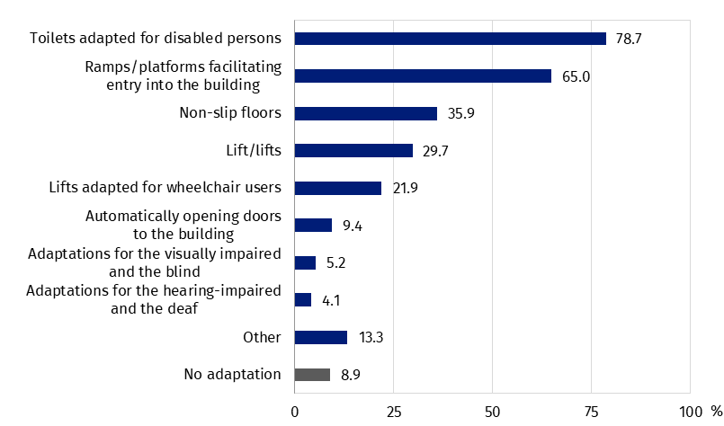
As of 31 December

Passenger road transport
As of 31 December urban transport in Poland had 12,512 buses and 3,026 trams. The share of buses adapted to transport disabled persons accounted for 97.6%, and trams for 57.5%.
In Poland the share of buses adapted to transport disabled persons accounted for 97.6%
In two voivodships the share of buses adapted to transport the disabled was below 90%: Lubuskie (86.5) and Opolskie (81.0%).
In Pomorskie voivodship all trams were adapted for the needs of the disabled (139). The least number, 38 out of 200 trams were adapted to transport the disabled in Zachodniopomorskie voivodship.
The number of operating bus stations owned or managed by the carrier amounted to 128, of which 72 were adapted for disabled persons (56.3%).

Map 5. Adaptation of trams to transport disabled persons in 2024

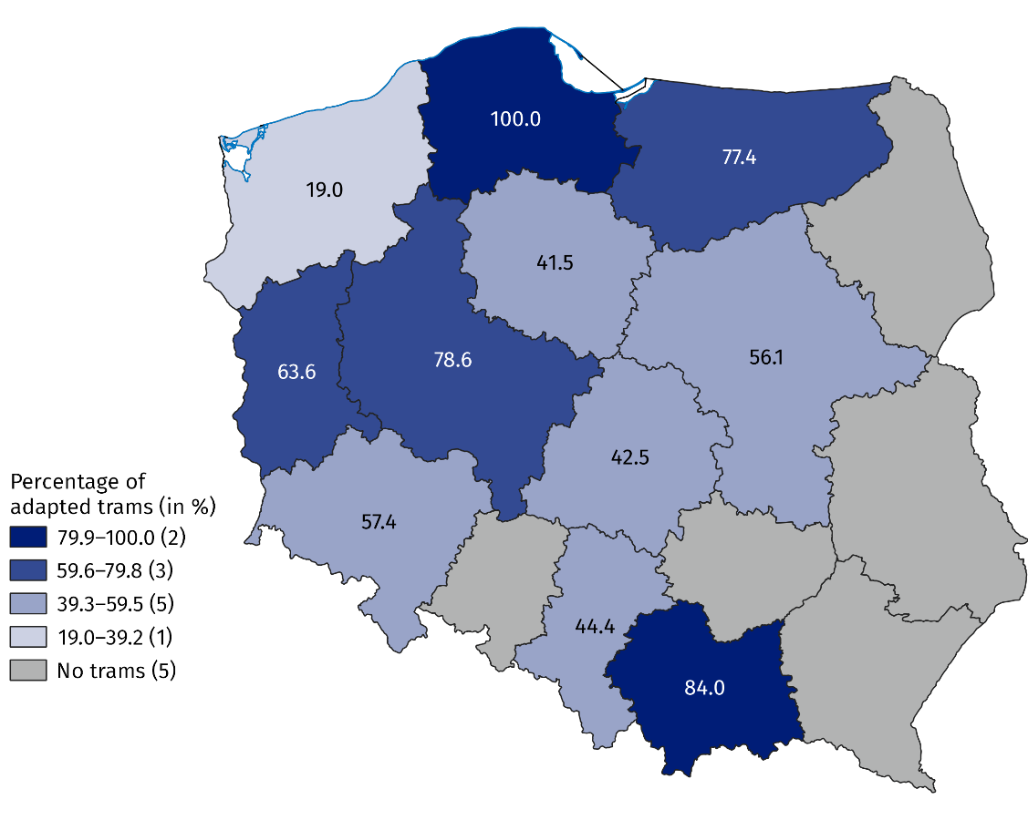
As of 31 December
Note: The number of voivodships was given in the brackets.

Methodological notes
- The disability certification system in Poland is defined by two fundamental legal acts:
- The Act of 27 August 1997 on Vocational and Social Rehabilitation and Employment of Disabled Persons, abridged: the Act on Rehabilitation – in Art. 2, disability is defined as permanent or temporary inability to fulfil social roles due to permanent or long-term impairment of the overall efficiency, in particular resulting in incapacity to work. Art. 3 defines the level of disability: severe, moderate and mild, while Art. 4a mentions children up to 16 years of age who are certified without determining their level of disability. Disability adjudication institutions are powiat and city (first instance) and voivodship (second instance) disability adjudication units. The final instance consists of labour and social security courts;
- The Act of 17 December 1998 on Retirement and Other Pensions from the Social Insurance Fund – Art. 12 defines person incapable to work as one who has completely or partially lost the ability to work for paid employment due to a deterioration of the physical or psychical health and is not expected to regain the ability to work after retraining. Decisions on: incapacity to work, incapacity to live independent life and on rationale of retraining, issued by the Social Insurance Institution, are converted into verdicts on the level of disability in accordance with Art. 5 of the aforementioned Act on Rehabilitation.
- According to Art. 62(3) and Art. 63 of the Act on Rehabilitation, persons certified as complete incapable to work in an agricultural holding are disabled if the certificates were issued before 1 January 1998, and are still valid, except that:
- persons who are entitled to care allowance are determined as the ones with severe level of disability,
- other persons are determined as the ones with mild level of disability.
Complete incapacity to work has been defined as permanent or temporary. The explanation of those notions can be traced to the Act of 20 December 1990 on Social Insurance of Farmers, where in Art. 21 it is evoked that complete incapacity to work on an agricultural holding is recognised as permanent if insured person is not likely to regain capabilities to personally perform works on an agricultural holding. Complete incapacity to work is treated as temporary if insured person is likely to regain capabilities to personally perform works on an agricultural holding. In case of permanent incapability the verdicts were issued for indefinite period, while in case of temporary inability the final date of legally recognised incapability was confirmed.
Along with a certificate of total incapacity to work on an agricultural holding, the beneficiaries are entitled to receive a certificate of inability to live independent life. In such case, farmers are entitled to nursing supplement. The benefit can be granted automatically – to persons who are more than 75, years old or upon submitting the application, with certificates on health enclosed – to adults who are completely incapable to work and to live independent life. In principle, entitlement to nursing supplement excludes its beneficiary from the right to nursing allowance, since beneficiaries are entitled to just one of those benefits. The benefits, though similar, differ in that:
- nursing supplement is paid by the Agricultural Social Insurance Fund, while the allowance by the local government executive organ – the village mayor, the mayor or the president of the city – competent in consideration of beneficiary’s home address,
- nursing supplement is paid jointly with retirement and other pension, while nursing allowance is paid regardless of other granted benefits.
In accordance with the Act on Social Insurance for Farmers, verdicts on permanent or temporary complete incapacity to work on an agricultural holding, which constitute one of the prerequisites for the entitlement to incapacity to work pension, are issued by medical expert (first instance) or medical examination committee (second instance).
Certificates of incapacity to work issued by medical expert or a medical examination committee of the Agricultural Social Insurance Fund after 1 January 1998 are not convertible into the levels of disability. Persons who have been issued a certificate of incapacity to work on an agricultural holding in the adjudication system of the Agricultural Social Insurance Fund after 1 January 1998 may apply to the examination committee to determine the level of disability.
- According to Art. 62 (1, 2) and Art. 63 of the Act on Rehabilitation, individuals holding verdicts on assigning to one of the disability groups, issued before 1 January 1998 by medical examination committees subordinated to the minister of competent for internal affairs and the Minister of National Defence on the basis of separate regulations on the assessment of capability to military service - the Act of 10 December 1993 on Retirement Provision for Professional Soldiers and Their Families and the Act of 18 February 1994 on Retirement Provision for Officers of the Police, Internal Security Agency, Intelligence Agency, Military Counterintelligence Agency, Military Intelligence Service, Central Anti–Corruption Office, Border Guard, Marshal Guard, State Protection Service, State Fire Service, Customs and Tax Service, Prison Service and their families – are converted into the following levels of disability:
- certificate assigning for group I of disability is equal to certificate of severe disability,
- certificate assigning for group II of disability is equal to certificate of moderate disability,
- certificate assigning for group III of disability is equal to certificate of mild disability.
The verdicts of medical examination committees issued after 31 December 1997 are not equal to the assessments of disability within the meaning of the Act on Rehabilitation. In compliance to Art. 5a of the Act on Rehabilitation, individuals may apply to the examination committees to determine the level of disability.
- The release news uses the datasets of:
- medical examination committees on persons holding valid verdict on disability or the level of disability (EKSMOoN);
- Social Insurance Institution on the recipients of retirement and other pensions with the verdict on the level of incapacity to work (ZUS EMIR and RENTIER);
- Social Insurance Institution on persons reported for social and health insurance by contributors who have presented a certificate on disability, level of disability or level of incapacity to work, issued by a relevant authority (from Central Register of Insured ZUS);
- Agricultural Social Insurance Fund on recipients of disability benefits;
Information on decisions on complete incapacity to work on an agricultural holding has been stored in the Agricultural Social Insurance Fund system since 2000. The analysed data does not refer to persons who, after 25 years of employment record, had their disability pension converted into retirement benefit (unless it is more favourable to the beneficiary);
- Ministry of National Defence on persons holding valid verdict on disability group, issued before 1 January 1998 by the medical committee subordinate to the Minister of National Defence;
- Pension Institution of the Ministry of Internal Affairs and Administration on persons holding valid verdict on disability group, issued before 1 January 1998 by the medical committee subordinate to the minister competent for internal affairs;
- Ministry of National Education on children and youth with the verdict of the public psychological and educational counselling centre (including public specialist outpatient clinic) on the need for special education or for individual education;
Special education is organised for children and youth with disabilities, socially maladjusted and at risk of social maladjustment, requiring special forms of learning and methods of work. It may be organised in the general school system or individually. School children with the certificate of special educational needs are not necessarily disabled in compliance with the provisions of the Act on Rehabilitation, likewise disabled school children do not need a verdict on the need of special education.
- Ministry of Science and Higher Education on students and doctoral students with a verdict on the level of disability issued by the relevant authority;
- from the reporting of Statistics Poland.
- The data presented in this release news on persons holding the valid certificate of disability or the level of disability issued by the Disability Assessment Committee are different from the data included in the quarterly information of the Office of the Government Plenipotentiary for Disabled Persons. The age of individuals was determined as of 31 December 2024, not as of the date of the verdict. The data may not record all verdicts of organs of appeal.
In the case of quoting data from the Statistics Poland, please provide information: "Statistics Poland data source", and in the case of publishing calculations made on data published by the Statistics Poland, please provide information: "Own study based on Statistics Poland data".
Prepared by:  Statistical Office in Kraków  Director Agnieszka Szlubowska  Phone: (+48 12) 420 40 50 | Issued by:  Press Office  Mobile: (+48) 695 255 032  Phone: (+48 22) 608 38 04, (+48 22) 449 41 45,  (+48 22) 608 30 09  e-mail: obslugaprasowa@stat.gov.pl

stat.gov.pl/en/

@StatPoland

@GlownyUrzadStatystyczny

gus_stat

glownyurzadstatystycznygus

glownyurzadstatystyczny
Related information
Social assistance, child and family services in 2023
Disabled persons in 2023
Disabled persons in Malopolska voivodship in 2022
Terms used inn official statistics
Disabled person
Disabled person with legal confirmation
Level of disability

Certificate of a level of disability issued by Social Insurance Institution or certificate of an incapacity to work on a farm issued prior to 1 January 1998 by the Agricultural Social Insurance Institution or certificate of level of disability issued prior to 1 January 1998 by the medical committee subordinate to the Ministry of National Defence or to the acting minister of internal affairs.
The data are not comparable in scope with those published in 2023 due to a change in the methodology of calculating the number of disabled persons with legal confirmation.
Determined by home address. When home address was unknown, determined by the mailing address, and when both addresses were unknown, the registered address was used.
Population as of 31 December.
Population as of 31 December.
Population as of 30 June.
Population as of 31 December.
In the case of 169 persons the address could not be determined.
Population as of 31 December.
In the case of 16 persons the address could not be determined.
Population as of 31 December.
Children with disability combined with autism, with Asperger’s syndrome, motor impairment, mental disability at moderate or severe level, blind, with eyesight impairment, deaf and with hearing impairment.
Children with combined disabilities, with mental disabilities, autism, motor impairment, deaf, with hearing impairment, blind, with eyesight impairment, socially excluded or threatened with social exclusion, who as of 30 September submitted the certificate on the need for special education.
Rehabilitation and educational centres are facilities that enable the implementation of the annual obligation of pre-school preparation, the obligation to attend school and the obligation to learn for children and young people with profound intellectual disabilities, who have a decision on the need for rehabilitation and educational activities, and with multiple disabilities, one of which was an intellectual disability, who have a decision on the need for special education.
In five voivodships (Lubelskie, Opolskie, Podkarpackie, Podlaskie and Świętokrzyskie) the trams do not operate.

